
Month: November 2025 Issue No: 89
This month we attended the Reading roundabout event in Reading organised by the Thames Valley and Great Western omnibus trust. This day was an excellent day to meet up with friends with the same interests and for riding vintage buses in and around Reading. Robert Williams CEO of Reading buses had his bus they in the form of Reading buses 701 MRD1R his other bus 814 M957VWY Optare Vecta couldn’t make it for personal reasons. More about this on page three. Usually at this time of the year there’s not much to report on has events are normally few and far between now. Unless we have an exhibition in Birmingham.
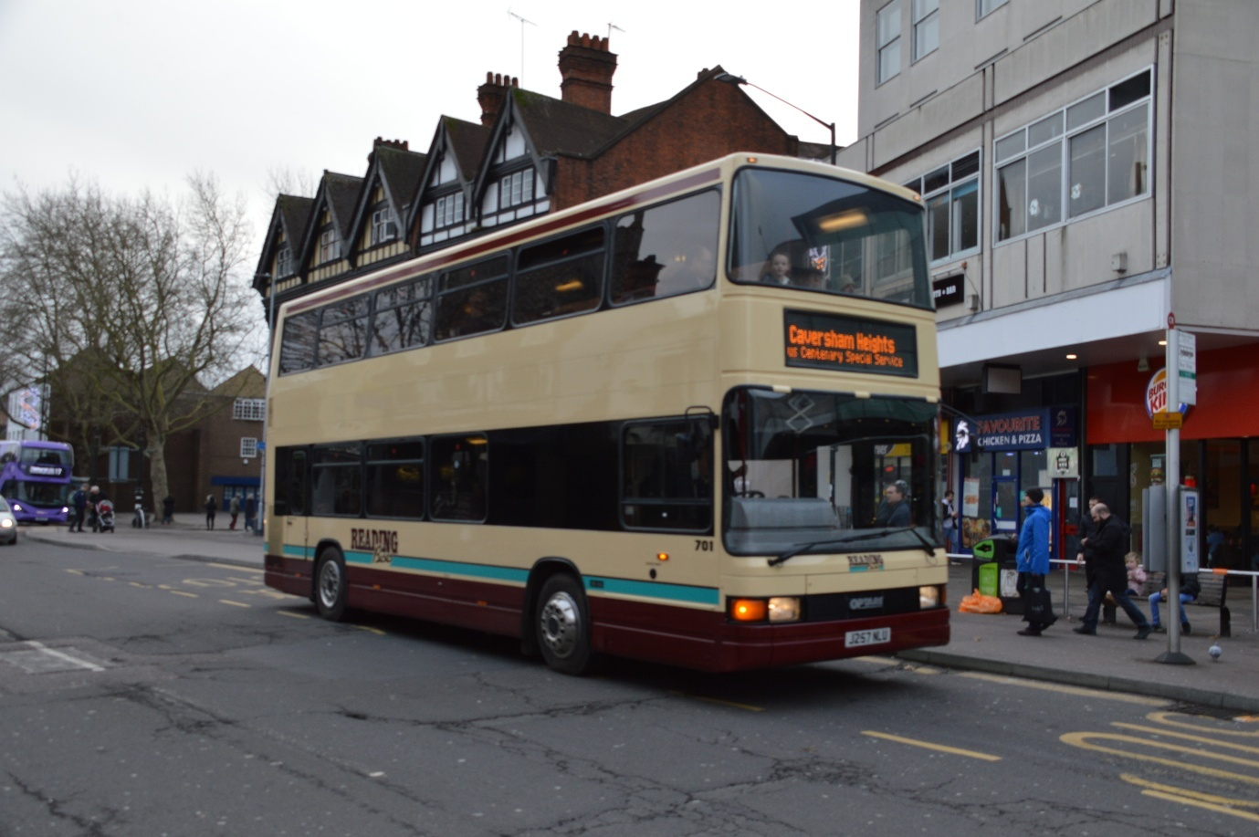
Photo credit to Gary Baxter Administration of Gary’s bus and coach photos: Reading buses 701 J257NLU now MRD1R photographed back in December 2019 at Thames Valley and Great western omnibus trust event celebrating 100 years of buses in Reading. Special running day organised by them. Now coming back in November 2025 for Reading roundabout special running day organised by the same organisation.
Flickr Albums
November 2025
Flickr Album Date: | Flickr Album Label | Flickr Album Link
3rd November 2025 | Maidenhead & High Wycombe | https://flic.kr/s/aHBqjCzGMk
5th November 2025 | Reading Berkshire | https://flic.kr/s/aHBqjCzWT6
16th November 2025 | Reading vintage bus running day | https://flic.kr/s/aHBqjCB1jX
18th November 2025 | Bracknell & Reading Berkshire | https://flic.kr/s/aHBqjCBe5v
20th November 2025 | Bracknell & Reading Berkshire | https://flic.kr/s/aHBqjCBnoi
21st November 2025 | Bracknell / London Transport Routemaster | https://flic.kr/s/aHBqjCBynE
Photo of the month
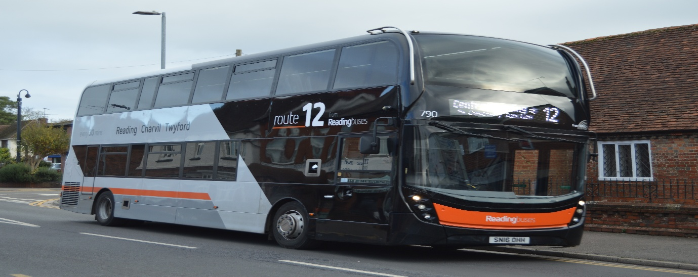
Photo credit to Gary Baxter Administration of Gary's bus and coach photos: RB790 SN16OHH ADL Enviro400mmc branded route 12 to Twyford photographed in Twyford Waitrose opposite bus stop more photos found in this album https://flic.kr/s/aHBqjCBnoi or www.flickr.com/photos/garysbusandcoachphotos this is photo of the month for November 2025. Photo from the highlighted album in the grid above.
Reading buses roundabout running day
We attended at the Reading buses roundabout running day in Reading on the 16th, November 2025. The day was excellent and the rides round Reading were good it was great to ride round the different places in Reading and to meet friends with the same interests. Photos and video from this event links found here or on website at www.garysbusandcoachphotos.co.uk https://flic.kr/s/aHBqjCB1jX no video from this event because was so busy on and off buses though out the whole day
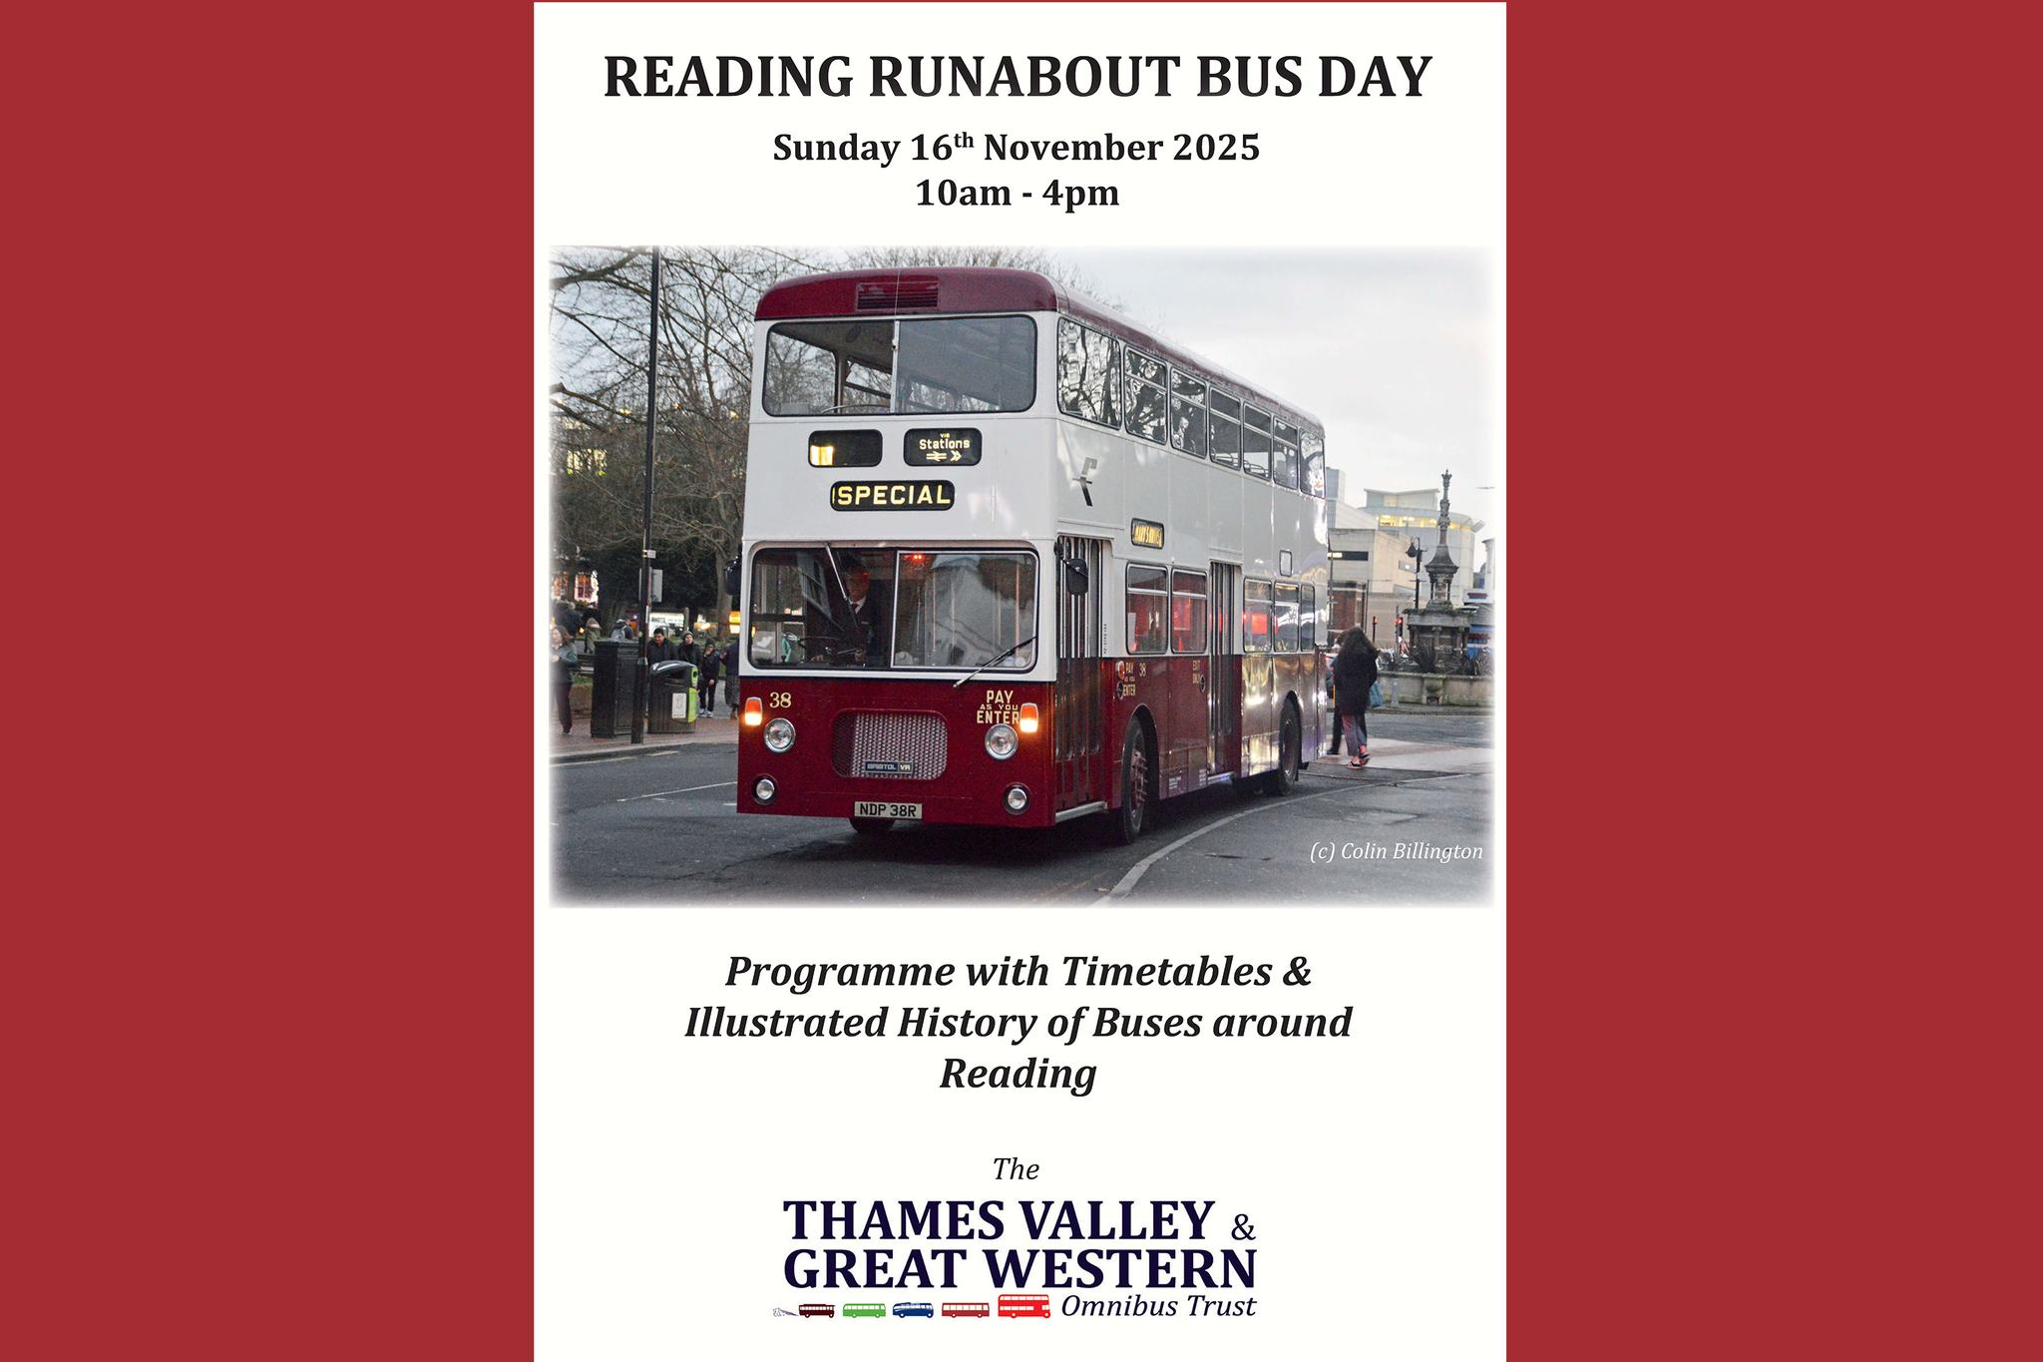
Events
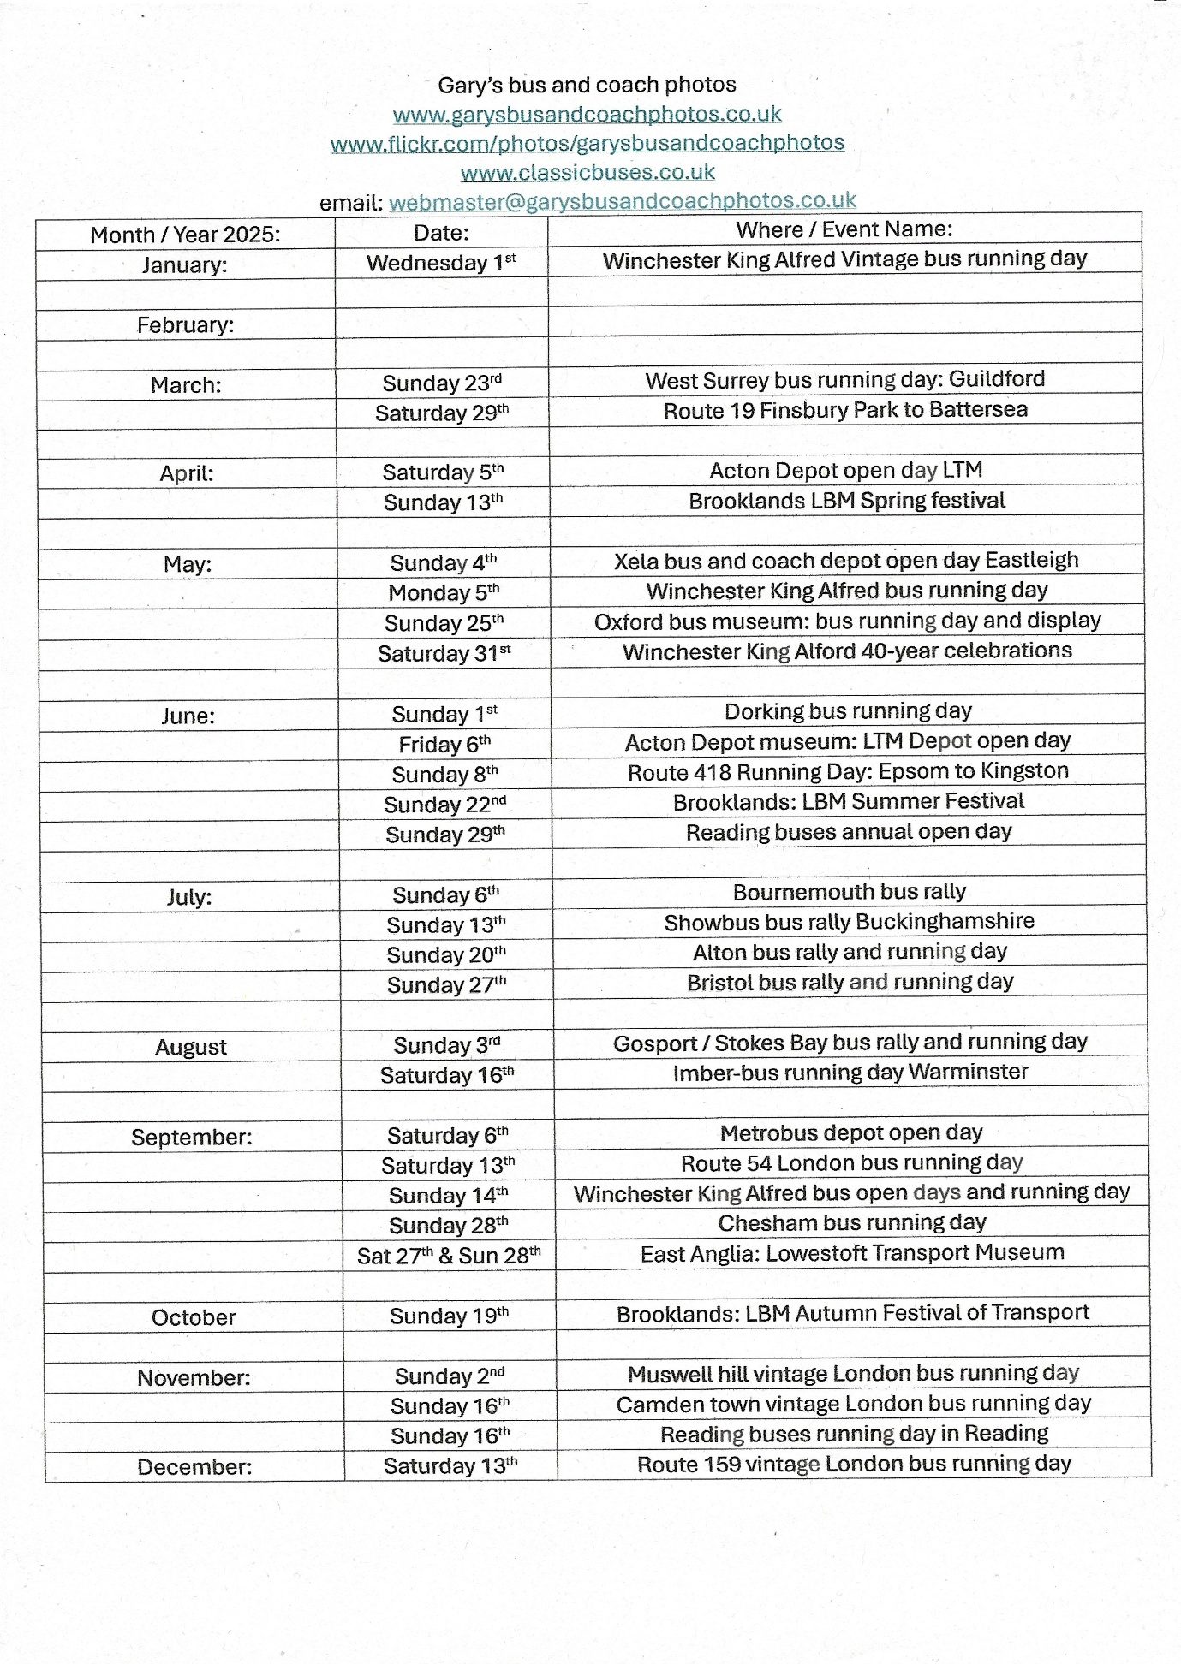

Thames valley buses launched a new route this month the new route operates from Maidenhead to High Wycombe via Cookham, Bourne end and Flackwell heath the number of this route is twenty. This is operated by Thames Valley buses Maidenhead division.
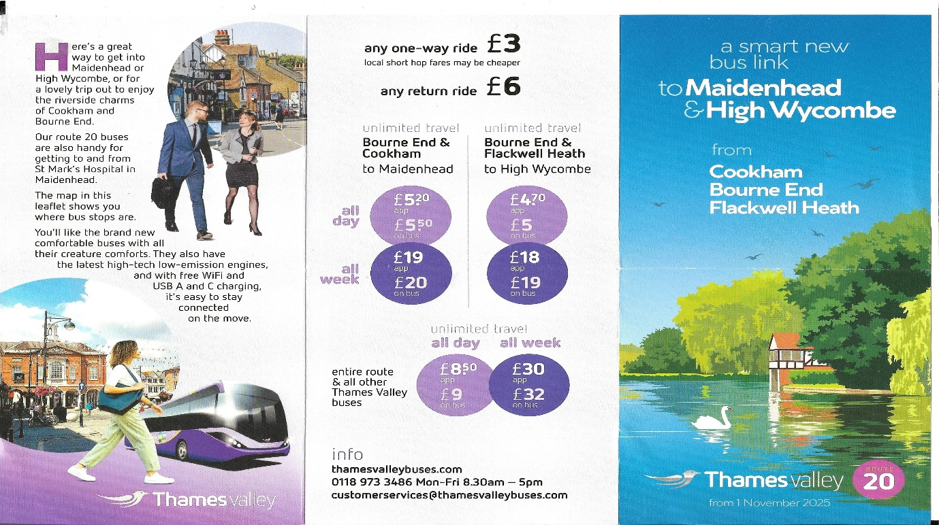
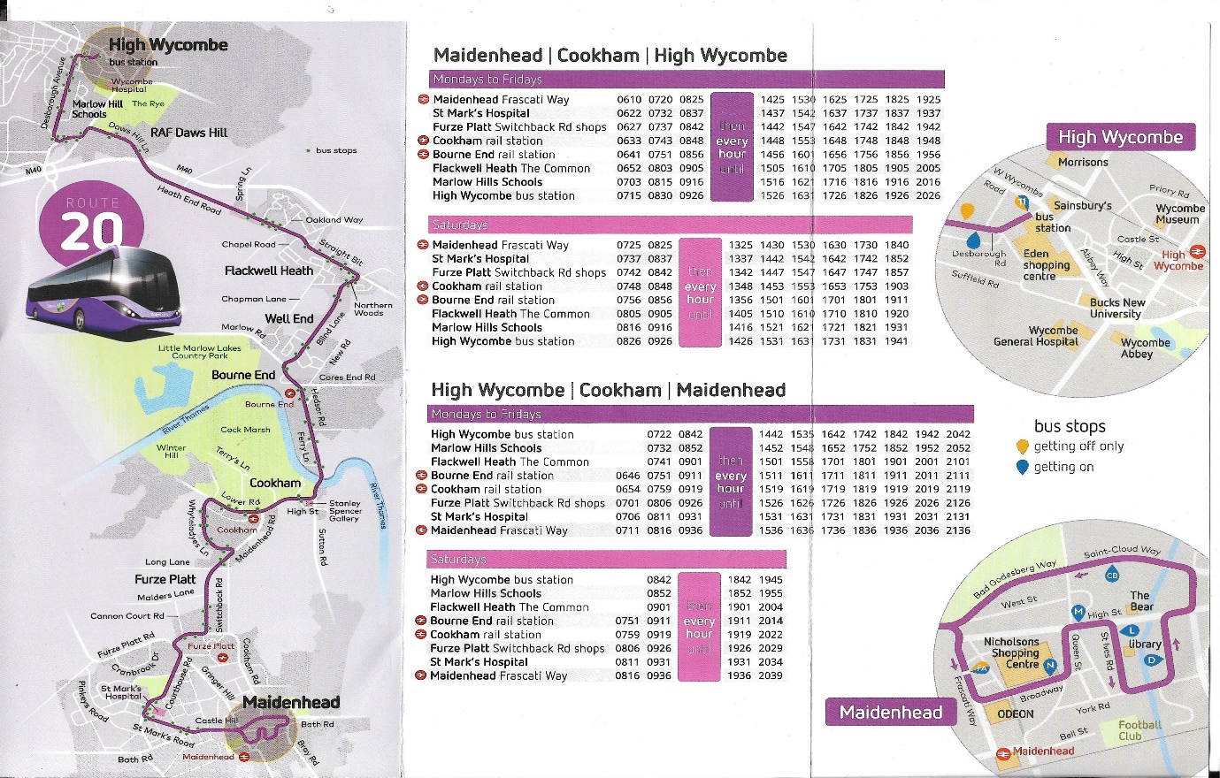
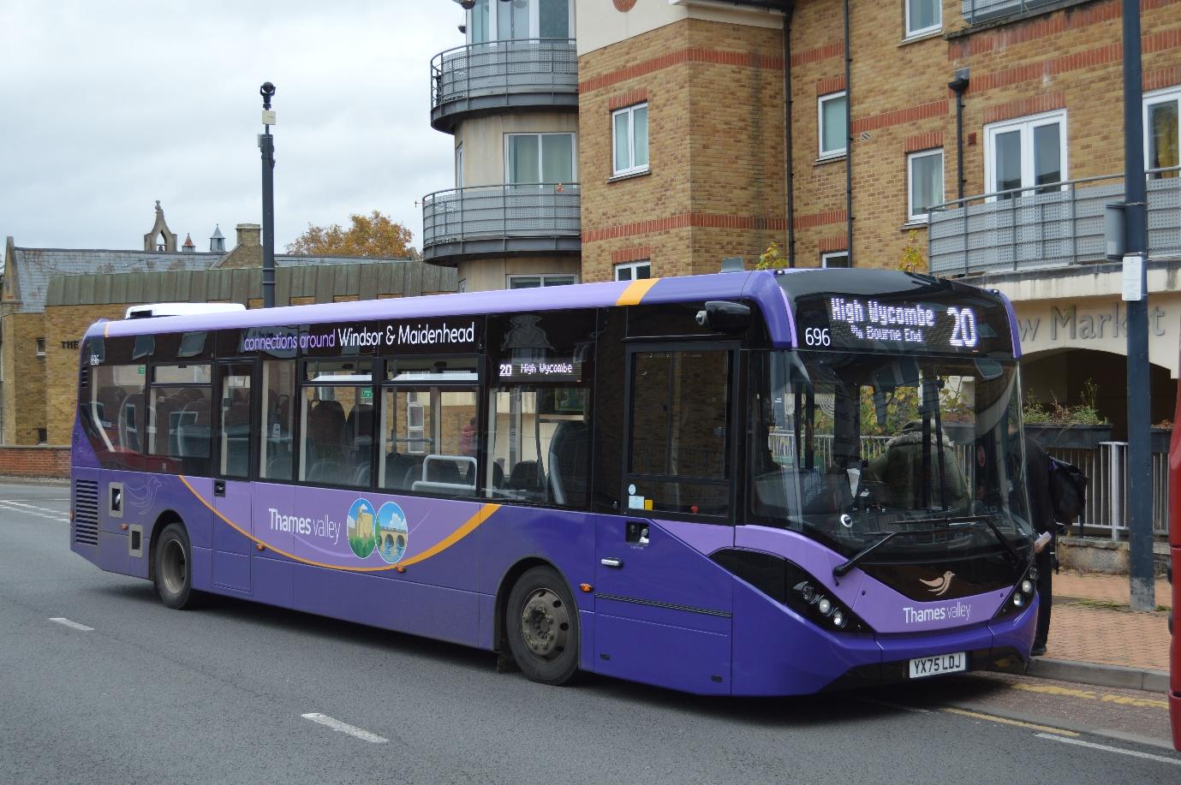
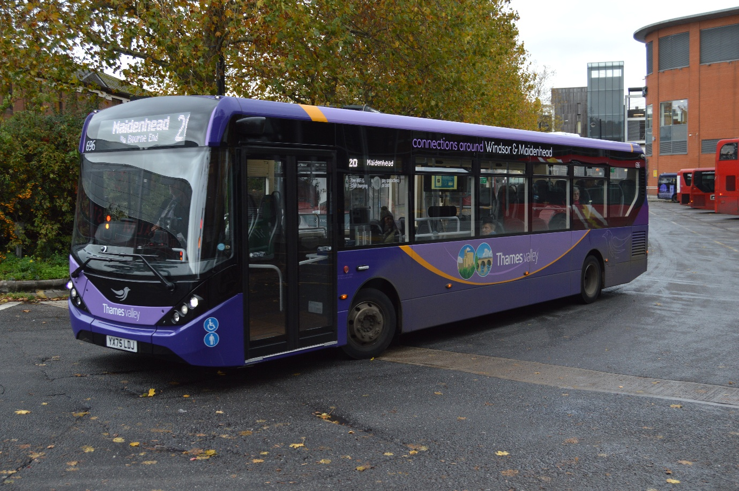
Photos credit to Gary Baxter Administration of GB&CP: TV696 YX75LDJ ADL Enviro200mmc photographed in Maidenhead and High Wycombe. The new route twenty to High Wycombe Via Cookham, Bourne End and Flackwell heath.

Reading buses have introduced a new route to its customers this route is route number 12 going to Twyford from Reading. Buses to be used on this route are Enviro400mmc’s from the Newbury and district fleet due to lose of school contracts.
Fleet Number | Registration Number:
789 | SN16OHG
790 | SN16OHH

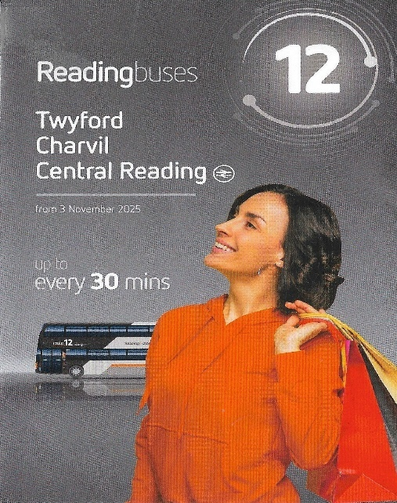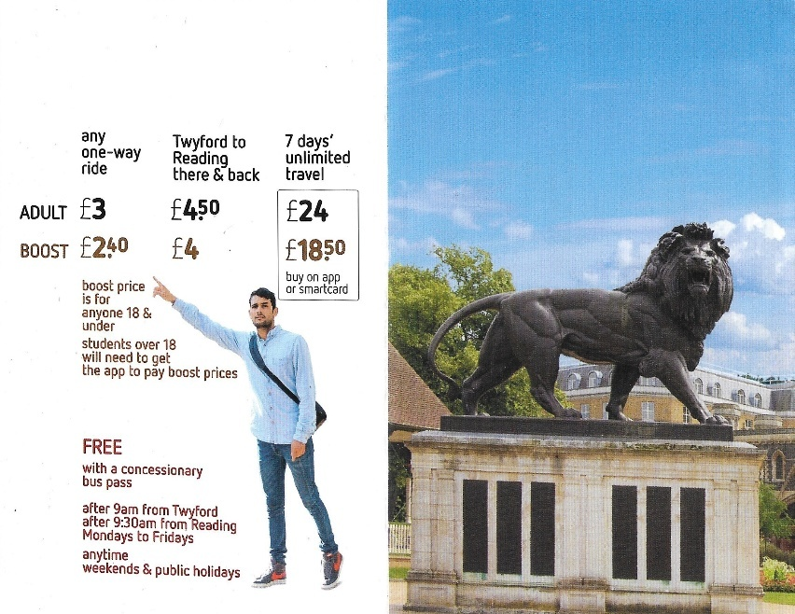
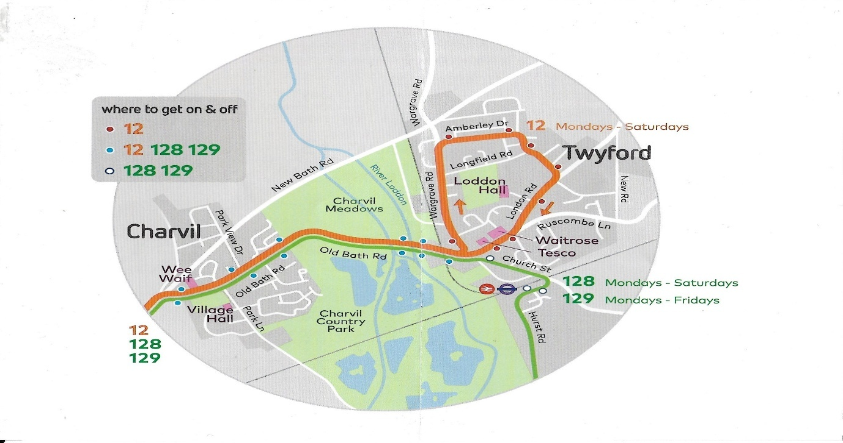
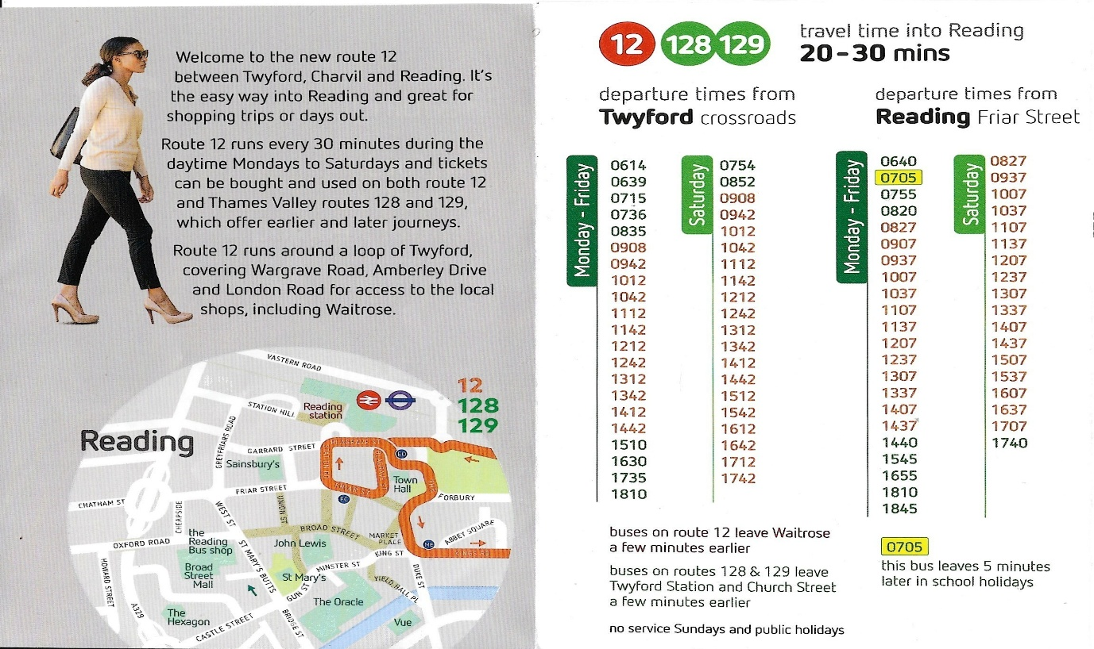
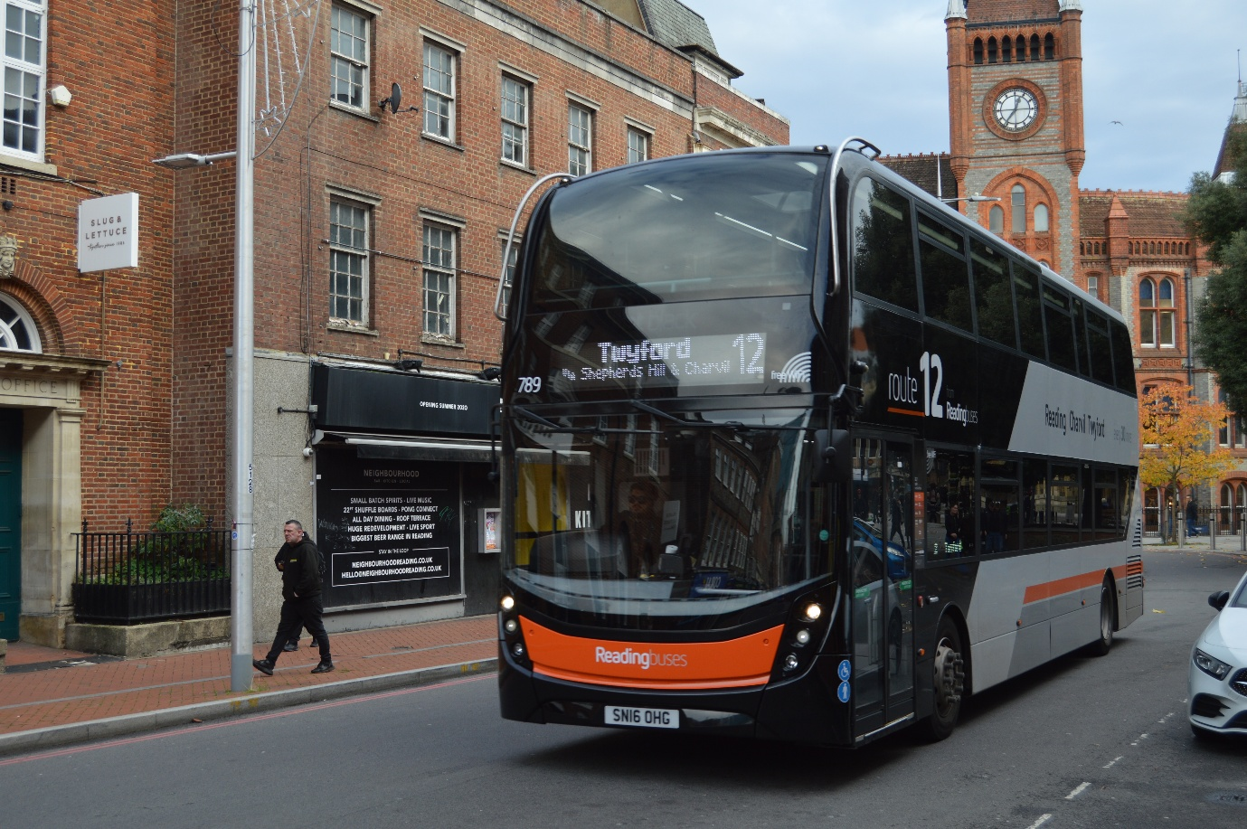
Photo credit to Gary Baxter Administration of GB&CP Reading buses 789 SN16OHG Enviro400mmc ADL Approaching the Reading town centre stop before heading back to Twyford on new route 12
www.facebook.com/groups/garysbusandcoachphotos
www.facebook.com/garysbusandcoachphotos
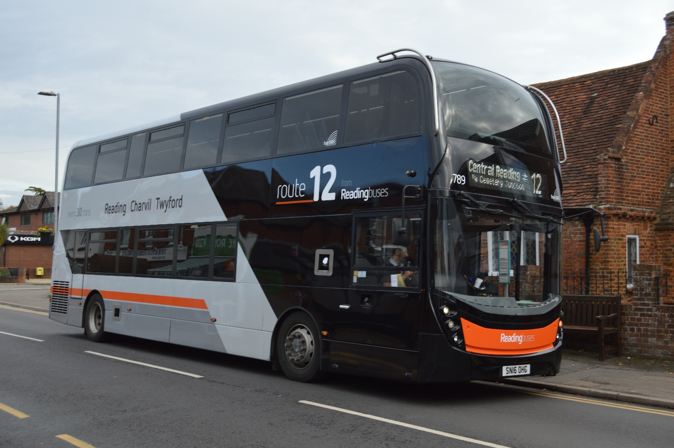
Photo credit to Gary Baxter administration of GB&CP: Reading buses 789 SN16OHG ADL Enviro400mmc photographed at the Waitrose bus on this route has terminus was on a housing estate so thought better to go here. Now photographed heading back to central Reading – Reading Friar Street Stop FC.
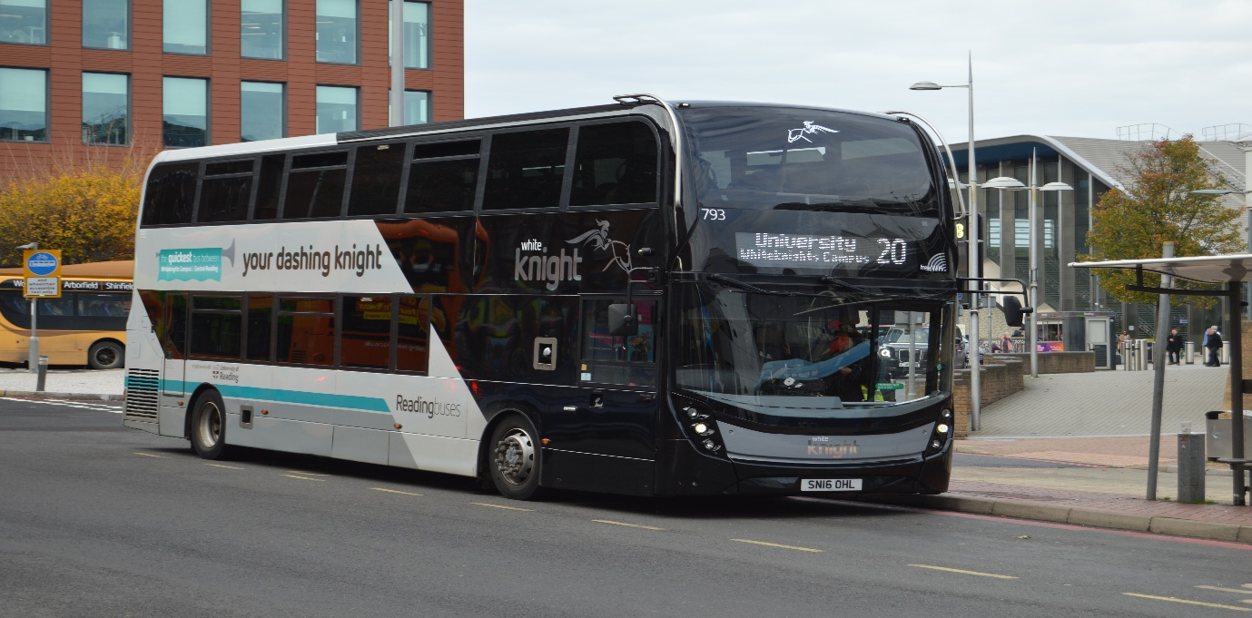
Photo credit to Gary Baxter administration of GB&CP: Reading buses 793 SN16OHL White knight route 20 from Reading town centre to University of Reading express photographed at Reading station.
Facebook Group Cover photo competition
Places | Names
1st | Anthony Moore
2nd | Andy Wilson and Barry Smith
3rd | Alan Lockey
4th | Busspotting.co.uk
Thank you to the people who take part in this month’s Facebook group cover photo competition. Next month’s Facebook group cover photo competition will be on the 12th, December 2025.
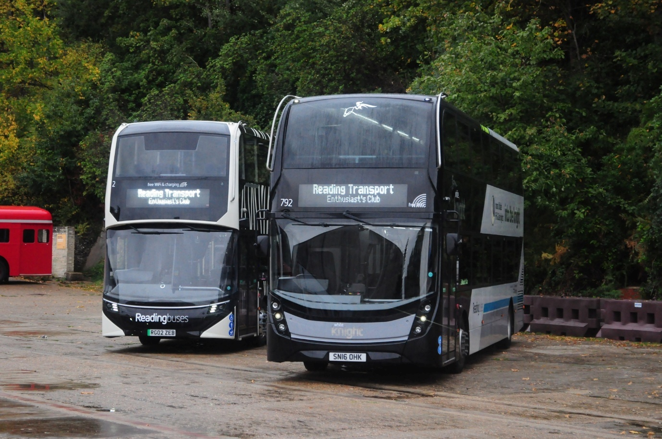
Photo credit to Anthony Moore Member of Gary's bus and coach photos; Reading buses 2 RG02ZEB and Reading buses 792 SN16OHK Enviro400mmc and EV ADL at Brooklands Transport fest. This is available on our website at www.garysbusandcoachphotos.co.uk also visible on our group at www.facebook.com/groups/garysbusandcoachphotos
www.flickr.com/photos/garysbusandcoachphotos
www.facebook.com/groups/garysbusandcoachphotos
www.facebook.com/@garysbusandcoachphotos
www.garysbusandcoachphotos.co.uk


Fleet movements
Fleet no: | Registration No | Engine | Body | Company / livery
783 | SN16OHA | Alexander Dennis | Enviro400mmc | Newbury & District Generic
784 | SN16OHB | Alexander Dennis | Enviro400mmc | Newbury & District Generic
785 | SN16OHC | Alexander Dennis | Enviro400mmc | Newbury & District Generic
786 | SN16OHD | Alexander Dennis | Enviro400mmc | Newbury & District Generic
787 | SN16OHE | Alexander Dennis | Enviro400mmc | Newbury & District Generic
788 | SN16OHF | Alexander Dennis | Enviro400mmc | Reading Buses Generic
789 | SN16OHG | Alexander Dennis | Enviro400mmc | Reading buses Route 12
790 | SN16OHH | Alexander Dennis | Enviro400mmc | Reading buses Route 12
791 | SN16OHJ | Alexander Dennis | Enviro400mmc | Reading buses White knight
792 | SN16OHK | Alexander Dennis | Enviro400mmc | Reading buses White knight
793 | SN16OHL | Alexander Dennis | Enviro400mmc | Reading buses White knight
Reading buses now operate Fleet number 788-793 under fleet movements due to Newbury and district losing school contracts so this freed up some double decker buses for other operations with in the company’s bus fleet number 788 is a generic for Reading buses 789-790 are believed to be liveried up for new routes twelve and 791-93 are White knight liveried for route twenty university express route to Reading university.
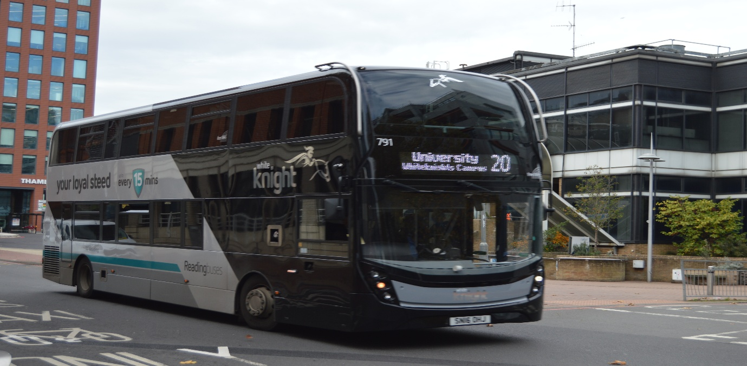
Reading buses White Knight 791 SN16OHJ ADL Enviro400mmc photographed in Reading sporting its new White knight livery up on leaving Reading station on express route twenty to Reading university.
Forthcoming events
December 2025
Date: | Event Name:
Saturday 13th | Route 159 vintage bus running day
After this event on the following week, we will be closing for christmas period up until the 1st or 2nd December 2025 than we will be in to 2026. Looking forward to the forth coming events on that year.
Shed No 2
Shed number two is a Moquette based company based on transport moquette from tube trains buses and coaches. He has a great selection of items made from this moquette’s such has bookmarks, laptop cases, phone cases, glass cases, tote bags, christmas stockings, cushions, luggage tags Keyrings off cut bags seat belt pads and custom products something you can make personal for yourself. Link here https://linktr.ee/shednumber2 facebook page www.facebook.com/@shedno2 he’s links can also be found on our website at www.garysbusandcoachphotos.co.uk
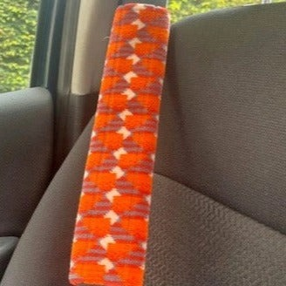

Photos credit to Shed No2 of some items that can be made of the moquette that he get hold of for custom products.
Facebook Group: Member photos
www.facebook.com/@garysbusandcoachphotos
www.facebook.com/groups/garysbusandcoachphotos
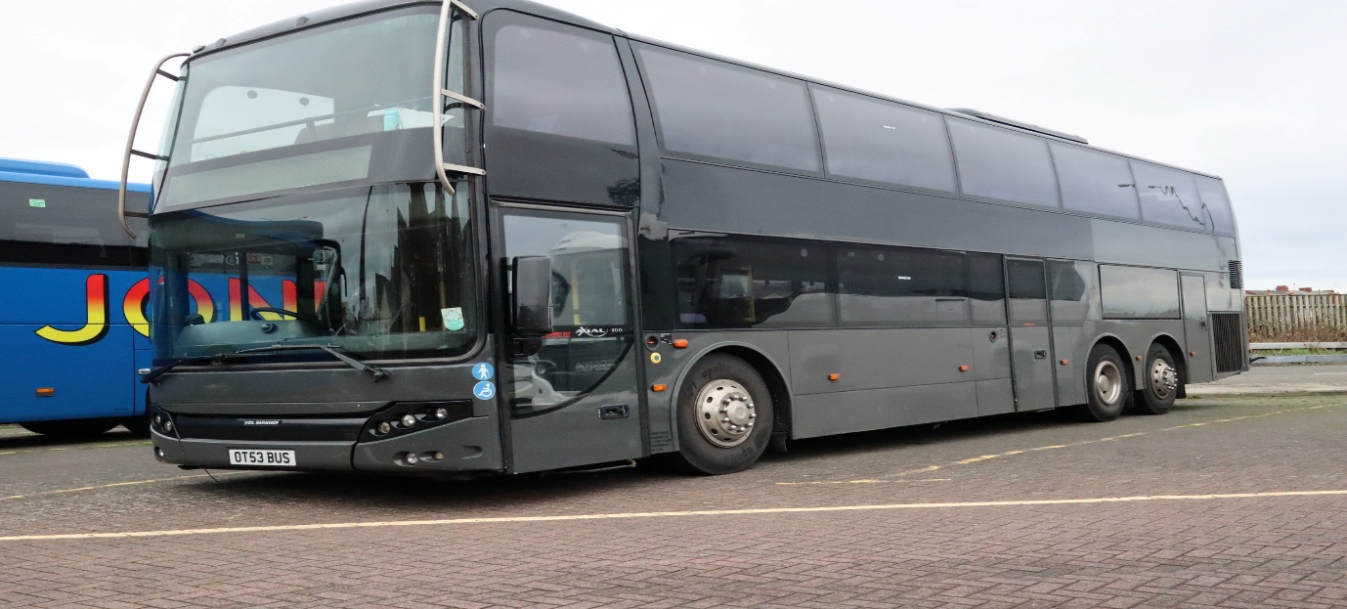
Photo credit to Alan Lockey Member of GB&CP: OT53BUS VDL Berkhof photographed in Blackpool.
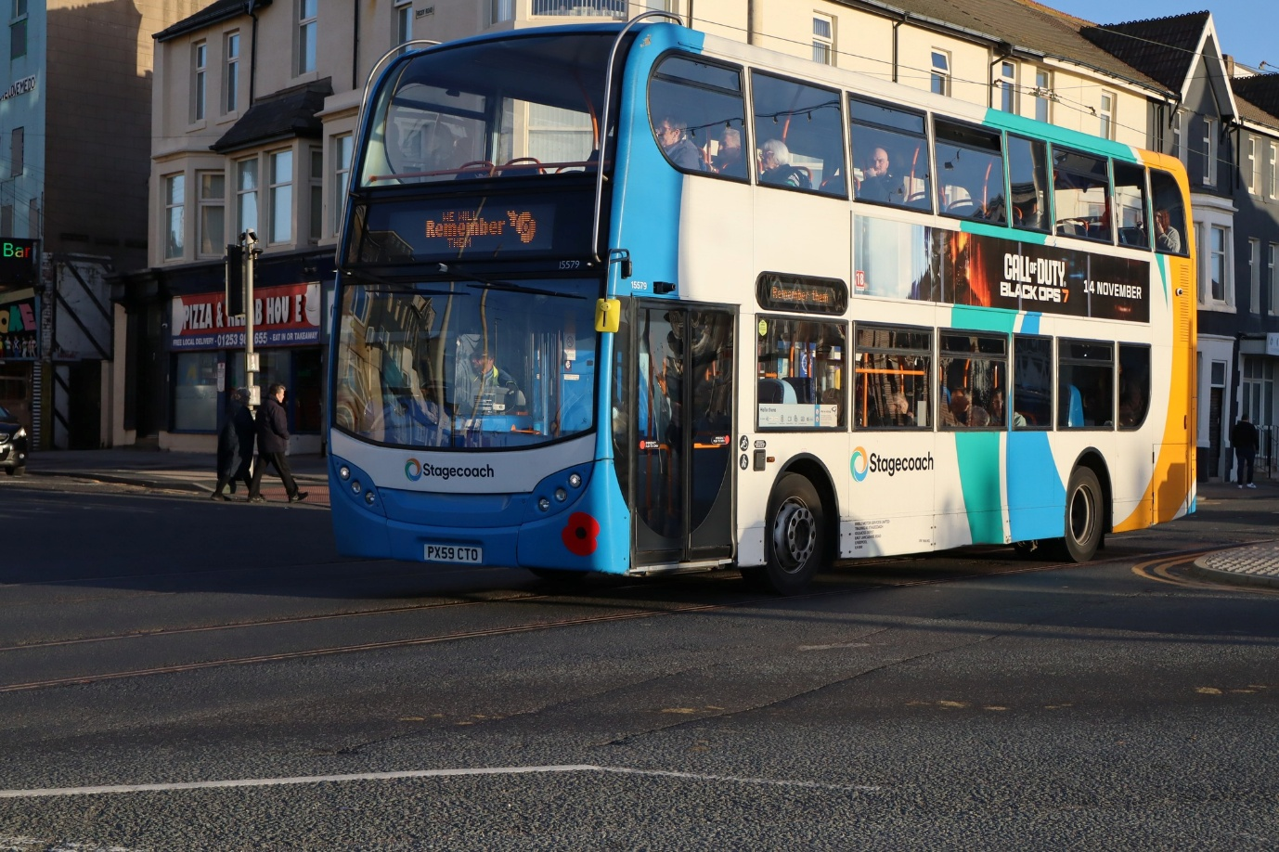
Photo credit to Alan Lockey Member of GB&CP: Stagecoach Preston 15579 PX59CTO ADL Enviro400
www.facebook.com/group/garysbusandcoachphotos
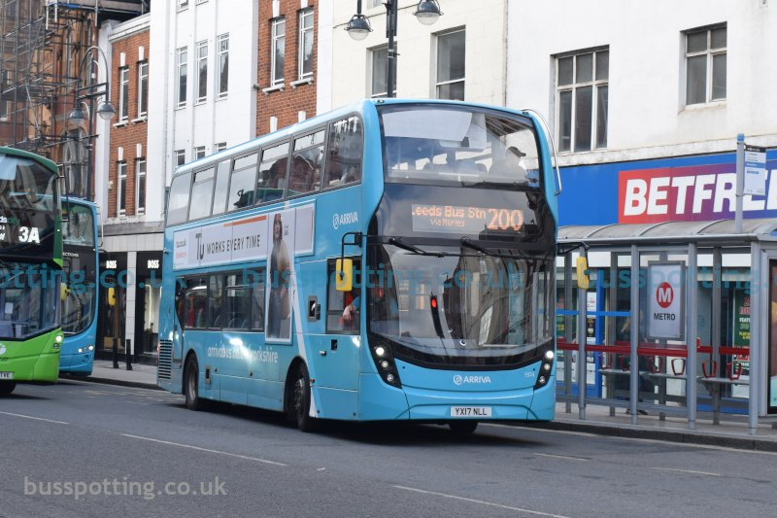
Photo credit to Buspotting.co.uk Member of GB&CP: 1974 YX17NLL ADL Enviro400mmc Arriva Yorkshire.
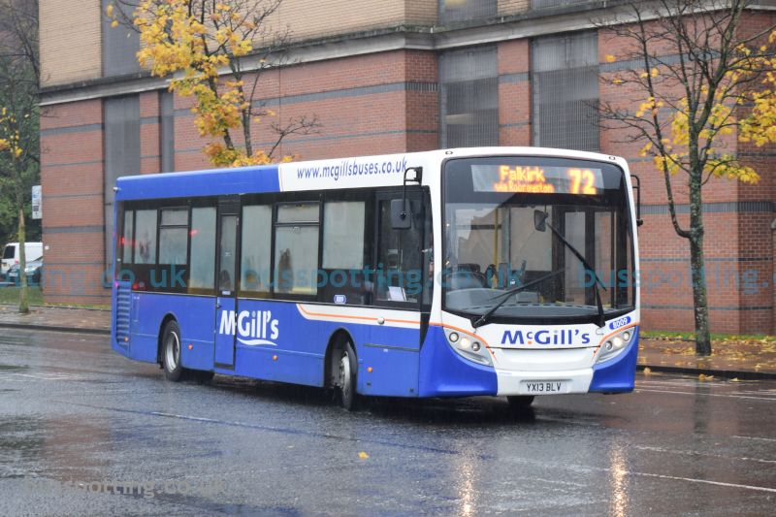
Photo credit to Buspotting.co.uk Member of GB&CP: 8009 YX13BLV ADL Enviro200 McGill's buses and coach Scotland.
www.facebook.com/@garysbusandcoachphotos
www.facebook.com/groups/garybusandcoachphotos
www.garysbusandcoachphotos.co.uk
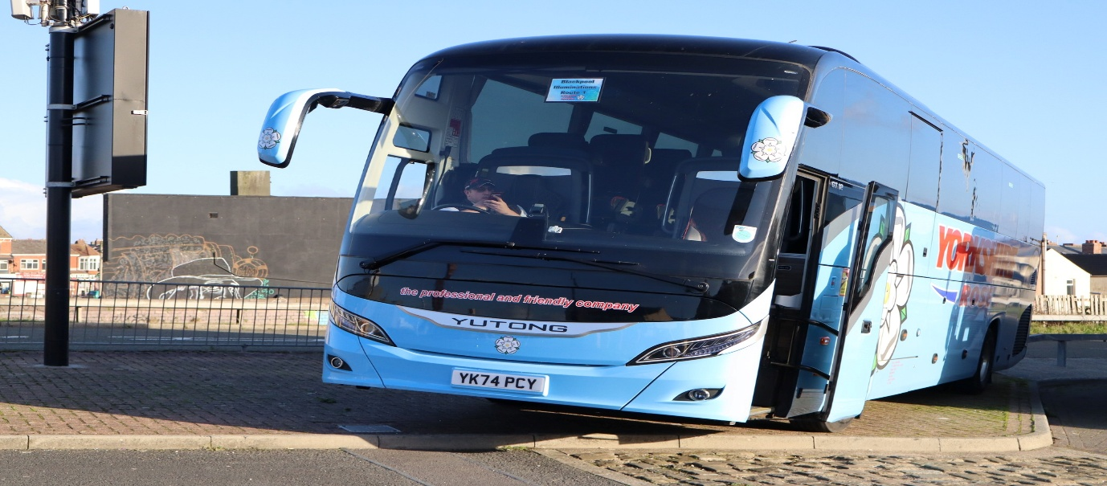
Photo credit to Alan Lockey member of Gary’s bus and coach photos; Yorkshire Rose YK74PCY Yutong Publican photographed in Blackpool.
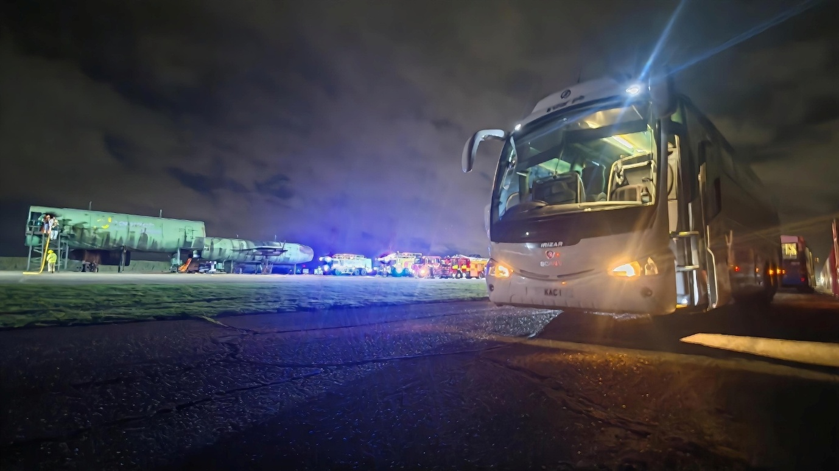
Photo credit to Andy Wilson member of Gary’s bus and coach photos; Dolphin travel KAC1 Scania Irizar at Norwich Airport.
www.garysbusandcoachphotos.co.uk
www.flickr.com/photos/garysbusandcoachphotos
www.facebook.com/groups/garysbusandcoachphotos
www.facebook.com/@garysbusandcoachphotos
www.youtube.com/@garysbusandcoachphotos
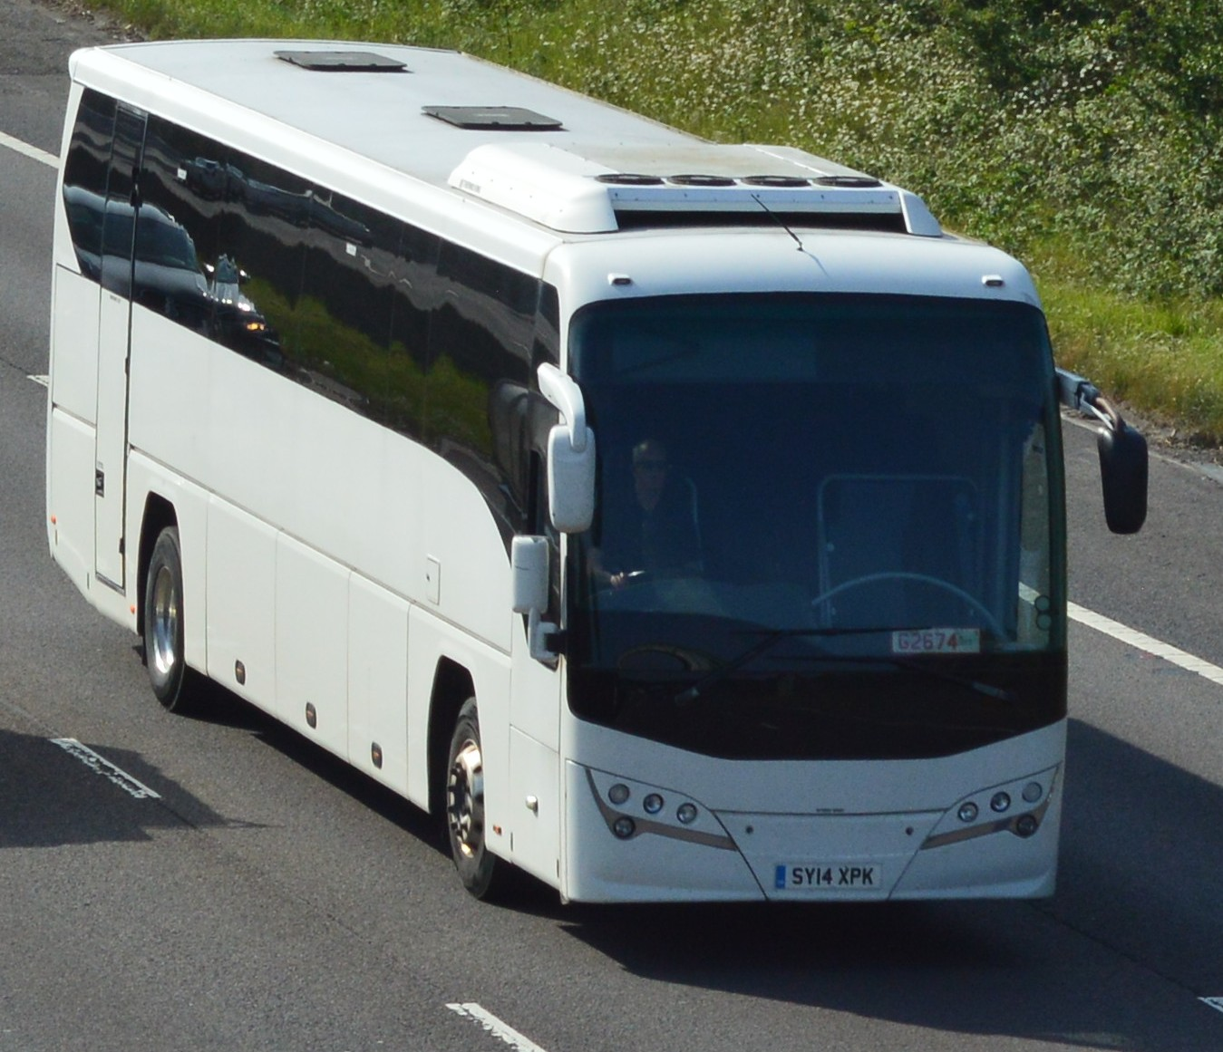
Photo credit to Barry Smith member of Gary’s bus and coach photos; SY14XPK Volvo Plaxton photographed on m1 Barnsley on trade plates.
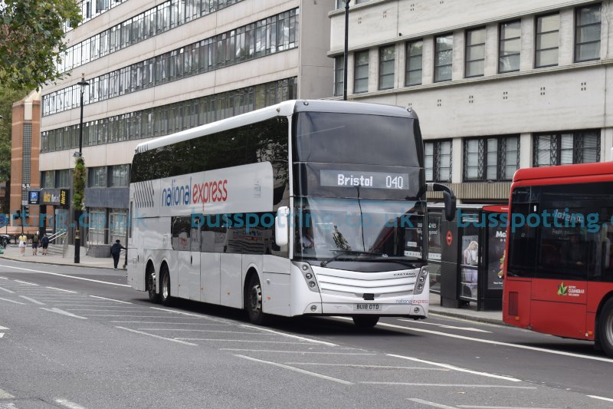
Photo credit to busspotting.co.uk member of Gary’s bus and coach photos; Edward coaches BU18OTD Scania Boa-vista double decker coach in NX livery.
www.facebook.com/groups/garysbusandcoachphotos
www.facebook.com/@garysbusandcoachphotos
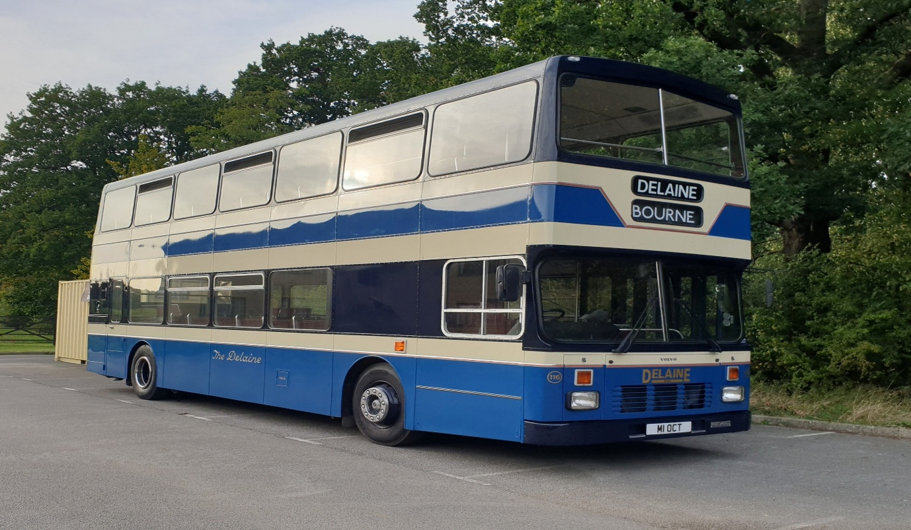
Photo credit to Charles Marshall New member of Gary’s bus and coach photos: M1OCT Volvo B10M Olympian Delaine coaches and buses of Peterborough.
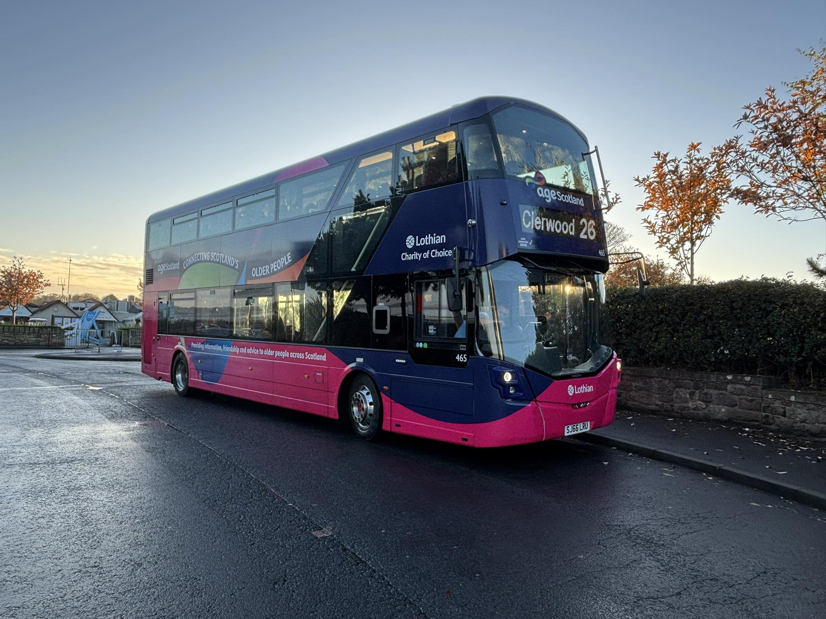
Photo credit to Chris Errett member of Gary’s bus and coach photos: LB465 SJ65LRU Wrightbus Streetdeck in special with age of Scotland Photo taken Port Seton.
The Londonline by Reading buses
Reading buses Londonline have changed the timings from Reading to Slough and London Victoria from Reading station they are now running five in the morning and one in the afternoon. Timings are has follows from Reading station 05:00, 05:30, 05:50, 06:25, 07:05 & 0817. The 08:17 only goes has far has Slough Wellington Street Timings from Bracknell from the above 05:22, 05:52, 06:12, 06:50, 07:32, & 08:44. The 08:44 only goes has far Slough Wellington Street afternoon time from Reading is 14:05 and from Bracknell 14:32.
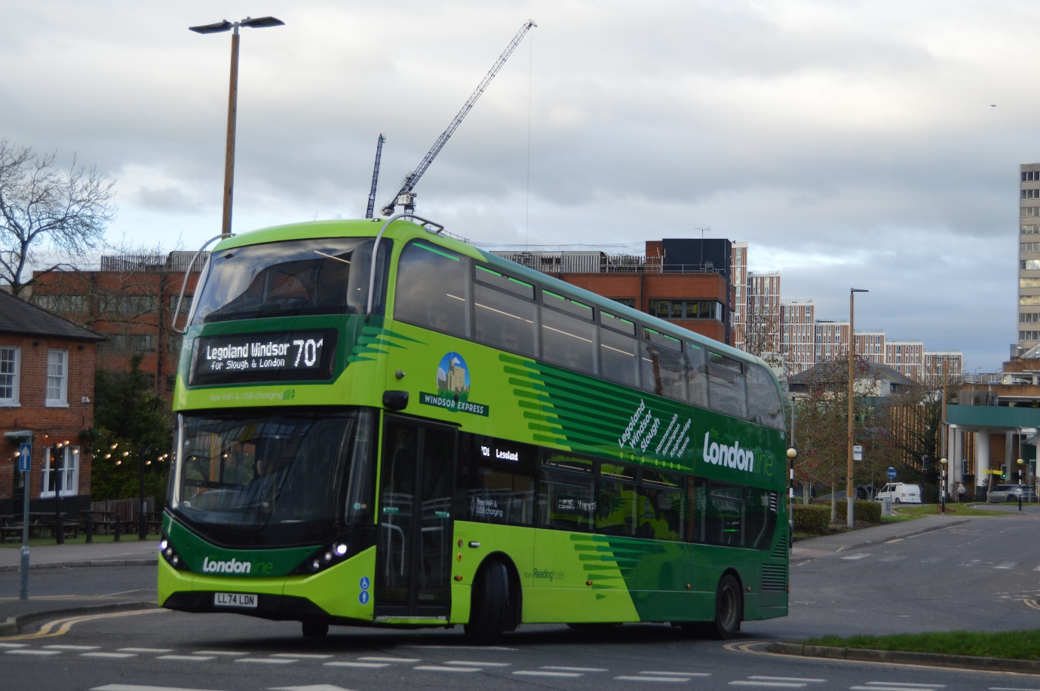
Photo credit to Gary Baxter Administration of Gary’s bus and coach photos: RB/LL745 LL74LDN ADL Enviro400city on route 701 to Legoland then once arrived at Legoland will change to route 702 to London Victoria this is the 14:05 departure from Reading and the 14:32 departure from Bracknell.
www.facebook.com/groups/garysbusandcoachphotos
www.facebook.com/@garysbusandcoachphotos
www.flickr.com/photos/garysbusandcoachphotos
www.garysbusandcoachphotos.co.uk
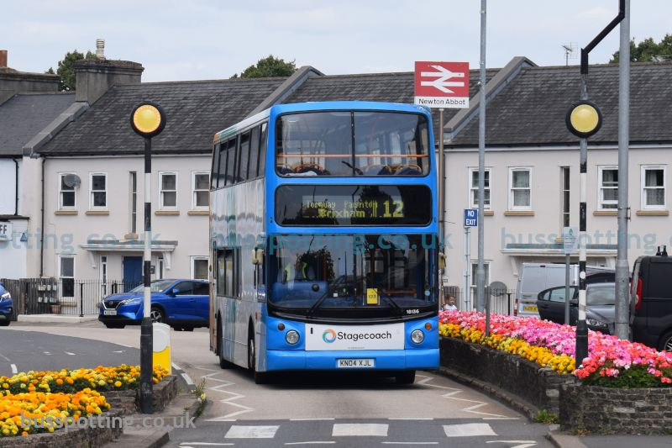
Photo credit to Busspotting.co.uk member of Gary’s bus and coach photos: stagecoach southwest 18136 KN04XJL ADL Transbus trident ALX400.
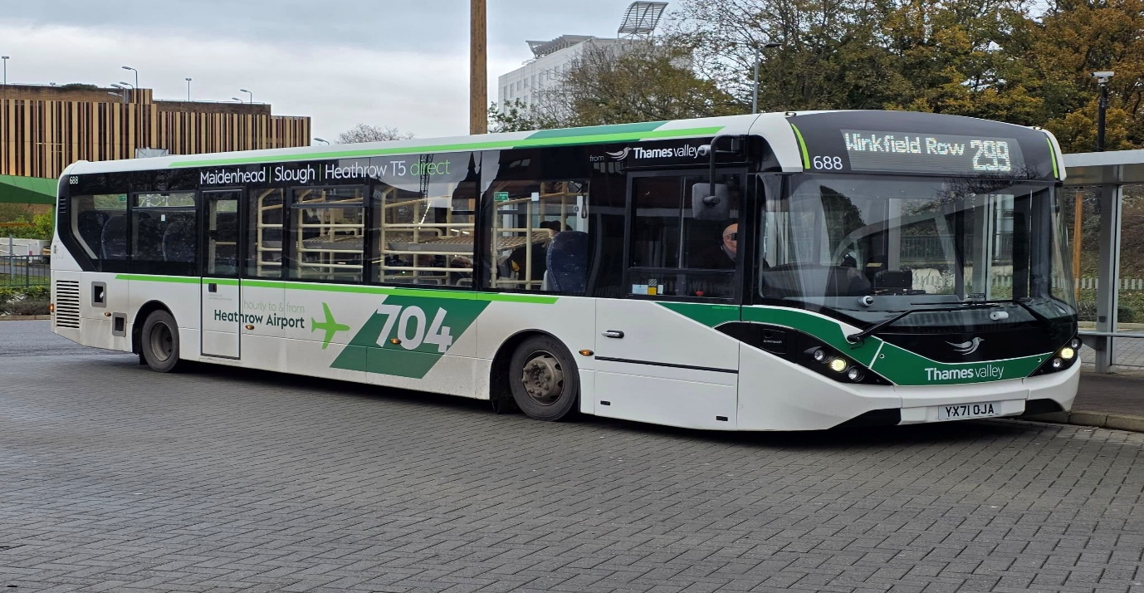
Photo credit to Ian Brown member of Garys bus and coach photos TV688 YX71OJA on route 299 Winkfield Row rounder.
www.garysbusandcoachphotos.co.uk
www.facebook.com/@garysbusandcoachphotos
Reading buses received an award for the top shire operator of the year. We at Gary’s bus and coach photos wished them congratulations for this award has they have been loyal supporters of our team and we have them. For them to receive top shire operator of the year is really good espeically because they team is full of amazing people who work amazingly well with Robert Williams and there team work is awesome. So well done to Reading buses and the group of operators under them.

Photo credit to Reading buses - Robert Williams Reading buses win top shire operator of the year Gold award.
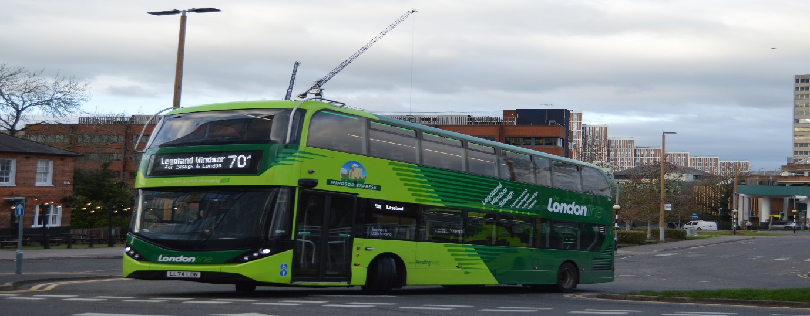
Photo credit to Gary Baxter Administration of Gary’s bus and coach photos: RB/LL745 LL74LDN ADL Enviro400city photographed departing Bracknell bus station on route 701 to Legoland on the 14:05 from Reading and 14:32 from Bracknell.

