
Month: June 2026 Issue No: 96
This month we attended at the 213 / 293 event in Kingston which runs from Sutton to Kingston / Epsom Clock Tower in Epsom this event we started at Kingston and went on couple rides from Kingston to Epsom / Epsom back to Kingston on various different bus types which was good and the event was excellent time to catch up with friends and meet new people. More about this on page five along with more explanation on later pages if they is one This month we also attended our annual supporters event Reading Transport open day in Great Knollys Street again this event was to celebrate the 125th anniversary of Reading transport. More about this on page five then more of Explanation on later pages if they is one.
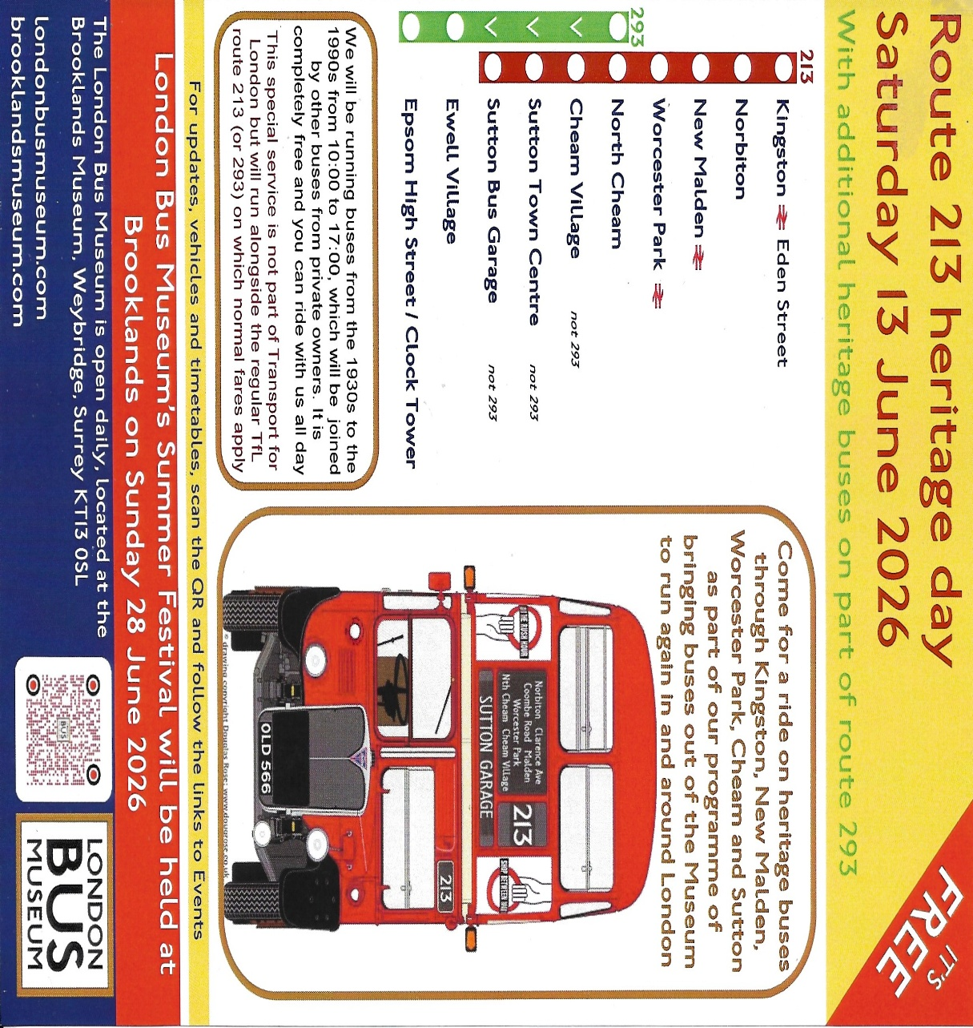

June 2026 Photo Albums
Album Date: | Album Name: | Album Link:
13th June 2026 | Kingston & 213-293 heritage bus running day | https://flic.kr/s/aHBqjCWMgt
19th June 2026 | Royal blue run in Basingstoke | https://flic.kr/s/aHBqjCXntB
28th June 2026 | Reading buses open day | Link on website / Next newsletter
Photo of the month by Gary’s bus and coach photos
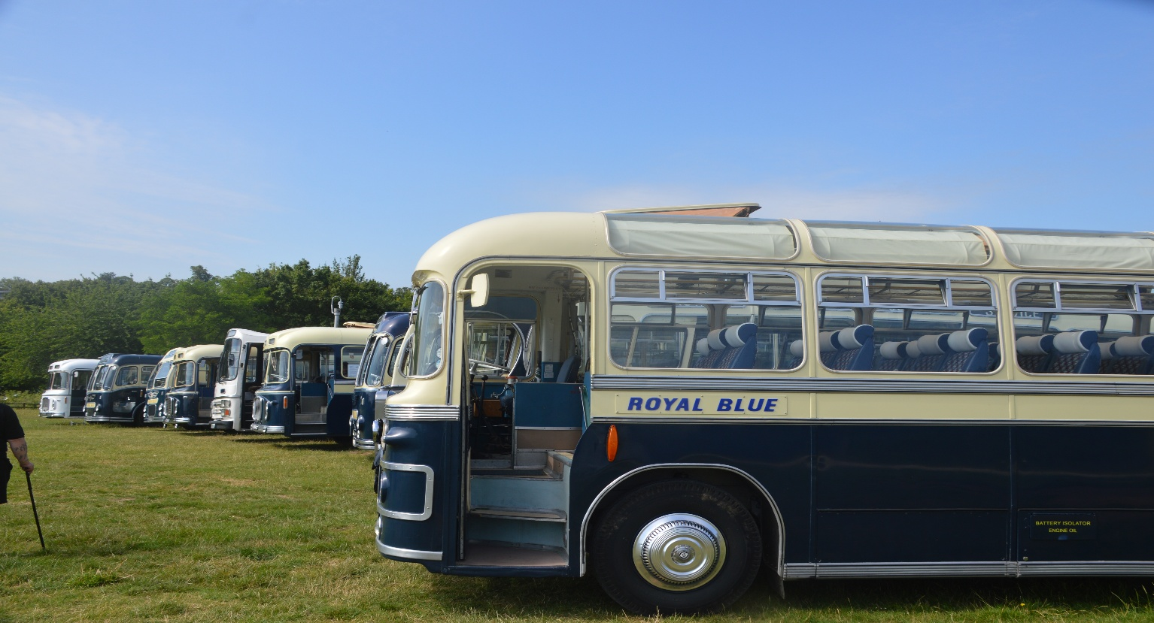
Photo credit to Gary Baxter Administration of Gary's bus and coach photos Royal blue coaches lined up at Milestones in Basingstoke for the Royal blue run 2026 photo of the month for June 2026. more photos found at www.garysbusandcoachphotos.co.uk also via this link https://flic.kr/s/aHBqjCXntB

Gary’s bus and coach photos Event Diary
Image below and available at www.garysbusandcoachphotos.co.uk
More reliable information on events www.classicbuses.co.uk
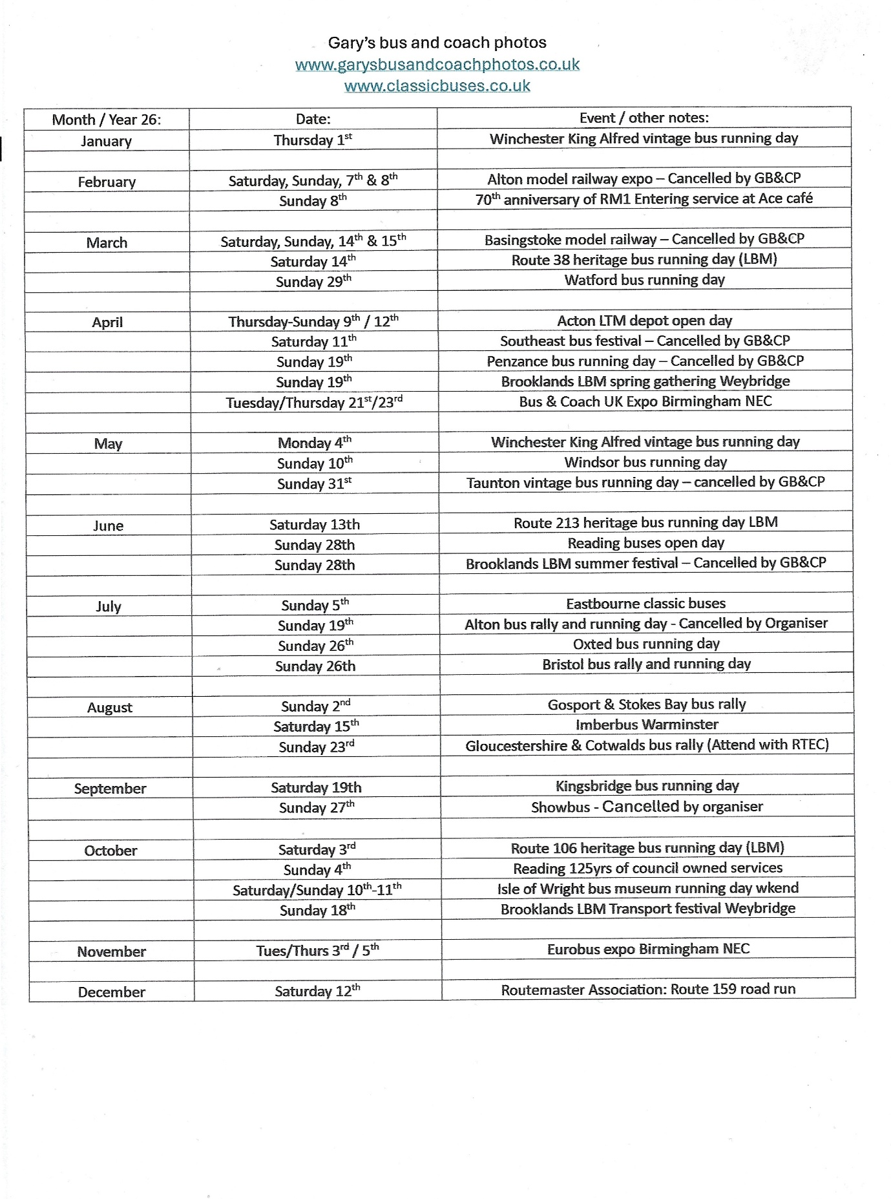
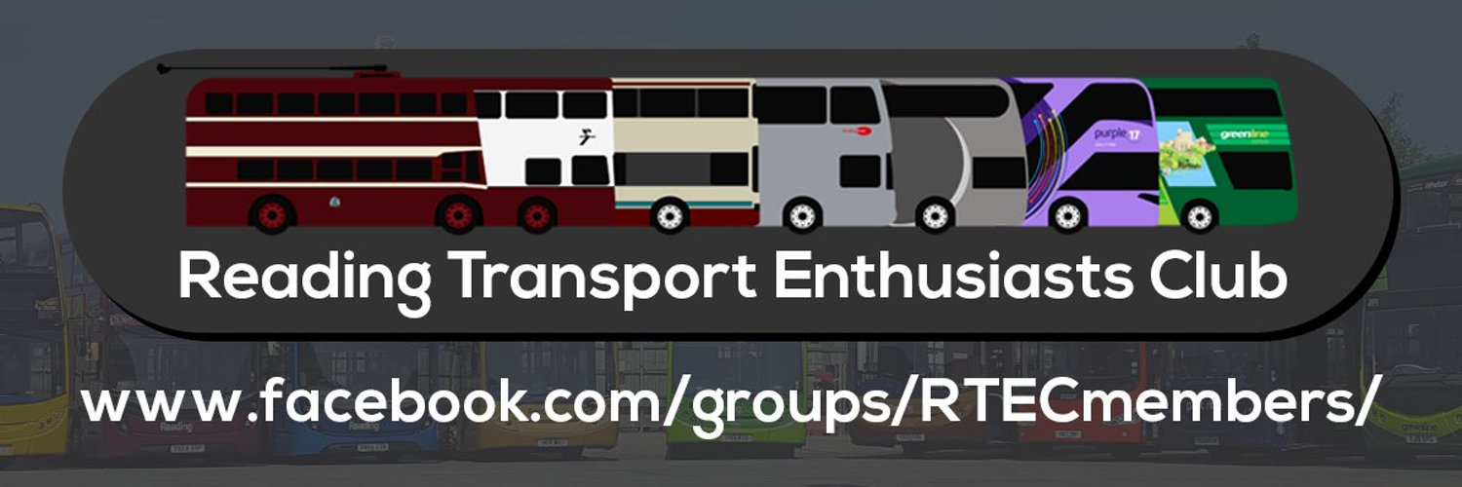
Image below of the Enthusiast club Event diary available on website at https://garysbusandcoachphotos.co.uk/rtec-%26-rocky-routemaster
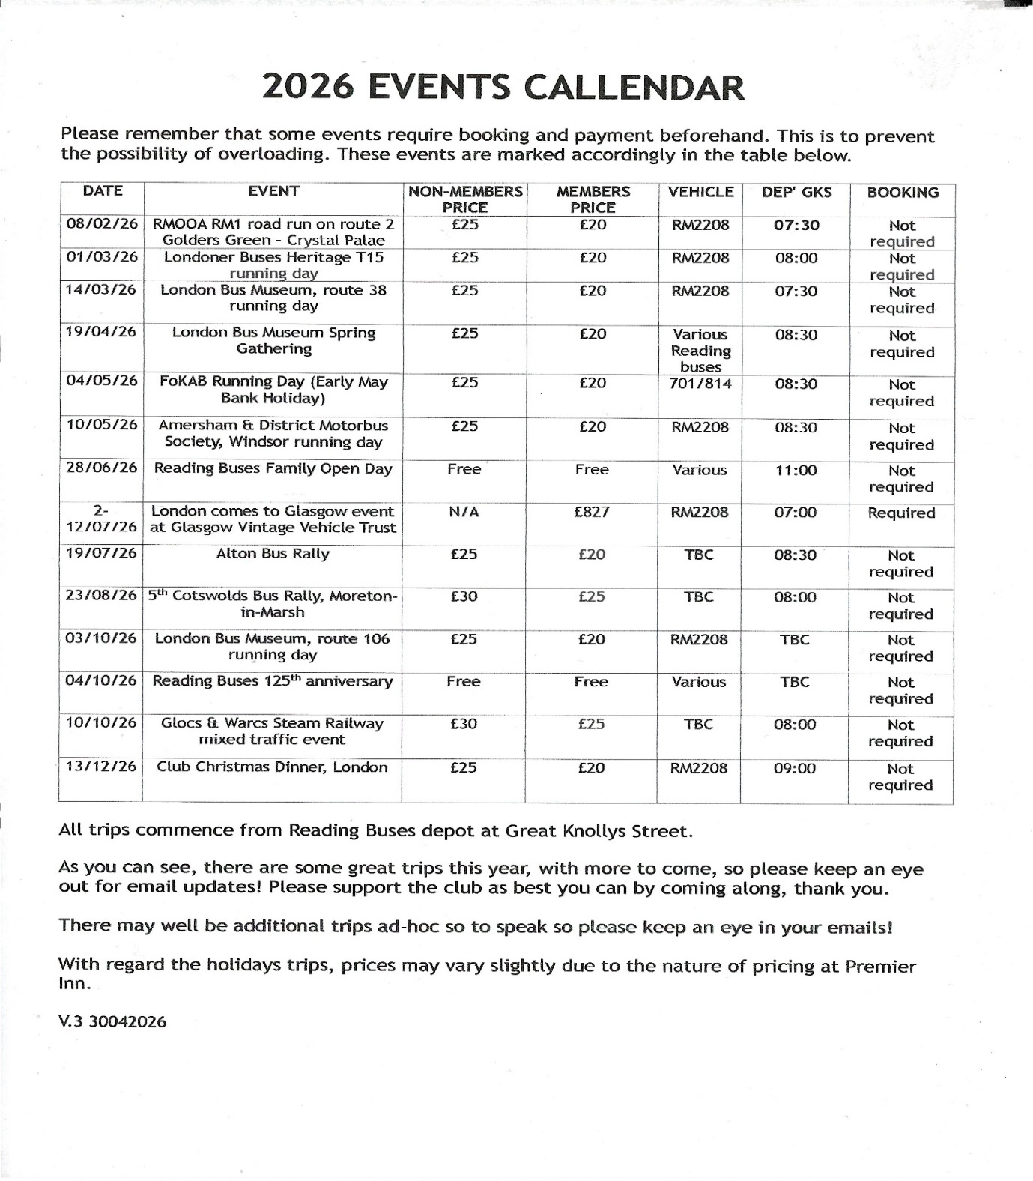

Events Attended this month
Event videos and photo albums can be found at www.garysbusandcoachphotos.co.uk also via these links www.youtube.com/@garysbusandcoachphotos www.flickr.com/photos/garysbusandcoachphotos
213/293 heritage bus running day from Kingston to Sutton
The heritage bus running day was hosted by the London bus museum this ran from Sutton or Kingston depending on where I started at the time and we ride on some lovely heritage buses and coaches from these two places now the two routes went to two different locations 293 goes from North Cheam to Epsom Clock tower / High Street route 213 goes from Kingston to Sutton just outside the Sutton bus garage. This was a nice event and a good opportunity to catch up with friends with similar interest’s photo album from this event can be found via these links https://flic.kr/s/aHBqjCWMgt and on website at www.garysbusandcoachphotos.co.uk more about this on page eight and nine.
Reading Transport / Reading buses open day plus celebrating 125 yrs
The Reading transport annual open day hosted a good day at the depot and was good to see so many in attendance at the depot for the 125 yrs celebrations plus to see all the new electric buses for the company. Has usual the event was hold in the depot and they had they usual tours of the depot like control room, Engineering, bus wash and guided tours of Banksy and town centre. Open topper Reading buses 520 and heritage bus giving tours which was good fun. Robert Williams and local councillors opened the event at 11am and gave a good talk about the depots and companies history. The depot before it moved to great knolley’s street was in Mill Lane for many years before they built the oracle shopping complex in its place. Photo album and video from this event can be found via this link and on website at www.garysbusandcoachphotos.co.uk
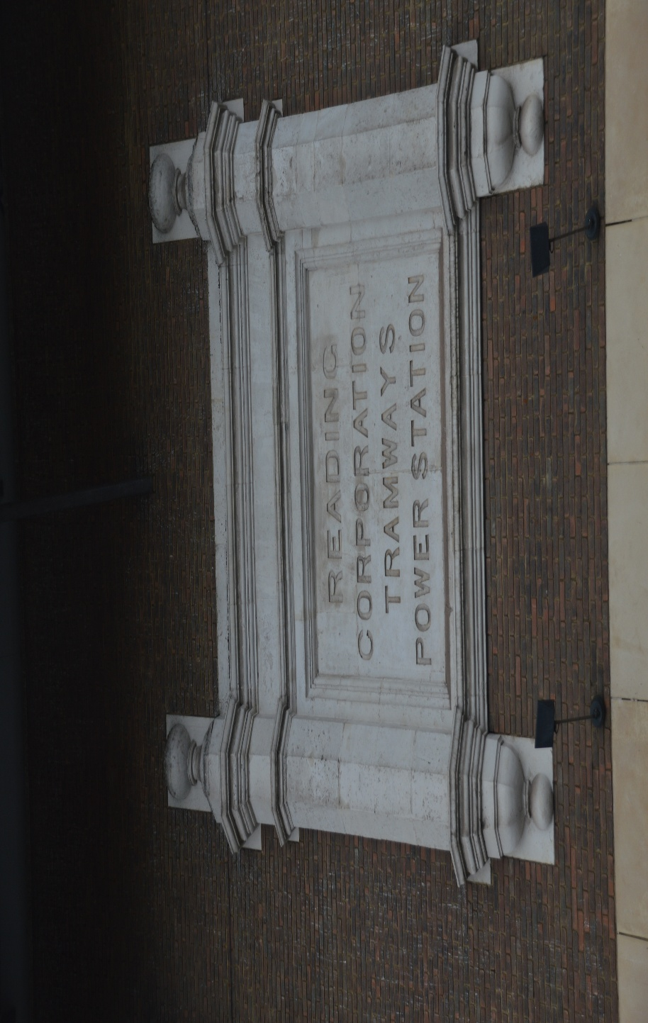
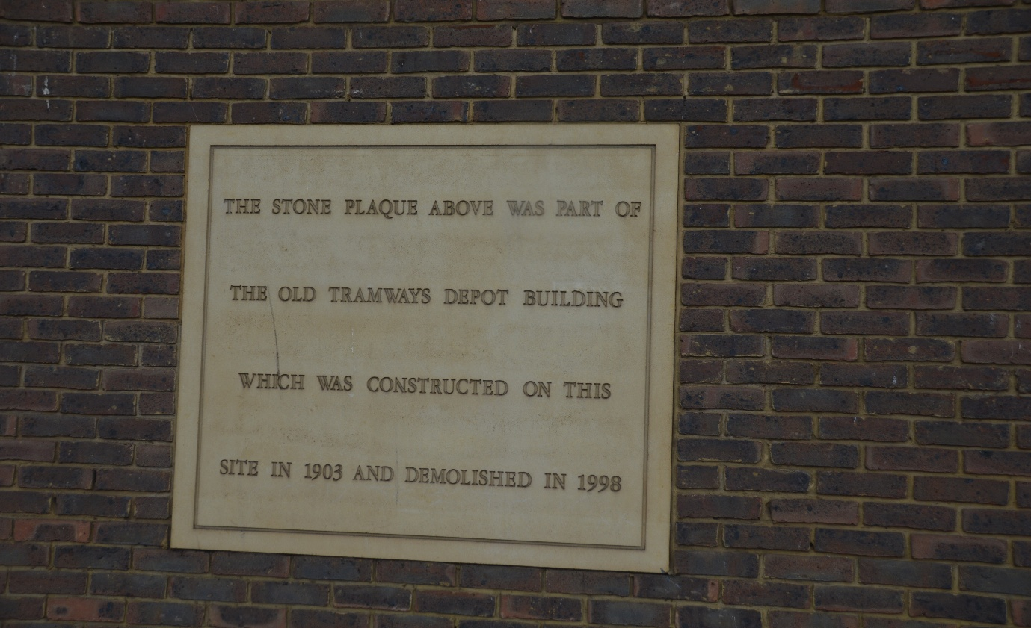
Photo above: Photo credit to Gary Baxter Administration of Gary’s bus and coach photos Reading corporation tramways power station / Mill Lane depot plaque.
Photo below: photo credit to Gary Baxter Administration of Gary’s bus and coach photos explaining what the stone plaque above it is about and why has been placed where it has. It is to commemorate the Mill Lane tramway depot that opened in 1903 and closed in 1998 to make way for the Oracle shopping complex. This is partly why Reading Transport Reading buses are celebrating 125 years of servicing the public. On the Reading buses YouTube channel, they also doing something each month to commemorate the occasion also at https://www.youtube.com/@readingbuses2608

This month saw the new route branded Yellow 26 ADL Enviro400EV’s entering service on this route the Fleet numbers and registration number and entering service date can be found in the grid below.
Fleet No: | Registration No: | Body | Engine | Date: | Branded
25 | RG25ZEB | Enviro400EV | Alexander Dennis | 01/06/26 | Yell 26
26 | RG26ZEB | Enviro400EV | Alexander Dennis | 01/06/26 | Yell 26
27 | YX26JZG | Enviro400EV | Alexander Dennis | 01/06/26 | Yell 26
28 | YX26JZH | Enviro400EV | Alexander Dennis | 01/06/26 | Yell 26
29 | YX26JZJ | Enviro400EV | Alexander Dennis | 01/06/26 | Yell 26
30 | YX26JZK | Enviro400EV | Alexander Dennis | 02/06/26 | Yell 26
31 | YX26JZL | Enviro400EV | Alexander Dennis | 01/06/26 | Yell 26
32 | RG26BUS | Enviro400EV | Alexander Dennis | 02/06/26 | Generic

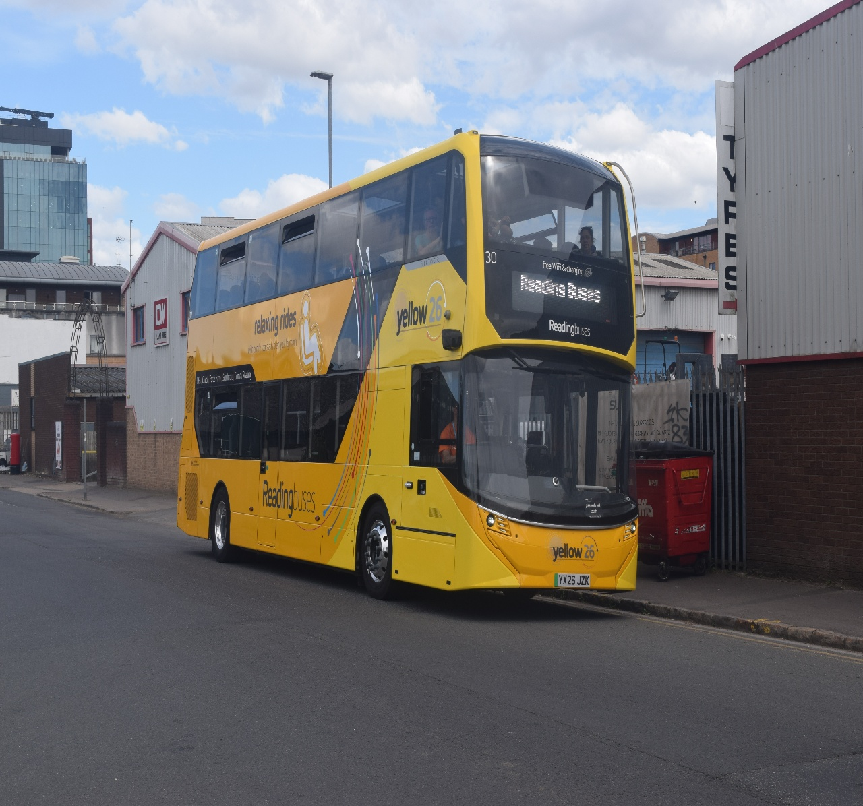
Photo taken to Gary Baxter Administration of Gary’s bus and coach photos: Reading buses 30 YX26JZK ADL Enviro 400EV branded route 26 livery.
London bus museum 213-293 heritage bus running day
The London bus museum organised an event for Kingston to Sutton / Epsom called the 213-293 heritage bus running day. This day started out okay and everything running to time and so on. It was physically impossible to travel on buses that were attending this event has the public take advantage of this by travelling on the free buses for this event was spoilt it for the enthusiast that were generally interested in the vintage buses. The museum need to implement a charge of some sort for the enthusiast who are attending the events like this like maybe charging £5 or £10 to ride on these buses as to keep the public from taking advantage of these services. We did go to the event in hope of riding some of these buses, but we did not get the chance to ride on them due to fullness of the buses from the public. We at Gary’s bus and coach photos went home early and very unhappy with the result in the event. For the museum to implement a small charge might help enthusiast like ourselves be over to ride the heritage buses at events like this Ensign-bus used to do for they event in Lakeside so for it to be implement by the transport museums themselves might help for enthusiasts to be over to ride the heritage buses with out the public taking advantage of the suggestion when the buses are free to implement a small charge for the enthusiasts might help keep the public from taking advantage of free services when museums are doing these kind of events.
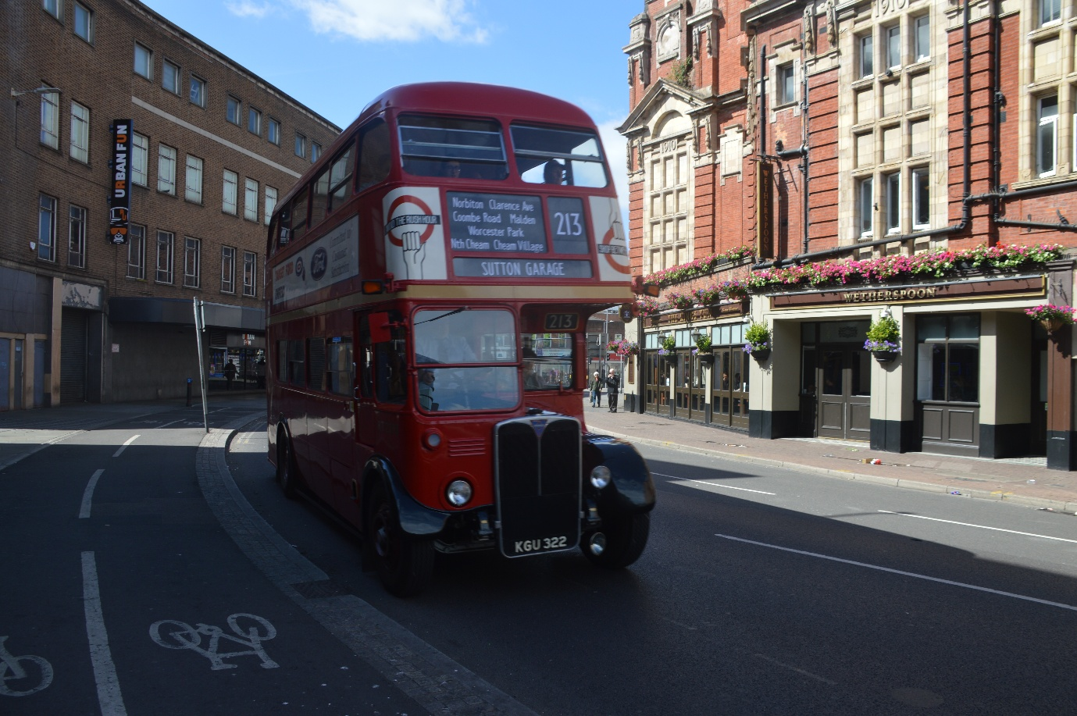
Photo credit to Gary Baxter Administrator of Gary’s bus and coach photos: KGU322 London Transport RT attending the Kingston to Sutton bus garage 213-293 heritage bus running day.
One of the buses we were hoping to ride on was FRM1 from the London transport museum in Acton but due to the public taken advantage of the free rides this was not possible and the ride for me got cancelled and spoilt has would have been nice to ride on this bus has it was the first time for it attending a running day in the united Kington. When we sort of left the event when looking through Wetherspoon’s Window out of they public house they were buses full about nine we saw were full and only three half full so for enthusiast to ride was impossible. According to a friend of ours it was not very well organised like other events organised by the London bus museum are has the people on FRM1 were told they weren’t loading on Stop D in Kingston Eden Street and were loading on the other side or said they were taking a break before heading out on the next run to Sutton Bus garage.
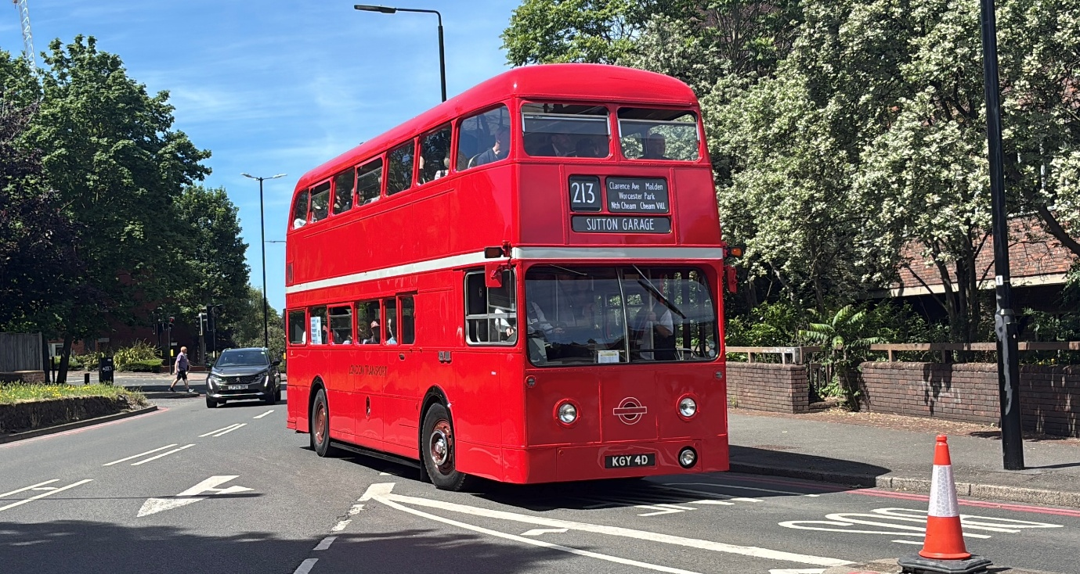
Photo credit to Theo Thompson member of Gary's bus and coach photos FRM1 KGY4D at 213-293 Kingston heritage bus running day. Looking nice in Sunny Kingston on the heritage bus running day its shiny red livery.
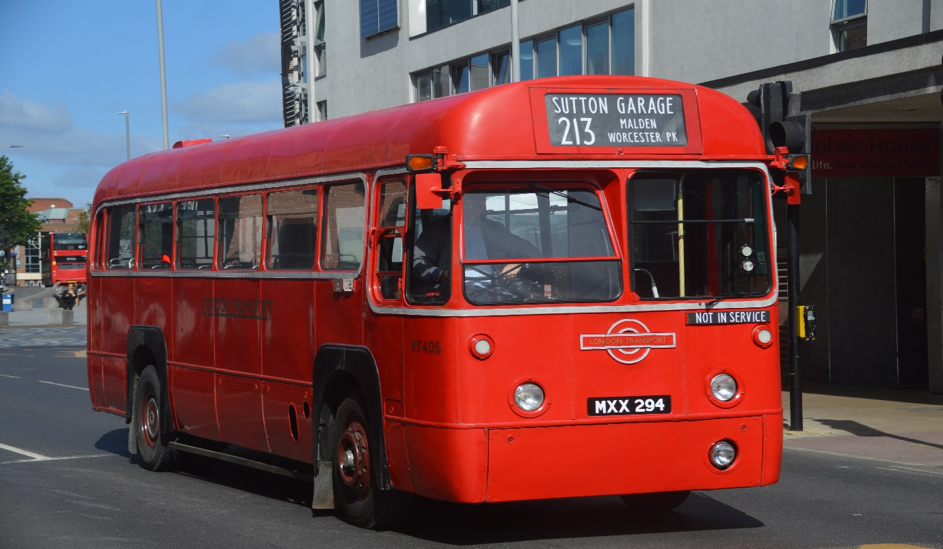
Photo credit to Gary Baxter Administration of Gary’s bus and coach photos: RF406 MXX294 in Kingston for the heritage bus running day on route 213-293.
ALTON BUS RALLY AND RUNNING DAY
The Alton bus rally and running day has had to be cancelled by the organisers due to building at the college so this will see no Alton bus rally and running day for 2026 they will look at bring this back in 2027 this is sad news for the bus enthusiast that might be have been looking forward to this, but needs must and so on it has to be done if the college is having building then it cannot be paused for a bus rally and running day to take part. So, a good decision by the organisers to cancel this for now and let the college or school to carry out the building work then maybe bring this back in 2027.
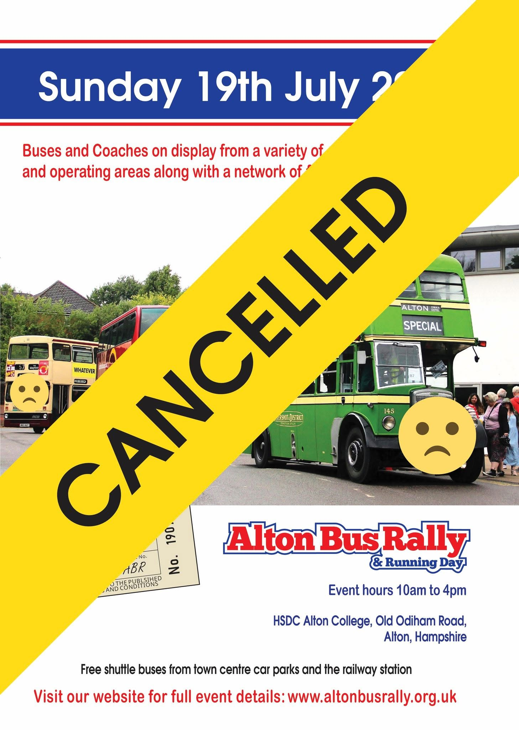
Royal blue run
This month we also went along to Basingstoke Milestone Museum to see the Royal blue run from Basingstoke to Taunton in South or North Devon. This was a good opportunity to take photos and video of the buses and coaches attending this three day from Basingstoke they were going to Taunton than on the other days they were going from Taunton to Barnstable on day 2 and on day 3 from Barnstable to Yeovil where the long week would finish and see everyone return home. Video and photos from this occasion can be found on website at www.garysbusandcoachphotos.co.uk/Social-media or via these links https://flic.kr/s/aHBqjCXntB https://youtu.be/WCHdBTgCmfs?si=j8j1NUpCTvnGVohp
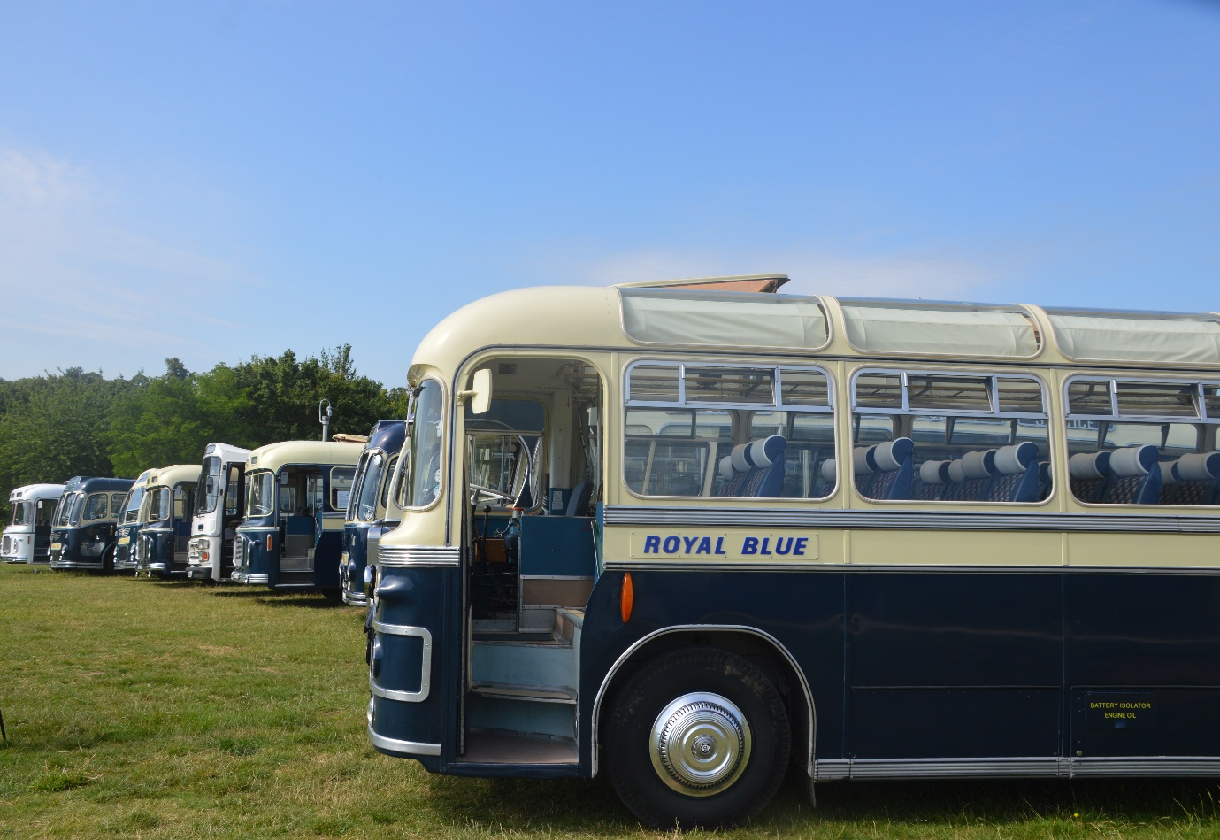
Photo credit to Gary Baxter Administration of Gary’s bus and coach photos: royal blue line up for in front of the Milestone museum in Basingstoke on the 19th, June 2026. This three-day tour was organised by the Thames Valley & Great Western Omnibus Trust.


