
Month: June 2025 Issue No: 84
We went to Dorking to take part in the Amersham and District running day and this was a lovely day. I went with my friend and fellow administrator Tim Wild and his friend Steve. The day was lovely more about this on page four. We attended the route 418 running day from Kingston to Epsom this was another well organised event by the London bus museum, more about this also on page four. We attended the London bus museum summer gathering on the Sunday 22nd June. This was another lovely day at the museum with plenty to see and do more about this on page five. We attended / helped Chef executive officer Robert Williams with the annual open day at Reading buses on the 29thJune 2025 more about this on page six.
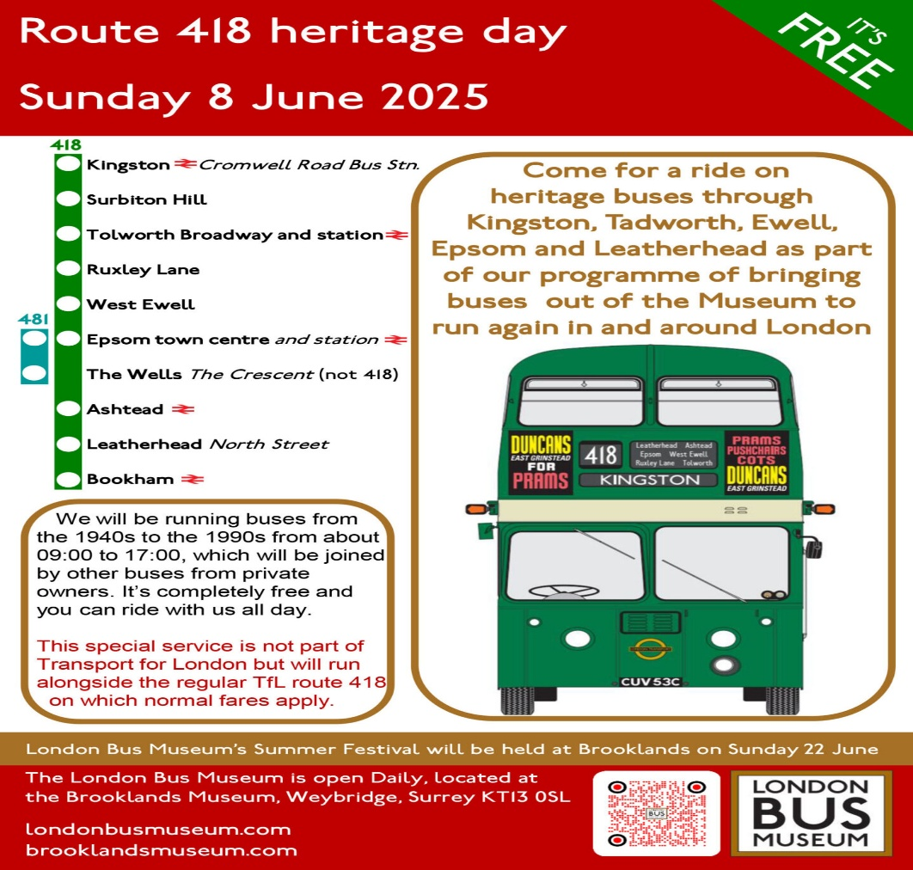
Poster credit: The London bus museum Event poster for the 418 vintage bus running day from Kingston to Epsom on Sunday 8th, June 2025.

Flickr Albums for June 2025
Flickr Album Dates: | Flickr Album titles | Flickr Album links
1st June 2025 | Dorking bus running day | https://flic.kr/s/aHBqjCgugz
??/??/???? | Dorking bus running day | https://flic.kr/s/aHBqjCgtdv
2nd June 2025 | Bracknell, Maidenhead, & London Heathrow Airport | https://flic.kr/s/aHBqjCgz8Y
8th, June 2025 | 418 Kingston to Bookham bus running day | https://flic.kr/s/aHBqjChhXD
16th June 2025 | Reading Berkshire | https://flic.kr/s/aHBqjCiomK
18th June 2025 | Camberley | https://flic.kr/s/aHBqjCio4h
22nd June 2025 | Brooklands Weybridge Summer festival LBM | https://flic.kr/s/aHBqjCj6b5
29th June 2025 | Reading buses annual open day | https://flic.kr/s/aHBqjCk4pc
The albums list above is of all photos taken in June 2025. This will appear in the newsletter every month from now on.
Photo of the Month
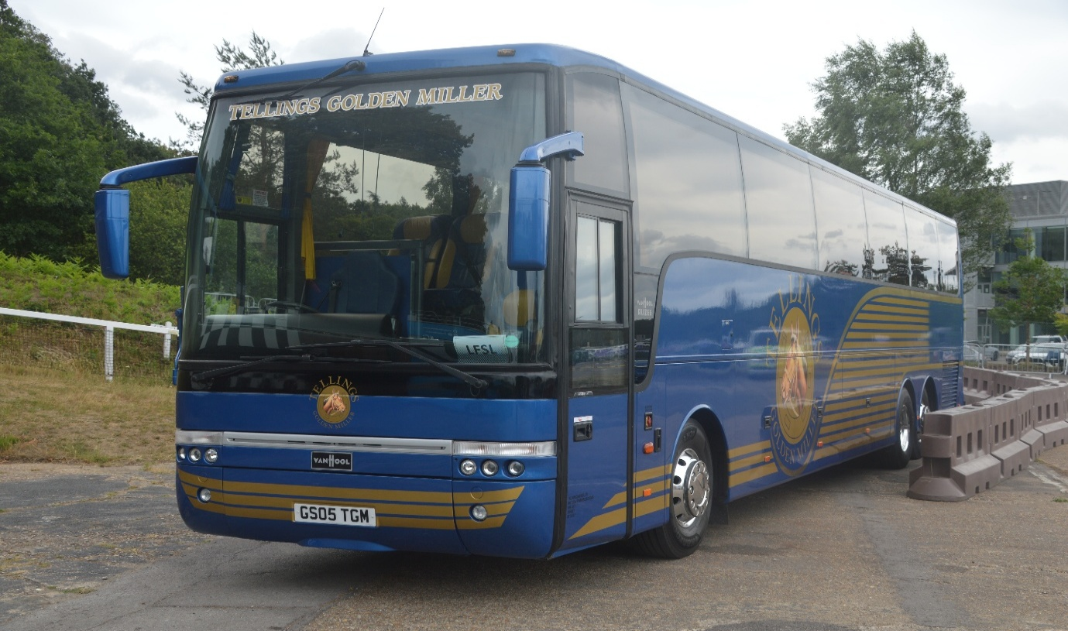
Photo credit to Gary Baxter Administration of Gary’s bus and coach photos: GS05TGM Vanhool Alizee Volvo B10M photographed at LBM Summer festival on the 22nd, June 2025 believed this is the first event it has attended as I preserved vehicle. Mine photo of the month for June 2025.
Facebook Cover Photo Competition
Place | Name
1st | Tracy Churchill
2nd | James Cusworth
3rd | James Rayburn, Andy Dyer, & Alan Lockey
4th | Alican Reilly
Thanks to everyone who take part in this month’s Facebook cover photo competition. The Facebook cover photo competition for next month will be on the 11th, July 2025.
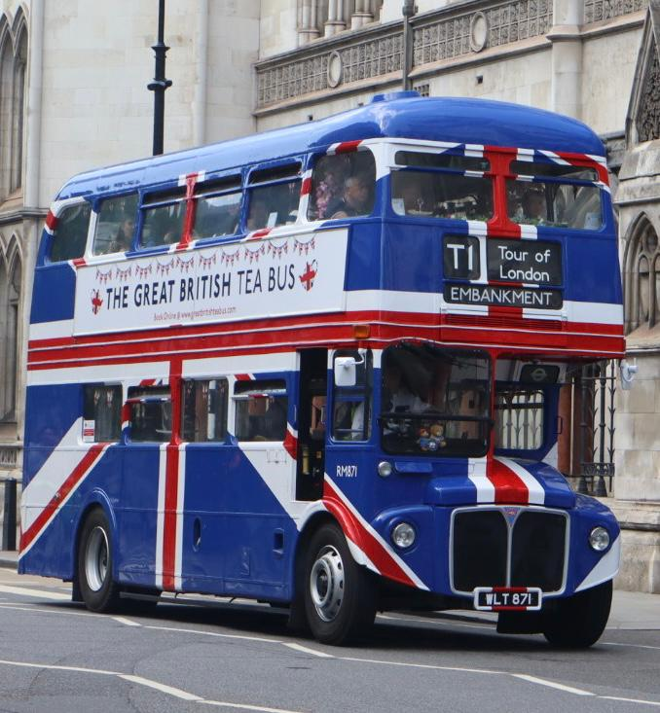
Photo credit to Tracy Churchill member of Gary’s bus and coach photos: London Transport RM871 WLT871 in union Jack branding the greatest British tea bus photographed in Fenchurch Street London.
Dorking Vintage Bus Running Day
We attended at the Dorking vintage bus running on the 1st, June 2025 We travelled to the event by train from Blackwater to Dorking Deepdene and then walked to Dorking railway station we were then greeted by a sense of vintage buses which was good. We met up with Theo and Robert Thompson take some photos and video and did a few rides out on buses to the different destinations advertised in the programme which was good. Photo and video can be found here and links to our YouTube channel and Flickr on our website at www.garysbusandcoachphotos.co.uk. No video from this event but photo album link found here. https://flic.kr/s/aHBqjCgtdv https://flic.kr/s/aHBqjCgugz
London bus museum route 418 vintage bus running day from Kingston to Epsom
We attended at the route 418 vintage bus running day from Kingston to Epsom organised by the London bus museum in Brooklands Weybridge. This was an amazing day focused on the route 418 the event was good day it was good meet up with friends with the same enthusiasm for buses and coaches has mine so was good day. It was also good for photos and video which we did for a little then take a trip up to Epsom and stayed up they for little while and got another bus back down to Kingston. The day went so fast we couldn’t believe where the time has gone. Photos and video from the event links can be found here. On the website for links to our YouTube channel at www.garysbusandcoachphotos.co.uk. No video from this event but photo album link here. https://flic.kr/s/aHBqjChhXD

London bus museum Summer Gathering
The London bus museum summer gathering was good day again like last year when we first did this event after many years of not doing it was good I went to the event with another administration Tim Wild We drove to the event and parked at the station or at Brooklands carpark. The event was good and saw some lovely weather which was good, we enjoyed looking round all the buses and coaches that turned up for this event it was a lovely day. We had some lunch in the gardens or on the grounds of where the event was being held along with some lovely music. The event was based on Alexander Dennis’s this meant they had a special display of Alexander Dennis vehicles on site. Along with they preserved D142. Photos and video from the event here. Can be found on our website at www.garysbusandcoachphotos.co.uk. For our flickr and YouTube channel. https://flic.kr/s/aHBqjCj6b5 https://youtu.be/3V-BukakcYY
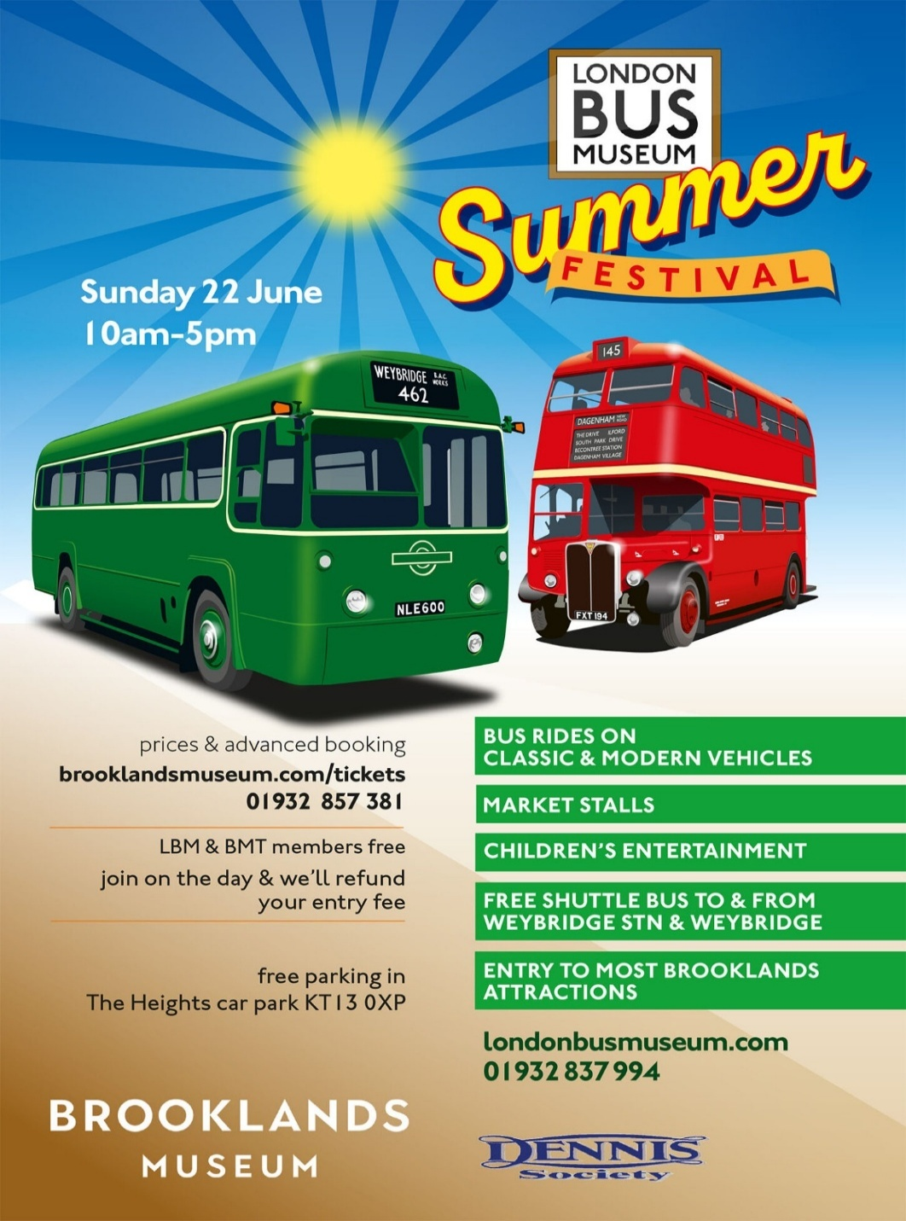

Annual Open Day 2025
We attended and helped chief executive officer Robert Williams with the annual open day on the 29th, June 2025 the annual open day was good it was a good chance to see behind the scenes of what goes on in the day to day live of bus drivers, controllers, engineers and management live behind the wheels of running a bus company. The annual event has its usual rainbow colour line up of buses and coaches in the depot. The event was hosted by Reading buses along with they charity of the year Berkshire youth looking after the young people, which was good and hopefully, they raised a lot of money for that charity more about how much raised in December newsletter. The event saw some lovely weather. It was good to be back at Reading buses helping with the annual event and to have a good catch up with my friend Robert Williams. Photos and video links can be found here. Also available from our website at www.garysbusandcoachphotos.co.uk links to our YouTube channel and Flickr there. https://flic.kr/s/aHBqjCk4pc link to YouTube channel www.youtube.com/@garysbusandcoachphotos video to follow
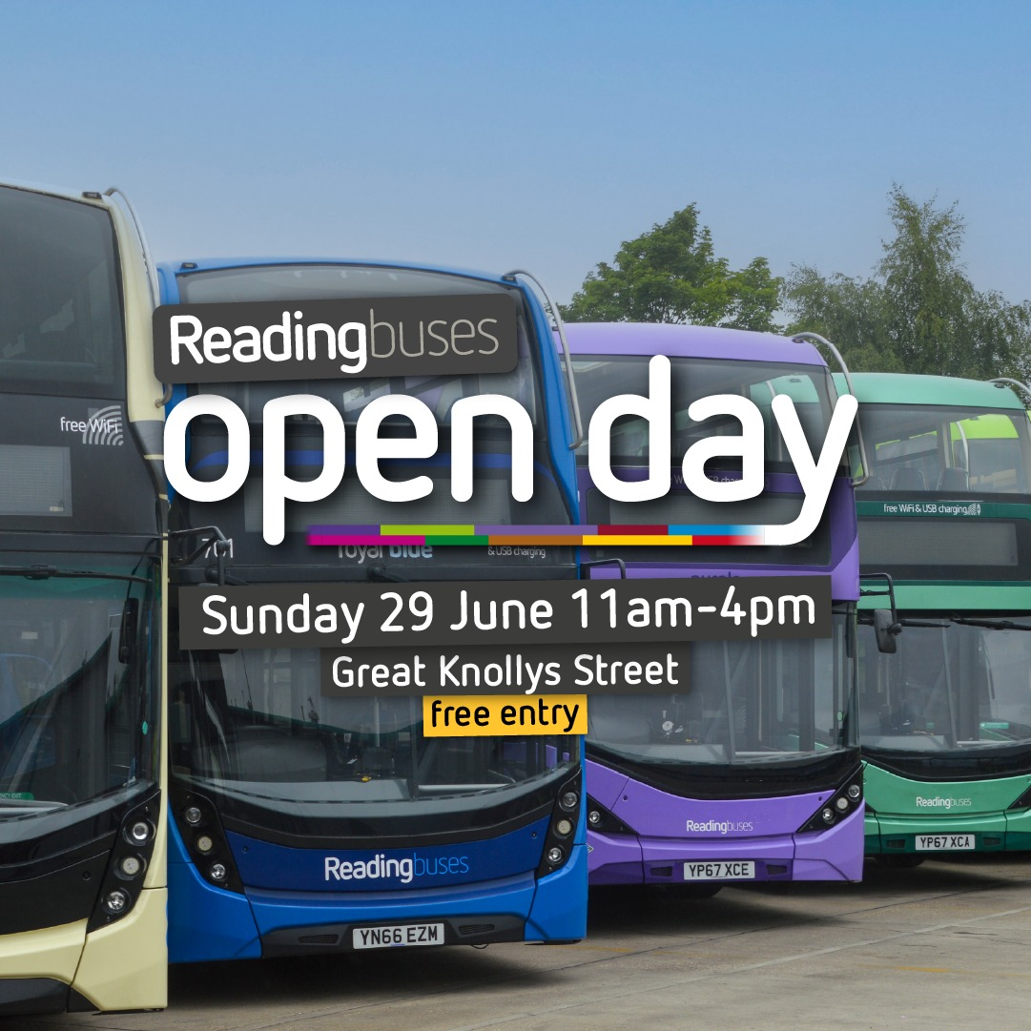

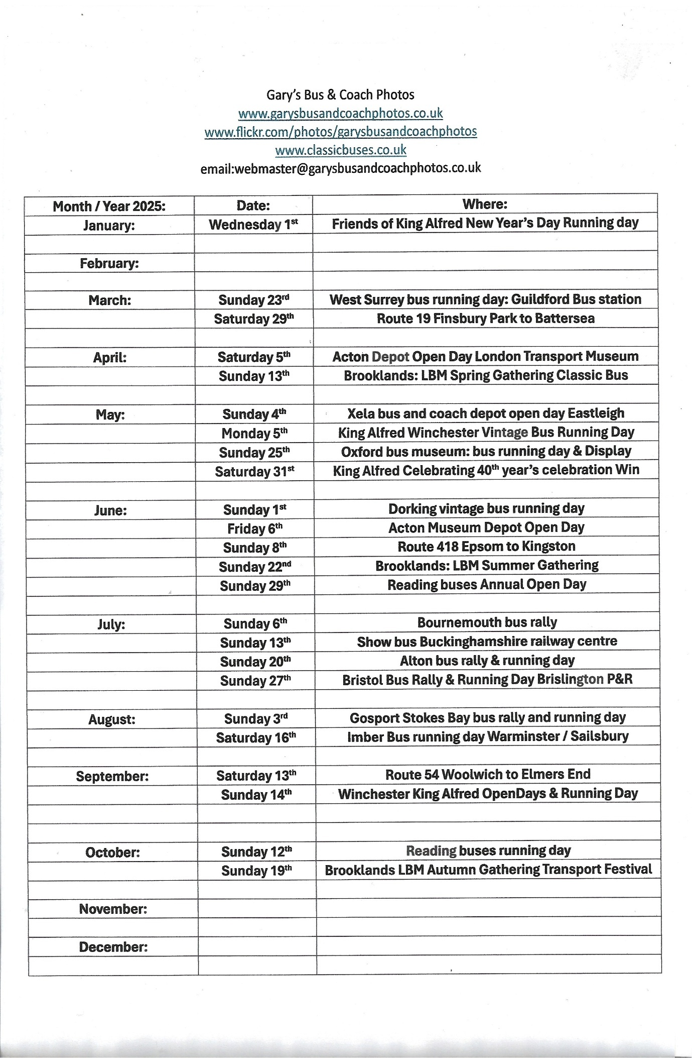
Reading buses
New Enviro400EV’s Fleet numbered 1-24 with the first Registration being MRD1 and RG02-24ZEB delivery of the first three is expected in June for driver training with entry into service pencilled in for August 2025 expect to see 201 MRD1 being registered 60 Plate. This month also saw the new route 704 start on the 2nd, June 2024 with 1009 and 687 being the operating vehicles for this route until the new buses come in for the route branding from the mistral dealership and are fleet numbered 688-689. 688 is registered M10FXO was previously YX71OJA 689 is YX71OJB this will be in dealership white with 704 branding on. 667 has been re-livered still in dealership white with Thames Valley branding.
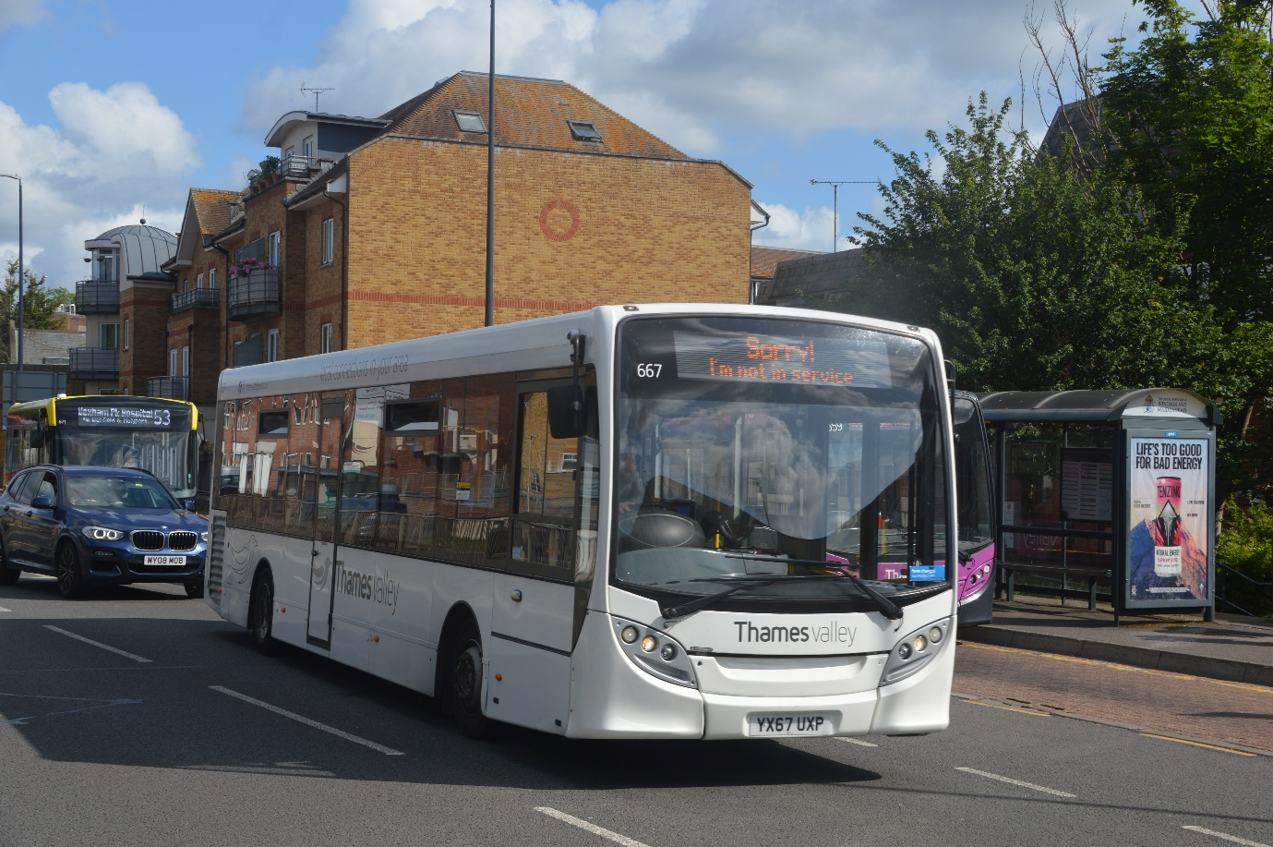
Photo credit to Gary Baxter Administration of GB&CP: TV667 YX67UXP ADL Enviro200 generic-white Thames Valley branded photographed in Maidenhead-on-Maidenhead local route earlier this month.

Route 704 Thames Valley Maidenhead to London Heathrow Airport
this month saw a new route being introduced to the Thames Valley division this route being the 704 from Maidenhead to London Heathrow Airport this service operates via Taplow and Slough and then on to London Heathrow Airport the buses being used on this route will be two Enviro200mmc’s in dealership white with 704 vinyl branding attached to the buses. Fleet number of buses being used on this route will be 688-89 registrations M10FXO and YX71OJB. For the time being buses being used on this route are 687 and 1009 687 is TV74BUS and 1009 is YX24OZP
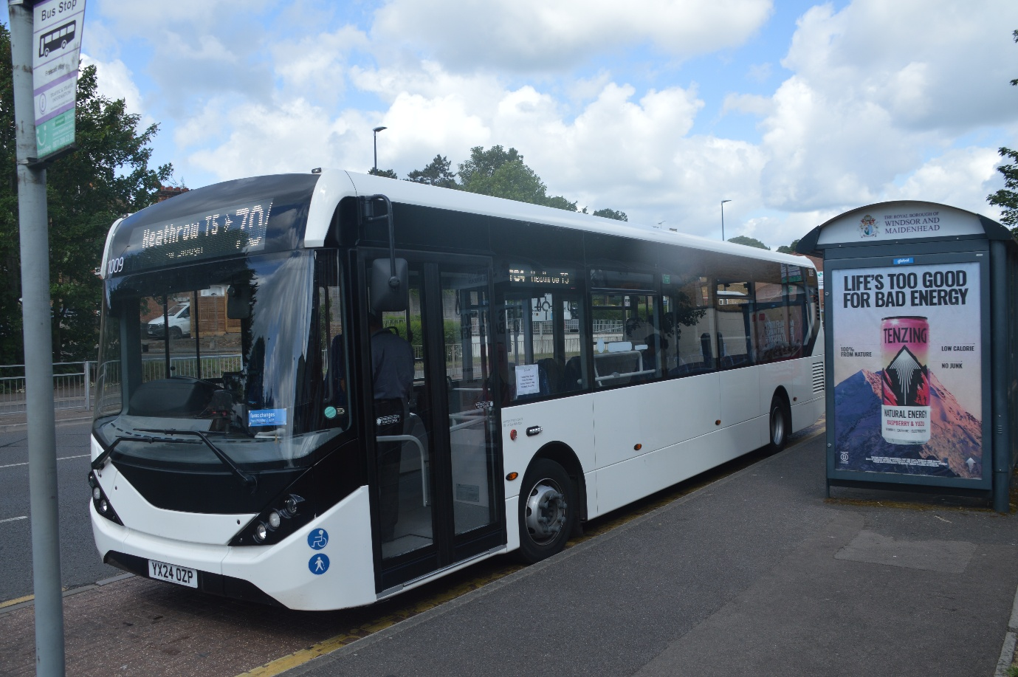
Photo credit to Gary Baxter administration of GB&CP: RB-TV1009 YX24OZP ADL Enviro200mmc parked up at Maidenhead waiting departure on route 704 to London Heathrow Airport.
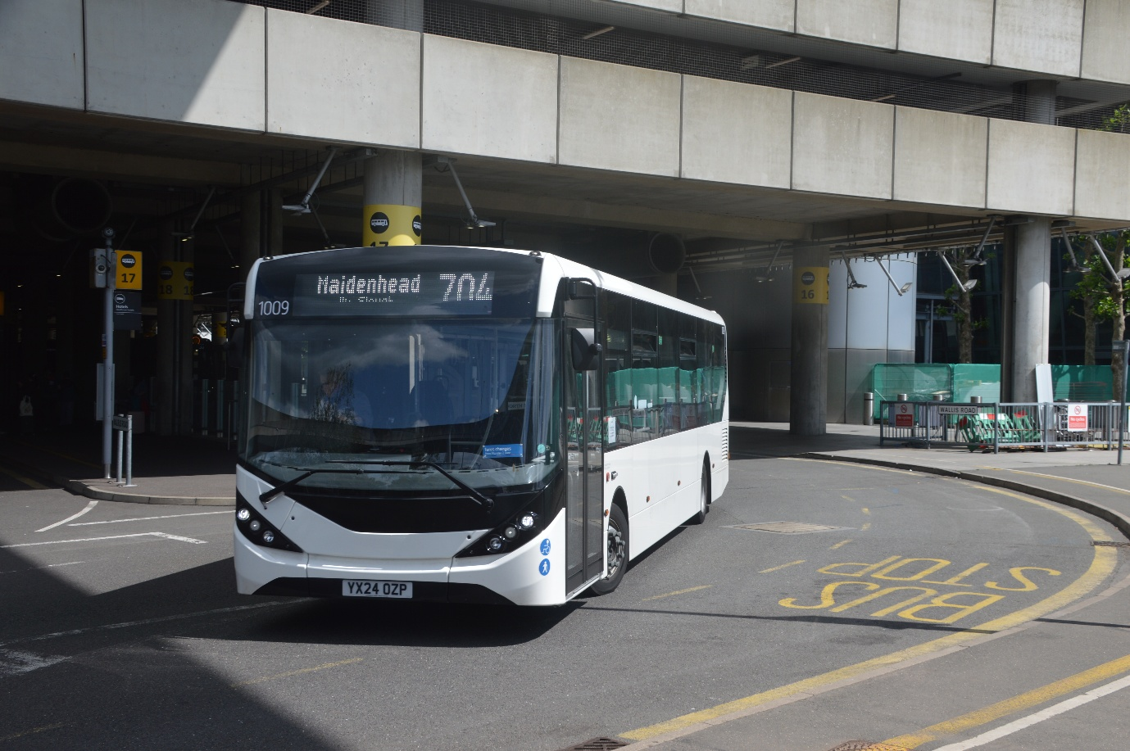
Photo credit to Gary Baxter Administration of GB&CP: RB-TV1009 YX24OZP ADL Enviro200mmc photographed departing London Heathrow Airport for Maidenhead Via Slough and Taplow.
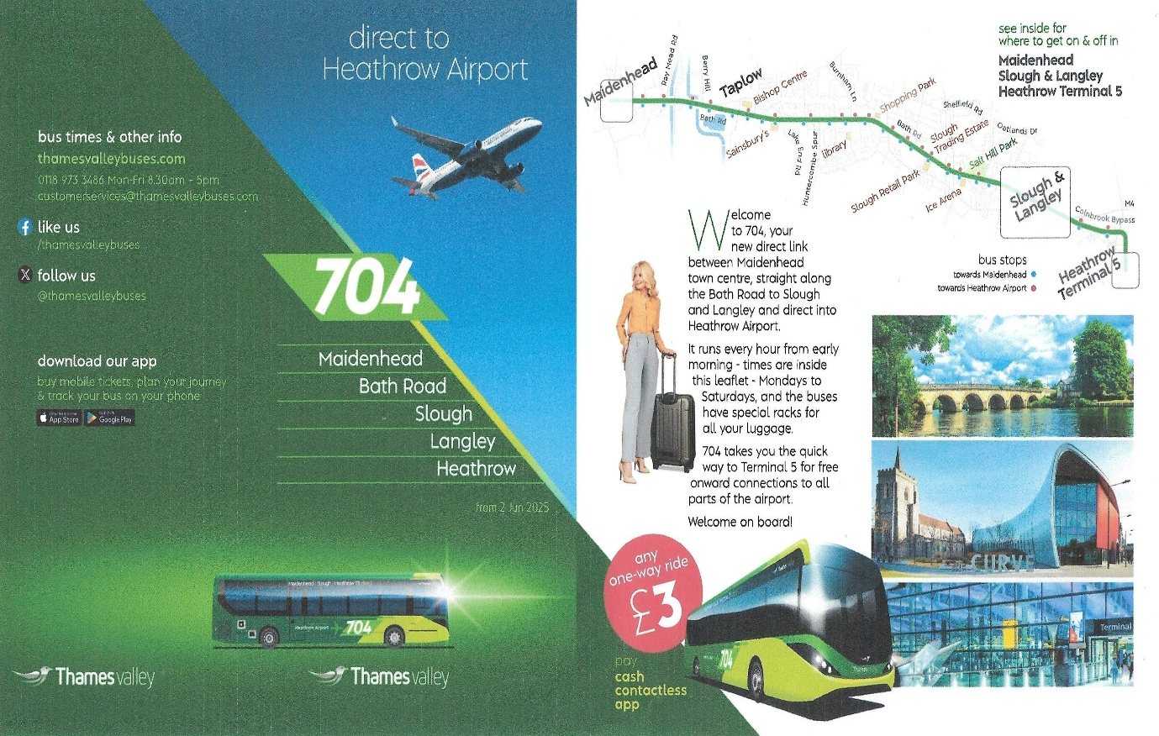
The Front cover of the timetable for new 704 from Maidenhead to London Heathrow Airport via Taplow and Slough.
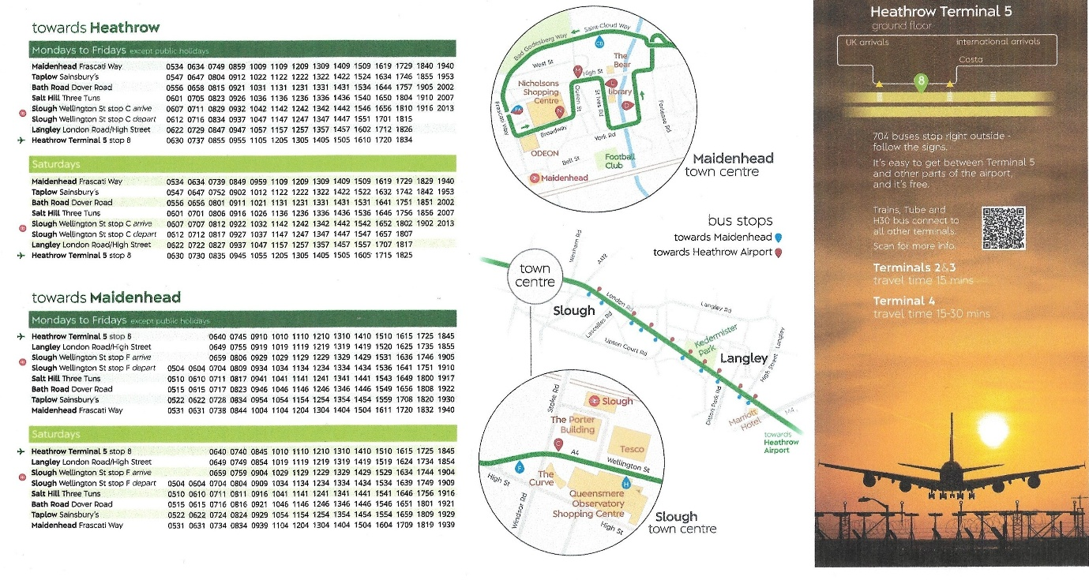
Timetable for new route 704 from Maidenhead to London Heathrow Airport via Taplow and Slough
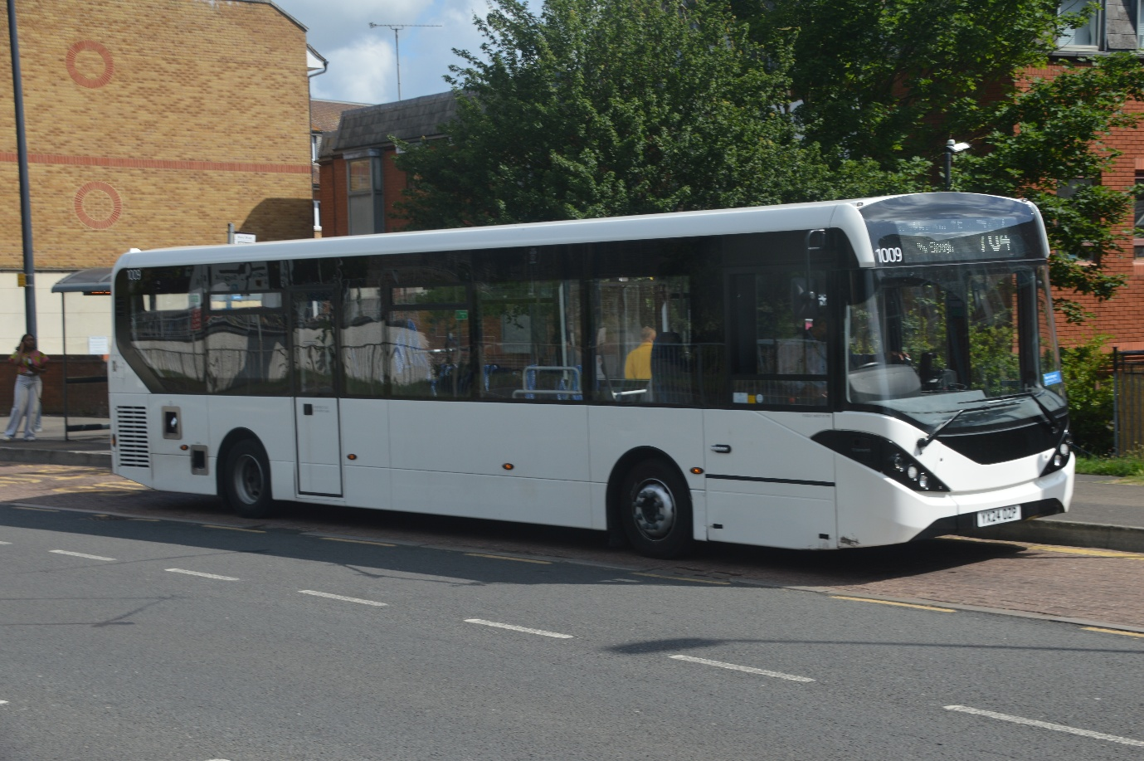
Photo credit to Gary Baxter administration of GB&CP: RB-TV1009 YX24OZP ADL Enviro200mmc photographed in Maidenhead on route 704 to London Heathrow Airport. I ride this to London Heathrow airport and it is very nice, but seems has it was first day of service I was the only one on the bus to London Heathrow Airport, but hopefully more people will use this from Maidenhead it runs hourly from Maidenhead and London Heathrow and the same from London Heathrow Airport to Maidenhead in both directions this goes via Taplow and Slough.
Fourth coming events for GB&CP & RTEC
July 2025
Dates: | Event
Sunday 6th | Bournemouth Bus Rally
Sunday 13th | Showbus Buckinghamshire railway centre
Sunday 20th | Alton Bus Rally & Running Day
Sunday 27th | Bristol Bus Rally & Running Day

Date: | Event: | Non-Member Price | Member Price | Depart from & time
Sunday 6th | Bournemouth bus rally & Running Day | £20 | £15 | GK 08:00
Sunday 13th | Showbus Buckinghamshire railway centre | £20 | £15 | GK 08:00
Sunday 20th | Alton Bus Rally & Running Day | £20 | £15 | GK 08:30
Sunday 27th | Bristol Bus Rally & Running Day | £20 | £15 | GK 08:00

These are the fourth coming events for Gary’s bus and coach photos and the Reading transport enthusiast club. Both tables shown above on this page. The Reading Transport enthusiast clubs time GK= Great Knollys Street Depot Reading RG1 7HH
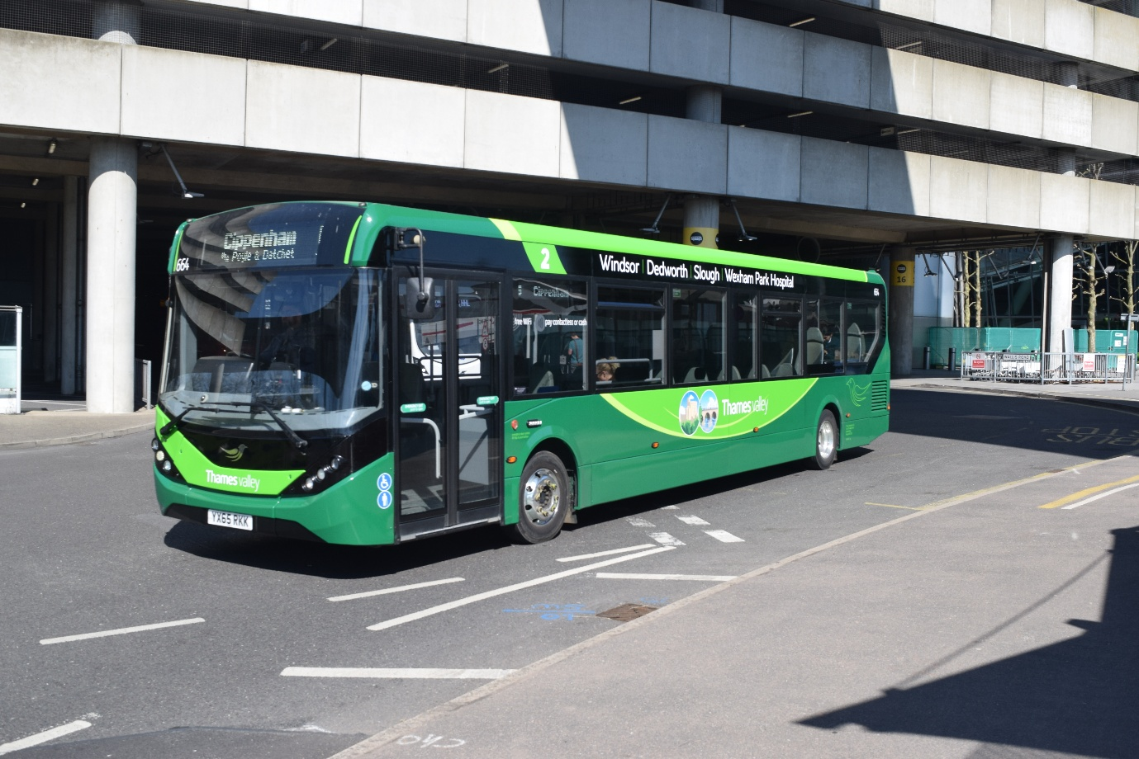
Photo credit to Gary Baxter administration of GB&CP: 664 YX65RKK photographed on route 5 from London Heathrow Airport to Cippenham branded up for route 2 to Wexham Park hospital from Slough Via Windsor & Dedworth. Photographed taken a couple of months again.
Facebook Member Photographs
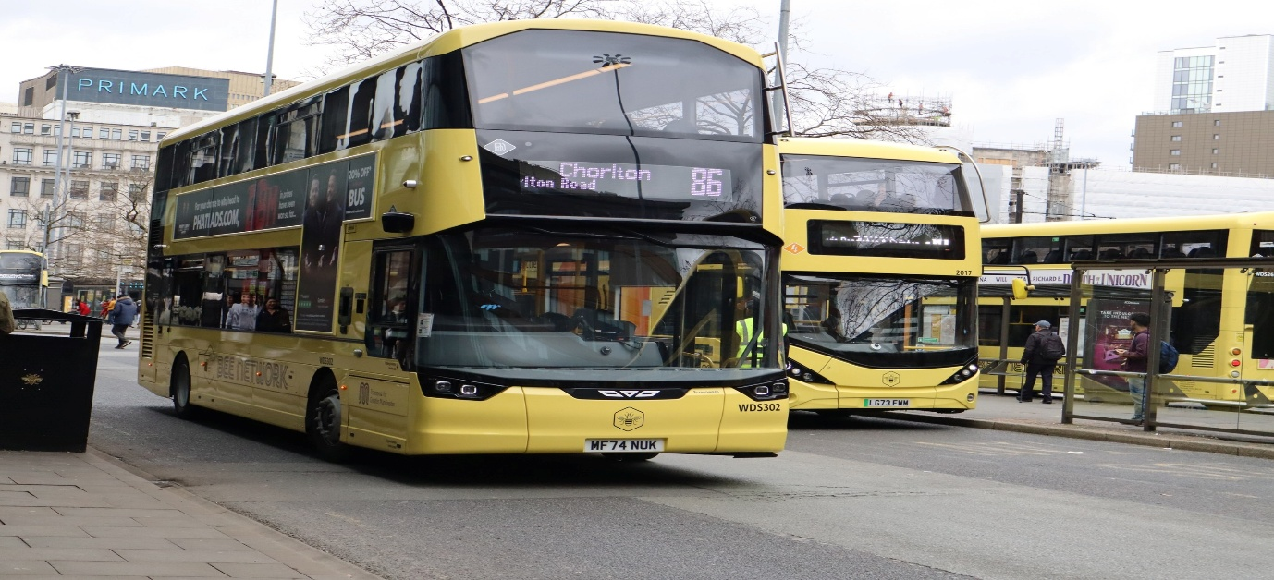
Photo credit to Alan Lockey member of Gary’s bus and coach photos: Greater Manchester bee network WDS302 MF74NUK Wrightbus Streetdeck – Metroline
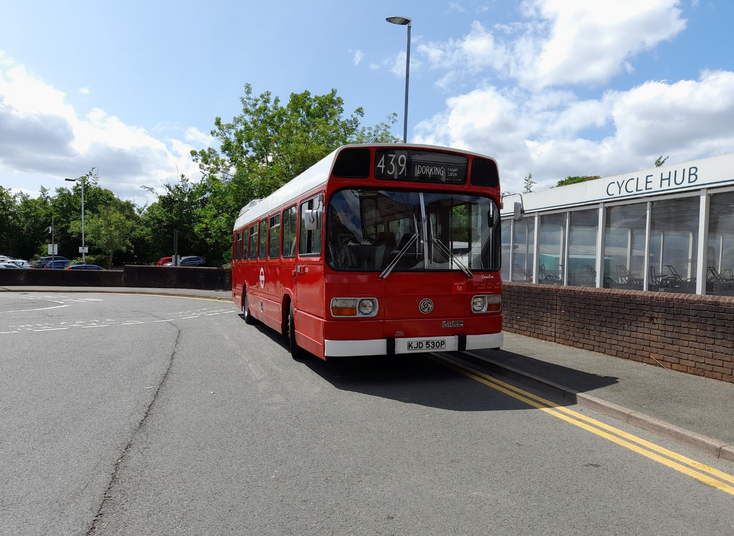
Photo credit to Alican Reilly member of Gary’s bus and coach photos: KJD530P London Transport Leyland National preserved and running around on Dorking vintage bus running day on 1st, June 2025.
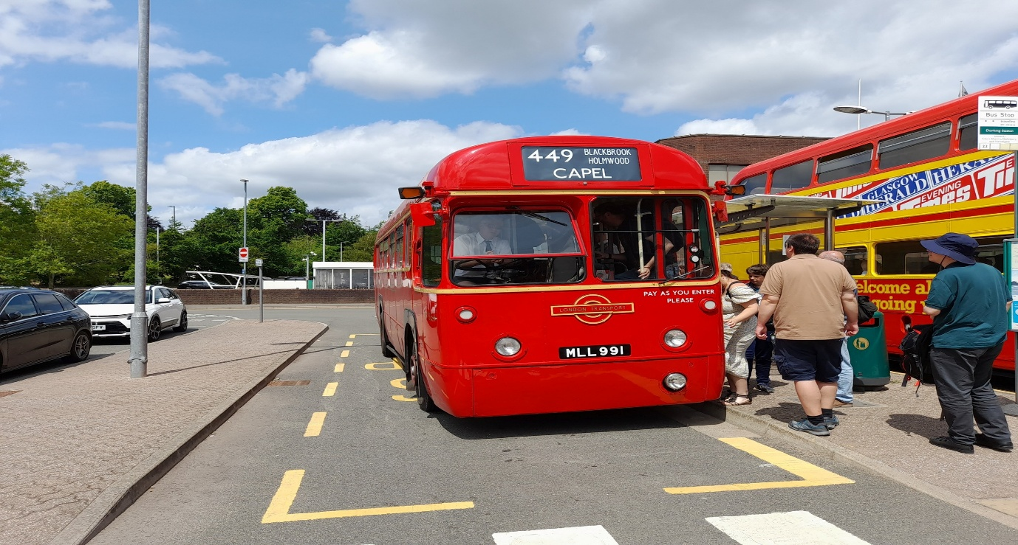
Photo credit to Alican Reilly member of Gary’s bus and coach photos: MLL991 AEC RF at Dorking vintage bus running day 1st, June 2025.
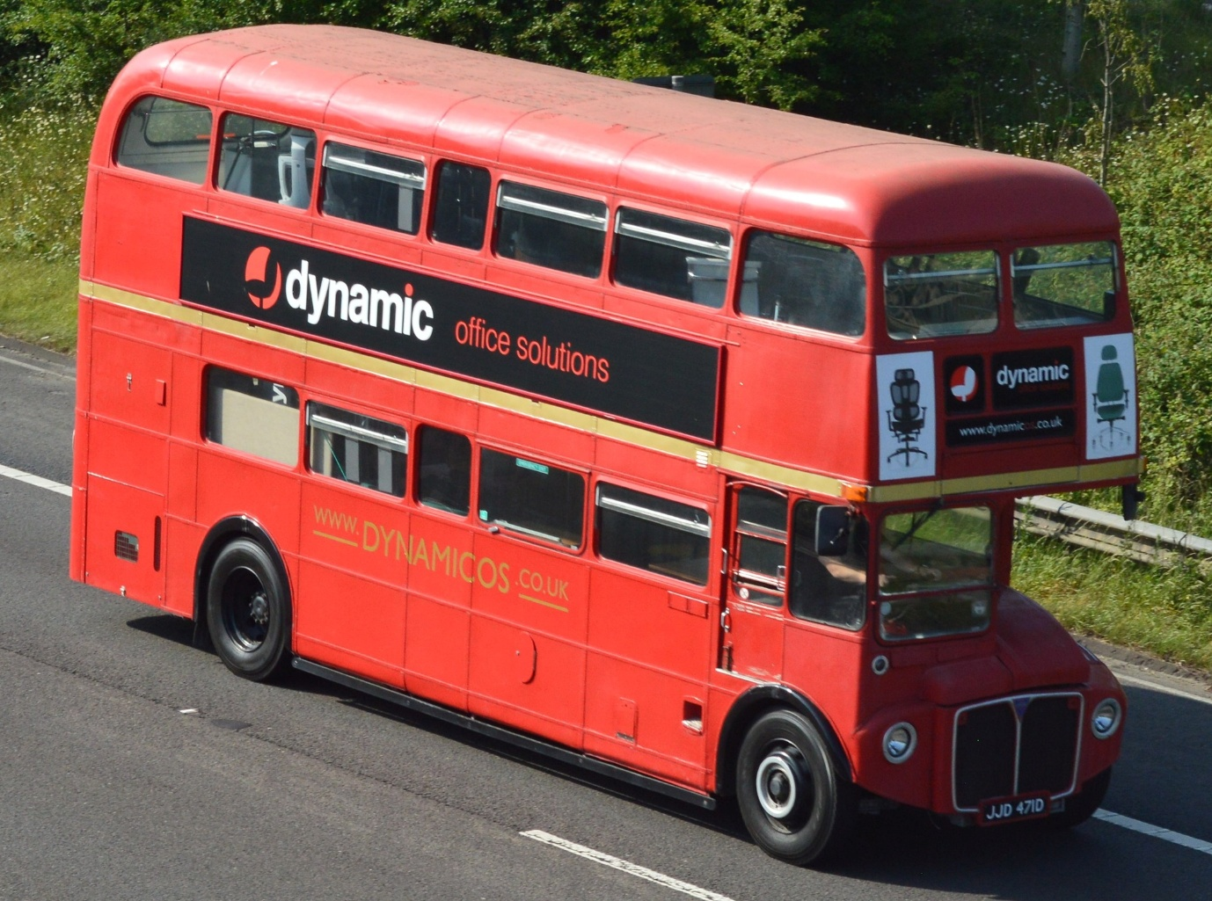
Photo credit to Barry Smith member of Gary’s bus and coach photos: London Transport Routemaster JJD471D advertising dynamic office solutions.
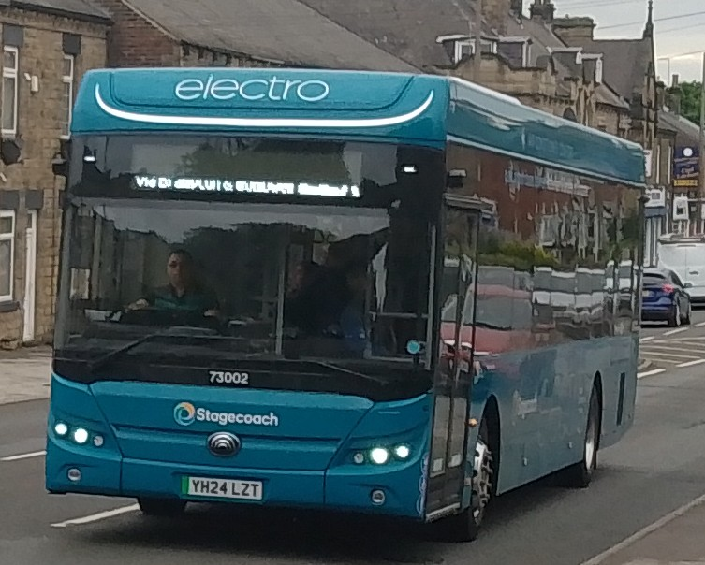
Photo credit to Barry Smith member of Gary’s bus and coach photos: Stagecoach Yorkshire 73002 YH24LZT Yutong publican.
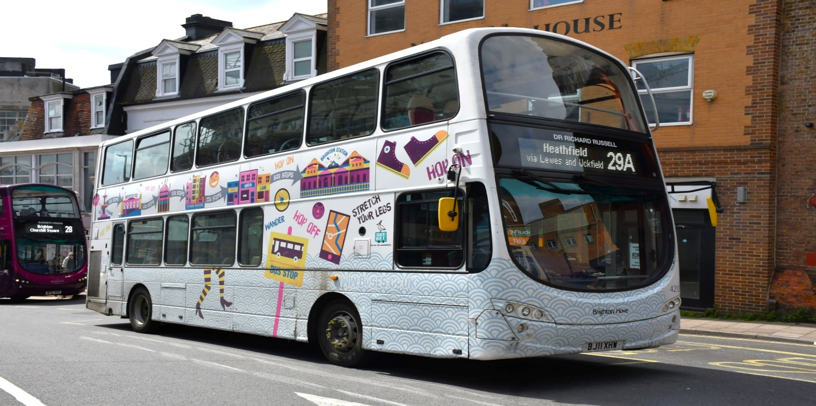
Photo credit to Steve Poole member of Gary’s bus and coach photos: GH/B&H 420 BJ11XHW Wrightbus Gemini Eclipse Brighton & Hove DR Richard Russel.
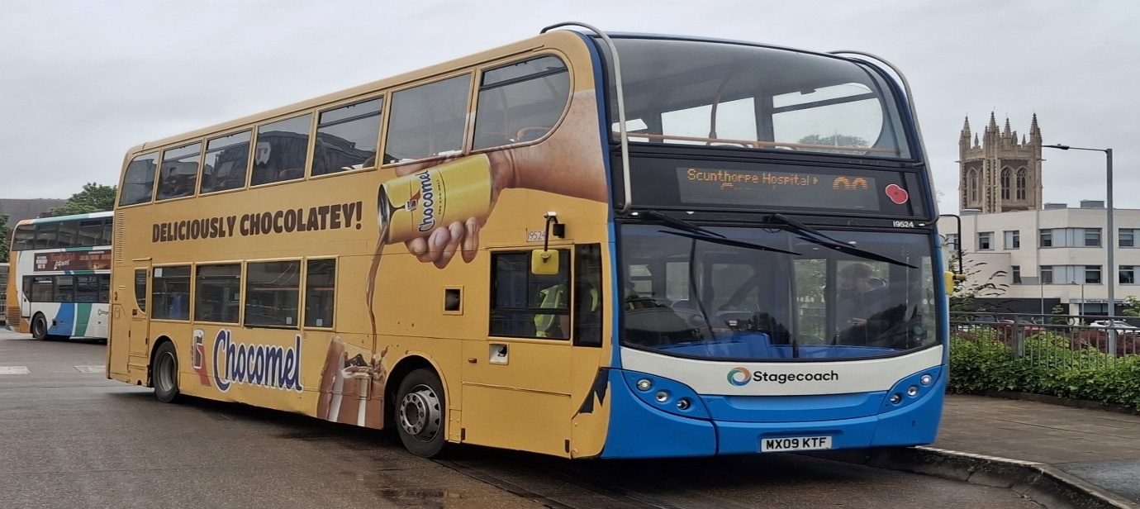
Photo credit to Andy Dyer Administration & member of Gary’s bus and coach photos; Stagecoach Scunthorpe 19524 MX09KTF ADL Enviro400 milk shock advert.
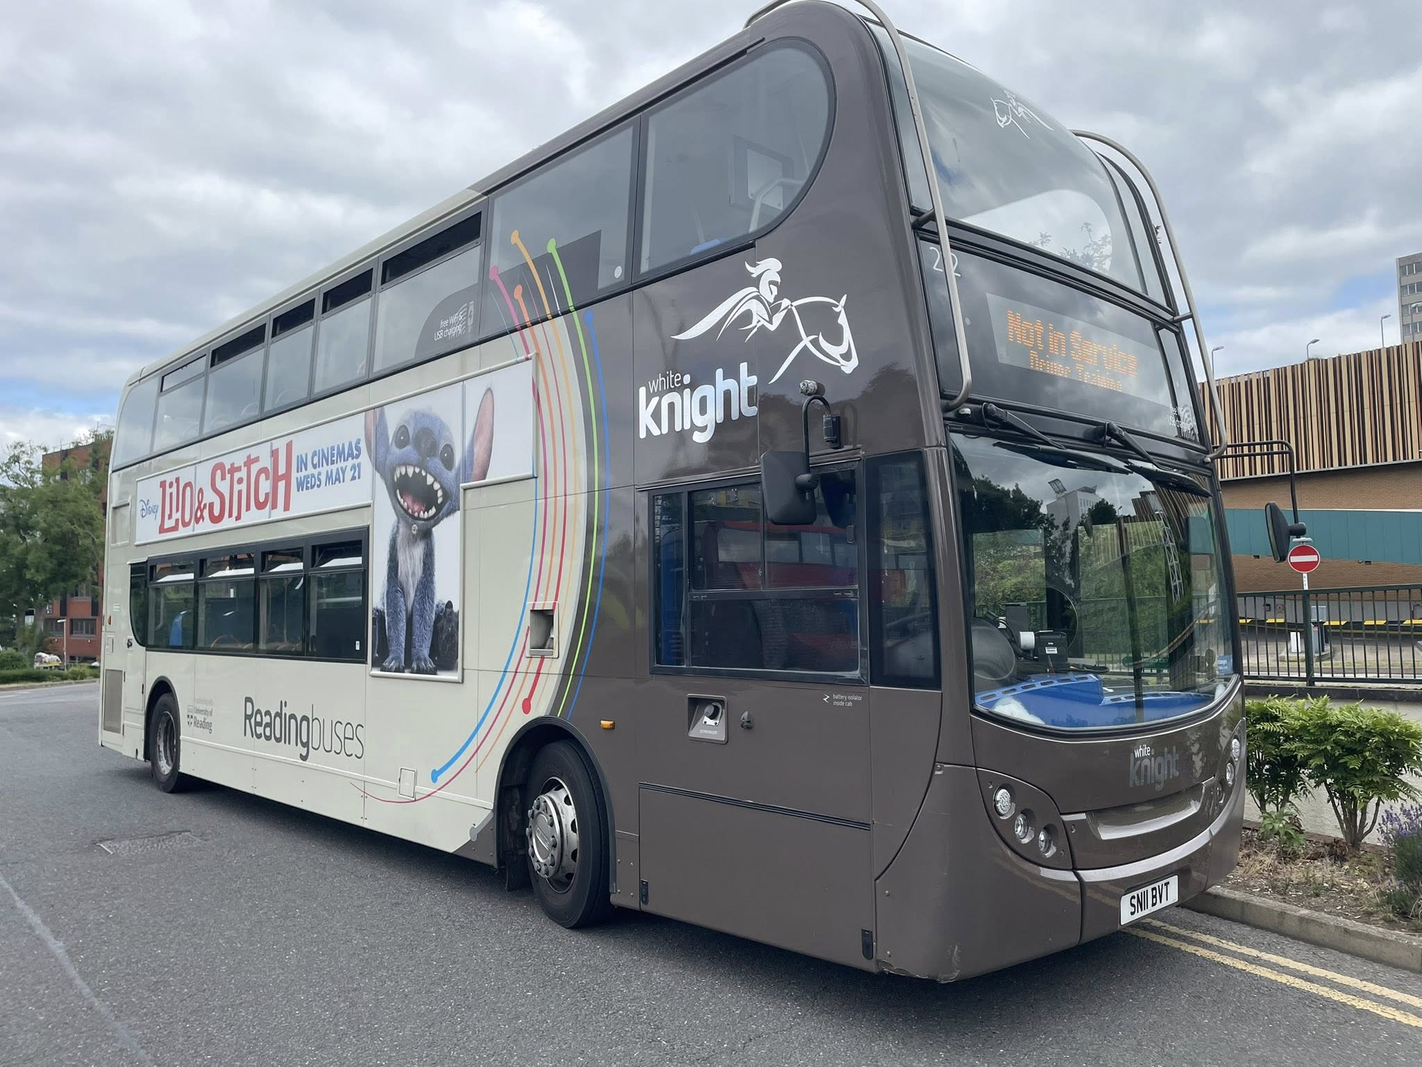
Photo credit to James Rayburn member of Gary’s bus and coach photos; Reading buses 212 SN11BVT ADL Enviro400 White knight 20.
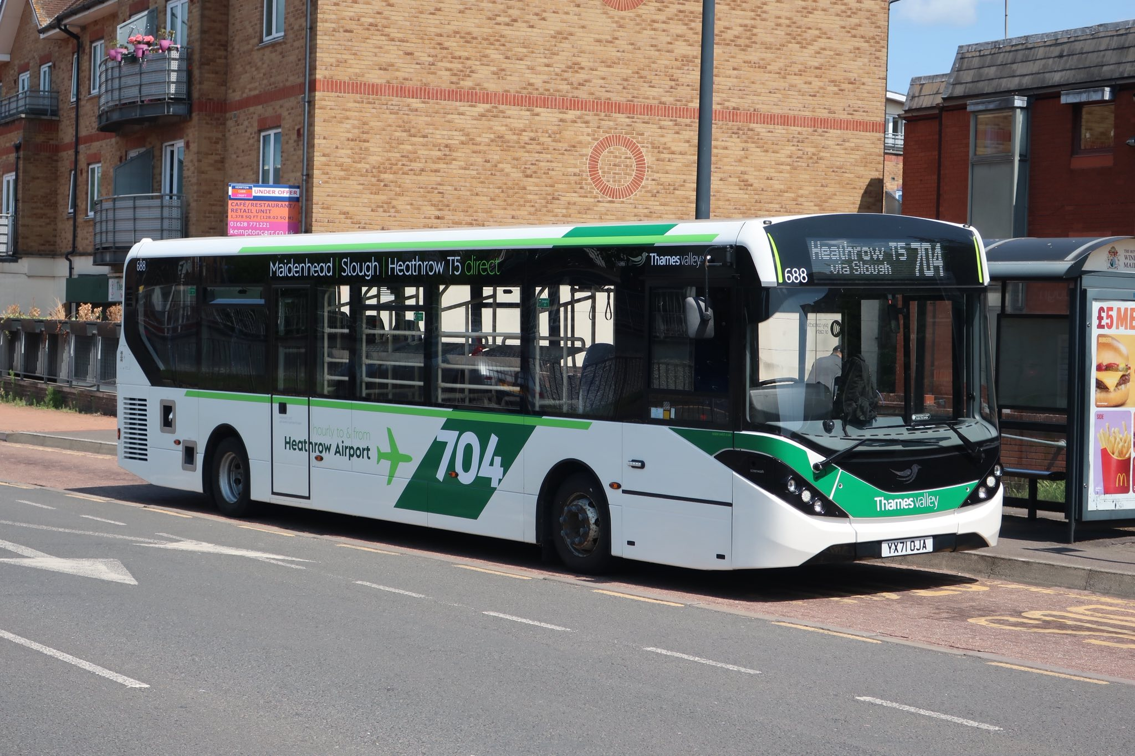
Photo credit to James Cusworth member of Gary’s bus and coach photos: Thames Valley 688 YX71OJA ADL Enviro200mmc 704 branded for London Heathrow Airport.
Theo Thompson YouTube Channel
My good friend Theo Thompson’s YouTube channel has seen some good events and videos over the past month. This month Video list below also link to his channel is www.youtube.com/@theothompsonbusenthsiast
Title | Link
Dorking bus running June 2025 | https://youtu.be/MdgyQrERVLQ?si=a-rCw0OY2K_tA16H
Buses at Heathrow Central Jun 2025 | https://youtu.be/QhZLIDbA-Lk?si=jqgGR7TU6rXSc4df
Buses at Heathrow Airport T5 | https://youtu.be/HzQrq8etNq4?si=S_c50bL9SoT6q7wt
Route 418 running day Kingston | https://youtu.be/3rKP38eBcLA?si=ZiRov25MXaw0odZs
Buses in Kingston June 2025 | https://youtu.be/lgOCX6w9uiA?si=gNHVEFnuSnEFYxvU
London bus museum summer festival | https://youtu.be/fY0zdkDl3w4?si=Qf4LrvjUA27yPqWO

Theo Thompson’s Flickr
Theo’s flickr can be found via this link here
Theo Thompson | Flickr

Friends Flickr & YouTube channels

Name: | Link | Media Name:
Tony Ford & Tracy Churchill | https://flickr.com/photos/202982794@N05 | Flickr
Theo Thompson | Theo Thompson | Flickr | Flickr
Theo Thompson | www.youtube.com/@theothompsonbusenthsiast | YouTube
Alex Young / Hello Wallace | Alex Young | Flickr | Flickr
Alex Young / Hello Wallace | (1) Hello Wallace - YouTube | YouTube
These links can all be found on www.garysbusandcoachphotos.co.uk/flickrandyoutubefriend that is where i’ll share links to fallow enthusiast friends YouTube channels and Flickr.



