
Month: February 2026 Issue No: 92
This month we attended at the Routemaster one event in Stonebridge Ace café this event was a nice event celebrating 70 years of the first Routemaster entering service on route two. We attended this event with Reading transport enthusiast club and RM No17 859DYE. Excellent day to see some friends and make new friends at the same time more about this on Page six.
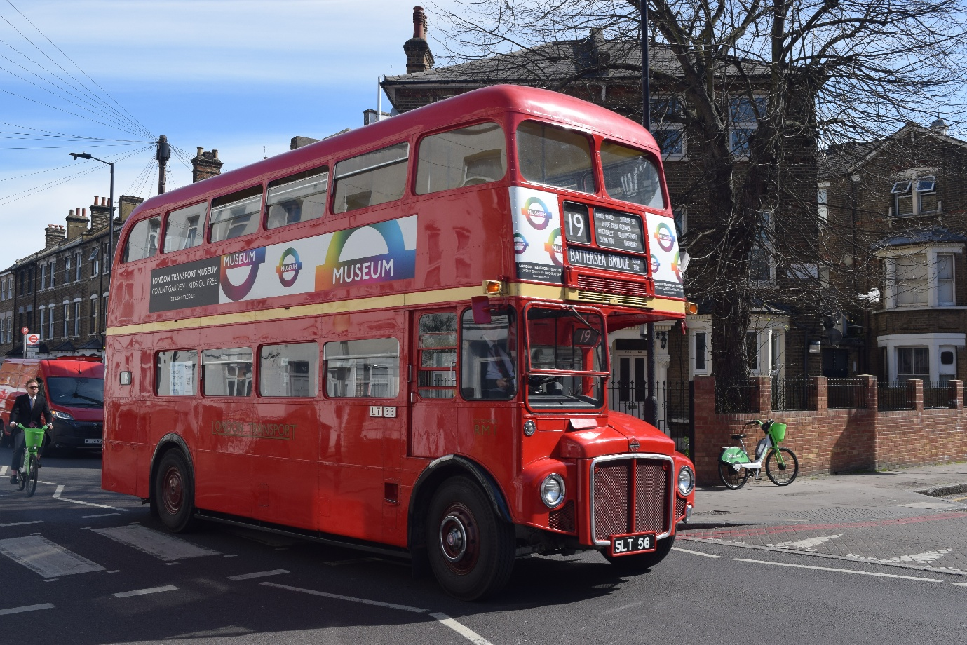
Photo credit to Gary Baxter Administration of Gary’s bus and coach photos: RM1 SLT56 photographed in March 2025 at Route nineteen running day from Battersea bridge to Finsbury Park this photo taken before heading back to Battersea bridge.
www.facebook.com/groups/garysbusandcoachphotos
www.facebook.com/@garysbusandcoachphotos
Flickr Albums
Album Date: | Album Name: | Album Link:
6th February 2026 | Reading | https://flic.kr/s/aHBqjCK1Yr
8th February 2026 | Ace Café Stonebridge & Crystral Palace | https://flic.kr/s/aHBqjCJTzq
25th February 2026 | Bracknell | https://flic.kr/s/aHBqjCLwKL
26th February 2026 | Bracknell & Reading | https://flic.kr/s/aHBqjCLwXK
Photo Of The Month
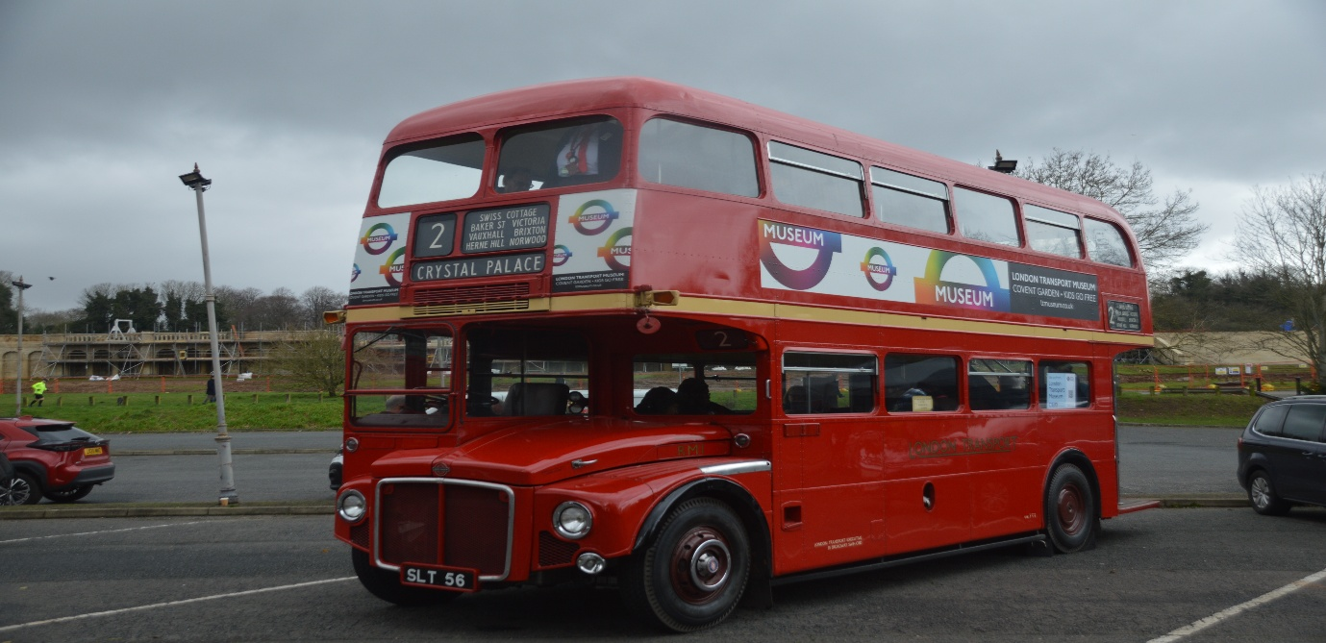
Photo credit to Gary Baxter Administration of GB&CP: RM1 SLT56 London transport Routemaster on the road run route 2 event for RM1 entering Service for the first time on 8th, February 2026 originally entering service 9th, February 1956. Photo of the month for February 2026. More photos from this day here: https://flic.kr/s/aHBqjCJTzq
Events
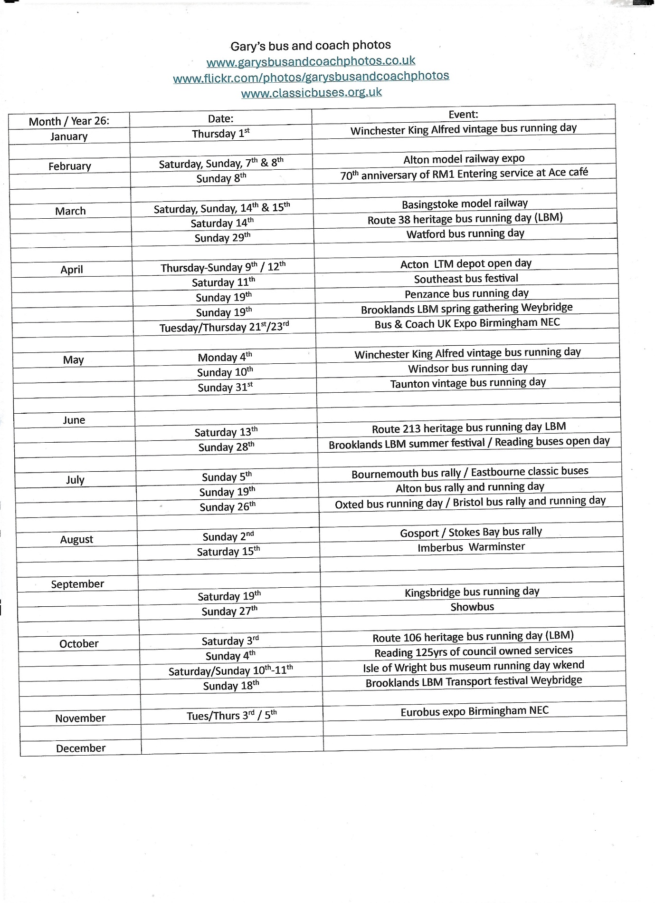


Electric bus News from Robert Williams CEO
I am delighted to confirm that the electric buses are expected to enter service from 4am on Friday 6 February on purple 17 and claret 21.
We are going back to the start with fleet numbering, numbering them 1-24, with the first carrying the Reading mayoral registration plate MRD 1 that is on loan from the Council. The others have RGxx ZEB registrations with numbers that match the fleet number, RG standing for Reading, and ZEB for Zero Emission Bus.
Bus 1 is in generic silver.
Bus 2 carries a ZEBRA design to promote Zero Emission Buses for the Reading Area, following on from bus 421 that has a cow design to promote our biomethane gas buses, and the leopard and lion bus routes.
Bus 3 carries the latest global warming stripes, with a couple more years than similar bus 431. The stripes were designed by Reading University lead scientist Ed Hawkins as a visual representation of the change in temperature over the past 100+ years. Each stripe or bar represents the temperature in Berkshire averaged over a year, the darker red being the hottest. They often feature on news items relating to the climate, at COP conferences, and on Greta Thunberg’s Climate Book.
Bus 4 will carry a surprise livery to mark the company's 125th anniversary of local ownership.
Buses 5-18 are branded for purple 17, and 19-24 for claret 21. Each have individual adverts on the sides and rear promoting the virtues of the buses, and a photo mural on the stairwell.
The buses have an electric heat pump which not only provides heating in the winter, but also air conditioning in the summer. They also have our standard second wheelchair bay, wood effect flooring, high back seats, USB A/C charging, tables on both decks, glazed staircase, skylights, audio visual next stop information system with hearing loops, and LED mood lighting that incorporates the route brand colour. The next stop screen that is normally above the wheelchair bay has been relocated to the handrail due to the ducting required for the heating/cooling system.
All are single door because the centre doors have not proven particularly effective in reducing dwell times on the purple 17. There are only a limited number of locations where people get on and off in meaningful numbers, and the doors have a significant impact on seating capacity in the valuable low floor area. The buses are also our first for a while without offside destination displays, this is due to the first windows not being full width on this design of body, and therefore unable to accommodate the display.
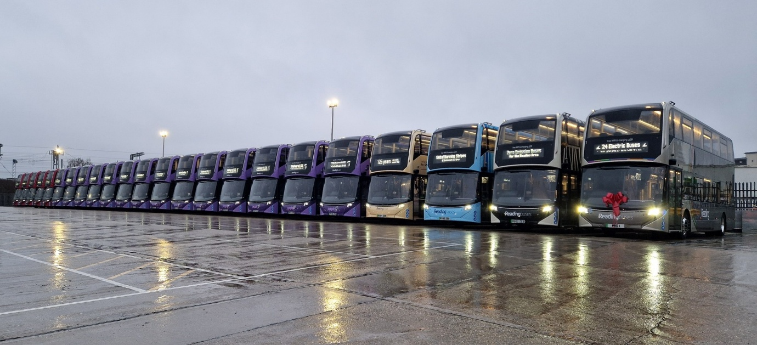
Photo credit to Robert Williams member of Gary’s bus and coach photos: 1-24 excluding 21 ADL Enviro400EV’s line up at Great Knollys Street Reading.
ADL Enviro400EV’s: The Fleet numbers and the registration of the new electric Alexander Dennis enviro400ev’s has follows below for routes 17 and 21.
Fleet No | Reg No | Company | Date Entered Service
1 | MRD1 | Reading buses | 6th February 2026
2 | RG02ZEB | Reading buses | 6th February 2026
3 | RG03ZEB | Reading buses | 6th February 2026
4 | RG04ZEB | Reading buses | 6th February 2026
5 | RG05ZEB | Reading buses | 6th February 2026
6 | RG06ZEB | Reading buses | 6th February 2026
7 | RG07ZEB | Reading buses | 6th February 2026
8 | RG08ZEB | Reading buses | 6th February 2026
9 | RG09ZEB | Reading buses | 6th February 2026
10 | RG10ZEB | Reading buses | 6th February 2026
11 | RG11ZEB | Reading buses | 6th February 2026
12 | RG12ZEB | Reading buses | 6th February 2026
13 | RG13ZEB | Reading buses | 6th February 2026
14 | RG14ZEB | Reading buses | 6th February 2026
15 | RG15ZEB | Reading buses | 6th February 2026
16 | RG16ZEB | Reading buses | 6th February 2026
17 | RG17ZEB | Reading buses | 6th February 2026
18 | RG18ZEB | Reading buses | 6th February 2026
19 | RG19ZEB | Reading buses | 6th February 2026
20 | RG20ZEB | Reading buses | 6th February 2026
21 | RG21ZEB | Reading buses
22 | RG22ZEB | Reading buses | 6th February 2026
23 | RG23ZEB | Reading buses | 6th February 2026
24 | RG24ZEB | Reading buses | 6th February 2026

Routemater one road run
We attended at the Routemaster one road run with the Reading transport enthusiast club. The Routemaster one road run started at the Ace Café in Stonebridge near London. This was to create the first day of Routemaster one first day in service on route 2 to Crystral Palace from Golders Green or in this case the Ace Café in Stonebridge. Also to celebrate Routemaster one’s 70th anniversary. The day started at 8am at the Ace café in Stonebridge and RM1 departed the ace café at 08:30am for Golders Green bus station and then on to coach park for photo shoots up until 16:00hrs when the event closed and finished. Photos from this day can be found at www.garysbusandcoachphotos.co.uk also via these links. https://flic.kr/s/aHBqjCJTzq a video from the event can be found at www.youtube.com/@Theothompsonbusenthusiast
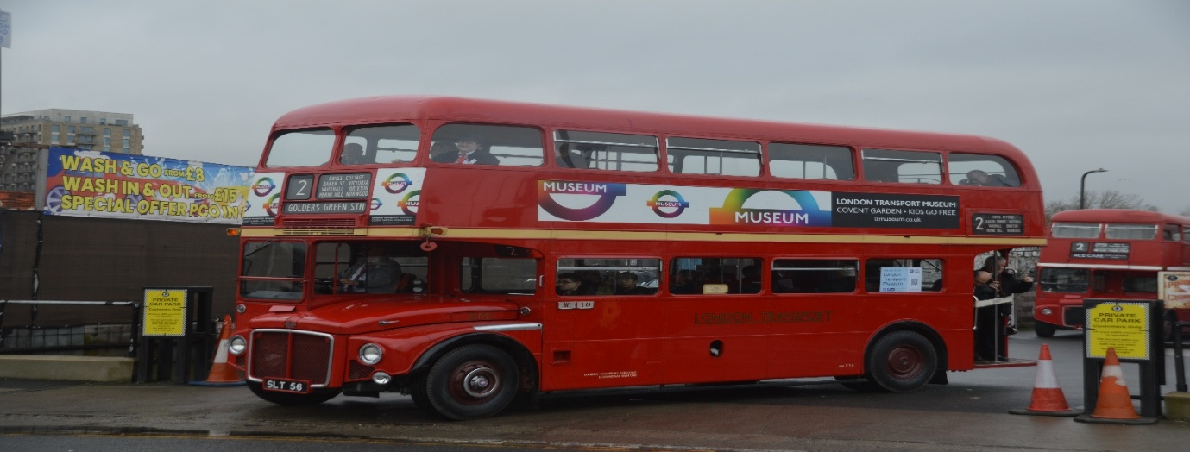
Photo credit to Gary Baxter Administration of Gary’s bus and coach photos: RM1 SLT56 London Transport Routemaster from the London Transport museum depot at the 70th anniversary road run celebrating seventy years of the first Routemaster entering service on London roads. Photographed up on departure from Ace café in Stonebridge to head to Crystral palace.
Facebook Group members photos
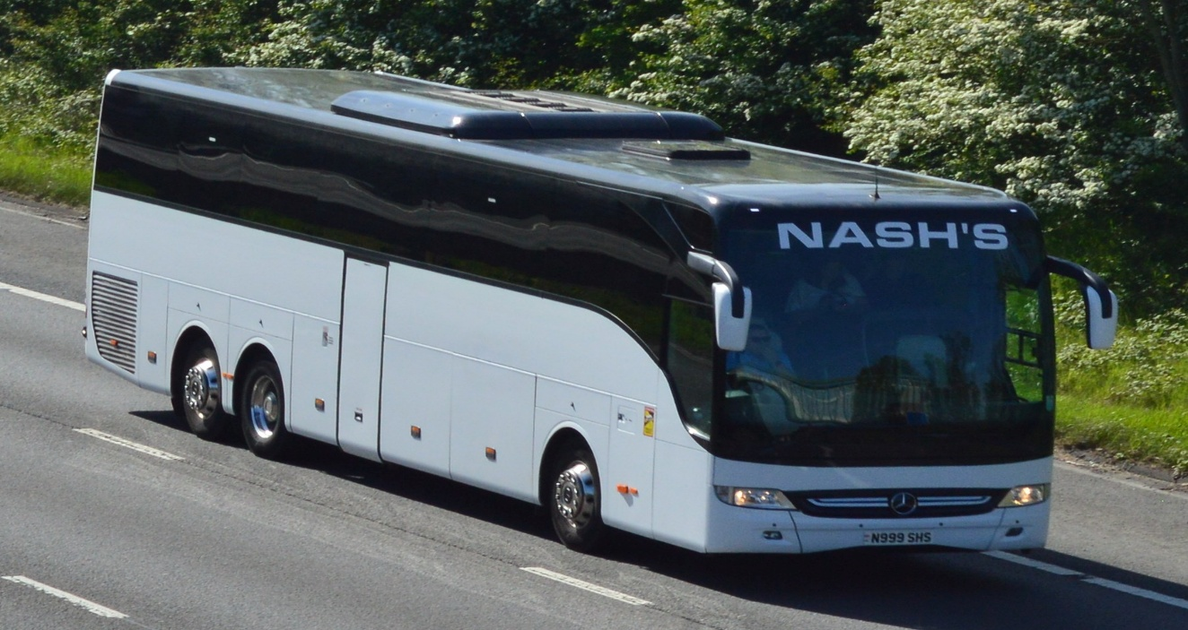
Photo credit to Barry Smith member of GB&CP N999SHS Mercedes Benz Nash's coaches.
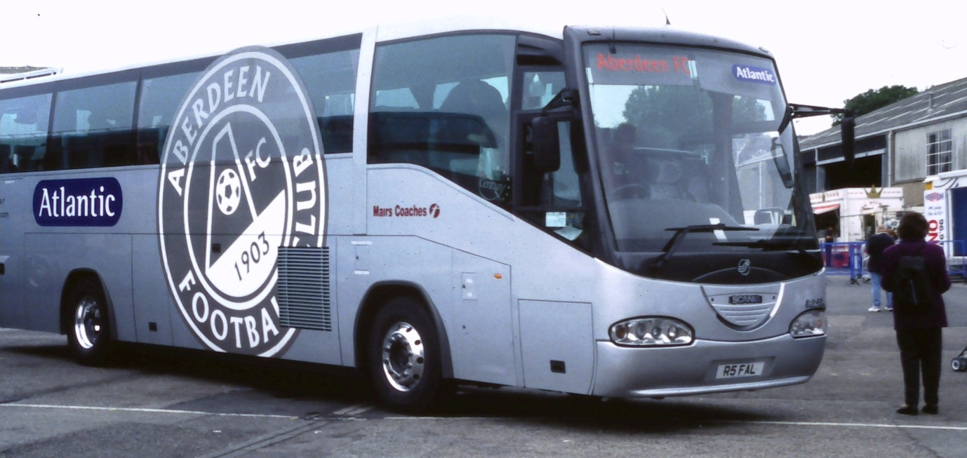
Photo credit to Barry Smith member of GB&CP R5FAL First Mairs coaches Aberdeen Football club team coach.
www.facebook.com/groups/garysbusandcoachphotos
www.facebook.com/@garysbusandcoachphotos
www.flickr.com/photos/garysbusandcoachphotos
www.garysbusandcoachphotos.co.uk
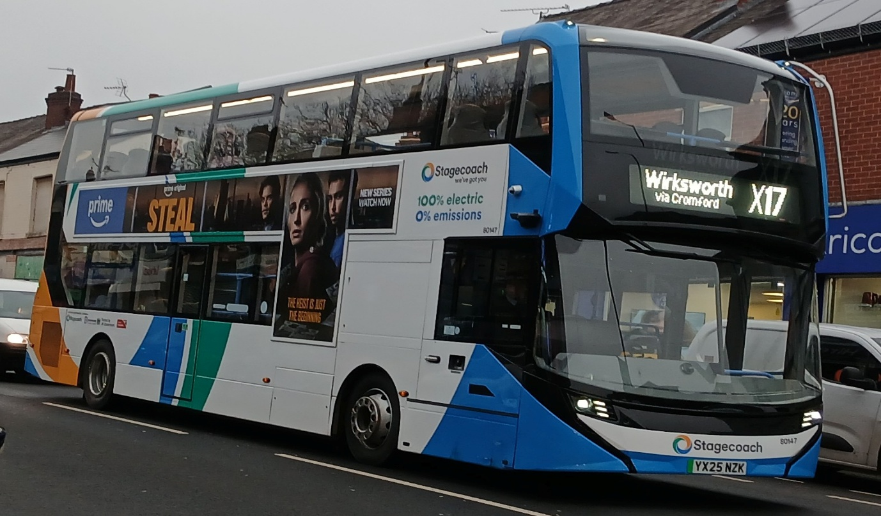
Photo credit to Barry Smith member of GB&CP Stagecoach Yorkshire 80147 YX25NZK ADL Enviro400EV.
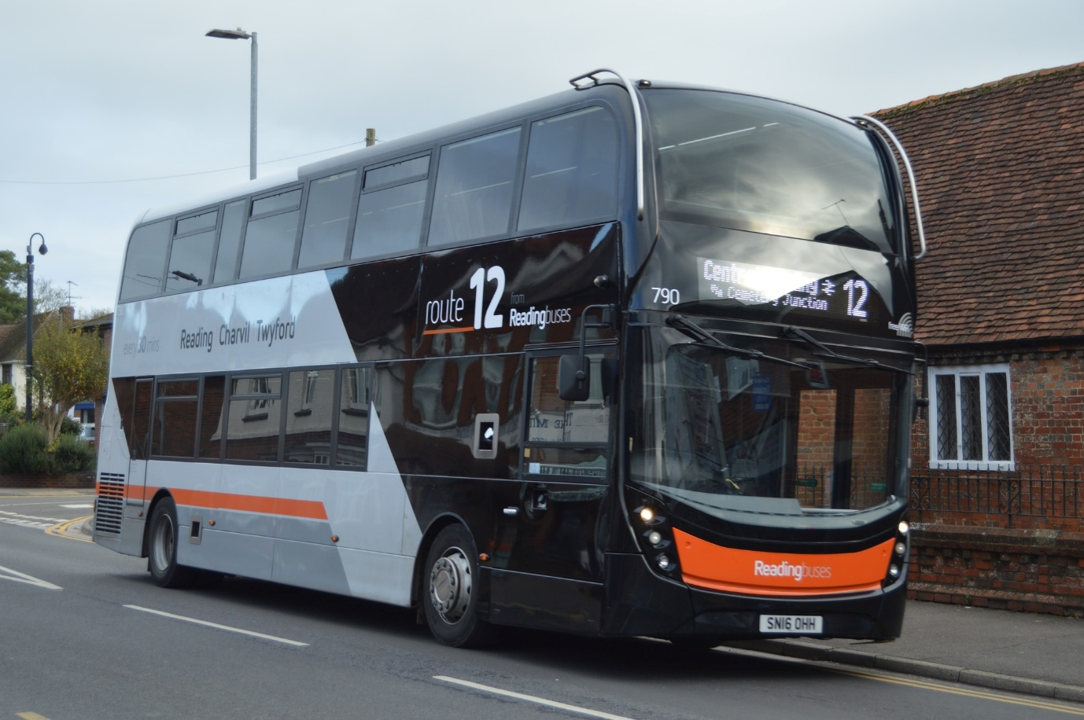
Photo credit to Gary Baxter Administration of GB&CP Reading buses 790 SN16OHH ADL Enviro400mmc branded route 12 to Twyford.
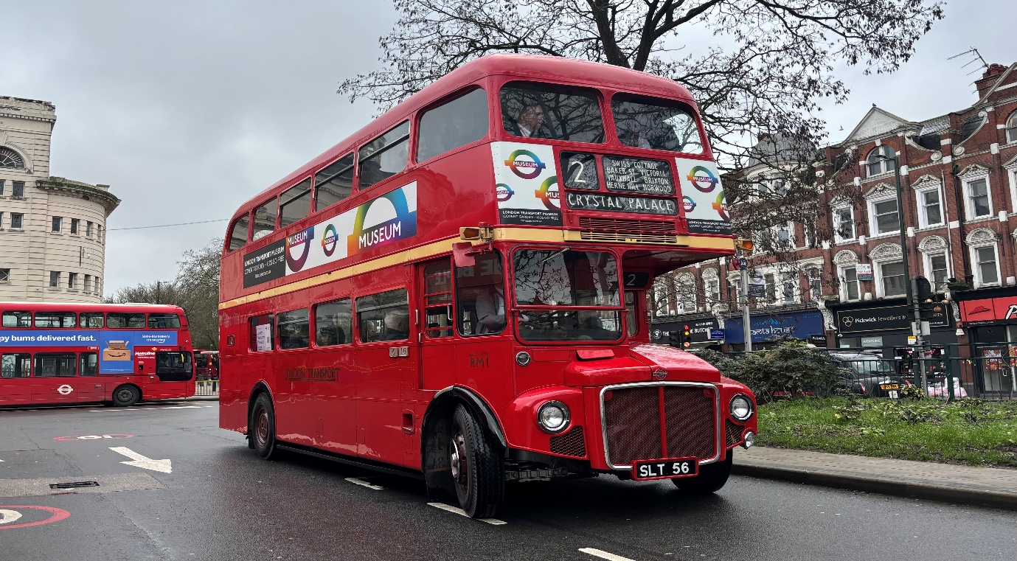
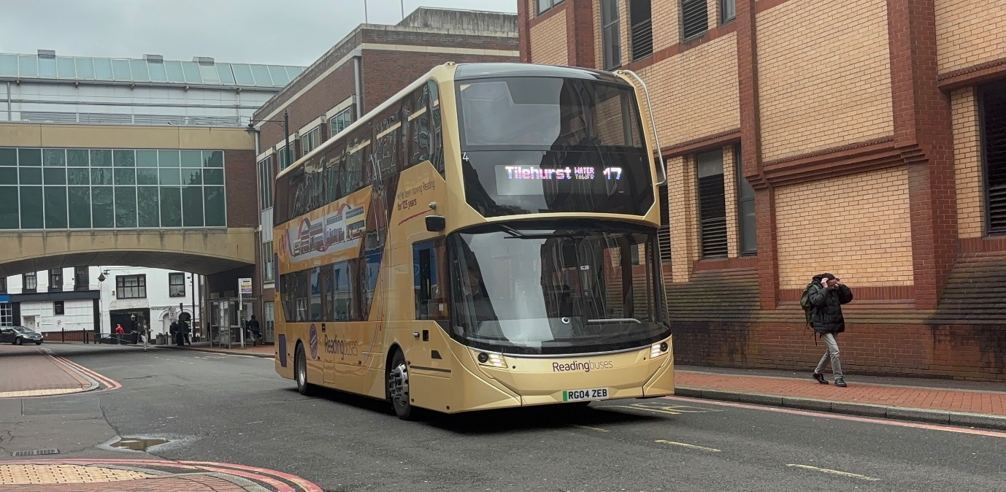
Photo above: Photo credit to Robert Thompson on behalf of Theo Thompson members of GB&CP RM1 SLT56 on route 2 road run organised by Routemaster Association.
Photo below: Photo credit to Robert Thompson on behalf of Theo Thompson members of GB&CP Reading buses 4 RG04ZEB ADL Enviro400EV Special branding for 125yrs.
Theo Thompson Flickr & YouTube
https://www.flickr.com/photos/199041540@N05/
https://www.youtube.com/@theothompsonbusenthusiast

