
Month: January 2026 Issue no: 91
In January 2025 we went to visit your coach hire at Model farm in Wokingham this visit was a good visit the people were friendly and always happy to have chat were very helpful getting the coaches into photographable position to photograph them all separately. We have known Gavin Rutter a little while now but to meet his team behind the creation of your coach hire was one of a different kind his staff were very friendly and made Tim Wild and I feel very welcome.
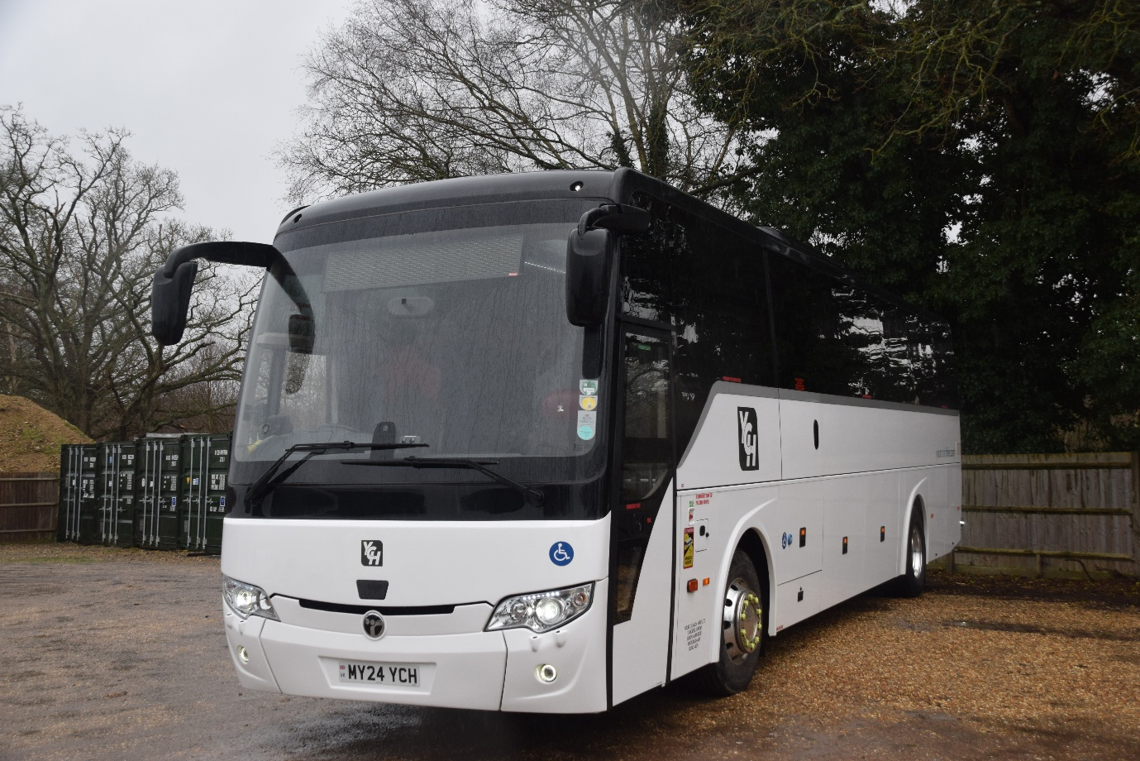
Photo credit to Gary Baxter Administration of Gary’s bus and coach photos: MY24YCH Temsa electric coach photographed at Model Farm coach depot in Wokingham. January 2025.
We have known the team at your coach hire now for year and are very good friends with them, and hopefully we will go and visit them again this year. They really did make us feel very welcoming and comfortable. This year saw them getting our sponsor calendar.
www.garysbusandcoachphotos.co.uk
www.facebook.com/groups/garysbusandcoachphotos

Photo albums of January 2026
Photo album date: | Photo Album Name | Photo Album link
1st January 2026 | Friends of King Alfred buses running day | https://flic.kr/s/aHBqjCFvk4
18th January 2026 | Bracknell | https://flic.kr/s/aHBqjCH6KR
Photo of the month
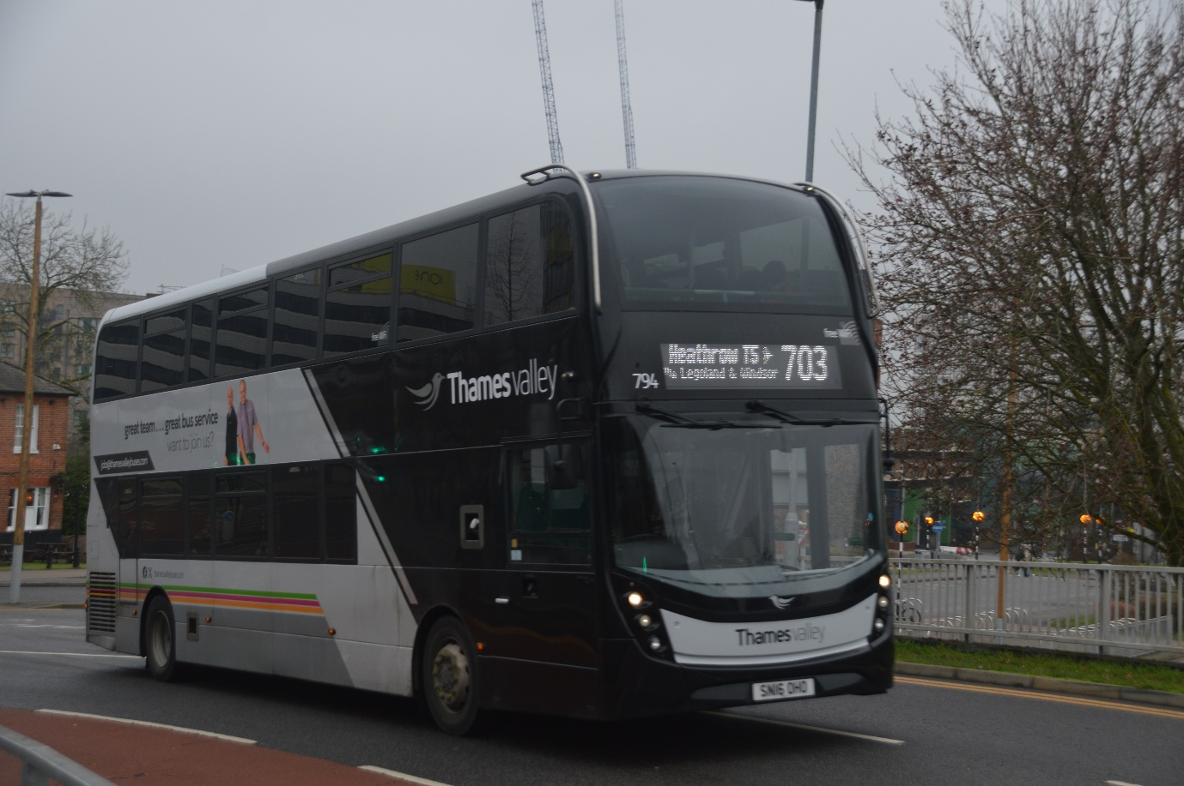
Photo of the Month for January 2026: Photo credit to Gary Baxter Administration of Gary's bus and coach photos: Thames Valley / ex Newbury & district 794 SN16OHO ADL Enviro400mmc on route 703 to London Heathrow Airport from Bracknell on the 18th January 2026 more photos from this can be found here https://flic.kr/s/aHBqjCH6KR
Facebook Group cover photo of the month
Places | Names
1st | Tracy Churchill
2nd | Mark Apcar & Barry Smith
3rd | Alan Lockey
Thank you to everyone who take part in this month’s Facebook Group cover photo competition of the month next month’s Facebook Group competition will be on the 6th, February 2026.
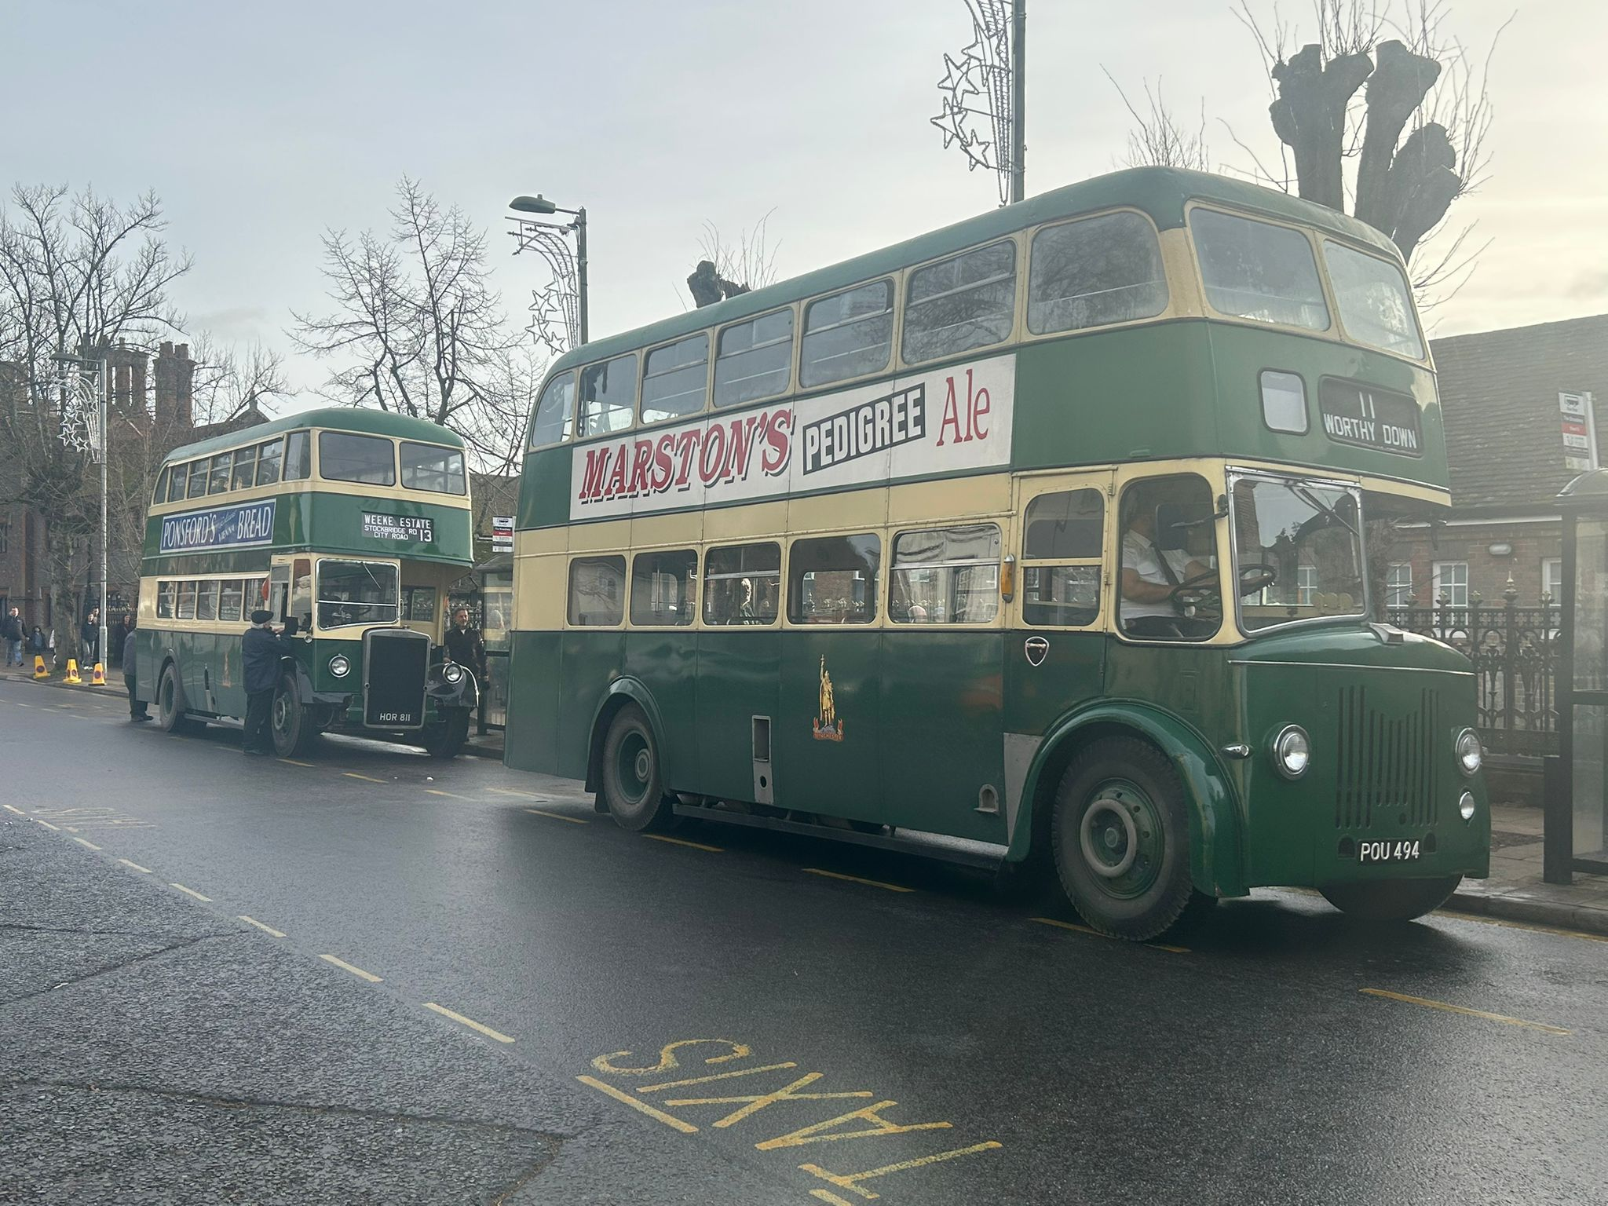
Photo above copyright to Tracy Churchill member of Gary's bus and coach photos: photo taken at the Friends of King Alfred running day on New Year’s Day in Winchester this is the Facebook Group Cover Photo Competition Winner for January 2026.
Worthing bus rally and running day
The worthing bus rally community after decades of running this event have taken it up on themselves to say goodbye to the Worthing seafront bus rally which used to take place the last weekend in July every year. This used to be a lovely event by the seafront with over 100-200 buses and coaches. This event did not take place in 2025 and in December 2025 saw a post from the organisers saying that the event will no longer take place or someone or another organisation can take it on. It was a hard decision for them to make I guess but when the time is up the time is up. This event has seen some many people try to organise this event and sometimes it is too much stress to worry about organising this event lovely though it was sometimes people must put they health before organising anything has stressful has organising this and events are not cheap to organise in this day and age especially in a cost-of-living crisis. Worthing bus rally will be remembered and not forgotten remembering all the good events and the bad events.
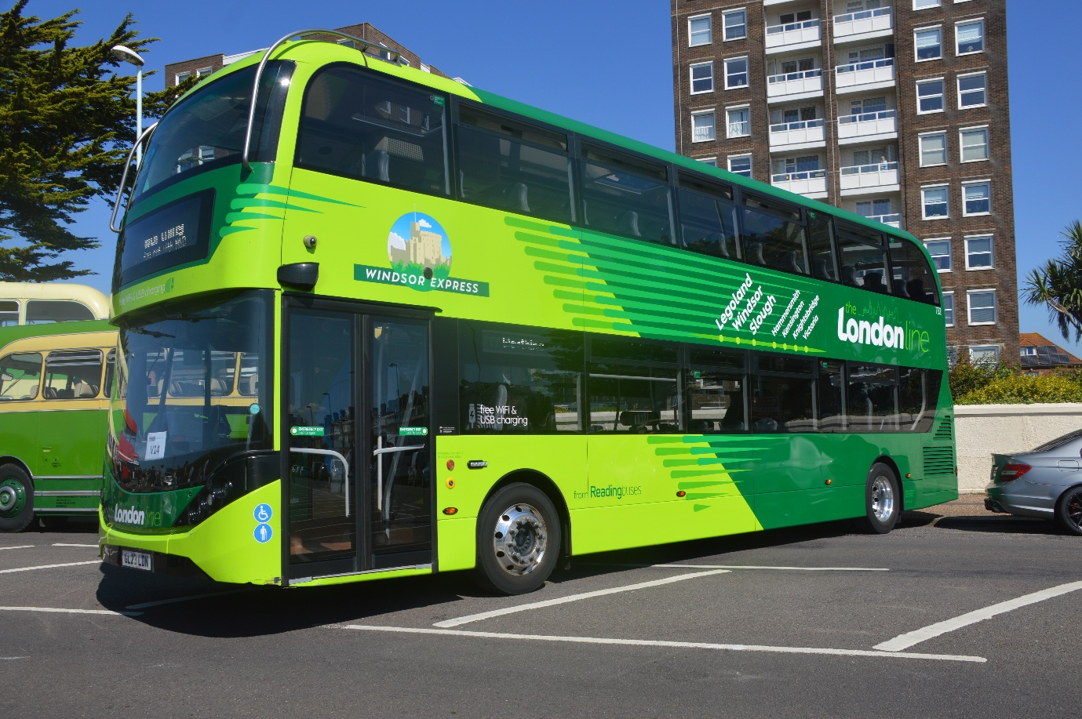
Photo credit to Gary Baxter Administration of Gary's bus and coach photos Reading buses London line 732 GL23LDN Londonline Windsor express at Worthing bus rally 2024.

Friend of King Alfred New year’s vintage bus running day
We attended at the friends King Alfred new years day vintage bus running day. We travelled to the event by train from Sandhurst to Reading then Reading to Winchester then had to walk down to the Broadway where the running day was taking place. This would see lots of enthusiasts taking rides around Winchester city. The day was cold but saw some lovely sunshine when it came to the early evening it was good to get some night shots of the buses and coaches on the running day. Photo album and video link: Photo album here https://flic.kr/s/aHBqjCFvk4 Video will follow.
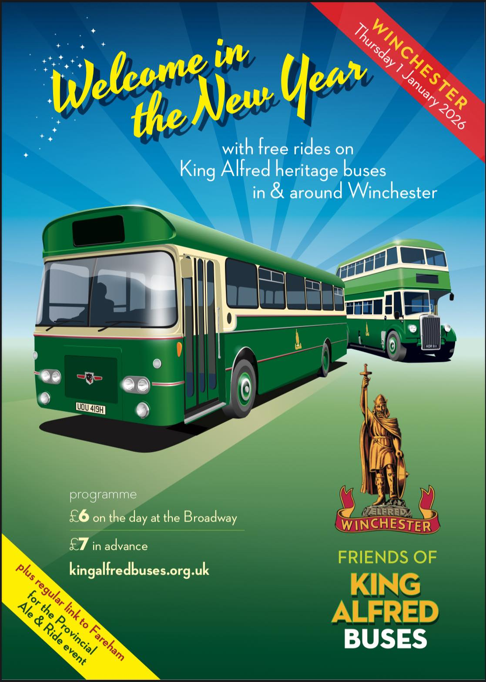
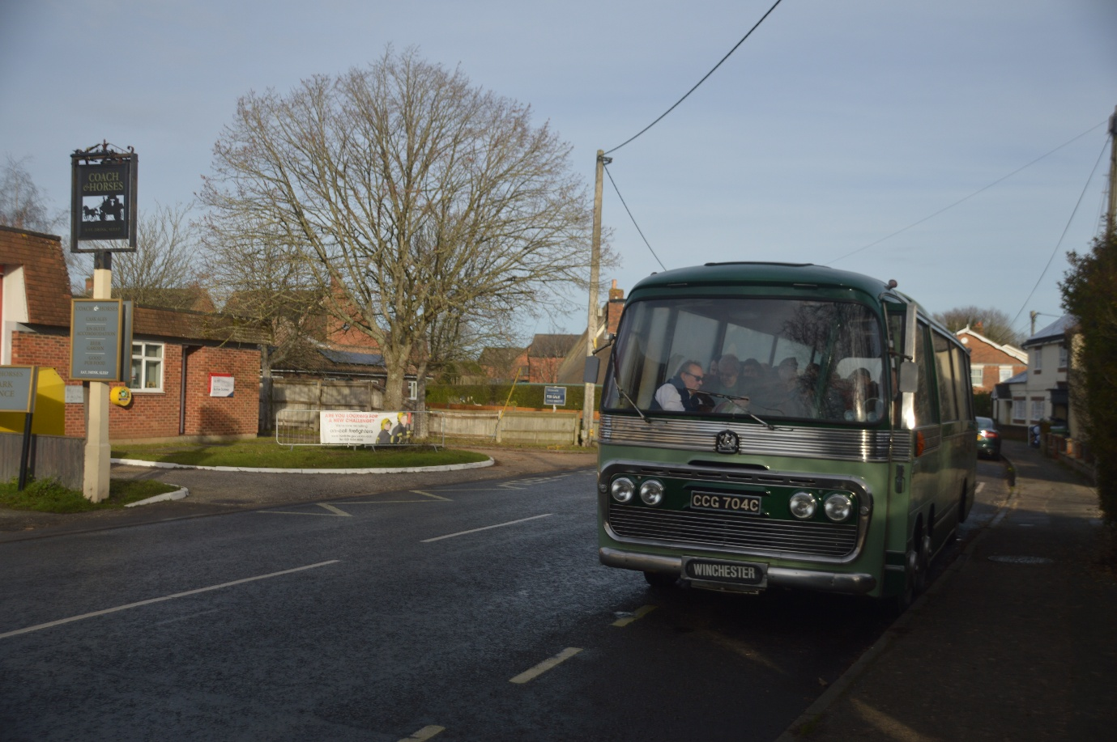
Photo credit to Gary Baxter Administration of Gary’s bus and coach photos: CCG704G Bedford Val on route 10 from Winchester to Sutton Scotney photographed outside the Coach and horses public house on New Year’s Day 2026.
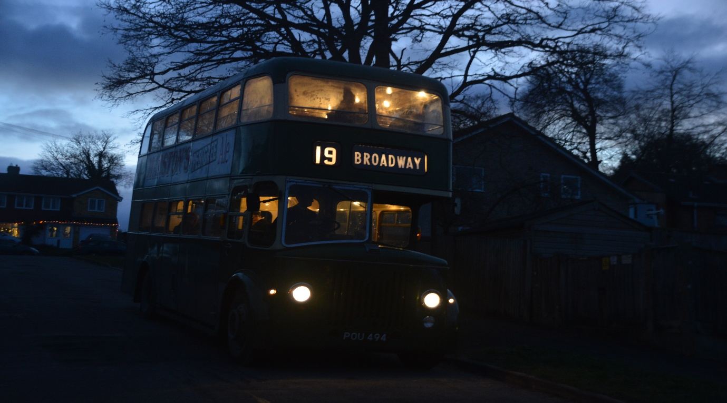
Photo credit to Gary Baxter administration of Gary’s bus and coach photos: POU494 photographed on route 19 from Broadway to Teg down Groveland’s RD. photographed just has the night / Evening was setting in, this was the last ride of the day.
Events
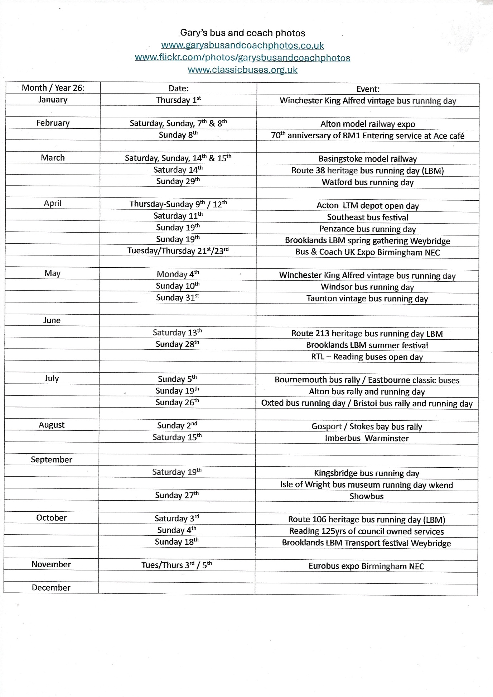
London bus museum & London Transport Museum & Depot
Month | Dates | Event / Museum
March | Saturday 14th | LBM route 38 heritage bus running day
April | Thurs-sun 9th & 12th | Acton Museum depot days
 | Sunday 19th | Spring Festival LBM Brooklands Weybridge
June | Saturday 13th | LBM Route 213-293 heritage bus running day
 | Sunday 28th | Summer festival LBM Brooklands Weybridge
July | Fri-Sun 3rd & 5th | Acton Museum Depot open days
September | Fri-Sun 18th & 20th | Acton Museum Depot open days
October | Saturday 3rd | LBM Route 106 heritage bus running day
 | Sunday 18th | LBM Autumn Festival Transport festival
While both museums are open daily, they have announced their special events for 2026 and these all announced in the grid below. The London transport museum is open daily in Covent Garden, but one museum is only open for special event this museum being the museum depot in Acton. All events announced in the grid below.

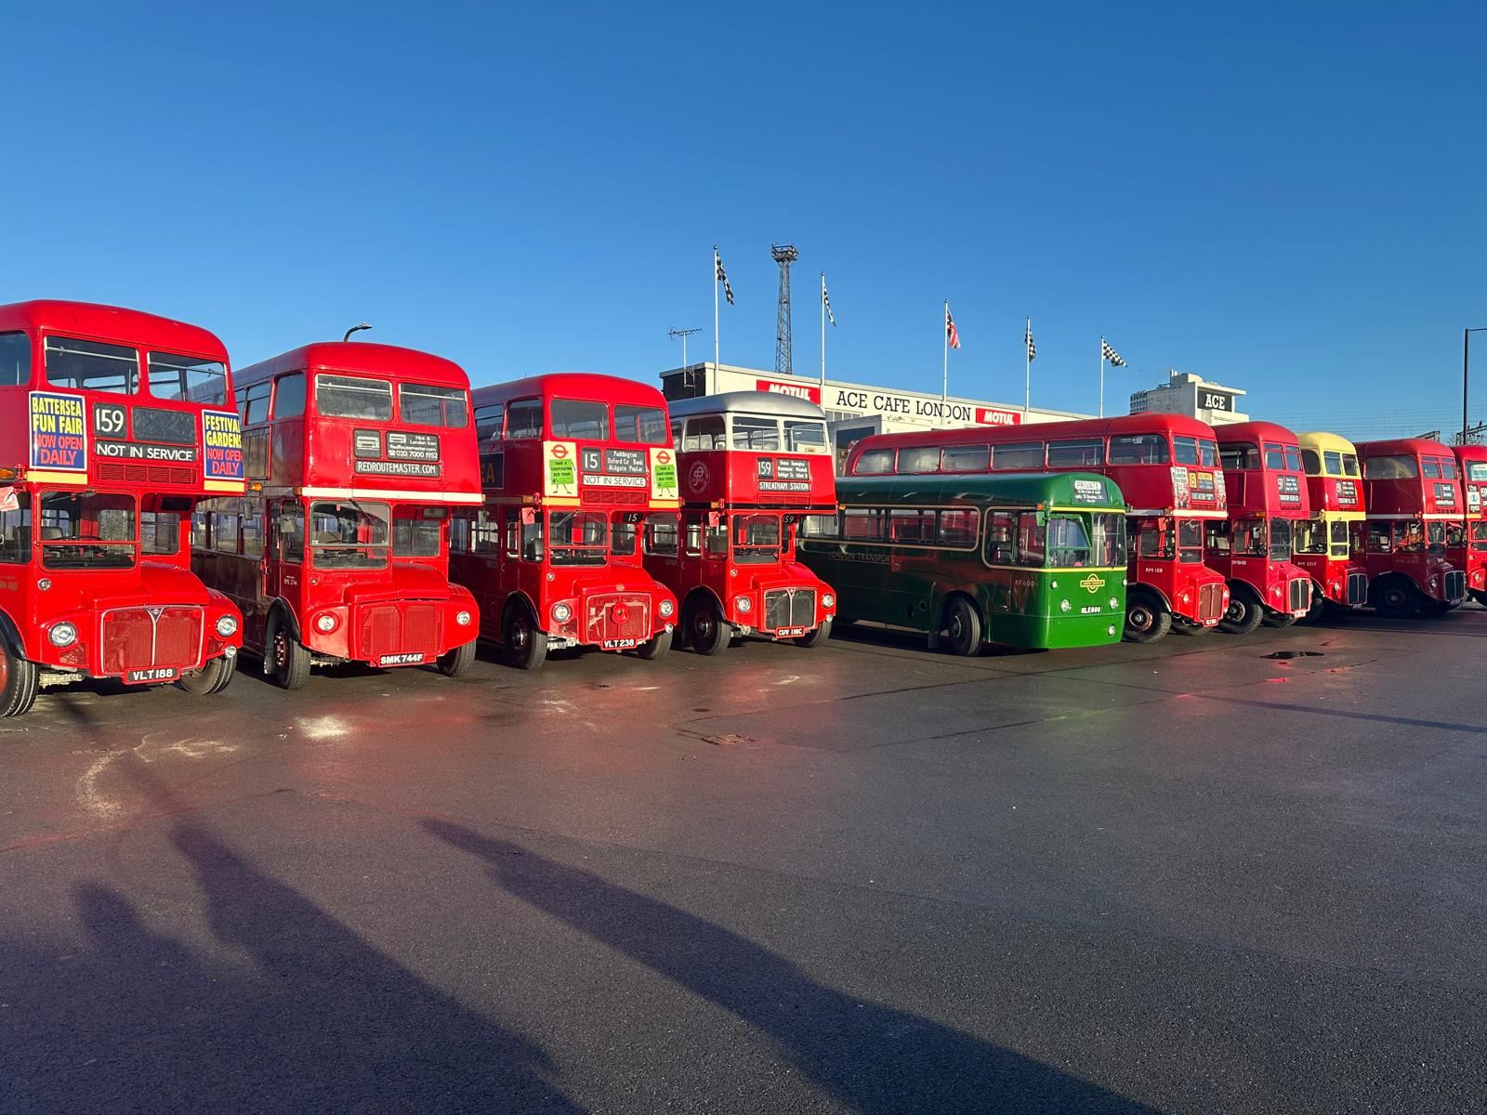
Photo credit to Gary Baxter Administration of Gary’s bus and coach photos: Routemaster's at Ace Cafe London Stonebridge December 2025.
Facebook Group Members Photos
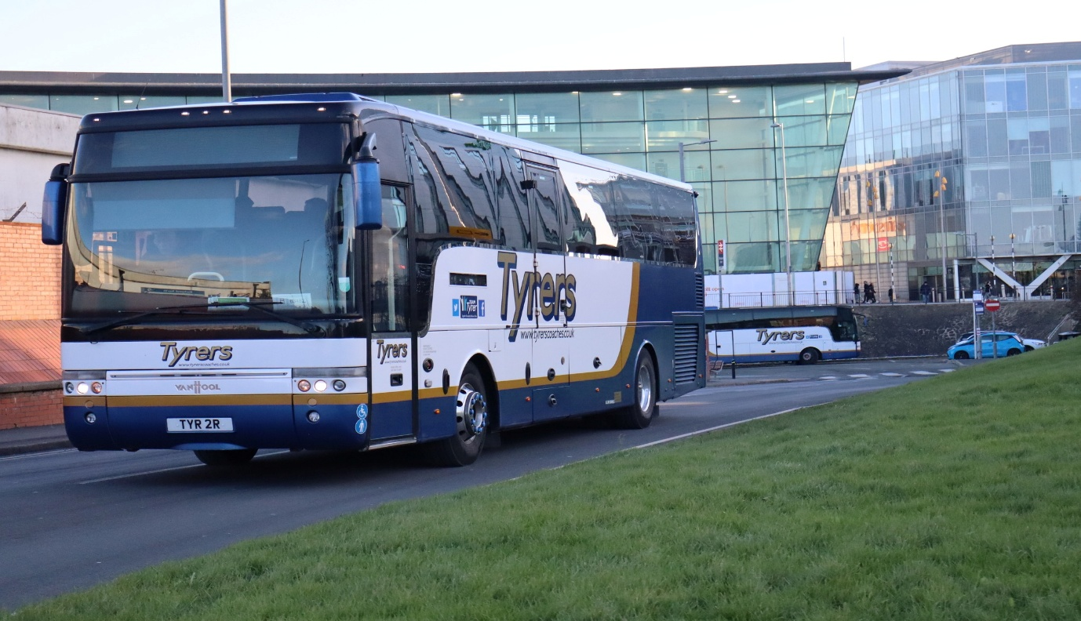
Photo credit to Alan Lockey member of Garys bus and coach photos TYR2R Vanhool Aliee T9 on Railway replacement in Blackpool for northern rail.
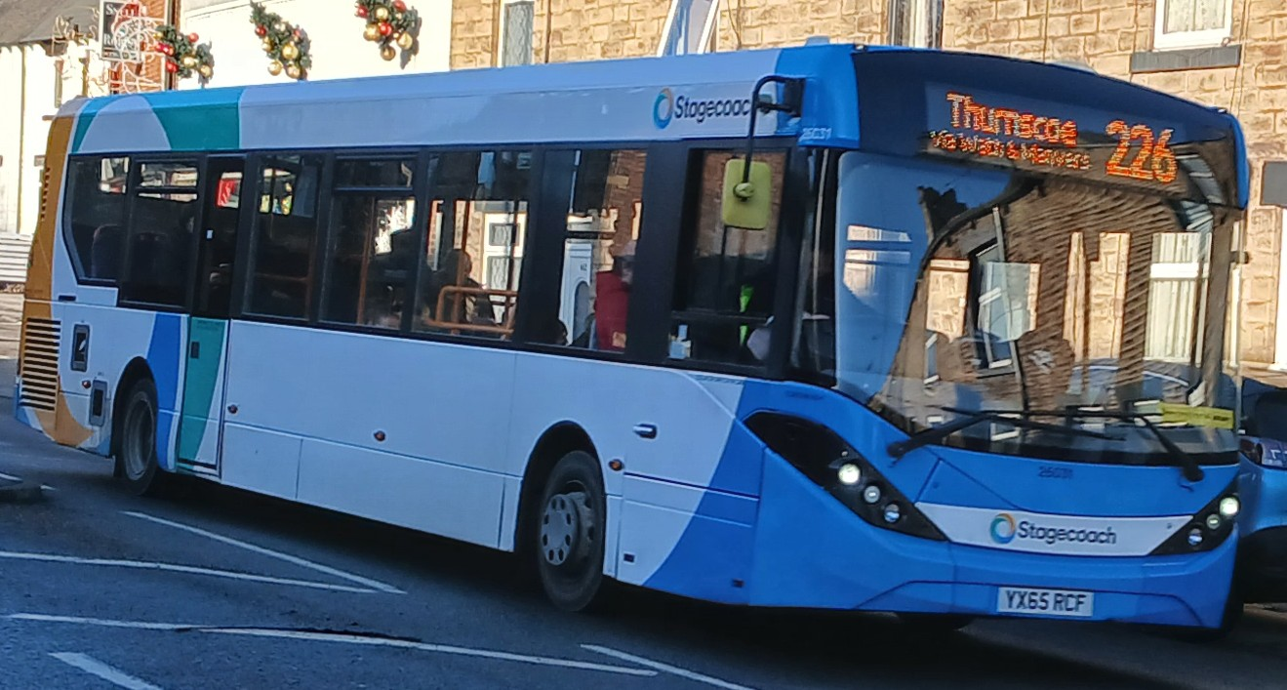
Photo credit to Barry Smith member of Garys bus and coach photos Stagecoach Yorkshire 26031 YX65RCF ADL Enviro200mmc.
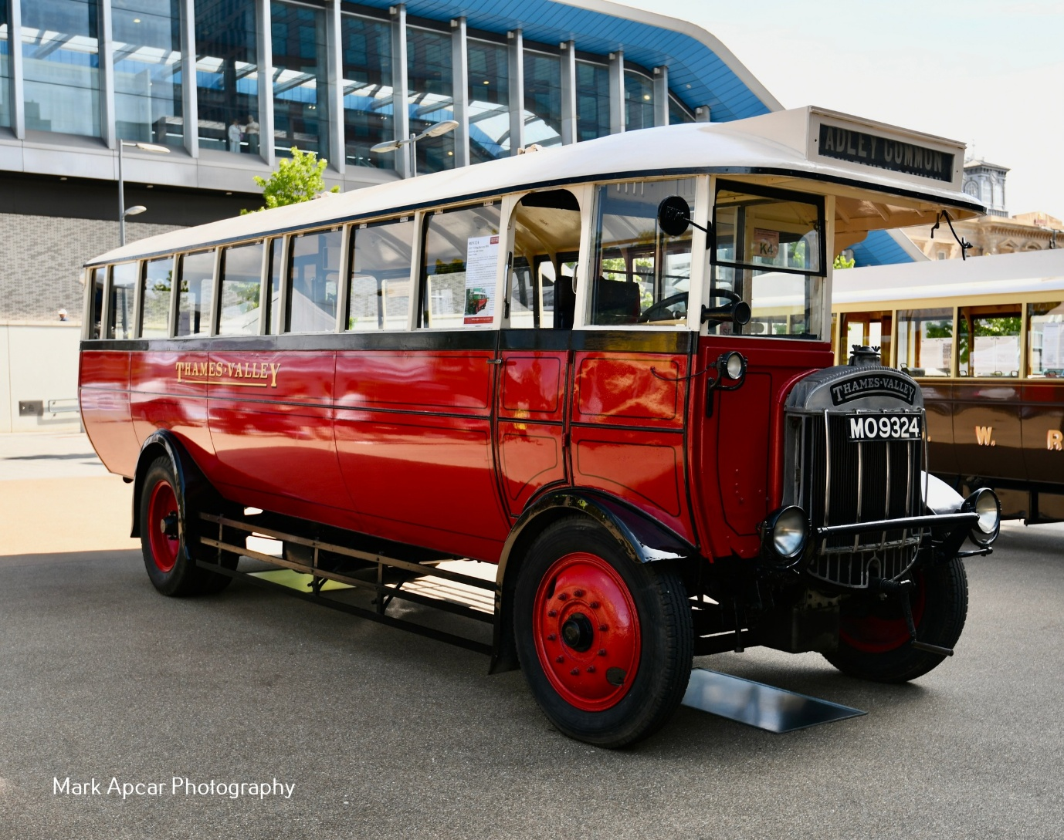
Photo credit to Mark Apcar member of Garys bus and coach photos MO9324 Thames Valley bus a Tilling Stevens B9A with brush bodywork.
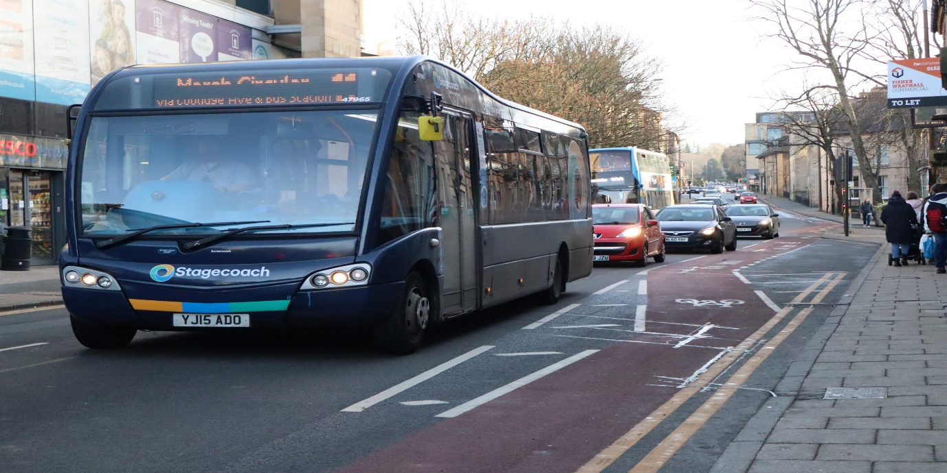
Photo credit to Alan Lockey member of GB&CP Stagecoach Blackpool 47965 YJ15ADO Optare-Switch Solo SR
Railway Replacement in Bracknell
This month we photographed are first goings and comings on railway replacement in Bracknell the Railway replacement was going from Staines to Reading. This time they were a good variety of buses and coaches on this especially one on standby in Bracknell bus station.
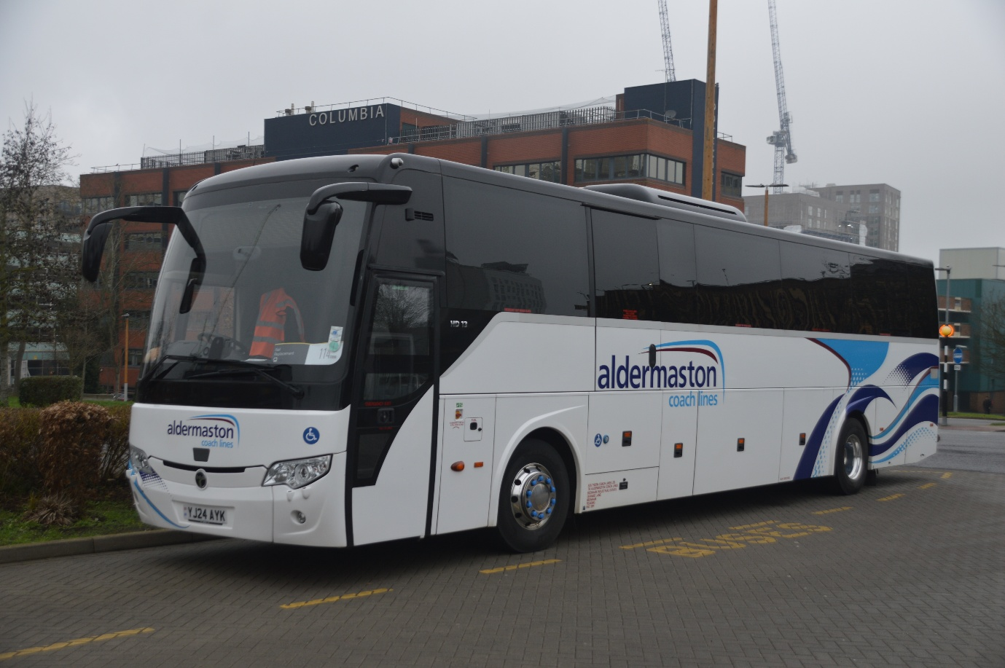
Aldermaston coachlines YJ24AYK Temus electric coach photographed on standby in Bracknell bus station on railway replacement for southwestern railway. Photo album from this link here https://flic.kr/s/aHBqjCH6KR on this day also was a good opportunity to photograph Sunday services in Bracknell which had not been done for a while.

News
Reading buses first or second bunch of Electric EV Enviro400’s is due to enter service on or around the 6th , February 2026 Ev’s were ordered for route 17,21,& 26 it is believed that these will enter service on the 6th, February 2026 all fingers and toes are crossed for these to be entering service round this date.
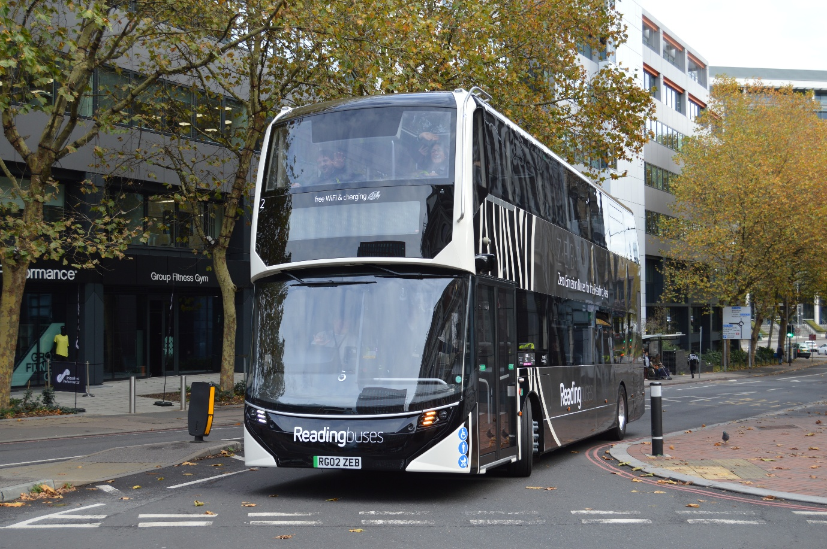
Fleet no RB2 RG02ZEB ADL Enviro400EV on trial in livery for Reading buses this is generic for any route within the borough of Reading.
Other photos from Flickr or Facebook Group
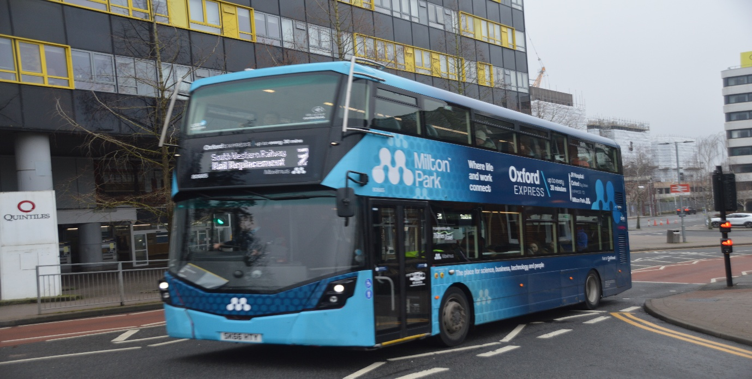
Photo credit to Gary Baxter Administration of GB&CP; GH,TT80665 SK66HTY Wrightbus Streetdeck on Southwestern railway replacement from Staines to Reading Sunday 18th, January 2026.
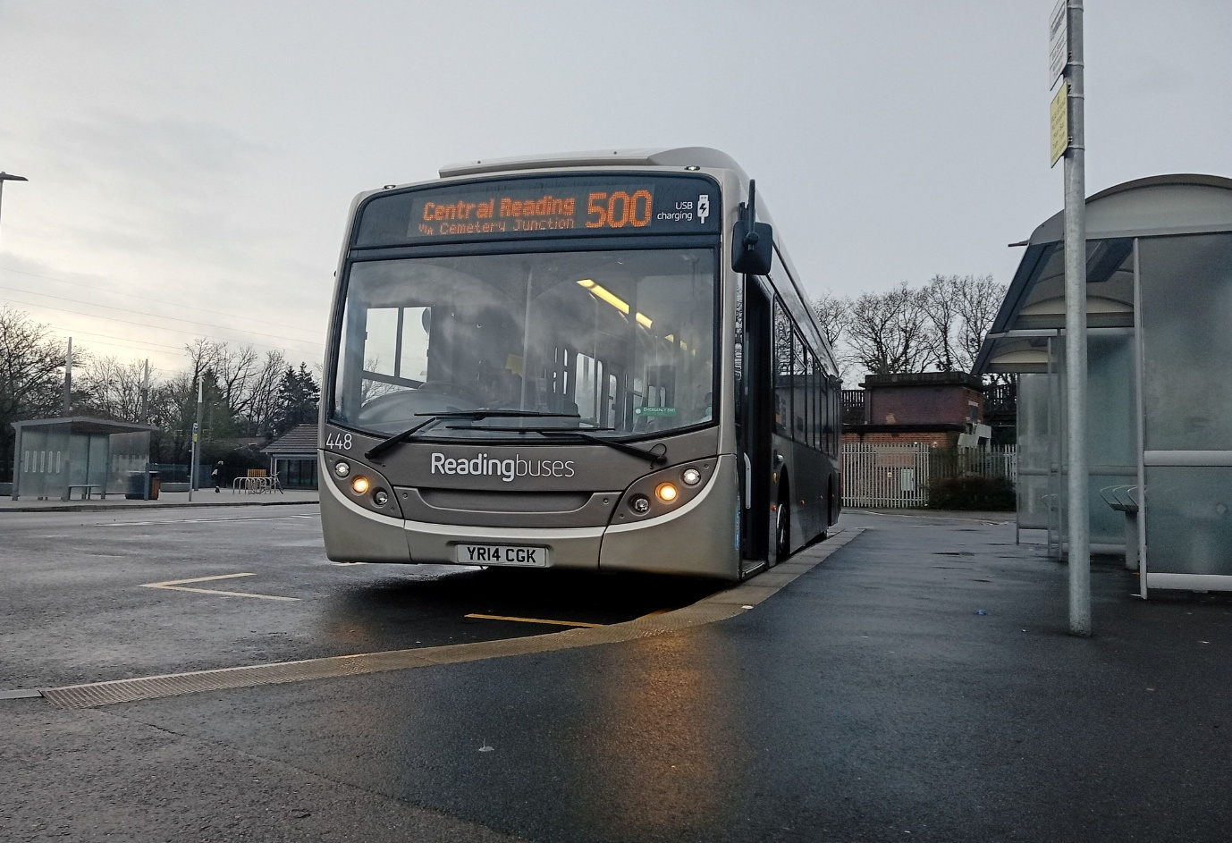
Photo credit to Katie Perry Smart RB448 YR14CGK ADL Enviro300 Gas bus photographed at Winnersh Triangle station on P&R 500 Reading buses.
www.facebook.com/groups/garysbusandcoachphotos
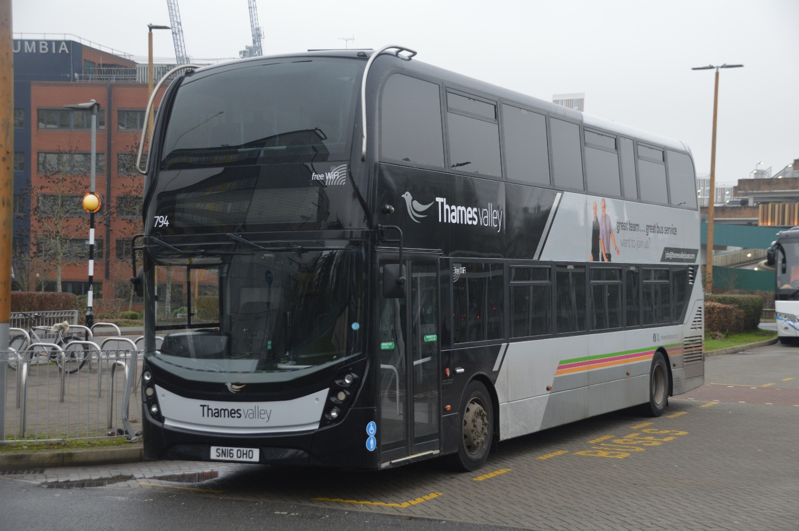
Photo credit to Gary Baxter Administration of GB&CP; TV794 SN16OHO Thames Valley ADL Enviro400mmc. This is a recent transfer from Newbury & district along with 788-93 for Reading buses.
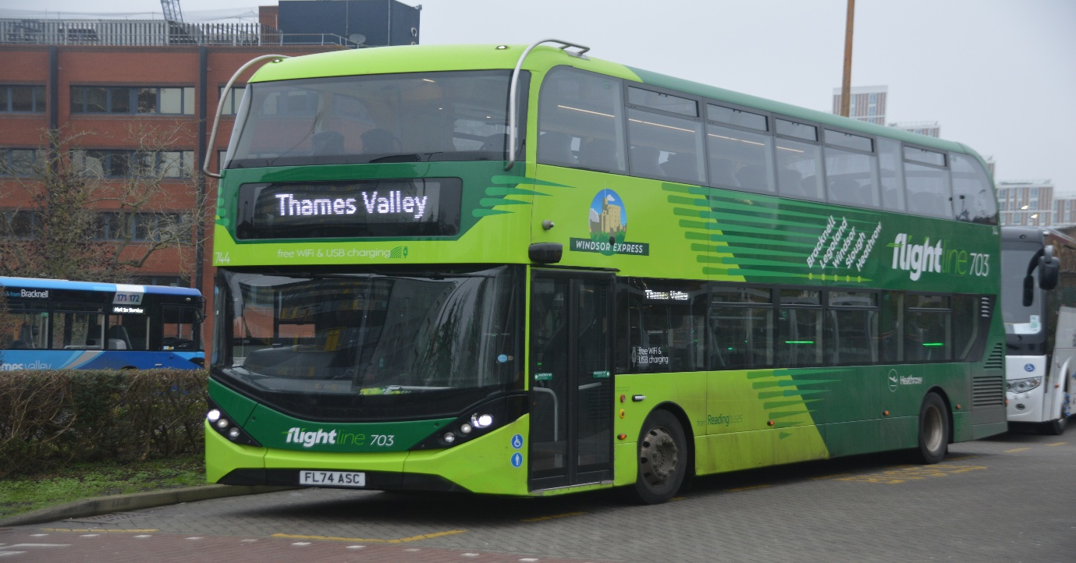
Photo credit to Gary Baxter Administration of Gary’s bus and coach photos: Thames Valley Flightline744 FL74ASC ADL Enviro400city on route 703 displaying Thames Valley on the destination blind a rear occasion this happens usually have Sorry!!! Not in service on the front. Photo taken 18th,January 2026
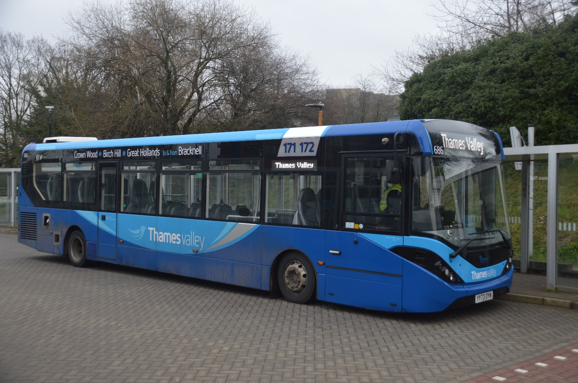
Photo credit to Gary Baxter Administration of Gary’s bus and coach photos Thames Valley 686 YY73OYN ADL Enviro200mmc branded 171/2 south Bracknell circular displaying Thames Valley on the destination blind unusually has this would normally have sorry!! Not in Service or 171 or 172 displayed ready for its next departure.

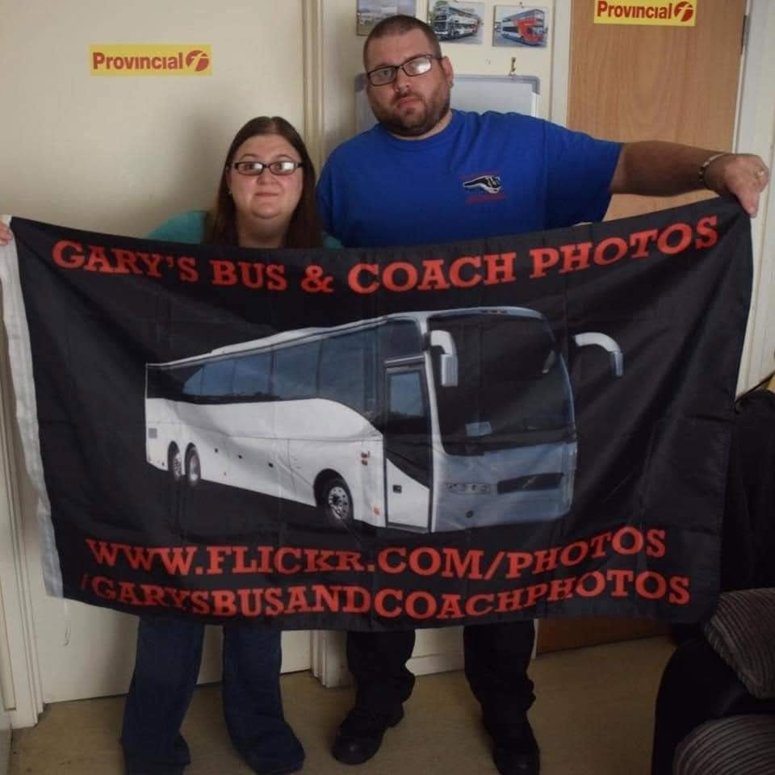
This year we celebrate running the Gary’s bus and coach photos communities for thirteen years we have come so far in that time, and it is all thanks to this lovely young woman next to me Dottie Rose Baxter for inspiring me to do this community. So, a big thanks goes to her and our supporters who enjoy receiving our calendars

