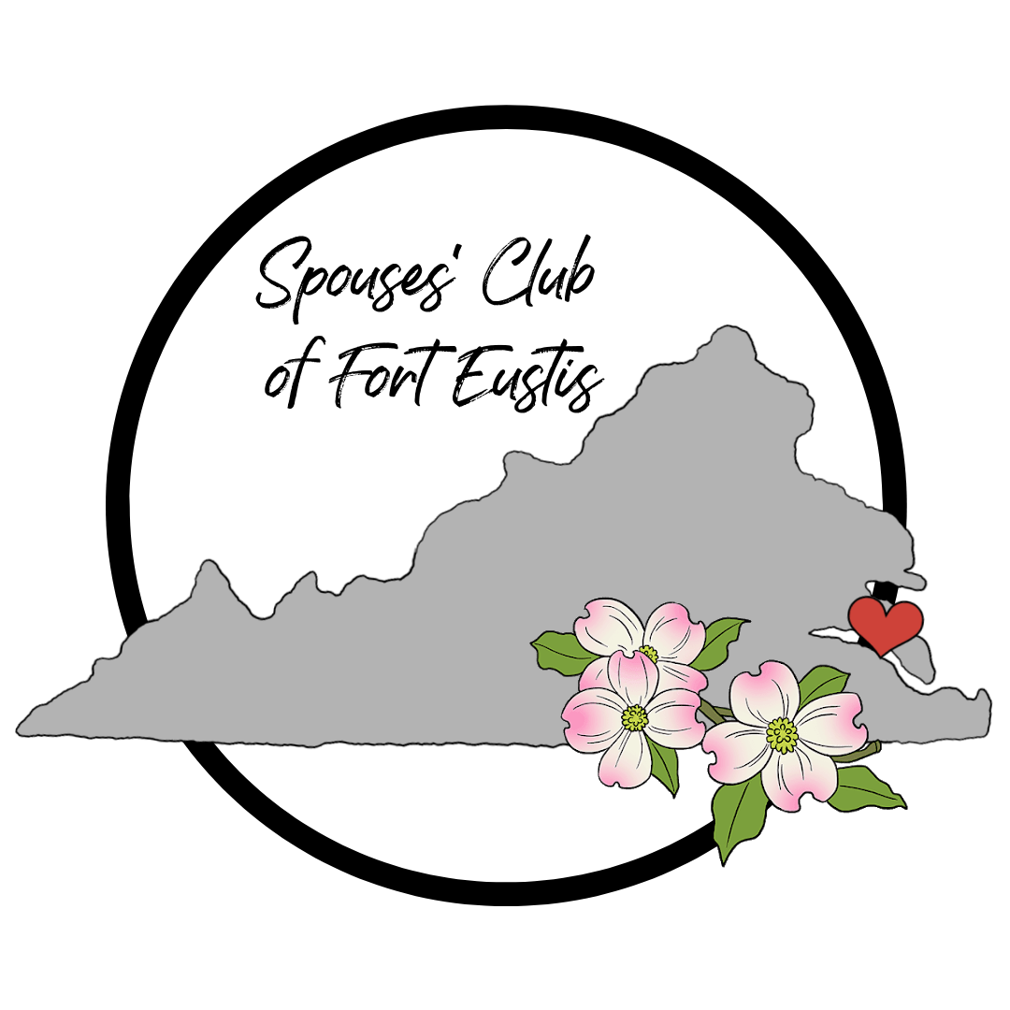

Spouses Club of Fort Eustis Scholarship Rules and Information

The Spouses Club of Fort Eustis (SCFE) has established a scholarship program for its members/members’ dependents/members’ spouses. These scholarships assist students as they further their education at the following levels:

- 2 year community college or 4 year university (online or resident)
- Graduate program
- Vocational/Trade school (DOES NOT INCLUDE Continuing Education CEUs)

SCFE scholarships are awarded based on educational performance, character, and service to community such as through participation in extracurricular activities and community service and references.

Applicants may be considered for a Scholarship of Resiliency & Determination, hereafter referred to as the SCFE Dogwood Scholar Award. The American or flowering dogwood is the state flower of Virginia; it was selected in 1918 and was selected for its resiliency and strength. This scholarship award seeks to honor students who have shown resiliency and determination in their educational journey, regardless of past challenges. This award may be granted annually at the discretion of the scholarship committee, based on the applications received.

Applicants who receive a “full ride” scholarship (covering tuition, room and board), ROTC scholarship, or who receive an appointment to attend a service academy must withdraw their application and forfeit any SCFE scholarship upon notification.

Scholarship Committee will:

- Review all applications anonymously and maintain confidentiality at all times.
- Determine dollar amounts awarded based on availability and advisement of the SCFE Treasurer and Scholarship Chair. The exact number of scholarships is also to be determined.
- The Scholarship Committee reserves all rights regarding the review and selection process. All decisions related to applications are final.

All questions and comments should be directed to the SCFE Scholarship Chair at scfescholarship@gmail.com.

