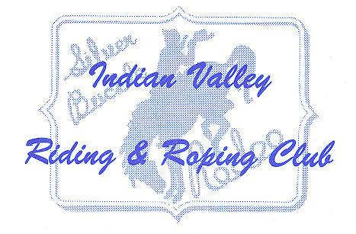
IVRRC ~ 2026

Most Meetings: Potluck @ 5:30/Meeting @ 6:00

April 1 6:00pm Meeting Only - No Potluck
April 26 10:00am Workday

May 5 3:00pm Cinco de Mayo 4-H
May 6 6:00pm Potluck/Meeting - Mexican Theme, Queen Applications Due
May 18-19 All Day Antelope Work Crew – Arena Closed During Days
May 30 10:00am Workday, Queen Practice

June 3 6:00pm Potluck / Meeting – Italian Theme
June 6 5:00pm Queen Practice
June 14 2:00pm Workday
June 14 5:00pm Summer Series Playday #1 - Moved to June 26th
June 17 5:00pm Queen Practice
June 23 5:00pm Queen Practice (optional)
June 26 5:00pm Royalty Competition/Summer Series Playday #1
June 27 9:00am Workday - Meeting
June 28 8:00am Obstacle Challenge
June 30 5:30pm Final Prep/Meeting for July 4 Rodeo & Ropings, Membership Due
July 1-3 All Day Jackpot Roping Club Members Need to Work
July 4 9:00pm 4th of July Dance at the Taylorsville Hall
July 4 All Day Parade & Rodeo- Club Members Need to Work
July 5 All Day Jackpot Roping Club Members Need to Work
July 6 9:00am Garbage Sweep of Arena/Clean Cookhouse
July 31 5:30pm Summer Series Playday #2

Aug. 5 6:00pm Meeting - Potluck - Chinese
Aug. 7-9 All Day Club Campout? – Location TBA
Aug. 12 9:00am Workday
Aug. 13 5:00pm Junior Rodeo Prep
Aug. 14-15 All Day Junior Rodeo
August 16 9:00am Garbage Sweep of Arena/Clean Cookhouse

Sept. 2 6:00pm Meeting - Potluck- TBD
Sept. 26 All Day Poker Ride
Sept. 26 All Day Frontier Days
Sept. 27 10:00am Workday/Clean-up

Oct. 7 6:00pm Meeting- Potluck-Appetizers & Desserts
Oct. 25 10:00am Winterize (Weather Dependent)

Nov. 4 5:00pm Summer Series Awards (Taylorsville Hall)
Nov. 4 6:00pm Meeting- Potluck Casserole & Soups
Nov. 16 4-6:30pm Community Supper (Taylorsville Hall)

Dec. 12 5:30pm Christmas Party – Chair: Megan Neer

