**“Go ye into all the world, and preach the gospel to every creature” – Mark 16:15**

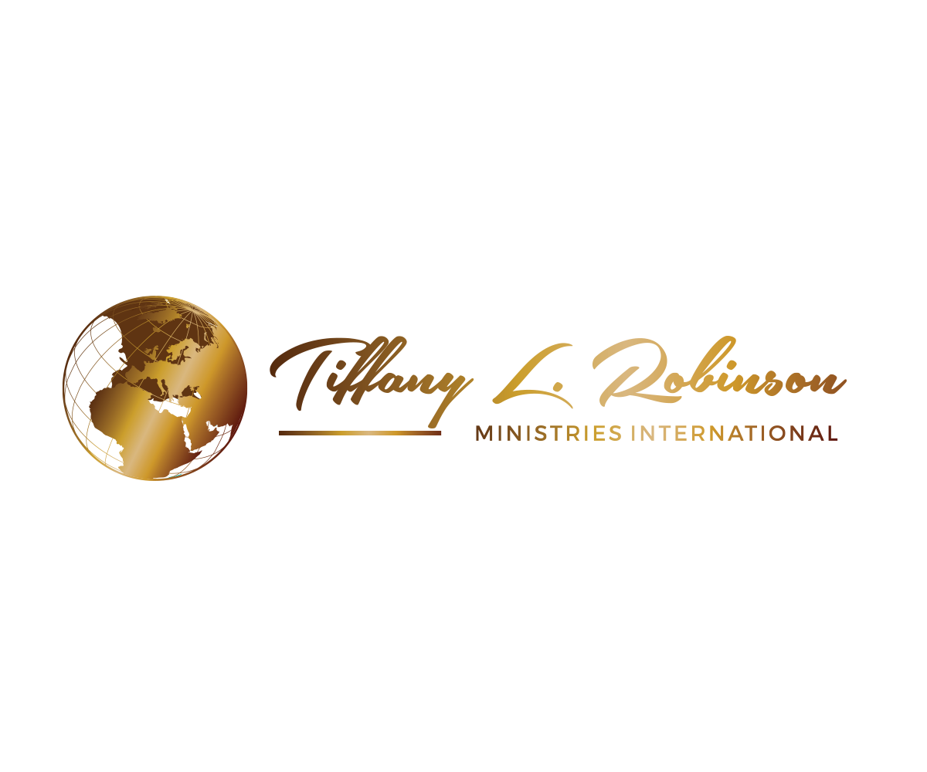**Prayer Confession for**

**TIFFANY L. ROBINSON MINISTRIES INTERNATIONAL**

**(Tiffany Robinson Ministries)**

Father as a “Covenant Partner”, I come boldly to the throne room of grace to intercede, on behalf of the vision for Tiffany L. Robinson Ministries International (TLRMI). I thank you that through prayer and partnership, we are reaching the four corners of the earth on a global scale with the gospel of the Kingdom of God. We are changing lives and transforming communities, through the word of God, impacting the spirit, soul, and body of man.

Father, I thank you that your chosen vessel, Tiffany L. Robinson, will hear the voice of the Holy Spirit. Father, I declare that the doors of utterance are opened to Tiffany L. Robinson world-wide to proclaim the Good News of Jesus Christ with signs and wonders following. She will speak the word of God and her preaching shall be seasoned with faith under the direction of the Holy Ghost.

Father, I decree that you make the way prosperous and cause this ministry to have great success in all of its endeavors. Thank you for supplying every need of the ministry according to your riches in glory by Christ Jesus. I declare that you have made all grace abound toward this ministry that it has all sufficiency in all things that it abounds to every good work and charitable donation.

Father, I thank you for providing this ministry with all of the resources needed to effectively share the word of God. I decree and declare that all audio broadcasts, conferences, internet and outreach endeavors, printed materials, speaking engagements, and teaching materials for the ministry are done in excellence. I declare that this global ministry is expanding exponentially and impacting billions of lives with the Gospel of Jesus Christ.

Father, I decree that millions of “Covenant Partners” are being added to Tiffany L. Robinson Ministries International daily from all over the world. Believers are uniting with the vision and faithfully supporting the building of the Kingdom of God through this ministry. An abundance of souls are coming into the Kingdom where they are taught that God is their only source. Believers are learning how to live independent of the world’s system. The Body of Christ is rising up and taking their rightful place of dominion as Kingdom Ambassadors in the earth realm.

Father, thank you that my covenant partnership enables me to partake in the same anointing, divine favor, earthly and spiritual blessing, abundant grace, and supernatural increase that is upon Tiffany L. Robinson Ministries International. I declare that the blessing of Abraham is on my life and the life of this ministry and together we are changing the world forever. In Jesus Name, Amen!