Optimist
Photography
Contest

The Optimist Club of Miami Lakes (OCML) is pleased to promote its newest contest for the youth in our community – The Optimist Photography Contest! Rules, instructions, and entrance forms can be found below. The last day to enter is Sunday, August 16th, 2020.

iMagine Highlighting “The Optimist Creed”

We are looking for youth photographers for our contest of any age up through high school and prior to postsecondary education. Students are asked to submit photos that illustrate/exemplify one of the ten verses/lines of “The Optimist Creed”.

Rules
1. This contest is open to any student from elementary through high school.
2. OCML will select three (3) winning photos to be identified as a 1st, 2nd, and 3rd place winner. The prizes are all gift cards worth $100 for 1st place, $75 for 2nd place, and $50 for 3rd place. All contestants will receive a certificate of participation and points toward the Roland Gomez Scholarship Award.
3. Photos will be judged for the photography quality and for how well the photo illustrates/exemplifies the verse of the Optimist Creed, which is identified on the photo mat frame.
4. Photos may be any of these sizes: 4” x 6”, 5” x 7”, or 8” x 10”, black and white or color photo. NO photo-shopping enhancements should be used other than basic cropping of the photo.
5. Photos should be matted, with “The Optimist Creed” verse/line stated clearly on the front of the mat frame, so judges will know what the photo is to exemplify. The photographer’s name and other identifying information, including the entry form should be attached to the back.
6. Each contestant may submit up to three (3) entries. However, no contestant may be awarded prizes for more than one photo.
7. Contest winners will be by a ballot vote of the judges (one ballot per person), the votes will be tallied with a weight of 5 points for a first place vote, 3 points for a second place vote, and 1 point for a third place vote, with the highest vote totals being awarded the prizes. Depending on the number of photos submitted, some adjustment to the procedures may be required in order to clearly establish the top three photographs.
8. Drop off entries at the Miami Lakes Sports Shop 6811 Main St, Hialeah, FL 33014 between the hours of 10AM and 7PM.
9. If there are any additional questions, contact the Chairperson for the contest.
10. RULES AND DATES ARE SUBJECT TO CHANGE.

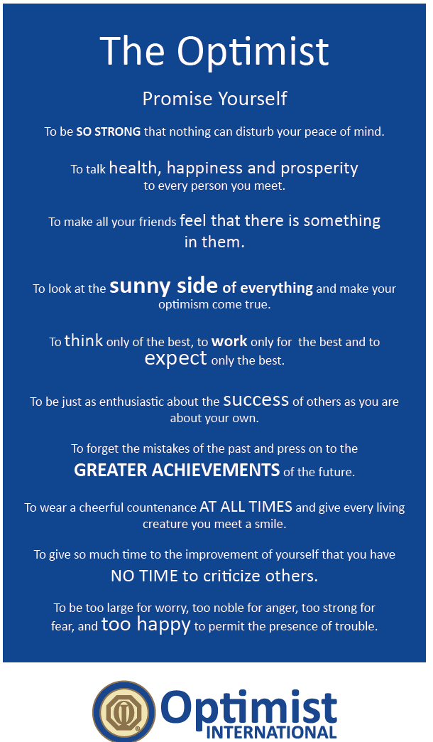

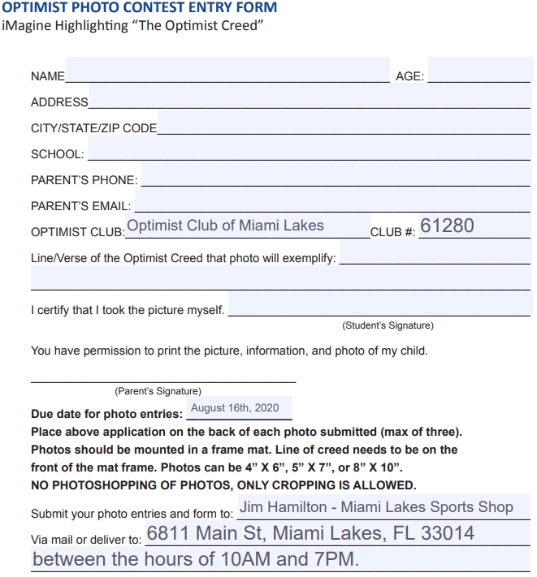

Photos should be matted and include the Optimist Creed verse that inspired the photo.

