Time | Monday | Tuesday | Wednesday | Thursday | Friday | Saturday
4:00-5:00 | Pre- Ballet | Primary  Gymnastics | Pre- Ballet | Pre-Primary  Gymnastics | Hip Hop | Flamenco Adult  10:00-11:00
5:00-6:00 | Pre-Primary | Primary | Primary | Pre-Primary | Musical  Theater | Flamenco Kids  11:00-12:00
6:00-7:30 | Level I &II  Contemporary | Level II  Pointe | Level I  Pilates | Level II  Partnering |  | Level I & II  12:00- 1:00
7:30-8:30 | Adult  Contemporary | Adult  Beginner | Adult  Technique | Adult  Intermediate
8:30-9:30
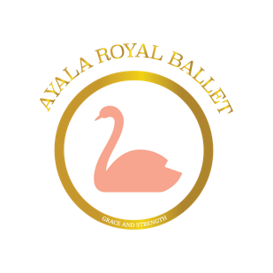
Royal Schedule

Children’s Program Pricing
Level | Age | Hours a week | Registration | Monthly Tuition
Pre-Ballet | 3-4 | 2 | $100 | $150
Pre-Primary | 5-6 | 2 | $100 | $150
Primary | 7 - 9 | 3 | $100 | $175
Level I | 10 - 12 | 4 | $100 | $195
Level II | 13 - 15 | 5.5 | $100 | $250
Extra Open Class | All Ages | 1 | - | $50

August 2019 to June 2020 - 45 weeks, with a winter break of December 21st to January 3rd

