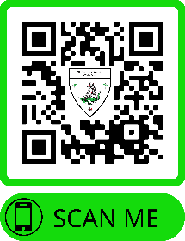

PO Box 783, Palm Beach, FL 33480 **SGSofPB.org**

**Couples Member Application Form**

Name (Last, First, MI): ___________________________________

(Last, First, MI): ___________________________________

Mailing Address: _______________________________________

_______________________________________

Telephone number: ____________________mobile ___________________mobile

Email: __________________________ ___________________________

Place of birth: _____________________ ___________________________

Occupation: _______________________ __________________________

How did you hear of the St. George’s Society? ____________________________

Check any of the following in which you may be interested:

_____Socials _____Social Media

_____Special events _____Increasing membership

_____Executive board _____Green initiatives

_____Other: _____________________________________

By signing, I acknowledge that I desire to be a member of the St. George’s Society of Palm Beach, further the aims and objectives of The Society, and attest that I am of: English birth, English origin, English descent, or am an Anglophile.

______________________________________ (Signature)

______________________________________ (Signature)

Current membership initiation fees are: $100 for individual adults (18 and over), $125 for couples, and $50 for junior members (0-17 years). Annual dues are $75/100/25 respectively. Your check must be included with the application and be made payable to **St. George’s Society of Palm Beach**. *Membership runs on a calendar year (January through December), and our schedule of events runs on a social year (October through April).* Fees will be as above regardless of join date, unless you join in November or December—then your dues will cover you through the following year.

*updated 10-20-2022