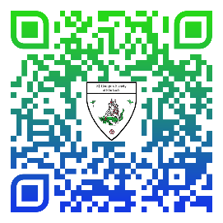

PO Box 783, Palm Beach, FL 33480 **SGSofPB.org**

**Associate Application Form**

Name (Last, First, MI): ___________________________________

Name (Last, First, MI): ___________________________________

Mailing Address: _______________________________________

_______________________________________

Telephone number: _______________________________________ (mobile only)

How did you hear about our Society: _____________________________________

How are you able to support the St. George’s Society of Palm Beach:

_____ Donations _____ Referring members Other: _______________________

By signing, I acknowledge that I meet the requirements to be an Associate member of the St. George’s Society of Palm Beach.

______________________________________ (Signature)

______________________________________ (Signature)

Associate members will be eligible to attend all events at non-member pricing, even events closed to all but members. There is no mandatory attendance. Associate membership fees are $25 per person per calendar year. *This is a donation.* Your check must be included with the application and be made payable to **St. George’s Society of Palm Beach**. Mail to the Society post office box listed above.

A copy of the official registration and financial information for our Society, number CH 23362, may be obtained

From the Division of Consumer Services by calling Toll-Free (800-435-7352) within the State. Registration does not imply endorsement, approval, or recommendation by the State.

On September 10, 2009, the Internal Revenue Service approved our 501(c)(3) application as a public charity. Proof of charitable status is available upon request. All contributions to the St. George’s Society of Palm Beach are tax deductible in accordance with section 170 of the Code.

*updated 10-19-2023