What’s happening in the Shed

Quarter 3 seemed to fly right past, busy with my fulltime job made it a little harder to get into the shed for some quality smithing time. Finished the Treadle Hammer and converted the plans to Metric, just need to put the final touches on the drawings and will send them off to ABANA for them to review and make available if they see fit. You can still buy imperial steel in Australia but sourcing the springs and leaf springs are more challenging hence the conversion to metric.

Made some modifications to the power hammer and added a wear plate to the back to help guide the hammer on the fall so if there is an odd shape that is being ‘massaged’ then it doesn’t kick the hammer off back or forwards. The rollers do a great job but this was an extra to provide some support. Ran the airlines inside of some PVC along the walls to neaten up the runs and minimise trip hazards and hot scale melting the lines.

One of the fellas at works’ son has decided to give blacksmithing a bash so I made him up some wolfjaw tongs and gave him my old original leg vice, a little 3-1/2” jaw that will get him started.

Rugby League fixtures – well it’s over and made my way off the bottom, we didn’t do the finals tipping but ended with 266 tips which a PB for me. Now we move into cricket season, looking forward to having it playing in the background while in the shed.

New Products
- Rail spike – shoe horns have been on the development and have come off pretty well, modest I know. They will become a product line moving forward but I’ll need to develop the handles a little more to extend the length of them for the less flexible crowd.
- Been making hooks out of the old D-Shackles that seem to turn up on our corner of the street on a semi regular basis, no pins just the D, fun little item while I wait for the forge to come up to heat

Refurbishing Updates
- Not much happened in this space this quarter just some odds and ends, old screw drivers, files etc that needed some TLC and new handles.

Product/Tool Developments
- Made some new dies for the power hammer to allow some consistency of thickness with 12, 14 and 20mm kiss plates/bottom dies which are proving worth the time to make especially with drawing out handles and converting some wrought iron odd shapes into square bars.
- Working on some wrought iron to make some split crosses

Product Reviews
HAFCO Metalmaster BS-7L 2020 model Band Saw is the quarterly review.
This has been a great addition to the shed and has performed countless cuts over the past 4 years. If you keep the coolant up to them and use the correct blade for the cut size then the blades last for ages. They do struggle on high carbon steel but I use the abrasive drop saw if that is needed, just need to be aware of the heat affected zone if using the abrasives.
I got put onto Pask Makes and saw his version of the modification to the band saw, I adopted a few of the suggestions and modified them to suit this saw. The link to his youtube video is below.
Transforming a Budget Machine into the Ultimate High-End Tool
I did at one stage have the guide and ruler on the outlet of the saw but as I cut odd shapes I had to keep removing it so ended up not putting it back on. The addition of the plate on the outlet side is a great addition as is generally catches the cut offs and minuses splashing. The coolant feed rate is adjustable by the tap and by doing so you can keep it on the blade and not have it splash everywhere.
I use the white soaker pads around the machine to catch any spills. When I built the shed after the concrete cured I coated it with a sealant so this also help preventing the concrete from absorbing the oil.
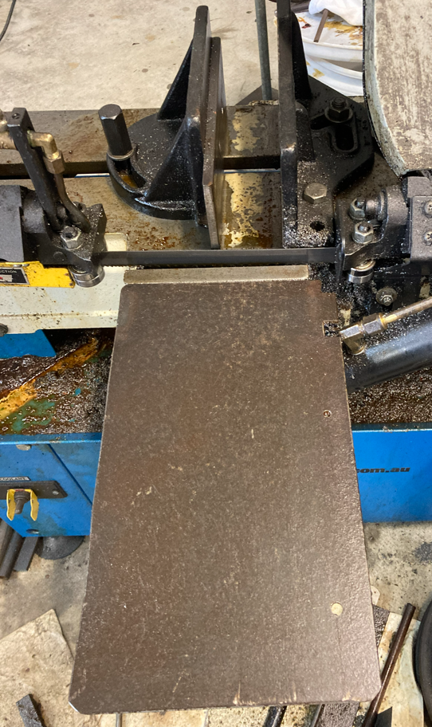

I have been using it in the vertical very little but did end up making a table for it then I did some further modifications on the horizontal which then threw out the set up for the vertical. That is why there is an extra cut on the plate as I had to move it to the left about 20mm. I have made an adjustable fence to make straight cuts allot easier. I don’t run the coolant in the vertical but do use the brush to prewet the parts with coolant.
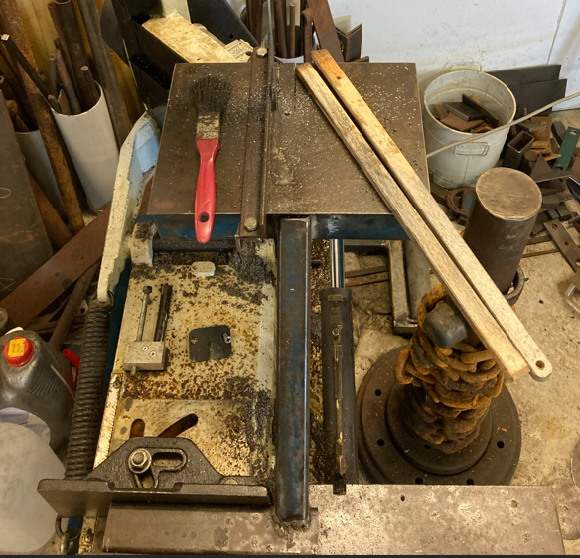
The coolant is a water soluble oil that I just top up with filtered water. The adjustable legs on the unit were very light duty and only spot welded so I added a washer and nut on the bottom to help support the load.
Words of advice –
- Never cut timber on the saw as the sawdust blocks up the strainers and is a pain to clean up.
- Use a push rod/stick -like I have pictured when using it in the vertical
- Always use coolant
- File the burrs off the edges as soon as you have finished the cut to prevent cutting yourself at a later date.
- Make a habit of cleaning the strainer and tray so the tray doesn’t overflow.
- Use bimetallic blades
- Don’t put too much force on the blade – ie slow down the drop rate of the arm if its bouncing then there is too much feed rate if its skipping then it is too slow.
- Set the wire wheel so it helps clear the cutting prior to it getting to the drive pulley otherwise you get build up inside the shroud.

What’s Catching my Attention on Youtube/Instagram
Started following/watching:
- HAL Heavy Duty Machining Australia – some really heavy metal work
Still staying in touch/up to date with:
- Keith Rucker from Vintage Machinery
- Curtis from Cutting Edge Engineering
- Dave from EngelsCoachShop
All great watching on the progress of their projects and new gear coming into their shops for their special touch.

Update on Touchmark Register
- No takers so far but have populated a few with tools I have that dated back to the early 1920’s as the touchmark register is not just for current but to track historical marks as well.
- Jump on and complete the form and send it to Jumbuckforge@gmail.com and I’ll add it to the register. I’ll be loading the register once I get 20 or so listed. Still working on the format.

What Podcasts have tickled my Ears this month
- Work for it – with Brian and the lads, great listening with some ongoing banter which makes the long drives bearable.
- Shirtload of science with Dr Karl has had a some plays this month, they are a short Podcast compared to what I normally listen to which works well for me as the drive to and from my work is about 25-30mins so I can listen to a whole episode in one hit.
- The Coal Cast – starting to get in the groove with these guys and they work well with each other.
- Fire and Steel podcast – the dynamic has definitely changed and it’s becoming more of a bitch session so have stopped listening to them for more entertaining podcasts

Market Days – where I’ll be for the next few months
- Was too busy with my main job but looks like my days off lines up with the December 14th Dalby Markets so will aim to be there for that.
Challenges Ahead
- Time in the shed, really busy with my main gig so will see just how much time I can spend in the shed as the daughter is graduating next quarter, we have our annual shutdown at work which will take some time so we will just have to see how it goes. Work life balance is important with family first before my passion.

Dad Jokes of the month
- What’s an astronauts favourite part of the computer….the space bar
- Why don’t eggs tell jokes…. because they would crack each other up.
New Purchases
- Bought some lathe cutting tools and inserts to practice with – some from Temu and other from HAFCO so will see how they go – stuffed up here and they were 12mm but the lathe needs 10mm. That’s ok will donate them to the Brother in law as his is a 12mm not going to shave them down.

Website visits
- Total (Last 12mths): 164
- Last 90 days: 58

Music
- Have been listening to 90’s playlists this month and quite a bit of my old Van Halen collection.
Facebook
Current follower level is at 1711 so thanks all of those that follow our journey.
Next Newsletter
Will aim to upload it in late December – stay tuned
If you want to be on the mailing list email me at Jumbuckforge@gmail.com and I will send it out to you

Until next time, whatever your interests are, get out there and give it a Red Hot Bash..

Cheers for now
Keith & Toby Wilson
