**What’s happening in the Shed**

This quarter I ventured into the build of an inline treadle hammer after watching John Switzer and Black Bear Forge utilise his I deemed it time to take the plunge and buy the plans. Additional to this young Toby (my son) has moved away to chase an apprenticeship in the big smoke. So it will be named T2 as it will effectively become my new striker. Now keep in mind these are in Imperial measurements and being from the land downunder we run metric. My mates will no doubt chip me on this one because I work in both units as I have been in Oil and Gas industry most of my working career. As they would say ‘we changed over back in 1966 taking you time to convert are we Keith….’ I digress the plans arrived thanks to the great people at ABANA and the conversions began. Not all parts need to be converted as you can still buy imperial sizing in steel but my aim was to buy metric where I could. The first stumble was the anvil, rather than making it from slabs of 2” I opted for the 125mm (5inch) round which came in 900mm not 36”. Then there were the roller blade wheels which are slightly different but that’s ok as they can be shimmed. Well the list goes on and so I aim to build one unit with the metric measurements and then backdraft the design, once I am happy that it all functions per the design. I will donate this to ABANA so they have the options to supply either Metric or Imperial in the future.

The old 10lb sledge hammer on a pivot has been dismantled and removed from the shed, there is a local kid that is starting out in blacksmithing so will see if it is of any use to him.

Did some product development on some rail spike BBQ scrappers including the tooling.

Cleaned up the leather working area so I can now actually access the flat bench in there, not sure how long that will last but we’ll see. I need to make a sheath for the Bowie knife I made a few years back, no I don’t do knives but was looking to enter it into one of the comp’s that Alex and Sam were running but just never got it finished in time.

Rugby League fixtures – well I’m having a shocker this year and hovering around the bottom of the comp ladder, still plenty of season to go and hopefully the teams will start to see some consistent form as to date it has been pretty woeful.

**New Products**

* Rail spike – scrappers for the BBQ using old buzz saw blades as the main blade and made a rivet jig for the flypress. Business card holder has finished development and is now on the product line. I have to thank my daughter for some inspiration here, she had some great little modifications that just finished it off nicely.
* Tyre iron bottle openers will have a limited run this month looks like about 20 will hit the website, neat little item for the bar or workshop.
* Kiridashi knife/scrappers from bearing races are starting to come to fruition and I now have them in left and right handed. I have given a few of these away to some mates to trial and the response is promising, Some mod’s have been requested and I will aim to have these either individually or as a set of left/right and draw scrapper.

**Refurbishing Updates**

* Came in possession of a couple of pipe vices at a clearing sale so had them in the vinegar for a day to clean up the layers of rust. Both have had a hard life with one having a cracked housing and the other having broken guide. All repairable so gave them a follow-up sand blasting. The housing is going to be heated and pulled back into shape and then brazed. I’ll make a new guide but it will be from mild steel and I will probably surface harden it with Cherry Red to give it a little wear resistance.
* Also picked up a number of old style wrenches (shifters) most missing the old wood handles. I soaked these in the vinegar too in order to loosen then up and allow the threaded connections to free up. Once out of the soup they were into the sandblaster for a surface treatment and then soaked in diesel for a few days to allow the threads to free up. Next will be to turn up some wood handles to finish these off – not sure when I will get to them as they are love job more than anything.

**Product/Tool Developments**

* Made a couple of rivet tools for the fly press to make flat and cup head rivets. These were made out of old oil and gas polished rod which is typically 4130 so should do the job nicely. The Myford Super 8 lathe worked a treat on this. Still have a lot to learn but starting to get the hang of it.

**Product Reviews**

Pferd abrasive disc for the grinder – specifically the 125mm (5 inch). This comes in a variety of grits and I tend toward the 36 and 80 grit for what I use them for. The 36 grit will seriously hog metal off and leave a very scratched surface so pull up early so you can buff them out with the higher grade grits else expect scratches in your work. I use these more on welding areas to clean up welds  ,profiling the ends of bars to give nice rounded ends and for areas where I just want stock removed that isn’t suitable for the beltgrinder.

There are no special attachments for the ones I use but they do need the standard backing plate. I don’t use a guard when using these as it just gets in the way but I do use double eye protection as when you are hogging metal off it does tend to become flying debris.

The 80 grit is a good finishing grit for metal and I also use this to clean up any metal surfaces that may have welding slag or the likes. They come in different colours for the different grits so at a glance you know what grit you have fitted to the trusty grinder.

I have found they last longer on the powered grinders vs the battery grinder most likely because of the higher rpm allows you to use less pressure to get the same result.

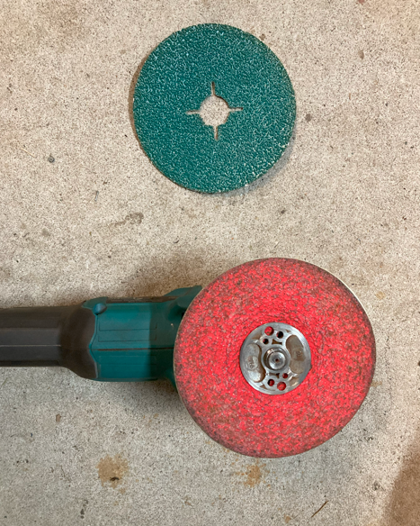

**What’s Catching my Attention on Youtube/Instagram**

Learning tips on the lathe from

* Quinn Dunki from Blondihacks

Still staying in touch/up to date with:

* Keith Rucker from Vintage Machinery
* Curtis from Cutting Edge Engineering
* Dave from EngelsCoachShop

All great watching on the progress of their projects and new gear coming into their shops for their special touch.

**Update on Touchmark Register**

* No takers so far but have populated a few with tools I have that dated back to the early 1920’s as the touchmark register is not just for current but to track historical marks as well.
* Jump on and complete the form and send it to Jumbuckforge@gmail.com and I’ll add it to the register. I’ll be loading the register once I get 20 or so listed. Still working on the format.

**What Podcasts have tickled my Ears this month**

* Shirtload of science with Dr Karl has had a some plays this month, they are a short Podcast compared to what I normally listen to which works well for me as the drive to and from my work is about 25-30mins so I can listen to a whole episode in one hit.
* Fire and Steel podcast – now with Chris Powell joining the team- changes the dynamic a bit with long pauses as Chris interprets the Pommy/Aussie sense of humour
* The Coal Cast – started listening to this for the first time and jury is still out – I’m trying to get in the groove of the style of this one but the topics have been great so far.

**Market Days – where I’ll be for the next few months**

* Did the Dalby Swap meet this period and was pretty hit and miss, not really the customer base as Swap Meets are more about bargain shoppers.
* Upcoming – looking to try and hit the-
  + - Millmerran Swap Meet in August 23rd and
    - The Creekside markets in September 6th in Dalby

**Challenges Ahead**

* Gears have arrived for the Mortice drill – just need to cut the keyways on them. Need to design a mount for the motor and the I’m also looking to put a VSD on the motor to account for the different styles of timber and sizes of the mortice chisels. Photos on Instagram if you’re interested.

**Dad Jokes of the month**

* A sandwich walks into a bar and orders a beer…. Bartender: Hey we don’t serve food here.
* A horse walks into a bar….. Bartender: Hey why the long face.

**New Purchases**

* Bought some lathe cutting tools and inserts to practice with – some from Temu and other from HAFCO so will see how they go.
* Bought a flycutter for the mill but waiting for the inserts to arrive.

**Website visits**

* Total (Last 12mths): 106
* Last 90 days: 52

**Music**

* Have been listening to 80’s playlists this month.

**Facebook**

Current follower level is at 1671 so thanks all of those that follow our journey.

**Next Newsletter**

Will aim to upload it in late September – stay tuned

If you want to be on the mailing list email me at [Jumbuckforge@gmail.com](mailto:Jumbuckforge@gmail.com) and I will send it out to you

*Until next time, whatever your interests are, get out there and give it a Red Hot Bash..*

*Cheers for now*

*Keith & Toby Wilson*

**