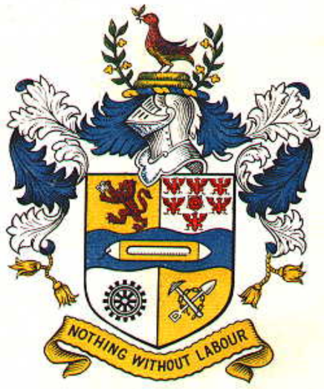
FRIENDS OF HASLINGDEN
CEMETERY

Health & Safety Policy

As a caring group, Friends of Haslingden Cemetery (FOHC) seeks to achieve high standards of health & safety to benefit volunteers, visitors, contractors and other interested parties.

FOHC supports the involvement of volunteers and will encourage consultation on health & safety issues.

The Committee accept that the identification, assessment and control of health & safety and other associated risks is a managerial responsibility. They will endeavour to allocate realistic resources to ensure that so far as is reasonably practicable, health & safety risks are eliminated or minimised.

The committee will ensure, so far as is reasonably practicable:

That FOHC organises and plans effectively for health & safety;
That all significant risks which could arise from FOHC’s activities are assessed, and either eliminated or reduced to acceptable levels;
That safe places and systems of work are provided and maintained;
That articles and substances provided for use are safe;
That volunteers are trained and competent to perform their duties;
That volunteers are consulted on health & safety issues;
That Volunteers are aware of their specific responsibilities for health & safety, and that the relevant safety requirements and codes of practice are adhered to;
That the effectiveness of this policy is monitored and reviewed at regular intervals;
That competent advice on health & safety matters is available.

Through the development of policies, planning, implementation of safe systems, monitoring, review and audit, the committee will work towards the provision of evidence to demonstrate that they are doing their reasonable best to achieve and maintain a safe working environment.

INTRODUCTION
It is a legal requirement for FOHC to have a Health & Safety Policy, to revise the policy where appropriate and to bring the organisation and arrangements for carrying it out to the attention of all volunteers.

This policy is intended to convey FOHC’s general intentions, approach and objectives for achieving a managed environment which ensures, so far as is reasonably practicable, the health, safety and welfare off, volunteers, contractors, visitors and other interested parties. It has been written in the light of current knowledge and best practice.

DOCUMENTATION
FOHC’s health & safety management system will be documented as follows: -

Policies
Policies will set out how health & safety will be managed. They will include policies on recognised areas of significant risk, together with policies on Risk Assessment of FOHC’s environment and activities. They will include FOHC’s arrangements and individual responsibilities for achieving the objectives within each policy.

Procedures
Health & safety procedures will be linked to Health & Safety Policies, but will contain detailed arrangements and instructions for carrying out tasks which contribute to maintaining health & safety within the cemetery. Sufficient information, instruction, training and supervision will be provided to volunteers and others to ensure that they are able to follow these procedures.

Records
Two types of records will be maintained:-
Records of things that have gone wrong e.g. accident report forms, in order to provide data for reactive monitoring.

Records of completed actions e.g. risk assessments and training records and records of active monitoring e.g. workplace inspections.

ORGANISATION
The organisational reporting arrangements for health & safety will be any active volunteer must report any foreseeable risk or accident to a board member immediately.

COMMITTEE
The Committee assumes overall responsibility for health, safety & welfare. They are responsible for endorsing the Health & Safety Policy, and that sufficient resources are provided to enable FOHC to meet its legal duties.
The Committee will ensure that accidents/incidents are reported in line with FOHC’s Accident/Incident Reporting Policy. In addition they will ensure that investigations are carried out as appropriate, in order to determine the causes, and that measures are put in place to ensure that further accidents/incidents are prevented, so far as is reasonably practicable.

SECRETARY
The Secretary is responsible for maintaining up-to-date health and safety policies and files. All records and minutes of meetings concerning health & safety matters should be kept readily available.

VOLUNTEERS
All volunteers have the following responsibilities: -
To take reasonable care of themselves and others who may be affected by their actions or omissions;
To co-operate with the Committee on health & safety matters;
To use any equipment or hazardous substances in the way they have been instructed;
Not to interfere with or misuse anything provided in the interest of health & safety;
To report any concerns over health & safety to a Committee member.

COMMUNICATING HEALTH & SAFETY

Committee Meetings
All Committee meetings will include health & safety as an agenda item, to ensure that FOHC’s health and safety performance is continually monitored, and that effective and clear lines of communication are maintained. Results of monitoring will be used to review and develop the Health & Safety Policy and arrangements to ensure legal compliance as a minimum standard.

Risk Assessment
In order to meet the requirements of The Management of Health & Safety at Work Regulations 1999 and all other relevant legislation, FOHC will ensure that all significant risks are assessed. So far as is reasonably practicable, risks will be eliminated or controlled, so as to reduce them to the lowest level reasonably practicable.
Risk assessments will be documented, and stored by the secretary of FOHC. Relevant volunteers will be provided with appropriate information on any remaining risks to their health and safety, and the measures FOHC has taken to ensure, so far as is reasonably practicable, their health & safety. Instruction, information, training and supervision will be provided as necessary. Risk assessments will be reviewed when circumstances change, or annually, whichever is the sooner.

The Committee will maintain a risk register which will be reviewed regularly to ensure that FOHC are aware of their risk profile.

Measuring Performance
Monitoring of HCL’s health & safety performance will take place regularly.
The results obtained will be used to learn lessons and to review and develop FOHC’s Health & Safety Policy and arrangements, to ensure legal compliance as a minimum standard.

Reviewing Performance
FOHC will review its health & safety performance regularly, to ensure that all legal duties are being met, and in order to provide information to develop increasingly high standards of health & safety.

Training
FOHC will ensure that all volunteers receive training to ensure that they have an adequate appreciation of health & safety at work. Volunteers will ensure that they co-operate and make themselves available for such training where appropriate.
Signed by:
Chairman (Andrew Taylor)

Secretary (Laura Drew)

Treasurer (Andrew Neil Taylor)

Adopted on Tuesday 12th November 2019.

