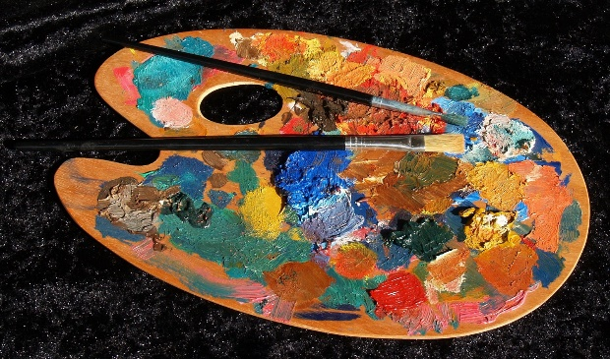
Eligibility

The Conanicut Island Art Association
44th Annual Art Exhibit

Opening Reception Tuesday July 24th, 2018 6pm - 8pm

Exhibit Hours
July 25th thru July 29th 10am - 4pm

Jamestown Community Center 41 Canonicus Ave (East Ferry) Jamestown RI 02835
401-855-2144
Current 2018 CIAA Membership Dues accepted on entry date.
$25.00 Entry fee for 3 works to be hung.
$10 Entry fee for up to 15 bin pieces.

Rules
Three original art pieces: Paintings, Graphics, Photography, Sculpture and any work that has not been previously shown in a CIAA exhibit.
Photographic reproductions will be accepted only as bin pieces and must be labeled as reproductions.
All hanging pieces must be securely framed and wired. No tooth hangers or clips. No wet paint. Work may not exceed 20lb. Maximum size 48" x 48". Connected works (diptychs, triptychs) must measure less than 48"H x 60"W. Works in a series will not necessarily be hung together.
CIAA reserves the right to reject unsuitable art work.
Only one of the three pieces can be labeled "not for sale" (NFS). If only one piece is entered it must be for sale.
Bin pieces must be backed and wrapped. Stretched canvas accepted at artist's risk.
Sculpture must be easily moved.
All sold work must remain on view for the duration of the exhibit.
The CIAA will take 25% commission on all works sold.

Registration Forms
Forms are available on line at: artinjamestown.org and at drop off. Please complete paper work in advance so that we may register work in a timely manner.

Receiving and Pick-up All work must be received on: Saturday, July 21st, 2018, 10am - 5.00pm All unsold work must be picked up: Sunday July 29, 2018, 4 - 6pm, or Monday July 30, 2018, 10am - 12pm Receipts must be shown.

Juror for Awards
This years, highly qualified Juror, will lend his expertise to CIAA to select work for cash awards. Del-Bourree Bach, is a contemporary realist painter of national and international fame.

Cash prizes.
All prizes will be awarded opening night.

People's Choice award Voting will take place from 6 - 7:00 pm on opening night. The winner will be announced at 7:45pm.

Questions? Contact Rick Meli by email. Email: pastelbyrick@gmail.com

