MassWildlife Advisory

Eastern Massachusetts Extended Archery Deer Season Takes Effect This Fall
Opening Date will be October 1, 2018 in Wildlife Management Zones 10-14

A recently approved expansion of the archery deer season in eastern Massachusetts will take effect this fall. In Wildlife Management Zones (WMZ) 10–14, the archery hunting season for deer will open October 1, 2018 and end November 24, 2018. Archery season for deer in the rest of the state (WMZ 1-9) begins October 15, 2018 and ends November 24, 2018. The expanded season will increase hunting opportunities in a region where deer numbers are above the statewide management range of 6-18 deer per square mile. Further information on the new season dates is on MassWildlife’s website at mass.gov/service-details/deer-hunting-regulations.

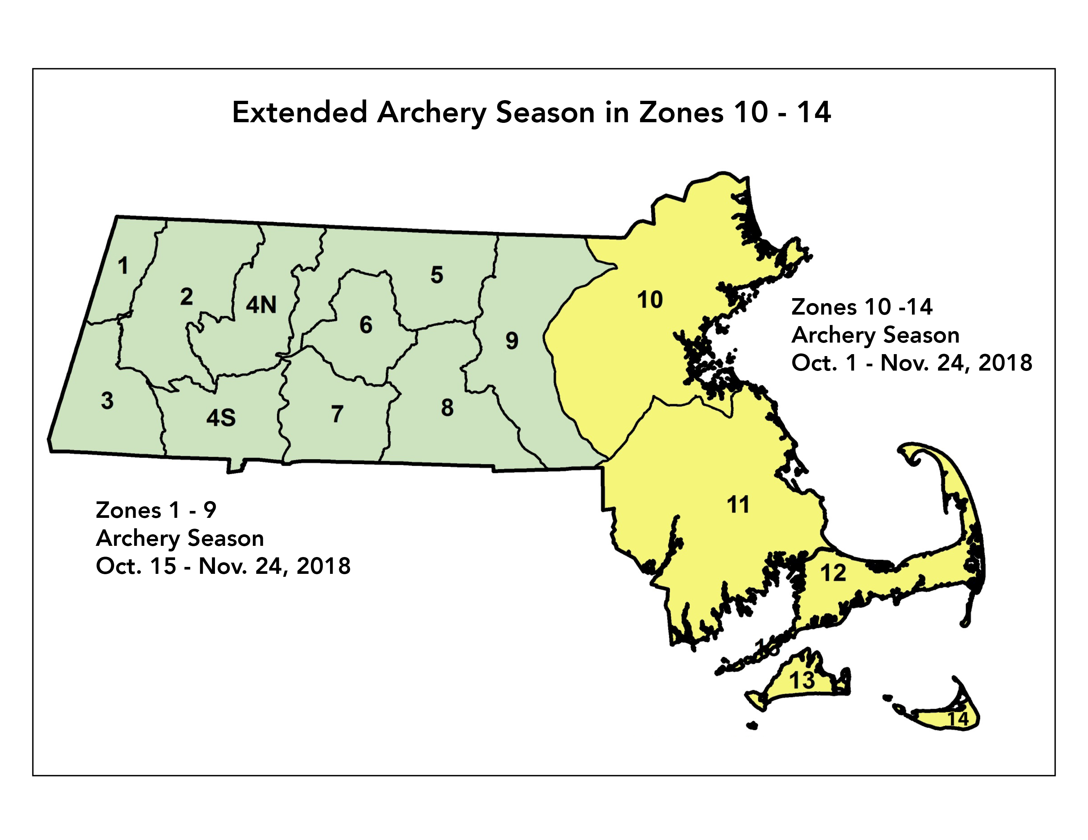

Link to detailed Wildlife Management Zone Map.

