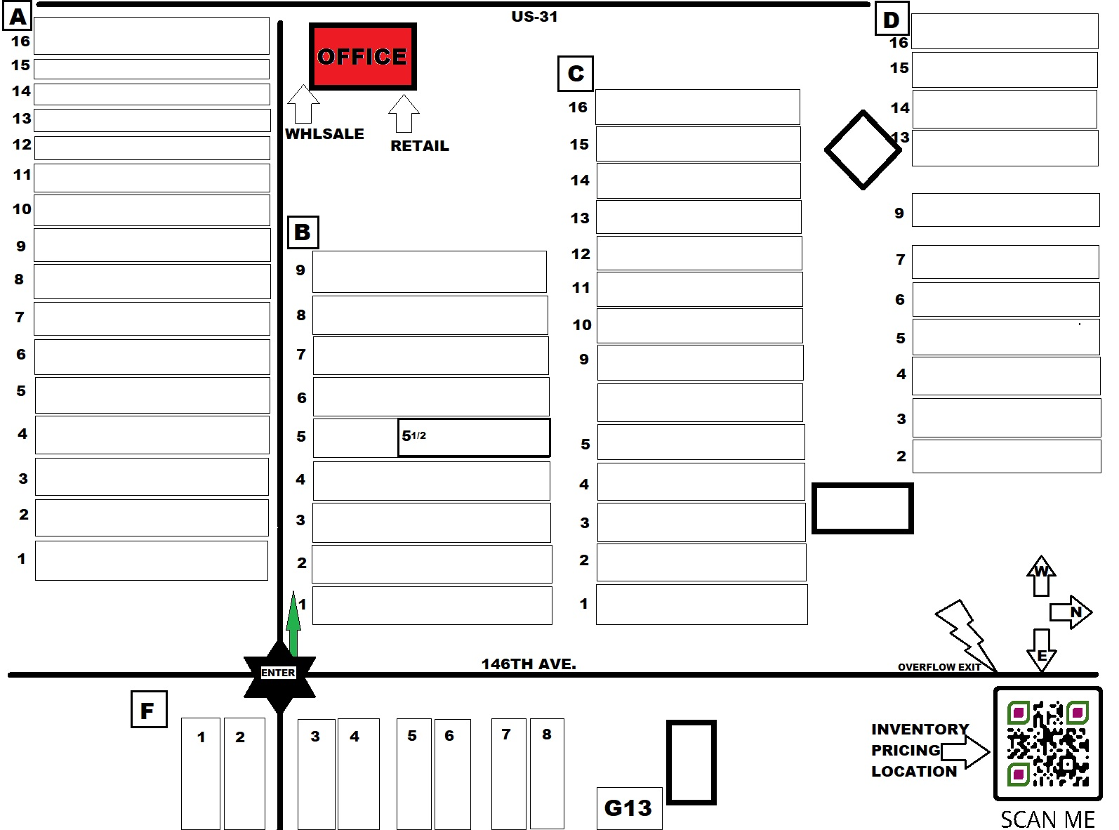

**US-31**

ORNAMENTAL TREES, FRUIT TREES

**2**

**3**

**4**

**5**

**6**

**7**

**9**

**13**

**14**

**15**

**16**

**12**

**13**

**14**

**15**

**16**

**TO TAYLOR STREET**

**TO CROSWELL STREET**

**1**

**2**

**3**

**4**

**5**

**10**

**11**

**12**

**13**

**14**

**15**

**16**

JAPANESE MAPLES, BAMBOO, TF HYDRANGEA, TF LILAC

AP

ASSORTED #5 POTS

ALTHEA, HYDRANGEA, VIBURNUM, WEIGELA

BARBERRY, BOXWOOD, HOLLY, SPIREA, WEIGELA

**16**

**15**

**14**

**13**

**12**

EVERGREEN / CONIFER

ARBORVITAE, JUNIPER, SMALL FRUITS, SPRUCE

ROSES, KNOCKOUT & DRIFT

BLEEDING HEART, FERN, CORAL BELLS, HOSTA, HELLIBORUS

BXWOOD,CLETHRA HYDRANGEA BXWOOD, HYDRANG, 9BARK

ASSORTED EVERGREENS, HYDRANGEA, BURNING BUSH

EVERGREEN / CONIFER

EVERGREEN / CONIFER

MAPLE, APPLE, ASSORTED ORNAMENTAL #5TREES

FALSECYPRESS, GRASSES, JUNIPER, YEW, ARBS

ASSORTED GRASS, LIRIOPE

ALTHEA, BUTTERFLY BUSH, HONEYSUCKLE, DEUTZIA

AZALEA, BURNING BUSH, HYDRANGEA, BARBERRY

AZALEAS

**OFFICES &**

**CASHIERS**

**D**

**C**

**B**

**A**

**1**

**2**

**3**

**4**

**5**

**6**

**7**

**8**

**9**

**10**

**11**

VIBURNUM, JAPANESE MAPLE, BXWOOD, AZALEA

ASSORTED #5 & #7 POTS, FRUITS & ORNAMENTALS

AZALEA, FERN, HOSTA, GRASSES, ITEA, HYDRANGEA

ASSORTED PERENNIALS

ASSORTED PERENNIALS

ASSORTED PERENNIALS

GRNDCVR, FLATS

SPECIALTY / SPECIMEN TREES AND SHRUBS

**1**

**2**

**3**

**4**

**5**

**6**

**7**

**8**

**9**

HOLLY, FOTHERGILLA, LILAC, SPIREA, VIBURNUM, FORSYTHIA

ENTER

CASHIER &

CHECKOUT

SEASONAL & MUMS

PRIVET, RHODODENDRON, 9BARK, WEIGELA, BUTTERFLY BSH

ASSORTED #5 POTS

BOXWOODS

ARBORVITAE, JUNIPER, PINE, SPRUCE, YEW

AZALEA, BXWOOD, LILAC, PRIVET, 9BARK, RHODY

ARBORVITAE, BXWOOD, HYDRANGEA, ITEA

CORAL BELLS, FERNS, GRASSES, HOSTA

BUCKTHORN, FOTHERGILLA, HYDRANGEA, ELDERBERRY

BARBERRY, BEAUTYBERRY, 9BARK, HYDRANGEA

AZALEA, FALSECYPRESS, JUNIPER, RHODY, EUONYMOUS

ASSORTED #1 POTS

HYDRANGEA, 9BARK, DEUTZIA,POTENTILLA, WEIGELA

BARBERRY, COTONEASTER, EUONYMOUS, WEIGELA, HYDWEIGELAHYDRANGEA

HOLLY, LILAC, PRIVET, SPIREA, WILLOW, VIBURNUM, BARBERRY

ALTHEA, HYDRANGEA, AZALEA, BLUEBERRY, RHODY, WEIGELA

HYDRANGEA