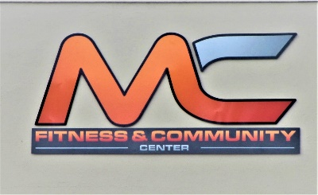
Membership Rates

Youth - Individual ages 17 and younger

Sign-up Fees: $20. (one-time fee) Monthly membership - $20.

Single - Individual ages 18 and older

Sign-up Fees: $50. (one-time fee) Monthly membership - $35.

Couple - Two people

Sign-up Fees: $50. (one-time fee) Monthly membership - $55.

Family - Husband & Wife & children under the age of 17

Sign-up Fees: $50. (one-time fee) Monthly membership - $60

Family- does not mean cousins, uncles, aunts, nephews, niece’s, or grandchildren, grandparents, nor brothers, sisters, brother-in-law, sister-in-law, father-in-law, mother-in-law,

or other relatives who do not live under the same roof and are not of the primary family domain.

Week Trial – Fill out membership form and pay $25

Punch Pass – Fill out membership form and pay $50

Day Trial – Fill out our visitor form and pay $5.00

Corporate Memberships:

Please contact Ginger Smith or staff member on duty.

www.mcfitnesscenter.org (208) 436-9622 123 C Street, Rupert, ID 83350

