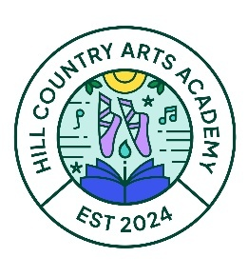
🎓 Overview
Hill Country Arts Academy maintains a uniform program that supports professionalism, comfort, and a strong sense of community. Beginning Fall 2026, HCAA will transition to Lands’ End as our preferred uniform provider. This partnership ensures consistent quality, reliable sizing, and long-term availability of approved items.
Families may begin purchasing approved Lands’ End items immediately, and students may wear them as soon as they are acquired.

1. Uniform Requirements
Monday–Thursday: Regular Uniform
Students wear the designated HCAA uniform pieces each Monday through Thursday. Approved items include:
• Pants & Shorts: Navy blue
• Skirts & Jumpers: Clear blue plaid
• Polos & Sweaters: Green or cobalt blue (new color option for 2026)
• Logo Requirement: Beginning next year, all polos, dress shirts, sweatshirts, and polo dresses purchased through Lands’ End will include the embroidered HCAA logo.
Grandfathered Items
All current French Toast uniform pieces remain acceptable for the 2026–2027 school year. However, any new purchases going forward must follow the updated dress code.
Logo Patches
Families who wish to continue using shirts purchased this year may add logo patches to existing polos.

2. Friday Dress Code
Fridays are designated Casual Dress Days. Students may wear comfortable, non-uniform clothing that aligns with the spirit of HCAA’s dress expectations:
• Neat, clean, and appropriate attire
• No offensive graphics or messaging
• Clothing that supports movement and participation in arts activities

3. Performance Uniform
Certain items in the Lands’ End store are designated Performance Only and are not part of daily uniform wear:
• White Oxford shirts (long sleeve)
• Ties (boys’ tie and girls’ cross tie)
• Girls’ Above-the-Knee Plaid Skirt
• Girls’ Classic Navy Knee-High Socks
• Boys’ Tailor Fit Navy Slacks
These items are reserved exclusively for concerts, recitals, and formal performances.

4. Ordering Through Lands’ End
School Code: 900208547
Families may shop directly at:
landsend.com and enter our unique school code under the school uniforms tab
Using the school code ensures:
• Only approved items appear
• Correct logo placement
• Access to HCAA-specific colors and patterns

5. Transition Timeline
• Now through Summer 2026: Families may purchase navy bottoms and Lands’ End items early.
• Fall 2026: Official transition to navy bottoms and Lands’ End as the primary provider.
• 2026–2027 School Year: French Toast items remain acceptable but will need to be transitioned when outgrown or damaged.
• 2027–2028 School Year: All students expected to be fully transitioned to the updated uniform program.
Performance Wear is the only item that cannot be grandfathered in; all students are required to be in the updated Performance Uniform for the 2026–2027 school year.

6. Socks, Tights, Leggings, Belts & Shoes
Socks, Tights, and Leggings
Students may wear the following solid colors:
• White
• Black
• Grey
• Evergreen
• Navy blue
Belts
• Belts worn with pants or shorts must be solid black.
Shoes
• Dress uniform shoes: Solid black
• Daily shoes: Must be playground-safe
• The following are not permitted:
• Slides
• Flip flops
• Crocs
• Sandals

Item #529185-BR2 | Kids Short Sleeve Interlock Polo Shirt | Cobalt Blue  School Logo Required | 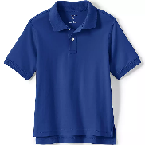
Item #529185-BR2 | Kids Short Sleeve Interlock Polo Shirt | Evergreen  School Logo Required | 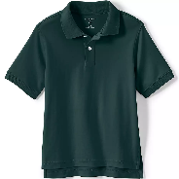
Item #529201-BR8 | Kids Short Sleeve Rapid Dry Polo Shirt | Cobalt Blue  School Logo Required | 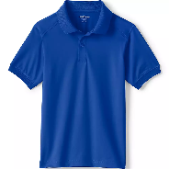
Item #529201-BR8 | Kids Short Sleeve Rapid Dry Polo Shirt | Evergreen  School Logo Required | 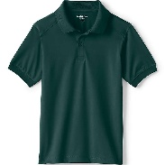
Item # 529188-BR6 | Kids Long Sleeve Interlock Polo Shirt | Cobalt Blue  School Logo Required | 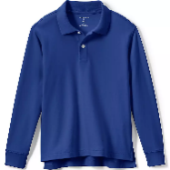
Item #529188-BR6 | Kids Long Sleeve Interlock Polo Shirt | Evergreen  School Logo Required | 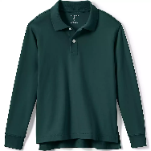
Item #529219-BR8 | Kids Full-Zip Mid-Weight Fleece Jacket | Evergreen | 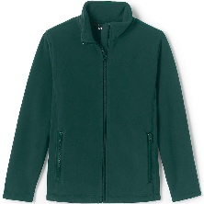
Item #529221-BR5 | Kids Lightweight Fleece Quarter Zip Pullover | Evergreen  School Logo Required | 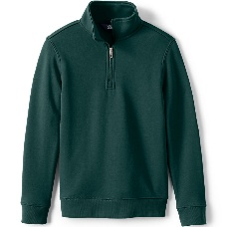
Item #540909-BR9 | Kids Long Sleeve Rapid Dry Polo Shirt | Cobalt Blue  School Logo Required | 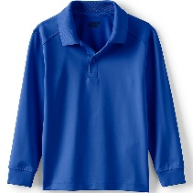
Item # 540909-BR9 | Kids Long Sleeve Rapid Dry Polo Shirt | Evergreen  School Logo Required | 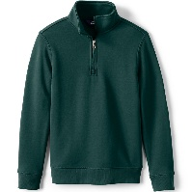
Item #529224-BR9 | Kids Cotton Modal Sweater Vest | Evergreen  School Logo Required | 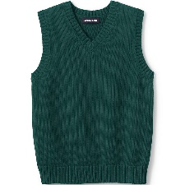
Item #529049-BR3 | Kids Elastic Waist Pull On Shorts | Classic Navy | 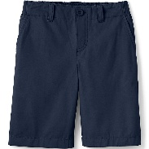
Item #529034-BR7 | Boys Iron Knee Blend Plain Front Chino Pants | Classic Navy | 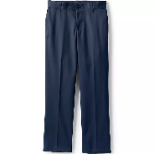
Item #529031-BR3 | Boys Elastic Waist Pull-On Chino Pants | Classic Navy | 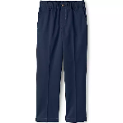
Item #546722-BRX | Boys Classic Active Performance Chino Shorts | Classic Navy | 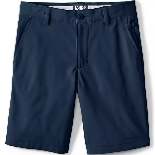
Item #529048-BR9 | Boys Plain Front Blend Chino Shorts | Classic Navy | 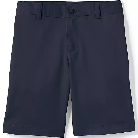
Item #529023-BR9 | Boys Tailored Fit Blend Iron Knee Plain Front Pants (Performance Uniform Only) | Classic Navy | 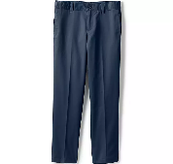
Item #529205-BR6 | Boys Long Sleeve Solid Oxford Dress Shirt (Performance Uniform Only) | White  School Logo Required | 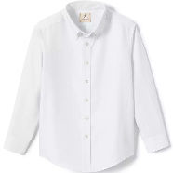
Item #426743-BR0 | Kids Plaid Tie (Boys) | Clear Blue Plaid | 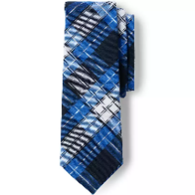
Item #527959-BR8 | Girls Plaid Jumper Top of Knee  (Grades PreK3 – 4th) | Clear Blue Plaid | 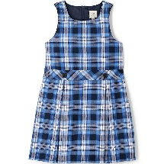
Item #550289-BRX | Girls Short Sleeve Mesh Pleated Polo Dress  (Grades PreK3-4th) | Cobalt Blue  School Logo Required | 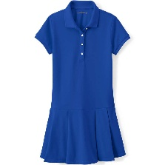
Item #550289-BRX | Girls Short Sleeve Mesh Pleated Polo Dress  (Grades Prek3-4th) | Evergreen  School Logo Required | 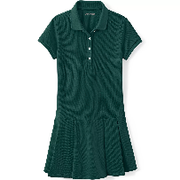
Item #550288-BR5 | Girls Long Sleeve Mesh Pleated Polo Dress  (Grades Prek3-4th) | Evergreen  School Logo Required | 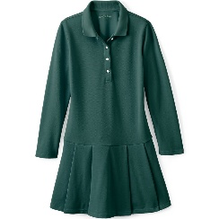
Item #528375-BR2 | Girls Elastic Waist Pull-On Chino Pants | Classic Navy | 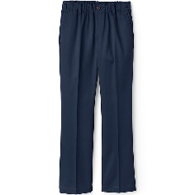
Item #528965-BR5 | Girls Iron Knee Blend Plain Front Chino Pants | Classic Navy | 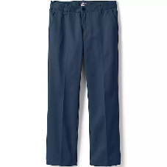
Item #543734-BR7 | Girls Plaid Skort Top of Knee | Clear Blue Plaid | 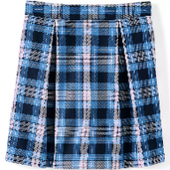
Item #403787-BR6 | Girls Wide Headband | Clear Blue Plaid | 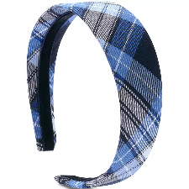
Item #528428-BR0 | Girls Stretch Chino Bermuda Shorts | Classic Navy | 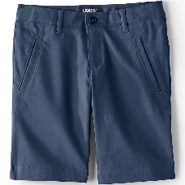
Item #528427-BR6 | Girls Plain Front Blend Chino Shorts | Classic Navy | 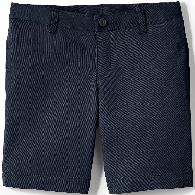
Item #093594-BR2 | Girls Solid Cable Knee Socks | Evergreen | 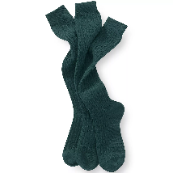
Item #527963-BR4 | Girls Plaid Pleated Skirt Below the Knee  (5th grade and up) | Clear Blue Plaid | 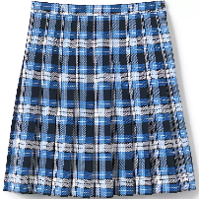
Item #527964-BR9 | Girls Plaid Box Pleat Skirt Top of the Knee  (Performance Uniform Only) | Clear Blue Plaid | 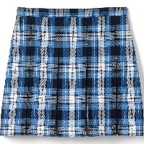
Item #528924-BR6 | Girls Long Sleeve Oxford Dress Shirt  (Performance Uniform Only) | White  School Logo Required | 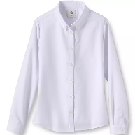
Item #0935394-BR2 | Girls Solid Cable Knee Socks (Performance Uniform Only) | Classic Navy | 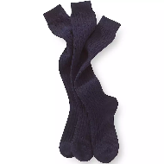
Item #442162-BR1 | Girls Cross Tie | Clear Blue Plaid | 