Last Name: First Name: Date of Birth: Address: City: State: Zip: Phone: Email: Chapter: Are you a registered voter: Voting Districts: Fl House: Fl Senate Us Congress Dist. : Membership Options $20.00: Lifemembership $600.00:

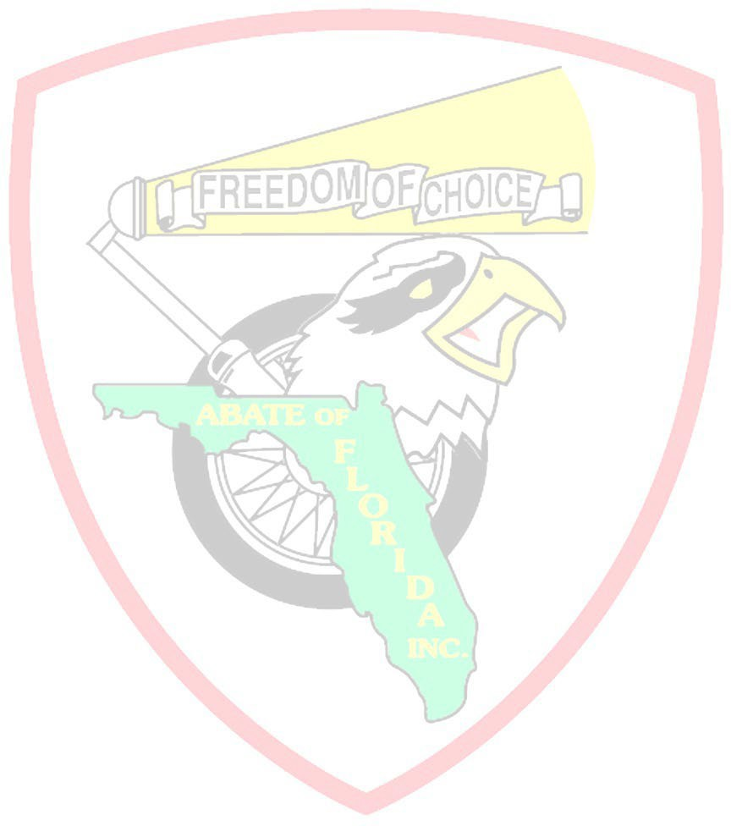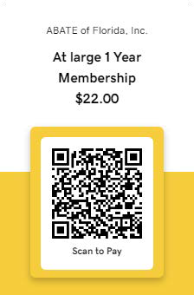

Member Transfer to New Chapter: From old Chapter:

Change of address: Name Change **Home Chapter:**

# Signature: Date:

ALL APPLICATIONS ARE SUBJECT TO APPROVAL. Membership is open to anyone 18 years or older. All members receive a membership card and voting privileges in their home chapter, Personal involvement in statewide Legislative actions and their freedom to ride. Mail to Po Box 614 Cantonment, Fl 32533 Questions: (386)943-9610

# Membership Verified By: Date paid: Do Not Mail Cash

*All payments made by credit card will be charge a 2.00 processing fee

ABATE of Florida, Inc has partnered with American Income Life to provide all members with a $4000.00 AD&D Policy Please fill out your Beneficiary Card below

Mail to State office: ABATE of Florida, Inc. Po Box 614 Cantonment, Fl. 32533-0614 Phone: (386)943-9610

# ABATE of Florida, Inc Members Information

Last Name: First Name: Date of Birth: Physical Address: City: State: Zip: Phone: Email: as of this date my Beneficiary is Listed Below

# Beneficiary Information

Last Name: First Name: Date of Birth: Physical Address: City: State: Zip: Phone: Email: Relationship: **Membership 2022**