The Spoon carver’s Cookbook
Delicious Fuel for the Hungry Woodworker

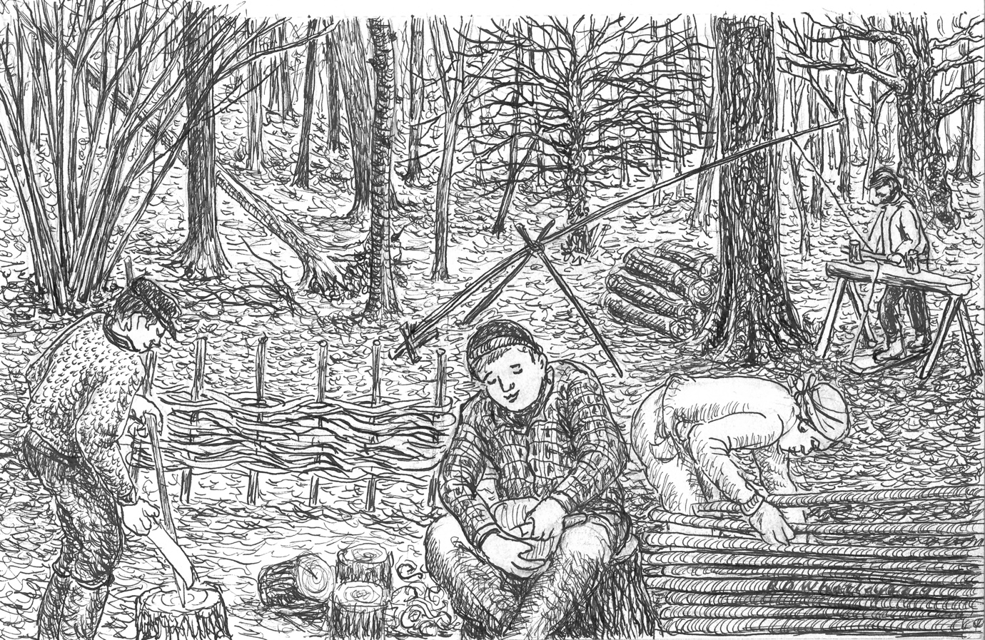

NICK & LauRA gOSMAN

The Spoon Carver’s Cookbook

Hand carving spoons and bowls every day is hard physical work and to keep myself going I need to consume a serious number of calories!
Anyone who has attended one of our workshops will know how physically hard it can be to carve all day.
Whenever I hold a workshop my wonderful wife Debbie does all the cooking for it and I wanted to create this cookbook to celebrate her delicious food, to enable you to enjoy some of the meals that the participants who attend our carving workshops can and to inspire you with ways in which you can use your wooden spoons and bowls.

Contents
Breakfast Kedgeree……………………………………………………………………….3
Scottish Porridge………………………………………………………………………….5
Eggy Bread………………………………………………………………………………..6
Scotch Broth……………………… ………………………………………………………7
Classic Lentil Soup (Workshop Soup)………………………………………………………...8
Campfire Damper Bread…………………………………………………………………….9
Griddle Cakes…………...…………………………………………………………………10
Vegan Chocolate Brownies (Workshop Brownies)……………………………………………11
Campfire Chocolate Bananas………………………………………………………………12
Reference Page…………………………………………………………………………....13

Breakfast Kedgeree
Kedgeree originates from a blend of spiced lentils, rice, fried onions, and ginger known as ‘Khichiri’. Khichiri dates to 14th century India and is eaten widely there. Kedgeree as we know it today began to evolve when the early British colonists took a liking to Khichiri upon their arrival in India. The Raj began to introduce Khichiri and fish to their breakfast tables which were eventually combined by Indian cooks. Eggs where then added to the dish as a garnish and when it was brought back across the sea to Edwardian homes flaked smoked haddock was added to the mix by the Scotts and the lentils were removed. Thus, kedgeree was born.
You may find one of the Gosman Spoon Co’s leaf-shaped cooking spoons helpful when serving up your kedgeree, as our customers have informed us that the pointed end of the spoon is excellent for extracting food from the edges of the frying pan.
Preparation time: Less than 30 minutes . Cooking time: 30 minutes to an hour . Serves: 6
Ingredients
- 475g/1lb 10z undyed smoked haddock fillet, cut in half.
- 2 bay leaves.
- 200g/70z basmati rice, rinsed in cold water and drained.
- 4 free-range eggs.
- 100g/3 ½ 0z frozen peas (optional).
- 40g/1 ½ 0z butter.
- 1 tbsp sunflower oil.
- 1 onion finely chopped.
- 1 heaped tbsp medium curry powder.
- 3 tsp double cream.
- 3 tbsp chopped fresh flatleaf parsley.
- ½ lemon juice only.
- Freshly ground black pepper.
Method
- Place the haddock in a large frying pan (skin-side up).
- Pour 500ml (18fl 0z) of water over the haddock, then add the bay leaves and bring the water to a gentle simmer.
- Cook the fish for 8-10 minutes until it is just cooked and flakes easily.
- Drain the fish into a colander which is placed over a bowl. Keep hold of the liquid that the haddock has been cooked in but discard the bay leaves.
- Poor the liquid that the fish has been cooked in into a saucepan and stir in the rice. Cover with a lid and bring to the boil.
- Reduce the heat and gently simmer the rice for 10 minutes., then turn off the heat and leave the rice covered for 3-5 minutes more. By this time, the rice should have absorbed all the fish liquid.
- While the rice is cooking boil some water in a saucepan. Then add the eggs and cook them for 8 minutes.
- Once the eggs are cooked drain them in a sieve under cold running water. When the eggs are cool enough to handle. Then peel them carefully and set them aside.
- If you decide to use the peas, then cook them into a saucepan of boiling water and drain them.
- Melt the butter with the oil in a large frying pan and cook the onion over a low heat for 5 minutes until it is well softened, stirring it occasionally.
- Place the cooked rice into the pan and stir it into the onions. Then add the peas, cream, parsley and a few twists of ground black pepper.
- Cut the fish into chunky pieces and add these to the pan. Then gently stir in the lemon juice and cook for 1-2 minutes.
- Cut the eggs into quarters and place them on top of the rice. Then cover the pan with a lid and heat everything through for 2-3 minutes or until the eggs are warm. The kedgeree is now ready to serve.

Scottish Porridge
Porridge was historically served in a communal bowl made of hard wood and eaten with a horn spoon. It is traditionally served with cream, milk, or buttermilk. The origin of the word ‘porridge’ can be traced back to the expression ‘pottage’ which is a variation of the French word ‘potage’, (a name for soup) and refers to the word ‘pot’, the saucepan. Sometimes the porridge would be thickened further and baked as flat cakes or in brick form on hot stones, or in the embers of a fire which then made the porridge more durable and portable.
Why not embrace the traditional way of eating Scottish porridge by serving your porridge up in a wooden breakfast bowl hand carved by the Gosman Spoon Co?
Serves: 4
Ingredients
- 2 pints of cold water (5 cups)
- 4 oz medium oatmeal
Method
- Bring the water to a rapid boil.
- Slowly sprinkle the oatmeal over the water, stirring the mixture constantly. Be careful not to add the oatmeal to the water too quickly otherwise lumps will form which will make the porridge unpleasant to eat.
- Stir the porridge until it returns to the boil.
- Cover the pan and simmer the porridge slowly for about 30 minutes, stirring frequently, or until it is a thick pourable consistency.
- Add about ½ a teaspoon of salt to the porridge, but not until at least 10 minutes after it has been simmering, otherwise it could harden the meal.

Eggy Bread
Eggy bread is also known as ‘French Toast’. According to recipes from the early 5th Century AD Eggy bread was being eaten as far back as the Roman Empire, however, the Roman’s called it Pan Dulcis. The recipe for Eggy bread as we know it today was invented by European cooks of the Medieval period who needed to use up every bit of food that they could find to feed their families. Other names for French Toast include ‘German Toast’, ‘Poor Knights of Windsor’ and ‘Nun’s Toast’. ‘Eggy Bread’ is the British name for French Toast.
Preparation time: 5 minutes . Cooking time: 5 . Serves: 1
Ingredients
- 2 medium eggs
- 1 tbsp of milk
- 2 slices of white or brown bread
- 1 tbsp of butter
Method
- Lightly beat the eggs in a shallow bowl along with the milk. Then season with salt and black pepper.
- Dip each slice of bread into the egg mix, making sure it has soaked up all the liquid.
- Heat a frying pan over a medium heat and add the butter.
- Swirl the butter around the pan and when it’s beginning to foam, add the bread and fry it on each side for 1 minute or until it is golden brown in colour.
- Transfer to a plate where you can serve your eggy bread with crispy bacon or fruit compote.

Scotch Broth
Traditionally Scotch broth was made from seasonal vegetables was particularly popular in the winter months and especially on New Year’s Day. Now it is enjoyed all year round. Scotch broth has been referenced in literature dating back to the 1600’s and its popularity has crossed many boarders including in America, where the recipe was detailed in an 1881 American publication ‘The Household Cyclopedia’.
Serves: 6-8
Ingredients
- 1 lb scrag end neck of lamb
- 3 pints of water (7 ½ cups)
- 1 oz of pearl barley (2 tablespoons)
- 2 oz dried peas, soaked overnight (4 tablespoons)
- 1 large carrot (sliced)
- 1 large onion (sliced)
- 1 small leek (trimmed and sliced)
- 1 small turnip (diced)
- 4 oz of shredded cabbage
- 1 level tablespoon of chopped parsley
Method
- Trim away the excess fat from the lamb, then place the lamb into a large pan with the water, pearl barley, the peas and plenty of seasoning.
- Bring the liquid to the boil, cover the pan and simmer for 1 hour.
- Add the carrot, onion, leak and turnip, and when the broth returns to the boil simmer it for another 30 minutes.
- Skim off the fat, season to taste, stir in the parsley and serve the broth piping hot.

Classic Lentil Soup (Workshop Soup)
The ancient Greeks absolutely loved lentil soup, as supported by a comment by Aristophanes: "You, who dare insult lentil soup, sweetest of delicacies." Lentil soup has even been mentioned in the Bible: In Genesis 25:30-34, Esau is prepared to give up his birth right for a pot of red lentil soup. Lentils were perhaps the first convenience food as, of all the pulses lentils cook the fastest.
Serves: 4
Ingredients
- 1 large onion, (chopped)
- 1 tbsp of olive oil
- 225g (8oz) split red lentils.
- 1 litre (1 ¾ pints) of vegetable stock or water
- 1-2 tbsp of lemon juice
- Salt and freshly ground black pepper
Method
- Heat the oil in a large saucepan and fry the onion for about 5 minutes or until it is lightly browned.
- Add the lentils and stock or water and bring it to the boil, then simmer it for about 20 minutes, or until the lentils are soft and golden.
- Blend the soup and add water to thin it if you wish.
- Add lemon juice to taste and season with salt and plenty of pepper.
- Reheat gently and serve.

Campfire Damper Bread
There is a question as to where damper bread originated from and when it was first created. However, it seems that damper was first invented in Sydney. According to historian James Bonwick the name ‘damper bread’ arose from the way in which baker William Bond first baked the bread. The bread was placed into the ashes of a fire to bake, also known as ‘damping’ the fire. In the bushland of Australia damper was cooked in the same way as in Sydney. It was a staple meal for the swagmen, drovers, stockmen and other travelers of the outback as the salt and flour needed to make it could easily be carried and only water needed to be added. As sugar began to become popular, the travelers of the outback began to eat their damper with golden syrup.
Preparation time: 10 minutes . Cooking time: 30 minutes . Serves: 8
Ingredients
- 450g self-raising flour
- 1 tsp salt
- 80g butter
- 200ml water
Method
- Preheat the oven to 200C.
- Line a baking tray with grease proof/not stick paper.
- Rub the butter cubes, flour, and salt together until the mixture resembles breadcrumbs.
- Gradually add the water until the mixture resembles a soft dough. If it is too stiff after adding the 200mls of water, then you can add a little bit more.
- Gently knead the dough for a minute or two until all the dough is fully combined and the salt is evenly dispersed.
- Turn the dough out onto a floured surface and shape into a large thick disk, roughly 16-18cm wide.
- Make 8 deep slashes across the top of the dough in a compass shape.
- Bake the bread for 30 minutes.
- After the bread has turned crusty turn the oven off and leave it until it is ready to eat.

Griddle Cakes
Not much is known about the history of griddle baking, but it is an ancient and widespread method that was used for baking. This is because it could be used by anyone with a fire and a flat stone. Griddle baking is associated with Scotland and Ireland, where locally dug peat is used for fuel and is unsuitable for oven baking. South Wales is also well known for griddle baking where coal was burned in open kitchen grates and a griddle balanced over the top.
Preparation time: 10 minutes . Cooking time: 10 minutes . Serves: 8
Ingredients
- 1 cup flour.
- ½ teaspoon baking soda.
- ¼ teaspoon salt.
- ½ teaspoon baking powder.
- 1 cup whole milk (or a milk alternative).
- 2 tablespoons melted butter.
Method
- Sift the flour, salt, and baking soda into a large bowl.
- In a separate bowl mix together the milk and baking powder.
- Combine the dry ingredients with the milk and baking powder and whisk them together until the batter is smooth without clumps.
- Add the melted butter into the batter and mix well for a few seconds.
- Before putting the griddle on top of the stove, spray it with cooking spray or dampen a paper towel with oil and rub it into the griddle surface to grease it. Heat the griddle on a medium-high heat.
- Using a ladle-spoon, pour 1/8 of the batter onto the hot griddle to form each griddle cake.
- When each cake has turned brown on the bottom and starts to bubble on the top, flip to cook them on the other side.
- Remove the cakes from the heat as they are cooked.
- Now you can enjoy your griddle cakes hot with your favorite toppings.

Vegan Chocolate Brownies (Workshop Brownies)
The brownie is believed to have been invented in America in New England at the beginning of the 20th Century. One legend about the origin of chocolate brownies states that the chef added melted chocolate to biscuits by mistake. A second legend goes that a cook was baking a cake one day, but they did not have enough flour left to finish the cake, but they baked it anyway and created a brownie. It wasn’t until the 1920’s that brownies as we know them today began to become popular.
Serves: 12
Ingredients
- 200g dark chocolate (at least 70% cocoa solids)
- 100g coconut oil (raw or odorless)
- 100g ground almonds
- 75g brown or white rice flour
- A pinch of salt
- 1 teaspoon baking powder
- 2 large eggs
- 150g soft light brown sugar
- 1 teaspoon vanilla extract (optional)
- 75g walnuts, roughly chopped.
Methods
- Preheat the oven to 180 degrees Celsius/Gas 4
- Line a brownie tin or baking tin, about 24 x 16cm or 20cm square, with baking parchment.
- Break up the chocolate into small pieces and put it into a heatproof bowl with the coconut oil.
- Set the bowl over a pan of just-simmering water and leave the chocolate to melt slowly, stirring it occasionally until it is smooth. Then leave the chocolate to cool until it is barely warm.
- Sift together the ground almonds, rice flour, salt and baking powder and set it aside.
- Whisk the eggs and sugar together, with the vanilla (if you are using it), until the mixture is well blended and frothy.
- Make a well in the center of the dry ingredients. Then pour in the egg and sugar mix, followed by the molten chocolate.
- Starting slowly mix the whole lot together with a wooden spoon or whisk until all the mixture is combined in an even but thick batter.
- Stir in the walnuts.
- Scrape the mixture into the prepared tin, spread it out with a spatula and bake for 20-25 minutes, or until the top looks firm and a skewer inserted into the center comes out clean but with a few moist crumbs sticking to it.
- Let the brownie cool in the tin completely-Leave the brownie for several hours or even overnight, then cut it into slices. If you put the brownies in the fridge then they will become a bit firmer.

Campfire Chocolate Bananas
A Scandinavian Kuksa carved by the Gosman Spoon Co would make the perfect bowl for you to enjoy your chocolate bananas from whilst away on a camping trip. The Scandinavian Kuksa’s 2-holed handle means that it can be clipped onto your rucksack, making it easy to transport. You may also find a Gosman Spoon Co eating spoon handy in this situation as they are shapely and compact spoons making them easy to take with you wherever you go.
Ingredients
- 1 banana for each person you are cooking for.
- Chunks of chocolate or chocolate buttons
- Tin foil
- A sharp knife
Methods
- With a sharp knife cut a slit lengthways along each banana, (this slit does not need to run the full length of the banana).
- Place the chocolate into the slit of each banana.
- Wrap each banana in tin foil and cook them on a grill set over a campfire, on the grill of a BBQ, or in the warm ashes of a campfire.
- The bananas do not take long to cook, just cook them long enough for the chocolate to melt and for the banana to go gooey in the middle.
- With a spoon scoop the banana-chocolate goo out of the slot in the middle of the banana and enjoy!

References
Australian Food History Timeline (2021): ‘1825 Australian Damper First Mentioned’: Damper first mentioned - Australian food history timeline (australianfoodtimeline.com.au)
BBC Food (2021): ‘Kedgeree’: Kedgeree recipe - BBC Food
Davies PTJ (2021) BBC Good Food: ‘Damper Bread’: Damper Bread | BBC Good Food
Encyclopedia.com (2018): ‘Baking’: Baking | Encyclopedia.com
Fearnly-Whittingstall Hugh (2014) River Cottage: Light and Easy: ‘Ultra Choc Brownies’ (pg. 379) Published by Bloomsbury Publishing Plc
Pigott Sudi (2017) The Economist: ‘World in a Dish: The Origins of Kedgeree’: The origins of kedgeree | The Economist
Riches Derrick (2019): The Spruce Eats: ‘Old Fashioned Griddle Cakes’: Old Fashioned Griddle Hotcakes Recipe (thespruceeats.com)
Warren Janet (1986) A Feast of Scotland: ‘Porridge’ (pg. 30) Published by Treasure Press
Warren Janet (1986) A Feast of Scotland: ‘Scotch Broth’ (pg. 55) Published by Treasure Press
Verival (2019): ‘The History of Porridge’: ‘Nutrition’: The history of the Porridge (verival.co.uk)
Information Britain (2021): ‘Scotch Broth’: Scotch Broth (information-britain.co.uk)
The Daring Gourmet (2018): ‘Traditional Scotch Broth’: Traditional Scotch Broth - The Daring Gourmet
Chocolate University Online (2011): ‘A Brief History of Brownies’: A Brief History of Brownies (chocolateuniversityonline.com)
Liquisearch.com (2021): ‘Lentil Soup-History and Literature’: Lentil Soup - History and Literature | History Literature (liquisearch.com)
Dean Dorothy, The Spokesman (1996): ‘Food and Dining with Dorothy Dean’: ‘Lentil Soup Offers a Taste of History’: Lentil Soup Offers A Taste Of History | The Spokesman-Review
Elliot Rose (2010) New Complete Vegetarian: ‘Classic Lentil Soup’ (pg. 21) Published by HarperCollins
Clark Esther, BBC Good Food (2021): ‘Eggy Bread’: Eggy bread recipe | BBC Good Food
The Breakfast Shoppe (2021): ‘Myth: French Toast is French’: The History of French Toast | The Breakfast Shoppe
Grayston Gav, Get Out with the Kids.Co.UK (2018): ‘Sticky Chocolate Bananas-Ideal for Campfires or BBQs’: Sticky Chocolate Bananas - Ideal for Campfires or BBQs (getoutwiththekids.co.uk)

