GARDEN CLUB FEDERATION OF PENNSYLVANIA

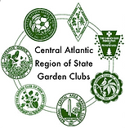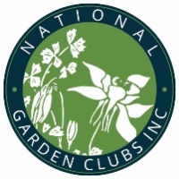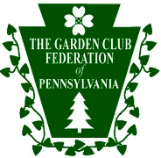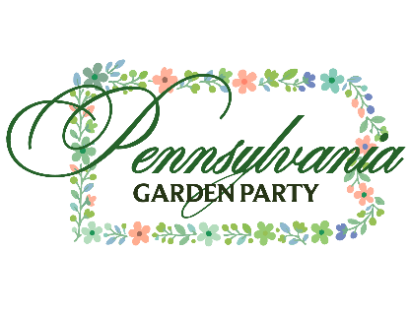

SATURDAY, JUNE 20, 2026

SATURDAY, JUNE 27, 2026

The Garden Club Federation of Pennsylvania is hosting a statewide garden tour called the PA Garden Party! We would like for you to be a part of this celebration of the beautiful gardens in our keystone state by taking an ad in the tour booklet.

Your ad assists Garden Clubs to continue their local and statewide efforts. Here are some facts to consider:

GCFP has 5,000 members and 103 clubs

One hundred gardens will be open for paying visitors on Saturday, June 20 and 27, 2026

$25 buys a ticket and a **statewide tour booklet** for both days

Your ad will be seen by thousands of people across the state and in your area

GCFP members support local communities with:

* Youth Gardening Programs
* Club, State and National College and Trade School Scholarships
* Statewide Art, Gardening and poetry contests
* Civic Beautification projects
* Highway Blue Star Markers and Gardens to Honor Our Military
* Flower Shows to Educate the Public
* Statewide and Local Conservation Environment Programs
* Horticulture Therapy in Rehab Facilities and Nursing Homes

We hope that you will ‘Join the Party’!