GARDEN CLUB FEDERATION OF PENNSYLVANIA

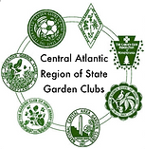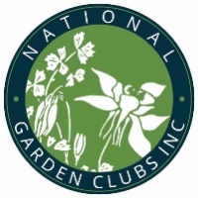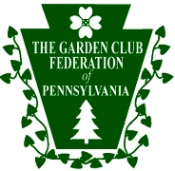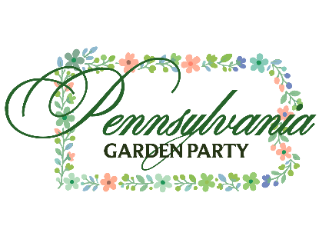

SATURDAY, JUNE 20, 2026

SATURDAY, JUNE 27, 2026

The Garden Club Federation of Pennsylvania is excited to be hosting a statewide garden tour called the PA Garden Party! We would like for you to be a part of this celebration of our beautiful state.

GCFP has 5,000 members and 103 clubs

Approximately 100 gardens will be open for paying visitors on Saturday, June 20 and 27, 2026

$25 buys a ticket and a statewide tour booklet for both days

GCFP members support local communities with:

* Youth Gardening Programs
* Club, State and National College and Trade School Scholarships
* Statewide Art, Gardening and poetry contests
* Civic Beautification projects
* Highway Blue Star Markers and Gardens to Honor Our Military
* Flower Shows to Educate the Public
* Statewide and Local Conservation Environment Programs
* Horticulture Therapy in Rehab Facilities and Nursing Homes

We are so grateful that you will allow us to showcase your beautiful garden as part of our PA Garden Party. Here is some information that you should know:

Gardens will be open to paying guests from 9:30 until 4:00. The Garden Club hosting your garden will inform you if yours will be open on Saturday, June 20 or Saturday, June 27. This is a rain or shine event.

There will be hosts/hostesses present at your property serving in shifts during the day.

Guests are not permitted to use your facilities.

Please be sure that paths are free of obstacles or tripping hazards. Indicate to your Garden Club Representative if your garden is wheelchair accessible.

It will be appreciated if cold water could be available for guests.

Please direct any questions or concerns to your local Garden Club Representative. Thank you for your generosity in sharing the beauty of your garden. We are delighted that you are ‘Joining the Party’!