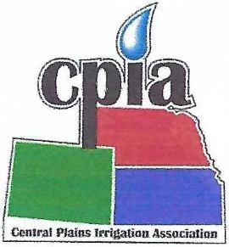
CENTRAL PLAINS IRRIGATION ASSOCIATION
760 N. Thompson Colby, Kansas 67701 Phone/Fax: 785-462-7574 Email: donnalamm@yahoo.com

EXHIBITOR REGISTRATION
CENTRAL PLAINS IRRIGATION
EQUIPMENT EXHIBITOR REGISTRATION
February 28-March 1, 2023 Younes Center, Holiday Inn Kearney, Nebraska

Company Name _____________________________________________________________

Company Representative ______________________________________________________

Address ____________________________________________________________________

Telephone ______________________________ Fax ________________________________

Representative’s Email ________________________________________________________

Booths are 8 feet by 8 feet and cost $450. It includes a 8-foot table and chairs. Cost includes booth space and CPIA membership for 2023. Please indicate if you need electricity. ______________YES ___________ NO

A Power Point presentation that includes 3-5 images of exhibitor products will be displayed at the conference. If interested in this activity, please send your images to Donna Lamm by Feb. 21.

CPIA will be giving away door prizes throughout the day. If you would be willing to donate something for a door prize please check here. _______

The person listed above receives free registration with the purchase of a booth. If you are bringing additional staff please list them below. Registration is $55 for each additional person.

_________________________________________________________ _________________________________________________________

_________________________________________________________ _________________________________________________________

PLEASE RETURN THIS FORM, AND ALL FEES (check or credit card; payable to Central Plains Irrigation Association) by Feb. 20, 2023, to: Donna Lamm, Executive Assistant
760 N. Thompson Ave.
Colby, KS 67701

Credit Card Number ______________________________________ Exp Date __________ CSC _________ ZIP Code ____________

