|  |  |
| --- | --- |
| G:\Emergency Management\500050\Karlee\Logo\triad-logo_FINAL-circular.png  Assessment of Vulnerabilities that effect regional healthcare  2023-2024 | Quick Guide to Regional Hazard Vulnerabilties |

**Table of Contents**

Pg. 2-4: Regional Hazard Vulnerability Analysis

Pg. 5: Regional Critical Infrastructure

Pg. 6: Hazard and Vulnerability Assessment Tool

Pg. 7: Regional Population Density

Pg. 8-9: Regional Participants

Guided by the Administration of Strategic Preparedness & Response (ASPR) the Hazard Vulnerability Assessment (HVA) process includes “conducting a risk assessment that is required by the CMS Emergency Preparedness Rules, The Joint Commission Emergency Management, and NFPA (Healthcare 99-101, Chapter 12, Emergency Management).” Every medical facility and county emergency management entity within the region must create and update an HVA. These documents explain which aspects of natural and technological disasters the entity is most vulnerable to. This opportunity allows the Triad Healthcare Preparedness Coalition (THPC) to understand the events and circumstances that may assist in reducing the ability of healthcare facilities to provide care.

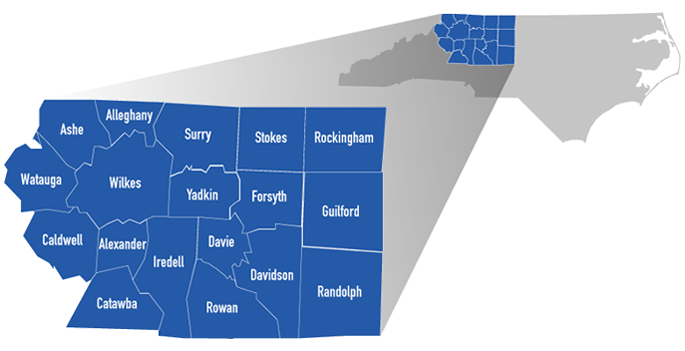

Within the 18-county region, each county has various vulnerabilities that may not coincide with other areas. Population, elevation, access to medical care, transportation routes, and various other markers of concern differentiate vastly from one side of the region to another.

Each long-term care facility, hospital, and county emergency management have created HVAs for their areas and critical infrastructure. The below are identified as the most likely to impact regional healthcare capabilities.

|  |  |
| --- | --- |
| Hazard | Cause |
| Inclement Weather | This hazard is ongoing throughout the year with many different aspects. Heavy rains, high wind speeds, lightening, flooding, landslides, tornadoes, and hurricanes are all possibilities within the region. |
| Staffing Issues | All agencies across the state and nation have been faced with staffing crisis of some depth. This may be in the form of overall staffing numbers, or trained staff with abilities to function at a normal capacity. |
| Hurricane | While our region does not typically face direct landfall implications, we do have remnants of hurricanes through our region. This may result in flooding and landslides in our mountain portion. The remainder of the area may see severe weather and tornado outbreaks from outer bands of storms coming through. |
| Facilities Failure | Disruptions of facilities poses many issues within the region. These may be easy to rectify or week(s) long issue. We have recently seen within the state a domestic terrorist attack causing major facilities failures that have shown to have many continuity issues a year later. Maintaining facilities is a very important aspect to providing continuous medical care. |

**Methodology**

Regional medical continuity is the main concern of THPC. Healthcare systems should be able to prepare and mitigate possible situations that may keep them from continuity of care. In order to utilize the most updated information from the region, communications were sent to all stakeholders within the THPC region. Stakeholders include long term care facilities, county emergency management, hospital, public health, and supportive care facilities. The below information has been updated based on HVAs that were turned in for viewing.

**Conclusion**

With stakeholder input, THPC is able to create a well-rounded HVA that shows the most updated hazards from the region. Knowing the vast differences throughout our region can assist THPC with being better prepared to respond to events regionally.

**Regional Critical Infrastructure**

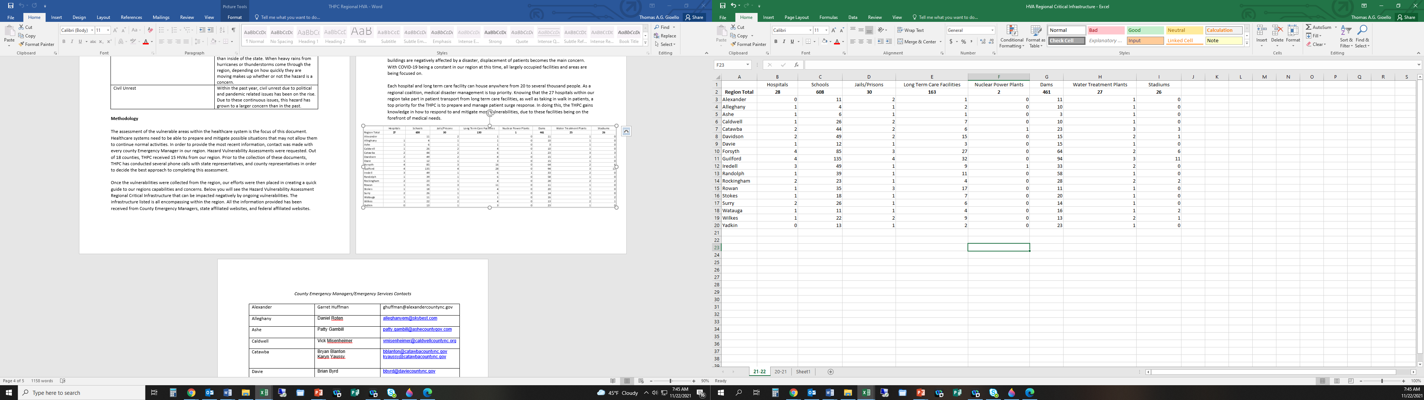

**Kaiser Permanente**

**Hazard and Vulnerability Assessment Tool**



**Population Density Per Regional County**

|  |  |  |
| --- | --- | --- |
| **Rank** | **County** | **Population** |
| 3 | [Guilford County](https://www.northcarolina-demographics.com/guilford-county-demographics) | 541,299 |
| 4 | [Forsyth County](https://www.northcarolina-demographics.com/forsyth-county-demographics) | 382,590 |
| 14 | [Iredell County](https://www.northcarolina-demographics.com/iredell-county-demographics) | 186,693 |
| 17 | [Davidson County](https://www.northcarolina-demographics.com/davidson-county-demographics) | 168,930 |
| 18 | [Catawba County](https://www.northcarolina-demographics.com/catawba-county-demographics) | 160,610 |
| 20 | [Rowan County](https://www.northcarolina-demographics.com/rowan-county-demographics) | 146,875 |
| 21 | [Randolph County](https://www.northcarolina-demographics.com/randolph-county-demographics) | 144,171 |
| 31 | [Rockingham County](https://www.northcarolina-demographics.com/rockingham-county-demographics) | 91,096 |
| 34 | [Caldwell County](https://www.northcarolina-demographics.com/caldwell-county-demographics) | 80,652 |
| 37 | [Surry County](https://www.northcarolina-demographics.com/surry-county-demographics) | 71,359 |
| 40 | [Wilkes County](https://www.northcarolina-demographics.com/wilkes-county-demographics) | 65,969 |
| 49 | [Watauga County](https://www.northcarolina-demographics.com/watauga-county-demographics) | 54,086 |
| 57 | [Stokes County](https://www.northcarolina-demographics.com/stokes-county-demographics) | 44,520 |
| 60 | [Davie County](https://www.northcarolina-demographics.com/davie-county-demographics) | 42,712 |
| 64 | [Yadkin County](https://www.northcarolina-demographics.com/yadkin-county-demographics) | 37,214 |
| 67 | [Alexander County](https://www.northcarolina-demographics.com/alexander-county-demographics) | 36,444 |
| 73 | [Ashe County](https://www.northcarolina-demographics.com/ashe-county-demographics) | 26,577 |
| 94 | [Alleghany County](https://www.northcarolina-demographics.com/alleghany-county-demographics) | 10,888 |

Source: United States Census Bureau 2020 statistics. Date Accessed November 2023.

**Hazard Vulnerability Assessment Participants**

|  |  |  |
| --- | --- | --- |
| **Participant** | **Entity/Facility** | **County** |

|  |  |  |  |
| --- | --- | --- | --- |
| Eddie | Bowling | Novant Medical Center | Davidson |
| Lisa | Johnson | Pine Ridge Health and Rehab | Davidson |
| Daniel | Fox | County Emergency Management | Alexander |
| Joyce | Hughes | Novant Medical Center | Davidson |
| Zack | Faircloth | Hugh-Chatham Memorial Hospital | Surry |
| Darin | Manuel | Northern Hospital of Surry County | Surry |
| Jordan | Cramer | Caldwell Memorial Hospital | Caldwell |
| Joel | Inman | Frye regional Medical Center | Alexander |
| Matthew | Merritt | Novant Medical Center | Forsyth |
| Rodney | Cates | County Emergency Management | Rockingham |
| Cyndi | Owens | Hospice of the Piedmont | Guilford |
| Chad | Scott | Novant Health Rehab | Forsyth |
| Kyle | James | AHWFB Wilkes Regional Medical Center | Wilkes |
| Phillip | Hernandez | AHWFB Davie Medical Center | Davie |
| Christie | McCorquodale | Randolph Hospital | Randolph |
| Annette | Cook | Outpatient Surgical Center | Forsyth |
| Dawn | Cutts | AHWFB High Point Regional | Guilford |
| Anne | Newsome | Novant Medical Center | Forsyth |
| Charlotte | Martin | Rockingham County Health Department | Rockingham |
| Timothy | Pennington | AHWFB Wilkes Regional Medical Center | Wilkes |
| Tiffany | Eldridge | Davie County Public Health | Davie |
| Donald | Brooks | Ashe Memorial Hospital | Ashe |
| Teresa | Matos | A New Outlook Long Term Care | Alexander |
| Alyson | Best | Guilford County Public Health | Guilford |
| Savannah | Hayes | Stokes- Reynolds Memorial Hospital | Stokes |
| Dino | DiBernardi | County Emergency Management | Caldwell |
| Thomas | Chang | AHWFB Lexington Medical Center | Davidson |
| Allyson | Summitt | Rowan County Emergency Management | Rowan |
| Leigha | Cordell | County Emergency Management | Forsyth |

**Additional reference information was obtained from:**

* + American Hospital Directory. Ahd.com
  + NC Department of Public Instruction
  + NC Department of Public Instruction
  + NC Department of Natural Resources
  + NC Division of Health Human Services
  + NC Department of Environmental Quality