Infiniti School Newsletter 

(Term 5, 2021)

This Term’s News

Dear Parents/Carers,

Welcome to the first Infiniti School newsletter!

We intend to use the newsletter to showcase the amazing things our students have been doing throughout the school year, celebrating their successes, and keeping you informed of any upcoming events.

As for any school, this year has been challenging.  Opening in October, remote learning for two weeks before Christmas, then back to school, then remote learning in the new year.  All this in the first few months of the school opening, and at the same time increasing the number of students and staff.

Students have taken part in a number of activities including Forest School, rock climbing, kayaking and ice skating, amongst others.  The attitude and engagement of students in all areas of the curriculum has been outstanding and we have seen lots of progress made.

Near the end of this term we plan to have an open day for parents to attend and see the progress their children have made.  We are waiting until we know that this can go ahead to send you the details, and will let you know as soon as we know.

FOREST SCHOOL & other outdoor educational pursuits

As you all know, *Forest School* is an integral part of how we run things here at *Infiniti*, and with the students having one day a week dedicated to it, we thought you might like to have a bit of an update on some of the exciting things our students were doing in Term 5 and the skills they have been learning as part of their wider curriculum. These include:

* Simple bushcraft skills such as how to build a shelter and a fire;
* Fishing, archery, climbing, cooking, canoeing to name a few

Jack offers us all some insight here:

*“We participate in multiple acitivities like* Forest School, *where we do fishing, archery and cooking and many more...*[While] *the lake… has loads of little fish, a lot of the time we try catching the large fish but so far we have had no luck. We really enjoy it….Our teachers always look after us if we are cold, [giving] up their coats just so we don’t freeze”* {Editor’s note: thankfully not cold anymore at the time of publishing this newsletter, lol}. *“At* Forest School *we can make catapaults, and whittle wood... as we explore the woods. We also learn team building skills.”*

In the words of Ethan in Year 10: ‘*Archery is a good new skill. You have to be determined to do it and not give up easily…if you fail and can’t do it remember that “FAIL” means “first attempt at learning.”’*

Ethan, we couldn’t have said it better…. Meanwhile, here’s Scarlet on *Forest* School fishing while fishing!

REMINDER - July 5 - Sailing Trip

Update: as Bill wrote to you early last term about the upcoming Sailing Residential Course, you will know that this wonderful, life-changing experience doesn’t come cheap. The students are VERY excited about this and although we have had generous contributions from a number of organisations, we STILL NEED YOUR HELP TO RAISE MONEY!

If you can help in ANY way, please email Bill directly: bjones@infinitischool.co.uk

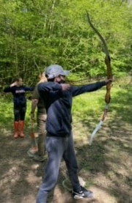



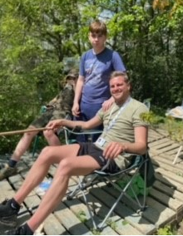

***Hi I’m Christopher and I’m in year 7. I attend forest school once per week on a Monday, where I have the opportunity to learn new skills. I have recently caught a Grass carp. (see picture of Grass Carp)***

***We can also do archery at forest school. We learn to use real arrows and a bow… pew pew. We are taught to use a bow and arrow properly to shoot arrows into a target. My highest score is a bulls eye.***

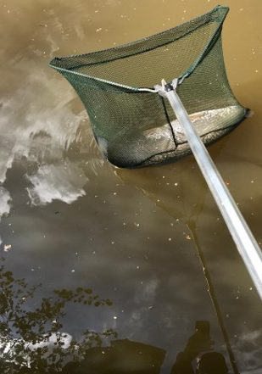

But don’t just take the Year 10’s words for it; *Forest School* is for ALL our students and this is part of what makes it such a unique aspect to our students’ educational enrichment:

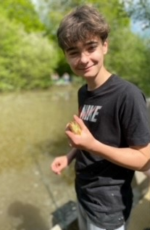

*“There is a massive fish in the pond called ‘Goldie’. I have tried to catch her many times. I did get her on once but she came off.”* (ed. note: *‘Whatevs, Jack*!’)

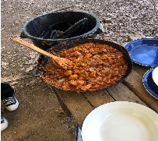

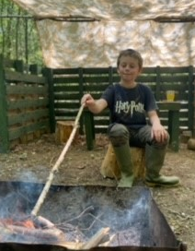

*“Climbing is really fun but also terrifying because it pushes your limits. Every time we went higher and higher the teachers would support us. I remember Scarlet once was scared. She tried her hardest to reach the top and face her fear. When we went canoeing she really did not want to go but she did and made it out safe and sound, unlike Chloe who fell in but was laughing about it afterwards.”* Jack – Year 10

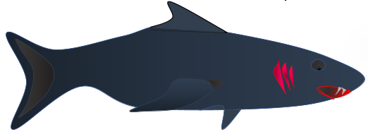

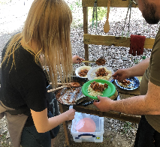



***“So this is me fishing on a sunny* [Forest School] *day. The sun glistened across the water… [and] I saw the reflective vivid colours of the fish swimming in circles… The gentle breeze swept across my arms and the soft sway of the trees made a slight rustle of the leaves across the water.***

***I felt a fish nibble at my bait on the end of my fishing rod, [pulling] the end of the rod into the water, bobbing in and out.”***

Infiniti School Newsletter

(Term 5, 2021)

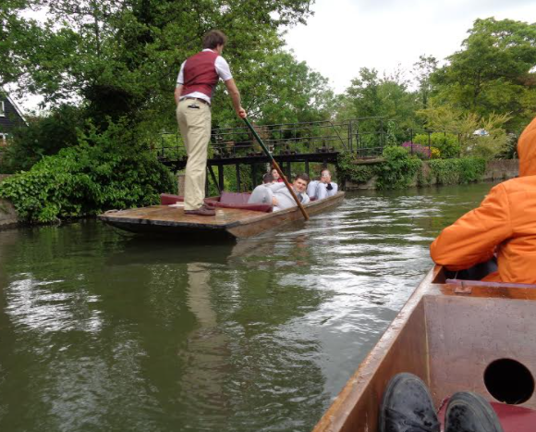

Year 9 Geography Field Trip

Year 9 have all worked extremely hard on the topic of Rivers in Term 5. To make our learning in the books relevant to real life, we followed the river Stour from its source in Lenham to the mouth in Pegwell Bay speaking about the components of the different lesson as we made our way through the Upper, Middle and Lower course, carrying out a variety of activities on the way. As the photos show, what a time was had!



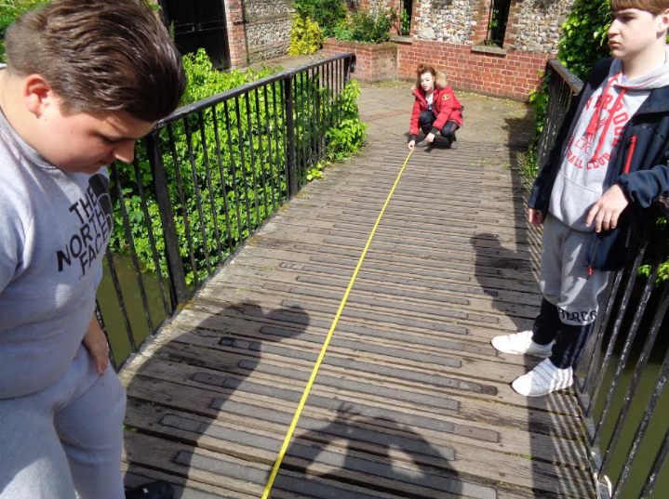

“Alone we can do so little; together we can do so much.” – Helen Keller

Upcoming Events & Key Dates

7th & 8th June – Staff Development Days

5th July – Sailing Residential: Cornwall, Dorset & Isle of Wight

21st July – End of Term 6



**Last Word.**

**Embracing School Values: Compassion**

Students are embarking on a project to investigate homelessness both locally and around the world. We will be making items from recycling crisp packets and landfill plastic to make survival items for the homeless and less fortunate communities. Please help us by saving your crisp packets. (washed and cut open and laid flat packets would be great!)

Key Contacts:

**Headteacher Nick Rogers:** *headteacher@infinitischool.co.uk*

**School Office** 01795886687