**FOR IMMEDIATE RELEASE**

**Baby Dog Goes to Washington**

Almost Heaven Media, LLC  
 PO Box 8892  
 South Charleston, WV 25303  
 Phone: (304) 415-6868  
 Email: hello@ahmdigital.com

**November 11, 2024**

**Subject: Baby Dog loves West Virginia, but she is going on an adventure to Washington, DC!**

**CHARLESTON, WEST VIRGINIA** — *Baby Dog Goes to Washington* is a charming new children’s book that brings together a love for animals, a passion for West Virginia, and a fun, educational look at U.S. government. Beautifully illustrated, the book appeals to children, dog enthusiasts, and proud West Virginians of all ages.

In this delightful story, Baby Dog shares the wonders of her West Virginia home before taking readers along on her big adventure to Washington, DC. Along the way, she introduces valuable lessons about the importance of voting, landmark sites in the nation's capital, and key structures of government. From the U.S. Supreme Court to the story behind the Constitution, Baby Dog explains America’s complex government system in a way that’s both playful and engaging.

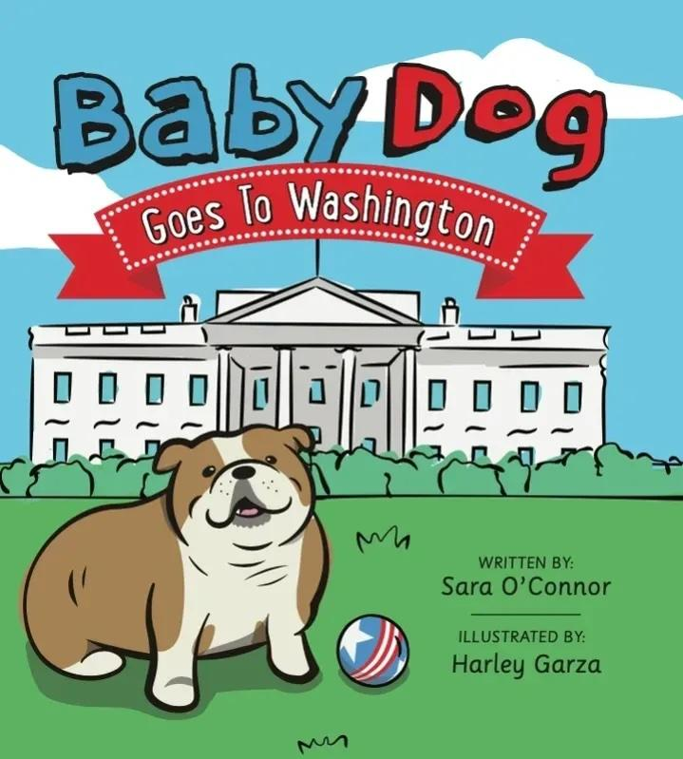

All proceeds from *Baby Dog Goes to Washington* will go to West Virginia charities, making each purchase a way to support the community.

**About the Creators** Author Dr. Sara O’Connor, a West Virginia native, mother, and physician, wrote *Baby Dog Goes to Washington* to help children understand how the U.S. government works and to support charitable causes throughout West Virginia. Illustrator Harley Garza, based in Florida, is a graphic designer making his debut in children’s books. He brings Baby Dog’s journey to life with vibrant artwork that’s sure to captivate readers.

For more information or to schedule an interview, please contact Almost Heaven Media at hello@ahmdigital.com. You may obtain copies of the book by visiting [babydoggoestowashington.com](http://babydoggoestowashington.com)