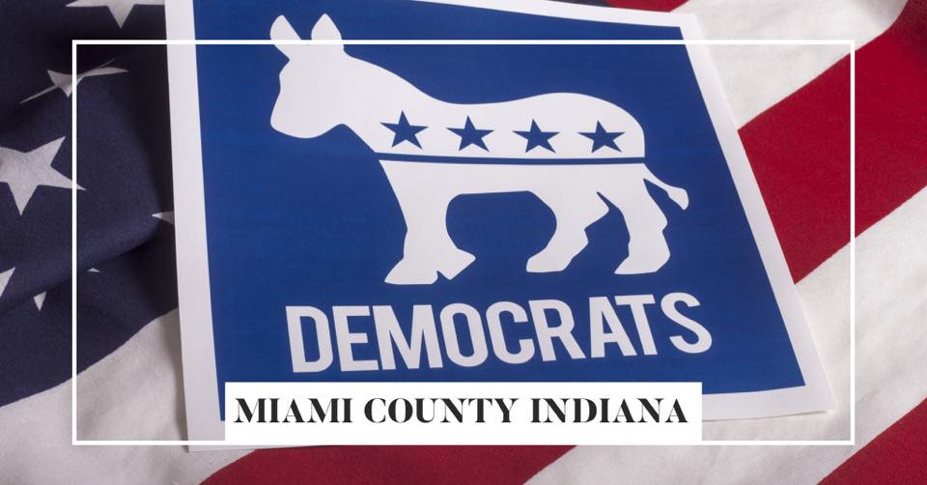

|  |  |  |  |
| --- | --- | --- | --- |
|  |  | MC DEM PEOPLE | April 2025  Issue 01 |
|  |  | The latest news, views, and announcements | |
| INSIDE  _  WELCOME  Who We Are  Next Meeting  __  CENTRAL COMMITTEE  February Meeting March Meeting  __  UPCOMING EVENTS  Central Committee Women’s Committee Election Committee Legislative Committee Pride Committee Diversity Committee  Young DEM Committee |  |  | |
|  |  | Democratically-Minded PeopleWELCOME!  * ***By INDEMS - Miami County Democrats***   We hope you enjoy this month’s information sharing. If you are interested in placing information in this newsletter, please contact us at [contactus@mcdem.org](mailto:contactus@mcdem.org).  WELCOME!  As Chair of the INDEMS - Miami County Democratic Party Central Committee, I am so pleased to send this inaugural newsletter. After being elected at our County Reorganization meeting on March 1, 2025, I promised the Precinct County Chairs in attendance that I would do three things:   1. I will automate our fundraising and set a leadership goal of fundraising $20,000.00 by the end of the year and introduce creative and thoughtful new ways of rebranding our time-honored traditions and value of the Party and our Community members. 2. I will lead by following the mission and rules of the Democratic Party, to include placing our Precinct Chairs in their authorized place of leadership, and answer to their leadership as directed by their constituents. 3. I will be transparent with the roles of leadership at the Central Committee level and in our clubs and groups, and ensure our efforts are inclusive, not divisive,   and work to encourage a robust list of candidates for all elections and appointments, within the Party and in our ascension to County, City, State, and Federal elections.  Please join us at the next meeting to learn more about our rebranding and our efforts to grow the Local Central Committee.  At our next meeting, I will be sharing the names of the members who will head up our committees and ask for volunteers for a few projects like the Peru Circus Week, and the H&H Dinner. If you are interested in the research form our Blue Summer Jam, please come to the meeting with your ideas to hear about this awesome event being researched and planned. WHO WE ARE: We are the Miami County Central Committee of the Indiana Democratic Party. We support the Democratic Party and **Reigniting Hoosier Pride:** BRINGING BACK BALANCE, COMMON SENSE, AND TRUE INDIANA VALUES. NEXT MEETING: The next meeting of the Miami County Central Committee will be April 28, 2025, at 6:00pm at the Peru Indiana Civic Center, 225 E. Riverview Dr., Peru, IN 46970. | |

|  |  |
| --- | --- |
| **MAY 3, 2025**  **PLEASE HELP – IT IS APPRECIATED!**  We need Volunteers for the Miami County Democratic Party Annual Pancake Breakfast. Please sign up for one or more of these tasks. | **Miami County Democratic Party**  **ANNUAL PANCAKE BREAKFAST**   |

|  |  |
| --- | --- |
| **DAY BEFORE EVENT – MAY 2, 2025 AT 5:00PM**   1. Pick up sausage at Royal Center Meat Locker. 2. Pick up supplies at GFS. 3. Setup and design on Friday night at the 4H Fairgrounds 4. Make Money Tree (done – Marilyn Wagner) 5. Flowers for table 6. Runners for table (paper) 7. Large pieces of cardboard for the floor to go under the grill where the pancakes are cooked and the   Sausage is fried.   1. Set up tables and clean them up.... 2. Decorate the tables and the room 3. We need 4 men to carry in grill parts and assemble grill and clean it and clean grill sausage will be cooked on. 4. Green frame for grill and hook to gas line. 5. Prep area the carry out area. 6. Signs needed: Front door to the patio area: (A) **Enter Here**, (B) **Sign for sale items from Women’s Club and other Miami County Democrat members**,(C) **Take a seat you will be served**,(D) **Thank You! From the Miami County Democrats!** | **DAY OF EVENT – MAY 3, 2025 (STARTING AT 5:00AM)**   1. Mix pancake Batter one hour before serving. 2. Start Grills make test pancakes one hour before serving (we start serving at 7:00AM). 3. Start Sausage grill and test that grill do not want grills too hot. 4. Hang signs. 5. Sell Tickets. 6. Check prepaid list. 7. Sell money tree tickets. 8. Serve and refill drinks. 9. Take orders and deliver plates of food (put sausage and pancakes on plate). 10. Clear tables. 11. Deliver clean silver and placemats. 12. Clear used plates and scrape plates. 13. Wash dishes and run dish washer have Dave set it up. |

# CENTRAL COMMITTEE MEETING NOTES

## FEBRUARY 2025 Meeting – We had 4 new attendees at the meeting, and 5 new people sign up for the Facebook group in the month of February. This was the last meeting before the March 1, 2025 reorganization elections. Thank you to the members who have sent $25 annual membership donation, or signed up for ActBlue recurring donations. If you are interested in donating to the good works of the Miami County Democratic party, please go to our ActBlue link, https://secure.actblue.com/donate/2025mcdems .

## MARCH 2025 Meeting – We had four new members at the meeting, and 3 new people sign up for the Facebook group in the month of March. The meeting was held at the Peru Civic Center and MC DEM members provided dinner, desert, and drinks. The attendees voted to not send tickets out for the Pancake breakfast, but members will receive a postcard to alert them of the breakfast information. The DEM leadership at the County, District, and State level have been asked to attend and make themselves available to the members and attendees. The Executive Board of Peru Pride did a presentation for MC DEM on upcoming events and how to be a good ally, highlighting statistical County information for targeted demographics.

|  |  |
| --- | --- |
| UPCOMING EVENTS | |
| Central Committee | April 28, 2025 6PM - Member Meeting  May 3, 2025 7AM-11AM – Annual Pancake Breakfast |
| Diversity Committee | PENDING |
| Election Committee | PENDING |
| Legislative Committee | PENDING |
| Pride Committee | PENDING |
| Women’s Committee | May 6, 2025 6PM– Women’s Committee Meeting  INDEMS Women’s Caucus Training, 7 E Market St, Huntington, IN 1-4PM |
| Young DEM Committee | PENDING |