January 10, 2024

Regarding the 2024 Hospitality Room, Jay Kiser started an email communication with the Executive Board of the Virginia Mosquito Control Association on January 10, 2024 at 8:05am.

The VMCA members included in the email communication were Past President Wes Robertson, President Elect (Acting President) Karen Akaratovic, Vice President Lauren Lochstampfor, First Vice President Addie Weddle, Secretary/Treasurer Jay Kiser, Industry Representative Interim Zach Cohen, MAMCA Representative Tim DuBois, Local Arrangements Committee Chair Charles Abadam, and Hospitality Room Committee Chair Carolyn La Liberte.

Jay’s email communication stated:
Carol sent Charles and I her final cost breakdown for the hospitality room, and she wanted me to send it to all of you. I attached the pdf here. It looks like she is asking for $500 to cover the costs of food, drinks, and other supplies. I am not sure if we would like to make a motion via email, or wait till the next board meeting (January 31).
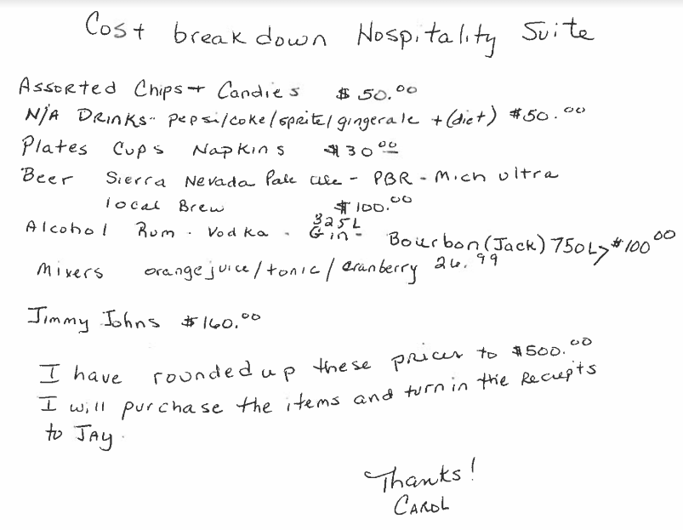
Karen said she didn’t mind a motion made by email. Both Karen and Tim thought the costs looked reasonable. Jay Kiser made a motion, seconded by Zachary Cohen, to allow Carol to spend up to $500 on food, beverages, and supplies for the 2024 hospitality room. There was no discussion, All voting members in favor, none opposed. Motion carried 1/17/2024 at 1:43pm.

Respectfully Submitted,

Jay Kiser
Secretary/Treasurer VMCA

