CONUS Guideline for Evaluating

Insecticide Resistance in Vectors

Using the CDC Bottle Bioassay

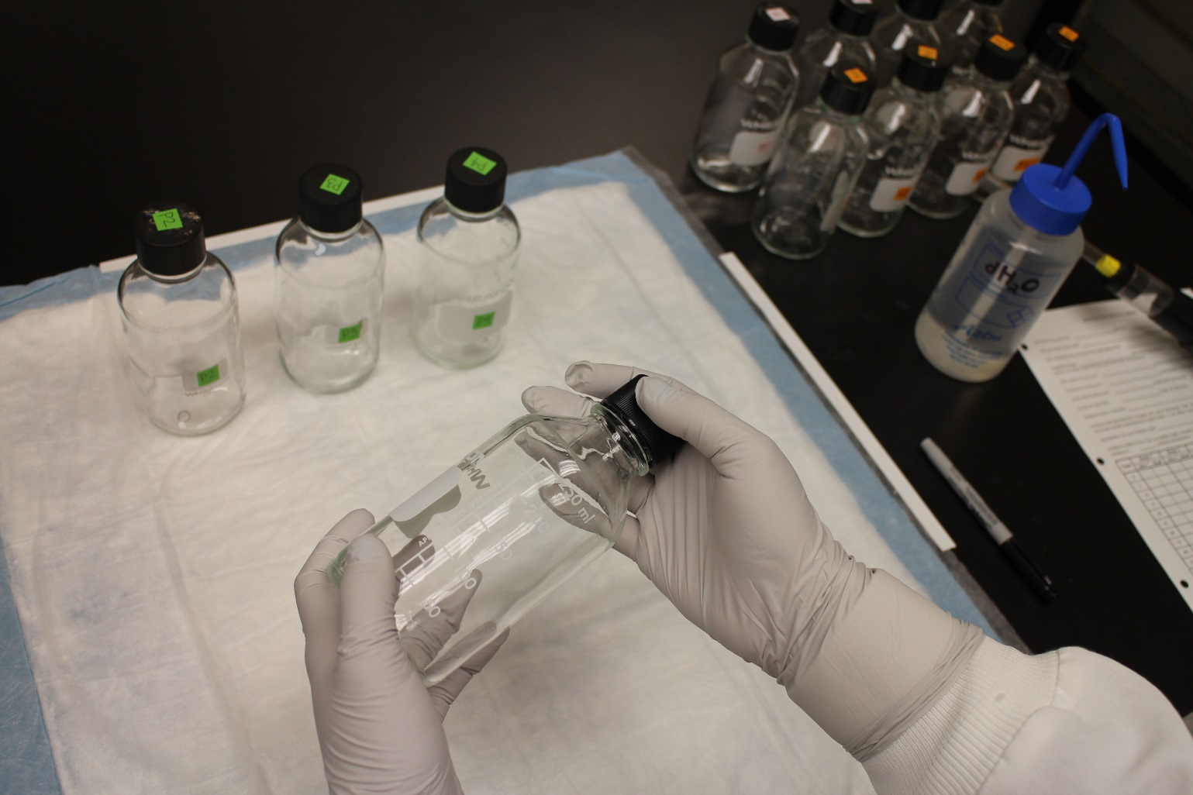

**INDEX**

**1. Introduction.....................................................................................................4**

**2. Material and reagents...................................................................................4**

2.1. Material.............................................................................................................4

2.2. Reagents...........................................................................................................5

2.3. Biological material...........................................................................................5

**3. Initial considerations......................................................................................6**

3.1. Diagnostic dose and diagnostic time...........................................................6

3.2. Preparation of stock solutions.........................................................................7

3.3. Mosquito handling...........................................................................................8

3.4. Procedures for cleaning and drying bottles before coating.....................8

3.5. Marking of bottles............................................................................................8

3.6. Bottle coating...................................................................................................9

**4. CDC bottle bioassay method......................................................................11**

4.1. General considerations.................................................................................11

4.2. Bioassay procedure.......................................................................................11

4.3. Handling of coated bottles..........................................................................12

4.4. Identification of mechanisms of resistance................................................13

4.5. Validity of the data........................................................................................13

4.6. Interpretation of results..................................................................................13

**5. Resistance surveillance...............................................................................15**

5.1. Background....................................................................................................15

5.2. Features of resistance emergence..............................................................15

5.3. Focal nature of resistance............................................................................15

5.4. Resistance and disease control...................................................................15

5.5. Guiding principles..........................................................................................16

**6. CDC bottle bioassay and synergists..........................................................16**

6.1. Background....................................................................................................16

**7. Bibliography.................................................................................................16**

**Appendix 1. Frequently asked questions (FAQs).........................................17**

**PREFACE**

Insecticide resistance in a vector population is initially detected and characterized by using some sort of bioassay to determine whether a particular insecticide is able to control a vector at a given time. Ideally, this fundamental question should be answered before a particular insecticide is chosen and procured for vector control.

The Centers for Disease Control and Prevention (CDC) bottle bioassay is a surveillance tool for detecting resistance to insecticides in vector populations. It is designed to help determine if a par­ticular formulation of an insecticide is able to control a vector at a specific location at a given time. This information, combined with results of bioassays using synergists and those of biochemical and molecular assays, can assist in determining which insecticide should be used if resistance is detected.

The aim of this document is to provide a practical laboratory guideline that describes how to per­form and interpret the CDC bottle bioassay. Information for resistance testing can also be obtained from the CDC website at <http://www.cdc.gov/malaria>.

We hope you find this tool useful in the support of vector control programs.

Sincerely,

Janet C. McAllister, PhD Mariah (Cassie) Scott

Research Entomologist Biologist

Arboviral Disease Branch Arboviral Disease Branch

Division of Vector-Borne Diseases Division of Vector-Borne Diseases

Centers for Disease Control and Prevention Centers for Disease Control and Prevention

3156 Rampart Road 3156 Rampart Road

Fort Collins, CO 80521 Fort Collins, CO 80521

Tel: 970.225.4239 Tel: 970.226.3547

E-mail: [jvm6@cdc.gov](mailto:jvm6@cdc.gov) E-mail: [gni6@cdc.gov](mailto:gni6@cdc.gov)

**GUIDELINES**

**1. Introduction**

Bioassays allow for the detection and characterization of insecticide resistance in a vector population. This guideline will describe the Centers for Disease Control and Prevention (CDC) bottle bioassay, a tool for detecting resistance to insecticides. The information provided by this bioassay, combined with results of bioassays using synergists and those of biochemical and molecular assays, can also assist in determining mechanisms associated with resistance.

The CDC bottle bioassay relies on time mortality data, which are measures of the time it takes an insecticide to penetrate a vector, traverse its intervening tissues, get to the target site, and act on that site. Anything that prevents or delays the compound from achieving its objective — killing insects — contributes to resistance. Information derived from the CDC bottle bioassay may provide initial evidence that an insecticide is losing its effectiveness. This methodology should be considered for routine use even before an insecticide is considered, and procured, for vector control.

The CDC bottle bioassay can be performed on vector populations collected from the field or on those reared in an insectary from larval field collections.

A major advantage of this bioassay is that different concentrations of an insecticide may be evaluated. Furthermore, the technique is simple, rapid, and economical compared to other alternatives. The CDC bottle bioassay can be used as part of a broader insecticide resistance monitoring program, which may include the World Health Organization (WHO) paper-based bioassay, and biochemical and molecular methods.

The CDC bottle bioassay can be used for any insect species. For the purposes of this guideline, mosquitoes will be used as an example.

**2. Materials and reagents**

**2.1. Materials**

* 250-ml Wheaton bottles with screw lids (Figure 1). Each bioassay typically requires five bottles: four for replicates and one for control;
* Graduated disposable plastic pipettes that can measure 1 ml, or micropipetters and tips;
* Aspirator apparatus for collecting mosquitoes;
* Containers for transferring/holding mosquitoes;
* Bottles for stock solutions. These can be amber-colored or foil-wrapped if clear bottles are used (50–1,000 ml depending on the user’s choice of stock solution volume);
* Timer capable of counting seconds;
* Permanent markers for labeling bottles, caps, and pipettes;
* Masking tape for labeling bottles, caps, and pipettes;
* Disposable gloves;
* Sheets, pens, and pencils for data recording.

**2.2. Reagents**

* Insecticide(s) to be tested (technical grade);
* Acetone or technical grade absolute ethanol.

**2.3. Biological material**

* Mosquitoes for testing.

**Note:** Use safety procedures as recommended by your institution when handling insecticides (e.g., procedure gloves, laboratory coat).

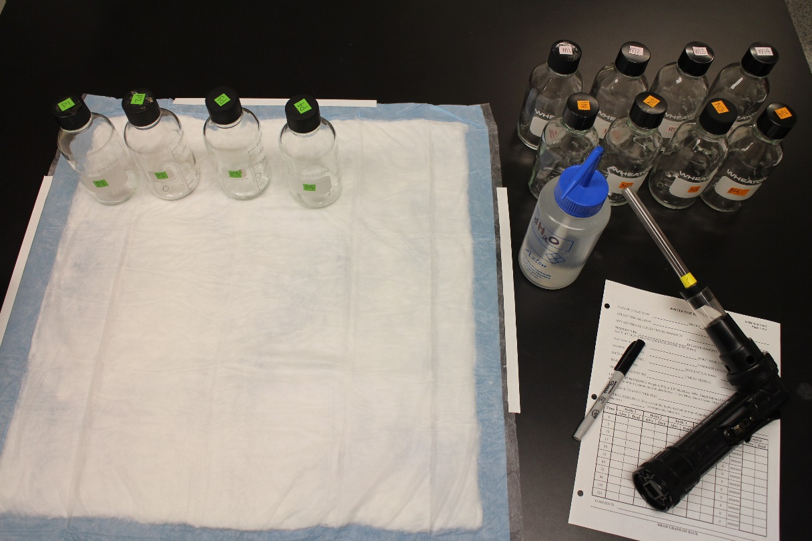

**Figure 1:** Materials and reagents for the CDC bottle bioassay.

**3. Initial considerations**

**3.1. Diagnostic dose and diagnostic time**

The first step in standardizing the CDC bottle bioassay is to determine the diagnostic dose and the diagnostic time. The diagnostic dose is a dose of insecticide that kills 100% of susceptible mosquitoes within a given time. The expected time for the insecticide to achieve this objective is called the diagnostic time. Those are the reference points against which all other results are compared. Resistance is assumed to be present if a significant portion of the test population survives the diagnostic dose at the diagnostic time.

The diagnostic dose and the diagnostic time should be defined for each insecticide, each region, and each vector species that is monitored. The diagnostic dose and the diagnostic time are validated using a susceptible population of vectors collected from the field. Once the diagnostic dose and the diagnostic time for a species from a given location have been determined, these parameters should be used for testing that particular vector population from that location from that time on. Use of the same parameters is required to detect changes in the response of the population over time (e.g., number of test mosquitoes surviving after an exposure time that originally killed 100% of the test population). Table 1 shows diagnostic doses and diagnostic times applicable to *Aedes aegypti*, *Ae. albopictus,*  *Culex molestus,*  *Cx. pipiens*, *Cx. quinquefasciatus,* and *Cx. tarsalis* mosquito populations as determined at the CDC in Fort Collins, CO. The diagnostic doses and the diagnostic times in Table 1 serve as sample reference points for the main insecticides used in the continental United States.

|  |  |  |  |  |  |  |  |
| --- | --- | --- | --- | --- | --- | --- | --- |
| **Table 1: Sample diagnostic doses and diagnostic times for technical grade insecticides.** | | | | | | | |
| **Insecticide** | **Insecticide concentration (µg/bottle)** | **Diagnostic time per species (minutes)** | | | | | |
| *Ae. aegypti* | *Ae. albopictus* | *Cx. molestus* | *Cx. pipiens* | *Cx. quinquefasciatus* | *Cx. tarsalis* |
| Chlorpyrifos | 20 | 45 | 45 | 45 | 90 | 45 | 60 |
| Deltamethrin | 0.75 | 30 | 30 | -- | 45 | 60 | -- |
| Etofenprox | 12.5 | 15 | 30 | 105 | 15 | 30 | 60 |
| Fenthion | 800 | -- | -- | 30 | 75 | 45 | 45 |
| Malathion | 400 | 15 | 30 | 30 | 45 | 45 | 45 |
| Naled | 2.25 | 30 | 30 | 30 | 45 | 45 | 45 |
| Permethrin | 43 | 10 | 10 | 30 | 30 | 30 | 30 |
| Prallethrin | 0.05 | -- | -- | -- | 60 | 60 | -- |
| Pyrethrum | 15 | 15 | 30 | -- | 45 | 45 | 30 |
| Sumethrin | 20 | 10 | 45 | 120 | 30 | 45 | 30 |

**3.2. Preparation of stock solutions**

The bottles used for the bioassay need to be coated inside with the diagnostic dose of the insecticide under evaluation. As can be seen from Table 1, the diagnostic dose is a determined amount of insecticide per bottle.

To make the insecticide stock solutions, add 1 ml of acetone or technical grade ethanol to the amber vial containing the technical grade insecticide provided in the CDC bottle kit and mix well. Add this amount to 49 ml of acetone or technical grade ethanol in the black conical tubes provided and mix well. It is important to label the stock solution bottle with the name of the insecticide, concentration, and date of preparation. Once the stock solution is made, it can be stored in the refrigerator (4°C) in light-proof bottles (amber-colored bottles or foil-wrapped if clear) for future use.

It is recommended to take the stock solutions out of the refrigerator at least 1 hour before running the bioassay to allow them to come to room temperature before use. The stock solution should be gently swirled before use to mix it.

|  |  |  |
| --- | --- | --- |
| **Table 2: Quantities of technical grade insecticide required for preparation of stock solution.** | | |
| **Insecticide** | **Weight (mg) of technical grade insecticide needed per volume**  **of stock solution** | |
|  | **50 ml** | **25 ml** |
| Chlorpyrifos | 1 | 0.5 |
| Deltamethrin | 0.0375 | 0.01875 |
| Etofenprox | 0.625 | 0.3125 |
| Fenthion | 40 | 20 |
| Malathion | 20 | 10 |
| Naled | 0.1125 | 0.05625 |
| Permethrin | 2.15 | 1.075 |
| Prallethrin | 0.025 | 0.0125 |
| Pyrethrum | 0.75 | 0.375 |
| Sumethrin | 1 | 0.5 |

**3.3. Mosquito handling**

Mosquitoes to be used in the bioassay can be collected as adults from the field (of mixed age and physiological status) or as adults of a known age reared from field larval collections. If field-collected adults are used, their physiological status (i.e., unfed, blood fed semi-gravid, gravid) should be recorded on the result sheet. It is recommended that a minimum of 100 mosquitoes, divided among four replicate bottles, should be tested for an insecticide at a given concentration. When it is not possible to collect this number of mosquitoes on a single occasion, results of multiple bioassays over a few days may be pooled to achieve the recommended sample size, 100 mosquitoes. In either case, each bioassay must include a control bottle with 10–25 mosquitoes.

Some field collections may contain different species. In those situations where different mosquito species exist, it is recommended that species be identified, either before or after the CDC bottle bioassay. If a predominant species is detected (i.e., more than 95% belong to one single species), consider this the species tested, and the results of the CDC bottle bioassay can be considered adequate for the predominant species.

**3.4. Procedures for cleaning and drying bottles before coating**

1) Wash the bottles with warm soapy water and rinse thoroughly with water at least three times. Tap water can be used for this step;

2) Place bottles in an oven (50°C) for 15–20 min or until they are thoroughly dry before using them;

3) If there is no oven, leave bottles to dry completely at room temperature or in the sun, with the caps off. In humid situations, bottles can be left to dry with caps off overnight or longer;

4) To assure that the cleaning procedure is adequate, introduce some susceptible mosquitoes into a sample of recently washed and dried bottles. Mosquitoes should not die right away. If they do, repeat the washing and drying procedure.

**3.5. Marking of bottles**

1) Since the bottles will be reused, consider using a piece of masking tape on the bottles and caps for marking them instead of writing directly on the bottles and caps (Figure 2). This may facilitate the cleaning of the bottles after the bioassay is completed;

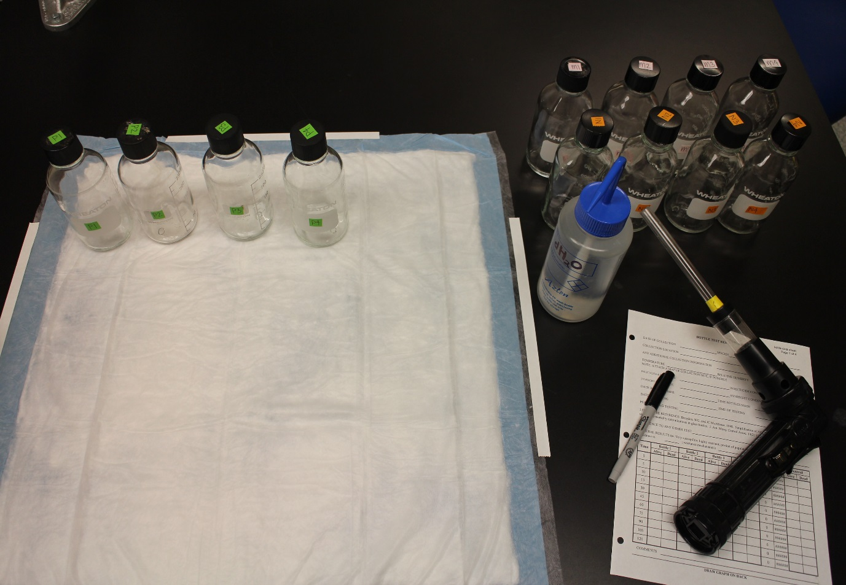

**Figure 2:** Labeling of bottles and caps.

2) Mark one bottle and its cap as control;

3) Mark the other four bottles and caps with the replicate number (1–4) and the bioassay date;

4) If more than one type of insecticide or more than one concentration of the insecticide is being tested at the same time, also label the bottles and their caps with the insecticide name and concentration;

5) Mark both the cap and the bottle so that bottles are associated with their respective caps. This is vitally important because the inside of the entire bottle will be coated, including the inside of the cap.

**3.6. Bottle coating**

1) Make sure that bottles and caps are completely dry;

2) Remove caps from the bottles;

3) If using disposable pipettes, label one pipette as ‘solvent only’ for the control bottle, and another pipette as ‘insecticide solution’ for the test bottles;

4) Add 1 ml of acetone/ethanol to the control bottle and put the cap back on tightly;

5) In the first test bottle, add 1 ml of stock solution to the bottle (Figure 3). Put the cap back on tightly;

6) Repeat Step 5 with the other three test bottles;

7) Swirl the contents inside the bottle so that the bottom is coated (Figure 4);

8) Invert the bottle and swirl to coat the inside of the cap (Figure 5);

9) Place the bottle on its side for a moment to let the contents pool. Gently rotate while rocking the bottle gently so that the sides all the way around are coated (Figure 6);

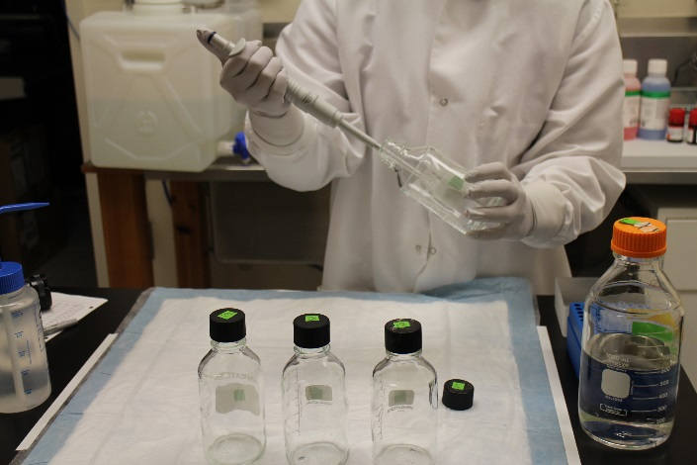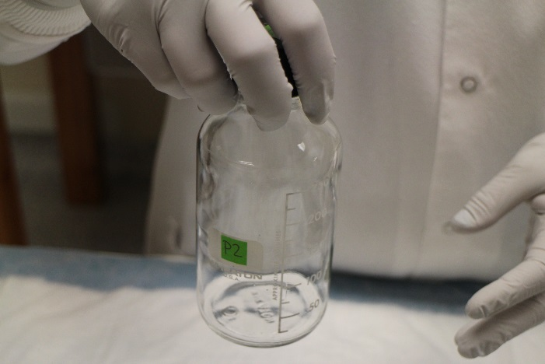

**Figure 3:** Adding stock solution to test bottle. **Figure 4:** Coating the bottom of the bottle.

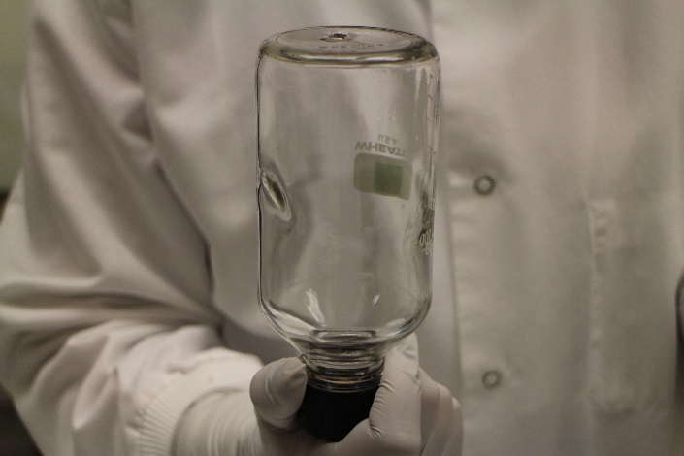 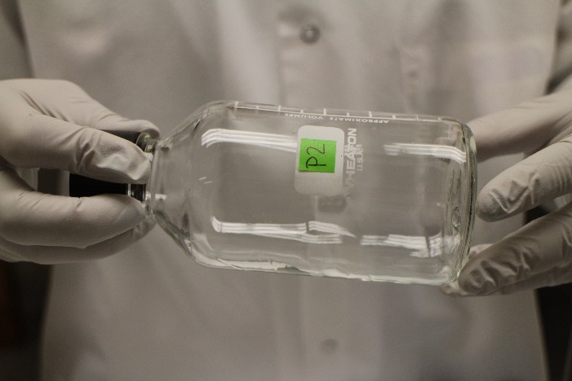**Figure 5**: Coating the cap of the bottle. **Figure 6:** Coating the sides of the bottle.

10) Repeat this for all the test bottles;

11) Remove the caps and continue rolling bottles on their side until all visible signs of the liquid are gone from inside and the bottles are completely dry;

12) Leave bottles on their sides and cover with something that will keep them protected from light;

13) If bottles are not used right away, store bottles in a dark place (such as a drawer) with the caps off to avoid moisture build-up. If shipping pre-coated bottles, ship the bottles with the caps on. More information on the storage of coated bottles is given in Section 4.3.

**4. CDC bottle bioassay method**

**4.1. General considerations**

1) Use a filter in the aspirator to avoid inhaling mosquitoes or insect fragments;

2) Blow gently to expel the mosquitoes into the bottles. If you blow too hard, the mosquitoes can be damaged by hitting the sides of the bottle and killed before the insecticide has a chance to do so;

3) Be careful not to touch the inside of the bottle with the aspirator, as this may contaminate the aspirator;

4) Remember that the number of mosquitoes in the each of the test bottles does not need to be equal.

**4.2. Bioassay procedure**

The bioassay can be performed with the bottles in an upright position or with the bottles lying on their sides. The important thing is to be consistent and follow the same procedure each time.

The steps:

1) Using an aspirator, introduce 10–25 mosquitoes into the control bottle. It is not necessary to count the mosquitoes; the exact number does not matter;

2) Introduce 10–25 mosquitoes into each test bottle; again, the exact number does not matter;

3) Start a timer. Be sure to examine the bottles at Time 0 and count the number of dead and/or live mosquitoes;

4) If you find dead mosquitoes at Time 0, make a note of them on the data form;

5) Record how many mosquitoes are dead or alive, whichever is easier to count, at 5 minutes, 10 minutes, then every 15 minutes until all are dead, or up to 2 hours. It is not necessary to continue the bioassay beyond 2 hours;

6) Record these data on the reporting form (attached in the email);

7) The Excel bottle data spreadsheet will graph the total percent mortality (Y axis) against time (X axis) using a linear scale.

8) Remember that mortality at diagnostic time is the most critical value because it represents the threshold between susceptibility and resistance. Refer to Table 1 for diagnostic doses and times for commonly used insecticides;

9) Take into consideration mortality in the control bottle at 2 hours (end of the bioassay) when reporting the results of the bioassay (Section 4.5). Use Abbott’s formula to correct results if the mortality at 2 hours in the control bottle is between 3% and 10%. You may need to discard the bioassay results if mortality in the control bottle at the end of the test was >10%. The Excel bottle data spreadsheet provided will automatically correct the results using Abbott’s formula.

Mosquitoes are considered dead if they can no longer stand. See Box 1 for more information.

A timer could be started for each bottle, but it is sufficient to start one timer when the first or last bottle receives its mosquitoes. It is, however, important to be consistent and follow the same timer start procedure each time. Mosquitoes alive at the diagnostic time (Table 1) represent mosquitoes resistant to the insecticide being tested. These mosquitoes may be transferred to a sleeved carton for further analysis (e.g., molecular or biochemical assays). Mosquitoes flying at the end of the bioassay in the control bottle may need to be killed to get an accurate count. Mosquitoes can be killed by freezing or stunning them.

**Box 1: Notes about mortality criteria.**

* “Dead” mosquitoes are mosquitoes that cannot stand.
* It helps to gently rotate the bottle while taking the count.

* Immobile mosquitoes that slide along the curvature of the bottle can be easily categorized as dead.
* It is easier to count the number of dead mosquitoes in the first readings of the bioassay, and it is easier to count the number of live mosquitoes when few remain alive.
* In the end, the percentage of dead mosquitoes at the diagnostic time (dead mosquitoes/total of mosquitoes in the assay) is the most important value in the graph.

**4.3. Handling of coated bottles**

More than one batch of mosquitoes can be run in a single bottle in one day. However, the main limiting factor for reusing previously coated bottles is moisture build-up with successive introductions of mosquitoes, especially in humid conditions. If the bottles are to be reused on the same day, it is necessary to leave some time (2–4 hours, longer if in a humid climate) between the bioassays for the bottles to dry out (with caps off) before introducing more mosquitoes. If the bottles are to be reused the following day, bottles with caps off can be left to dry overnight protected from direct light. Do not dry bottles in the oven after they have been coated with insecticide.

If the bottles are not to be used soon after coating them with insecticide, it is recommended to let them dry with their caps off. When the bottles are dry, they should be stored in a dark place (such as a drawer) with their caps off. Depending on the insecticide used, bottles can be stored from 12 hours to 4 days in this manner. The length of time bottles can be stored depends on the insecticide. Naled-coated bottles do not store well, so they should be used immediately after being prepared. Organophosphate-coated bottles should be used within 24 hours. Pyrethroid-coated bottles should be used within 2-4 days. To check if a stored bottle is still adequate, it is possible to put some mosquitoes known to be susceptible in the bottle. If they die in the expected time frame (within the diagnostic time), the bottle can still be used. Bottles can be coated in a central laboratory and shipped for use in the field. During transport, bottles should have their caps on.

**4.4. Identification of mechanisms of resistance**

Resistance is assumed to be present if a portion of the test population survives the diagnostic dose at the diagnostic time. Mosquitoes that survive the bioassay can be used for testing to identify mechanisms of resistance using enzymatic assays or molecular methods. Surviving mosquitoes may be easily released from bottles into a sleeved holding carton to separate them from those killed during the CDC bottle bioassay. Mosquitoes that will be further tested using enzymatic assays should be stored frozen. Mosquitoes to be used for molecular studies can be frozen, dried, or stored in 70% (or higher) ethanol.

**4.5. Validity of the data**

With practice, the mortality of mosquitoes in the control bottle at 2 hours (end of the bioassay) should be zero. In most cases, mortality of up to 3% in the control bottle may be ignored. In cases where mortality is 3%–10% in the control bottle at 2 hours, it is possible to either use Abbott’s formula to correct the findings (see Box 2), or discard results and repeat the bioassay. If mortality in the control bottle is greater than 10% at the end of the bioassay, the results of this particular run should be discarded, and the CDC bottle bioassay should be repeated. If a particular mosquito collection is essentially irreplaceable and the bioassay cannot be repeated, Abbott’s formula can be considered even when control mortality is >10%.

**Box 2: Abbott’s formula.**

Corrected mortality = (mortality in test bottles [%] - mortality in control bottle [%]) x 100

(100% - mortality in control bottle [%])

For example: If mortality in test bottles is 50% at diagnostic time and control mortality is 10% at 2 hours, the corrected mortality is [(50%-10%) / (100%-10%)] x 100 = 44.4%

**Note:** In cases of 100% mortality in test bottles, Abbottt’s formula has no effect. For example:

[(100% - 10%) / (100% - 10%)] x 100 = 100% corrected mortality

**4.6. Interpretation of results**

As with other resistance bioassays, data from the CDC bottle bioassay using test mosquitoes need to be compared with data from susceptible mosquitoes or from a population that will serve as baseline. Alternatively, if no baseline or susceptible data exists you can compare previous data generated from the same site over time or within a geographic area to spot trends both temporally and geographically. Calibration entails determining the diagnostic dose and the diagnostic time for a particular species in a given region, which correspond to the dose and time at which all of susceptible mosquitoes die (Figure 7). If test mosquitoes survive beyond this threshold, these survivors represent a proportion of the population that has something allowing them to delay the insecticide from reaching the target site and acting. In other words, they have some degree of resistance. In the example shown in Figure 9, all mosquitoes that died before the

diagnostic time when exposed to insecticide-coated bottles were susceptible. Test mosquitoes surviving beyond the diagnostic time threshold were assumed to have some degree of resistance. In the example, only 23% of the test population was susceptible. Recommendations for interpretation of bioassay data are shown in Box 3. The most important information is the mortality at the diagnostic time, but the bioassay is carried out beyond the diagnostic time to evaluate the intensity of resistance. It is important to note that resistance detected with this test does not necessarily translate into control failure. This test is much more sensitive in detecting the development of resistance than relying on failure of control to detect resistance. It allows you to determine if resistance is in a population before you lose the use of a chemical so that you can make management decisions in a timely enough manner to preserve susceptibility to that chemical.



**Figure 7:** Determination of resistance threshold.

**Box 3: Interpretation of data for management purposes.**

WHO recommendations for assessing the significance of detected resistance:

* 97%–100% mortality at the recommended diagnostic time indicates susceptibility;
* 90%–96% mortality at the recommended diagnostic time suggests the possibility of resistance that needs to be confirmed;
* <90% mortality at the recommended diagnostic time suggests resistance.

**Note:** Where <95% mortality occurs at the diagnostic time in bioassays that have been conduct­ed under optimum conditions and with a sample size of >100 mosquitoes, then resistance can be strongly suspected.

**5. Resistance surveillance**

**5.1. Background**

Although resistance data are often collected as part of vector control programs, this is often not done as regularly as it should be in a true resistance surveillance effort. Surveillance requires the regular collection and interpretation of epidemiological data to support changes in public health programs. It is important to consider the CDC bottle bioassay an instrument to collect information to support an insecticide resistance surveillance system. Resistance data are most valuable when collected over time to allow for comparisons and for monitoring of trends. It is important to consider how information collected as part of an insecticide resistance surveillance system will be used.

**5.2. Features of resistance emergence**

Several genetic, biologic, and operational factors influence the development of insecticide resistance. In many respects, resistance is a complex problem, with different outcomes possible in a particular area, depending on the influence of diverse factors on initial conditions. Even so, certain factors affect resistance development throughout the world. Major resistance characteristics are discussed below, showing why each manifestation of resistance is potentially unique and therefore must be evaluated on case-by-case basis.

**5.3. Focal nature of resistance**

Vector control personnel frequently assume that resistance in a particular species occurs throughout their control area, but insecticide resistance can be focal. Generally speaking, areas of ongoing vector control activities tend to have higher levels of resistance; when resistance levels in adjacent areas are compared, levels may be higher in areas of more intensive mosquito control.

**5.4. Resistance and disease control**

In some cases, vector control strategies in a given area may not be affected by the level of insecticide resistance. For example, a control program may be able to control only 75% of the vector population. In these cases, an

insecticide resistance level lower than 10% will likely not affect disease control efforts. In such a situation, it would be sufficient to increase surveillance and monitor the level and frequency of resistance but no change in control strategies would be needed.

**5.5. Guiding principles**

In general terms, resistance surveillance should be conducted in areas where disease transmission is a concern and where insecticide-based control measures are contemplated, ideally before purchase of insecticide. In addition to constraints imposed by economic resources, the number of sites that can be sampled is highly dependent on the size of the area contemplated for insecticide use. Due to the potential focal nature of resistance, efforts must be made to choose spatially distributed sites in the area of interest, if possible. Areas 1.25 miles or more apart should not be assumed to have similar resistance patterns. Another means of deciding on surveillance sites is to focus on those areas of active disease transmission. Even if only one or a few sites can be monitored, this is far preferable to having no surveillance sites. In addition, efforts should be made to operate sites for at least a few years, since comparative data are the most meaningful information.

Ideally each site should be monitored once a year. Where control efforts are seasonal, it may be useful to monitor at the beginning and at the end of the control season. If several vectors in the area are seasonal, the resistance testing schedule should be adjusted to the species of interest.

It is also important to consider that it will be necessary to try to identify resistance mechanisms once resistance is detected with the CDC bottle bioassay, whether using the CDC bottle bioassay with synergists, or biochemical and/or molecular methods. Decisions on which insecticide to change to will depend upon the specific mechanism(s) of resistance.

**6. CDC bottle bioassay and synergists**

**6.1. Background**

The CDC bottle bioassay using bottles that were coated with a single insecticide provides information on insecticide resistance to that particular insecticide in adult vectors. These data may provide early evidence that an insecticide is losing its effectiveness.

Once resistance is detected, or at least suspected, one must decide what to do next and which other compounds are likely to still be effective and not compromised by cross resistance. This requires knowledge of the resistance mechanism(s) in place, information usually acquired using either biochemical (microplate) assays or molecular methods. A rapid and inexpensive alternative to assess resistance mechanisms is to use the CDC bottle bioassay with synergists. Synergists are enzyme inhibitors of insecticide detoxification enzymes. Synergists are available for the metabolic detoxification enzymes: esterases, oxidases, and glutathione s-transferases. Synergists act by abolishing the apparent resistance observed in the CDC bottle bioassay if a detoxification enzyme plays a role in that particular resistance mechanism.

**7. Bibliography**

1. Brogdon, WG and McAllister JC, 1998. Simplification of adult mosquito bioassays through use of time-mortality determinations in glass bottles. J. Am. Mosq. Control Assoc. 14(2):159–64.

2. National Center for Infectious Diseases, Centers for Disease Control and Prevention (CDC). Evaluating mosquitoes for insecticide resistance: Web-based instruction. Available from: http://www.cdc.gov/malaria.

**APPENDIXES**

**Appendix 1. Frequently asked questions (FAQs)**

**1. What happens if there are not enough mosquitoes for a complete bioassay?**

When the number of mosquitoes captured in the field is insufficient for a full bioassay (four coated and one control bottles), you can reduce the number of bottles to be tested, but each bioassay must ALWAYS be run with a control until the required number is completed. If the testing takes place over a long period of time, use recently coated bottles if necessary. See expected lifetime of coated bottles in the guideline. Except in the case of organophosphate-coated bottles, coated bottles can be used multiple times over several days until the bioassay is completed, as long as moisture build-up from aspiration does not become excessive.

**2. Should some bottles be designated solely as control bottles?**

No, some bottles should not be designated as control bottles. Bottles should randomly be assigned as test or control bottles. This will provide an additional quality control to the adequacy of the washing procedure.

**3. What if there are no susceptible mosquitoes available for CDC bottle bioassay calibration?**

The diagnostic dose and diagnostic time for a particular species in a given area are similar. Use the diagnostic dose and the diagnostic time published in this guideline or consult the authors of this guideline or other users with experience in the method for that particular vector. Note that the value of the CDC bottle bioassay lies in showing changes over time in the characteristics of vector populations. Therefore, a baseline is useful even if some individual mosquitoes show resistance when the initial baseline is established.

**4. How can mosquitoes be introduced into the bottle without letting other mosquitoes escape?**

Some people have found it useful to employ a piece of cotton wool held against the aspirating tube at the top of the bottle as the mosquitoes are being introduced into the bottles. As the aspirator is withdrawn after the mosquitoes are introduced, the cotton wool can be used to close the bottle top, until the bottle cap is put in place. In our experience, a swift decisive puff of air will introduce mosquitoes without loss. Attempting to introduce mosquitoes into a bottle more than once may allow some to escape. This sometimes happens if the user attempts to put exactly the same number of mosquitoes into each bottle, which is not necessary.

**5. What happens if there are fed and unfed mosquitoes among the field-collected mosquitoes to be used in the bioassay?**

A collection of mosquitoes from the field may contain female mosquitoes in various physiological states, e.g., fed and unfed mosquitoes. There are two ways that this can be dealt with. First, mosquitoes can be randomly selected. Alternatively, mosquitoes can be held for one or two days for the blood meal to be digested and then used for the bioassay.