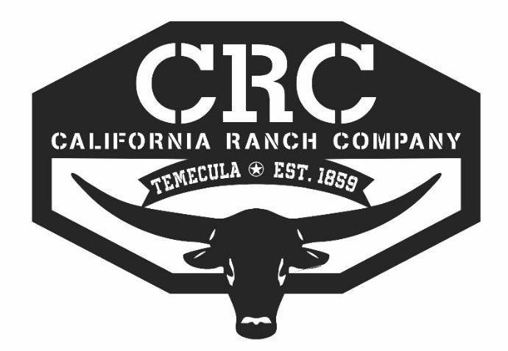$25 Haul In Fee
NAME_________________ PHONE___________ EMAIL____________________

RELEASE OF LIABILITY AGREEMENT:

This is a Contract. In consideration for being allowed on the premises whether to spectate, horseback ride, barrel race, exhibit and/or engage in any equestrian activity at CRC Ranch LLC, California Ranch Company, you must read, agree to all the terms and conditions of this Agreement and sign the document. If you do not sign this Agreement, you will not be allowed on the promises or to participate in CRC Ranch LLC, and California Ranch Company, Ranch’s functions and/or any equestrian activity while at CRC Ranch LLC, and California Ranch Company. Parents must sign if they have children under the age of 18 attending or participating any of our functions. Please initial next to each paragraph that you have read, understood, agreed to its contents and sign your full legal name at the bottom on your behalf and/or on behalf of your minor children, if any.

Please initial next to each paragraph:

______ I fully acknowledge that horseback riding, barrel racing and any other equestrian activity is a very dangerous sport, which carries risks of injury, death and damage to myself, my horse and/or my property. I further acknowledge the inherent risks of danger of being around horses whom are unpredictable and/or being in close proximity to horses or other stock. Knowing these inherent risks of injury, death or damage to myself, my horse and/or my property, I ASSUME ALL RISKS OF ANY INJURY OR DEATH TO MYSELFT, MY HORSE AND/OR DAMAGE TO ANY OF MY PROPERTY, whether known or unknown, while on the premises and/or participating in any equestrian activity at CRC Ranch LLC, and California Ranch Company and agree to hold harmless from any liability and responsibility and indemnify CRC Ranch LLC, and California Ranch Company.

______ I fully acknowledge, agree and have been fully warned that protective head gear which meets or exceeds the quality standards of the SEI CERTIFIED ASTM STANDARD F 1163 Equestrian Helmet should be purchase and worn while horseback riding, competing in barrel racing and/or being around horses. I further understand that the wearing of such head gear my reduce severity of some of the wearer’s head injuries, if any, and possibly prevent serious injury or the wearer’s death from happening as a result of a fall and other consequences. The undersigned agrees and covenants to assume all responsibility in selecting and wearing the appropriate helmet for their respective equestrian activity and further agree to hold harmless CRC Ranch LLC, and California Ranch Company from any responsibility or liability in selecting and/or failing to wear any protective head gear while engaged in any equestrian activity and/or being around horses at CRC Ranch LLC, and California Ranch Company.

______ I agree to hold harmless, release and discharge CRC Ranch LLC, and California Ranch Company/THE ARENA OWNERS or any of their principals, agents, employees, representatives assigns, members, owners, affiliated organizations and insurers from any and all claims of any liability or responsibility for any accident resulting in personal injury or death to my person, horse or property as a result of any negligence of CRC Ranch LLC, and California Ranch Company or any their principals, agents, employees, assigns, members, owners, venders, sponsors or affiliated organizations. This agreement is binding on my executors, heirs and assigns.

______ I expressly waive any and all of my rights I may have under California Civil Code 1542, which states “ a general release does not extend to claims which the creditor does not know or suspect to exist in his/her favor at the time of executing the release which if known by him/her must have materially affected his settlement.”

______ I agree that I will defend, and hold harmless the CRC Ranch LLC, and California Ranch Company and any of their principals, agents or employees, venders, sponsors, any co-sanction affiliate, and their members, and agents against any and all claims demands and causes of action, including court costs and actual attorney fees, arising from any claim, demand or lawsuit brought by or prosecuted on my behalf.

______ I hereby further agree and covenant not to sue CRC Ranch LLC, and California Ranch Company, their principals, agents, or employees, co-sanction affiliate, and/or affiliated organizations for any such injury, death, damage or loss to my person, horse and/or property. The undersigned agrees to assume any and all responsibility and risk for himself/herself, his/her employees, agents, invitees, and licenses arising out of or engaging in, participating in and/or spectating at any equestrian activities at CRC Ranch LLC, and California Ranch Company.

______ I agree that CRC Ranch LLC, and California Ranch Company, their principals, agents, employees and/or co-sanction affiliates shall not be liable for any damage which may accrue from any negligence or other act of CRC Ranch LLC, and California Ranch Company, their principals agents, employees and/or sanction affiliates, including but not limited to fire, theft, running away of animals, injury to a persons. Horse or property at all whatsoever.

______ I acknowledge that I have carefully read this RELEASE OF LIABILITY AGREEMENT and know and understand its contents, and (I, the undersigned parent, guardian or chaperone of the minor children in my family as listed in consideration of the child/children participating in the event.) Agreed to the terms and conditions of this Release of Liability Agreement.

______ I agree that CRC Ranch LLC, and California Ranch Company or any of their agents, employees have the right to call 911 in the event of a serious injury to myself/child.

______ I agree that CRC Ranch LLC, and California Ranch Company or any of their agents, employees have the right to call a veterinarian and/or animal removal on my behalf in the event of a serious injury or death to my horse or a horse under my supervision.

______ I agree that if any claim or lawsuit if filed on my behalf claiming injuries or death to my person, my horse or damage to my property, the prevailing party shall be entitled to reasonable attorney’s fees and costs, which may be set by the Court in this same action or in a separate action brought for the purpose, in addition to any other relief to which that party may be entitled.

______ All dogs must be on a leach at all times. (No Exception)

Agreement good for one (1) Year from today’s date:

___________________________________________ ___________________________________________
Signature of Rider (Or Parent if Youth is under 18) Print Name (And Relationship to Youth, if applicable

Emergency contact Name ______________________________________________________________________

Telephone Number: ___________________________________________________________________________

Insurance Carrier: ____________________________________________________________________________

California Ranch Company LLC - 34520 De Portola Road, Temecula, CA 92592 – (909) 261-9179

