

DUNES LEATHERNECKS DETACHMENT #1056
MARINE CORPS LEAGUE
VALPARAISO, IN

Keeping the Pantries Full Golf Outing

Dear Sir or Madam,

We, the Marines of the Dunes Leathernecks Detachment of Valparaiso, are seeking your help in our 15th Annual Golf Outing for the Food Pantries of Porter County. The outing is scheduled for June 29th, 2019 9:30am at the Forest Park Golf Course in Valparaiso, Indiana.

All proceeds from this event will be donated to the six major food pantries of Porter County. Last year we contributed $7,200 and with your help, we hope to meet and or exceed that amount.

You can help by sponsoring either a hole for $75, an event for $250, donation of gift certificates and or door prizes. With a $75 sponsorship, a poster with your name on it will be placed on one of the 18 holes on the course. For a sponsorship of $250, you will receive a banner with your name on it and the banner placed prominently at the event.

We hope a gift or sponsorship will be forth coming and if you are a golfer, we hope you will join us for this event. The fee is $75 per golfer or $300 if you would like to sponsor a foursome. Fees include green fees, cart, prizes and food with drink.

We thank you for your help. If you require more information, please contact Reggie Hess @ 219-926-3039 or email at reggiehess@yahoo.com

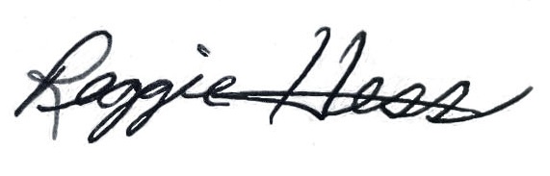
Cordially,
Please make checks payable to and mail forms to:

DUNES LEATHERNECKS DETACHMENT #1056
1319 JEFFERSON AVE
CHESTERTON, IN 46304

Reggie Hess
Commandant, Dunes Leathernecks

