### Safeguarding Policy

**Children have the right to be protected from all forms of violence; they must be kept safe from harm. They must be given proper care from those looking after them.** *(Article 19 - UN Convention on the Rights of the Child).*

In Wales this is further underpinned by the Rights of Children and Young Persons (Wales) Measure 2011.

**Let’s Protect Our Children**

**As an organisation working with children, The Lil Rascals has a responsibility to safeguard and promote children’s welfare and protect them from harm. The child’s welfare is always the paramount consideration and the protection of the child is The Lil Rascals and the Responsible Individual’s first priority.**

This policy has been developed in line with the

* Wales Safeguarding Procedures 2019 (<http://www.myguideapps.com/projects/wales_safeguarding_procedures/default/>)
* Safeguarding Children: Working Together under the Children Act 2004 (<http://wales.gov.uk/topics/childrenyoungpeople/publications/safeguardingunder2004act/?lang=en> )
* Social Services and Wellbeing (Wales) Act 2014
* Counter Terrorism and Security Act 2015 – section 26

The Local Authority is the prime authority for dealing with safeguarding investigations, although concerns may be reported to a police officer or an officer of the National Society for the Prevention of Cruelty to Children (NSPCC).

The Lil Rascals takes steps to protect children by:

* Maintaining a child-centred ethos in The Lil Rascals.
* Having a robust staff and volunteer recruitment procedure (this includes maintaining current enhanced DBS disclosures, and where relevant, Independent Safeguarding Authority (ISA) checks, referring to <http://www.isa.homeoffice.gov.uk/> for up to date information and requirements) and checks on fitness references and qualifications in line with relevant day-care regulations.
* Having an awareness of [The Protection of Children Act 1999: A practical guide to the Act for all organisations working with children](http://www.dh.gov.uk/en/Publicationsandstatistics/Publications/PublicationsPolicyAndGuidance/DH_4006939) which relates to the Government's aim of establishing a framework of a coherent cross-sector scheme for identifying those people considered to be unsuitable to work with children.
* Having robust procedures for staff, students, visitors and volunteers; including induction and supervision
* Ensuring no student, volunteer, visitor is left unsupervised at any time, and that a record of their attendance – including dates and times – is kept.
* Ensuring Staff and Volunteers are aware of their responsibilities for safeguarding making clear that they would also be held accountable. They should have a good understanding of who they should refer to and what to do if they continue to be concerned.
* Ensuring all staff attend safeguarding training and they regularly review and update this training
* Ensuring all staff are made aware of the Prevent Duty, including how to identify factors that can make people vulnerable to radicalization within 3 months of commencing employment. (see Prevent Policy).
* Maintaining appropriate staff:children ratios for the supervision of children (in line with, or exceeding, regulatory requirements).
* Implementing and maintaining a current risk assessment of all activity in The Lil Rascals and ensuring adequate insurance cover is provided.
* Designating a suitable Safeguarding Officer, Craig Lambourne who acts on behalf of The Lil Rascals in any child protection matters. Providing a name of a deputy who will cover when they are unreachable due to sickness or annual leave
* Informing all parents/carers of the safeguarding policy and procedures (including relevant contact numbers) as each family starts to use The Lil Rascals.

**Categories of abuse**

* Bullying and cyberbullying
* Child sexual exploitation
* Child trafficking
* Criminal exploitation and gangs
* Domestic abuse
* Emotional abuse
* Female genital mutiliation
* Grooming
* Neglect
* Non-recent abuse
* Online abuse
* Physical abuse
* Sexual abuse

**The procedure**

There are two routes:

Route 1: A disclosure about a child

Route 2: A disclosure about professional abuse

|  |
| --- |
| **Route 1: In the event of a member of staff having a concern/suspicion that a child has suffered abuse/neglect or if someone tells a member of staff that they or another child or young person is being abused/suffering neglect or is at risk of being engaged in extremism.**  The member of staff acts without delay (and as is appropriate to the age/stage of the individual child):   * Shows that they have heard what they are being told and that they take the allegations seriously. * Encourages the child to talk but does not prompt or ask leading questions. * Avoids making the child tell their story several times to different people. * Explains what actions they must take (using agreed procedures). * Does not promise to keep what they have been told a secret or confidential, but explains that they will share information only on a ‘need to know’ basis.   The member of staff:   * Writes down, using the exact words, what they have been told and/or seen - this is done without delay and within 24 hours * Makes a note of the date, time, place and people present in the discussion * The written record is passed to the designated Safeguarding Officer and kept safely and confidentially. * Reports the concerns to the Responsible Individual and/or designated Safeguarding Officer or in their absence their line manager as soon as possible but without delay. They may wish to discuss your written record with the member of staff. * Practitioners should seek to obtain consent from parents to speak to the child or to undertake an assessment where possible. Where a decision not to seek parental consent is made the reasons must be recorded and may include: * the possibility that the child would be put at further risk; * the possibility that a child would be threatened or otherwise coerced into silence; * a strong likelihood that important evidence would be destroyed/lost; * if the parent is identified as the alleged abuser; or * that the child in question did not wish the parent to be involved at that stage, and is competent to take that decision.   Any decision to speak to a child without the knowledge of the parent or carer must be recorded. The parent or carer must be informed as soon as practicable and consistent with the best interests of the child. (more information is available in the Wales Safeguarding Procedures, ‘[Seeking Consent to a Report](https://safeguarding.wales/chi/c2/c2.p16.html)’)  The written record must be updated and kept as part of the chronology for the child.   * Follow the Local Safeguarding Boards reporting procedures. Add to the chronology (ongoing record) with any updates as they occur. Under the Social Services and Wellbeing (Wales) Act 2014 The Lil Rascals’s Responsible Individual/designated Safeguarding Officer has a duty to report the concerns immediately to the Duty Social Worker at the local office. – without delay. Social Services must be informed at the point of report whether parent/carer and/or child consent has been given or withheld along with their wishes and desired outcomes, or why there have been no attempts made to seek consent.   The Lil Rascals are registered with CIW and if the incident is considered to breach Part 2 (child minding and day care for children) of the Children and families (Wales) Measure 2010, as amended by the Child Minding and Day Care (Wales) Order 2016, it should also be reported to CIW.  **The need to seek advice should never delay any emergency action needed to protect a child. Recording and reporting Safeguarding concerns is everyone’s responsibility.** |

|  |
| --- |
| **Route 2: If the behaviour of a colleague, adult (including members of the public) towards children or young people causes concern:**  **In such circumstances, it is critical that suspicions/allegations of child abuse and/or neglect are investigated in strict confidence thus enabling information to be given freely and fully, to reduce any fears of victimisation and protect the rights of the suspected person. Follow the guidance from Police/Social Services regarding informing parents/carers of the child/ren who have been affected.**  **It will also be necessary to consider what action should be taken with regard to other children whom the suspected person has ongoing or unsupervised contact. This must include:**   * **The person’s own children and family** * **Any community activities undertaken by that person in light of the suspicion/allegation of child abuse/neglect.**   It is important to differentiate between cases involving issues such as poor professional practice and cases that give rise to safeguarding concerns (including cases involving abuse of trust). Whilst the former may be handled through disciplinary procedures or other avenues, safeguarding concerns should always be dealt with through local safeguarding procedures in line with this guidance and, in particular, the guidance contained in Chapter 8 *(Dealing with Individual Cases). (Safeguarding Children: Working Together to Safeguard Children under the Children Act 2004.12.3)*   * The procedure as above (Route 1) is implemented and adapted as appropriate to the person who is making the disclosure. * The member of staff is informed and written records of discussions and decisions are made in line with the Staff Disciplinary Policy and Procedure * The Lil Rascals’ Responsible Individual temporarily suspends without prejudice from duty the member of staff pending decisions made at the Strategy Discussion (which is arranged by Social Services). * The Responsible Individual informs CIW of any allegations of serious harm to a child committed by any person looking after children in The Lil Rascals, or by any person living, working, or employed on the premises, or any abuse alleged to have taken place on the premises. |

**Making the Referral (following Route 1 or Route 2)**

* A referral to Social Services is made as soon as a problem, suspicion or concern about a child becomes apparent and at least **within 24 hours**.
* Outside office hours, referrals are made to the Social Services Emergency Duty Team or the Police: The Wales Safeguarding Procedure states that Police should be contacted if a child or unborn child is in immediate risk
* The Duty Social Worker taking the referral is given as much of the following information as possible by The Lil Rascals’ referrer:
  + The nature of the concerns.
  + How and why those concerns have arisen.
  + The full name, address and date of birth (or age) of the child.
  + The names, addresses and dates of birth/ages of family members, along with any other names which they use or are known by.
  + The names and relationship of all those with parental responsibility, where known.
  + Information on any other adults living in the household.
  + Information relating to other professionals involved with the family, including the name of the child’s school and GP.
  + Any information held on the child’s developmental needs and his/her parents’/caregivers’ ability to respond to these needs within the context of the wider family environment.
  + Any information affecting the safety of staff.
* The Lil Rascals Responsible Individual holds responsibility to ensure that safeguarding concerns are taken seriously and followed through, remaining accountable for their role in the safeguarding process. The member of staff who raises concerns about the child is also responsible for ensuring that the concern is taken seriously and should be made aware of what action to take if they feel the designated Safeguarding Officer or deputy is not taking appropriate action
* If they remain concerned about a child they will re-refer the child and/or bring this to the immediate discussion of the Social Services senior manager with responsibility for child protection for the area.

**Record Keeping**

* The Lil Rascals keeps accurate, concise and clear record keeping in straightforward language to underpin good child protection practice
* The Lil Rascals’ arrangements for retention, storage and destruction of electronic and paper records of child protection matters meet the relevant regulations (including Data Protection Act 1998, day-care regulations) and Social Services requirements where necessary.
* Records should::
  + - Use clear, straightforward language;
    - Be signed, dated and timed;
    - Be concise, legible and comply with professional standards and requirements;
    - Be accurate in fact and distinguish between fact, opinion, judgement and hypothesis;
    - Be organised and include detailed recording and chronologies and summaries including all contacts;
    - Be comprehensive;
    - Clearly record judgements made and actions and decisions taken;
    - Clarify where decisions have been taken jointly across agencies, or endorsed by a manager;
    - Record both formal and informal supervision discussions;
    - Record directions given and agreements or disagreements made in consultation with managers.
* The Lil Rascals’ representative (Safeguarding Officer) attends any multi-agency meeting held (e.g. Strategy Discussion) and provides reports as necessary and appropriate.
* The Strategy Discussion considers risk associated with any allegation and should determine whether or not a member of staff will be suspended from duty without prejudice.
* Decisions are recorded in writing.

In alignment with Wales's national minimum standards for regulated childcare, our safeguarding policy is designed to ensure that the welfare of children is paramount. A crucial aspect of this policy is the systematic procedure for recording any existing injuries sustained by children in our care. This procedure mandates that staff members are trained to document any observed injuries accurately and promptly, ensuring that all records are complete and confidential. If any injury is noted on drop off a member of staff will complete an ‘on entry’ form documenting the injury and how it was sustained. Such diligence facilitates an appropriate response to any safeguarding concerns, upholding our commitment to child welfare.

Furthermore, our policy outlines a clear procedure to follow in the event of an allegation against the designated safeguarding lead or the responsible individual. Should an allegation arise, it is imperative that the matter is reported immediately to an appropriate authority (CIW or Monmouthshire Children’s Services), independent of the individual involved. This ensures an impartial investigation and protects the integrity of both the child and the personnel concerned. All staff members are required to familiarise themselves with this procedure and participate in regular safeguarding training to promote a safe and secure environment for all children. By adhering strictly to these guidelines, we strive to maintain the highest standards of care and protection for every child under our supervision.

### 

**Prevent**

Under section 26 of the Counter Terrorism and Security Act 2015, the Club has “due regard to the need to prevent people from being drawn into terrorism”, known as the Prevent duty.

We recognise that there is no single way to identify an individual that is likely to be susceptible to radicalisation but, in line with our safeguarding policy, we are familiar that any behaviour of concern from an individual will require action from ourselves.

We will:

* Ensure all staff are made aware of the Prevent duty, including how to identify factors that can make people vulnerable to radicalization.[1]
* Ensure the Designated Safeguarding Lead undertakes Prevent awareness training and is able to provide advice and support to other members of staff on protecting children from the risk of radicalisation1.
* In our everyday play, help raise children’s self esteem and confidence and help them to recognise and manage risk, make safer choices and recognise when pressure from others threatens personal safety and wellbeing.
* In line with our equal opportunities policy, challenge discrimination in all areas of our organisation, and help children explore diversity found within society and show mutual respect.
* Assess the risk of children and adults involved with the setting being drawn into terrorism and we will be alert to: any changes in behavior, which could indicate that they may be in need of help or protection and; any efforts to display or hide their views which may indicate a risk of radicalization. We will also contact the local authority or local police to help us assess the risk within the particular area.
* Ensure that children are safe from terrorist and extremist material when accessing the internet[2] (refer to Media Policy)
* Take action when we observe behaviour of concern.

**Procedure**

* If a concern is raised about a particular child or young person or staff member, then we will follow our normal safeguarding procedure.

**Further information**

Each local authority in Wales has a Local Safeguarding Children Board, which coordinates what is done by its members to safeguard and promote the welfare of children in the area of the authority.

**Training**

The club will be cognisant of national and local training requirements and guidance, which will include GSB guidance, advice and training opportunities.

* The club will ensure that the Designated Safeguarding Officer (DSO) will have received initial training (Safeguarding Level C) when starting their role and continued professional updates as required. Specific updates as suggested by national and local requirements will be central to the DSO’s development. The designated deputy will be initially supported by the designated person and consideration for joint opportunities for training with the DSO will be given.
* All staff/volunteers will be regularly updated during the year as appropriate from the designated lead but will receive specific awareness raising training within a 2-year period. All staff will complete Safeguarding Level B training every two years.

**Contact Details**

Monmouthshire. Tel: 01291 635 669 (duty team)

Email: ChildDuty@monmouthshire.gov.uk

After 5pm and on weekends and bank holidays please contact the South East Wales Emergency Duty Team on 0800 328 4432.

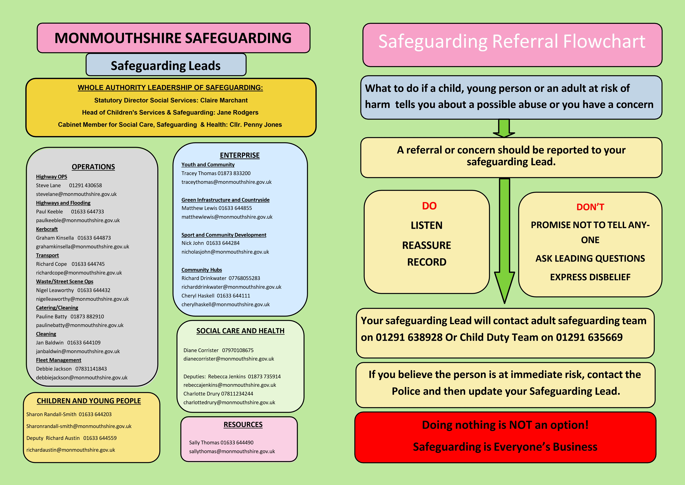

1. **The Department of Education (updated August 2015) ‘The Prevent duty Departmental advice for schools and childcare providers’** [<https://www.gov.uk/government/publications/protecting-children-from-radicalisation-the-prevent-duty> Accessed 09 05 2019]

   An online awareness training module of Channel is available [http://course.ncalt.com/Channel_General_Awareness/01/index.html Accessed 09 05 2019]

   Detailed guidance on Channel is available [https://www.gov.uk/government/publications/channel-guidance Accessed 09 05 2019]

   The Home Office has developed core training ‘Workshop to Raise Awareness of Prevent (WRAP)’, which may be available in your area.

   Providers may identify other local training that may be available
2.