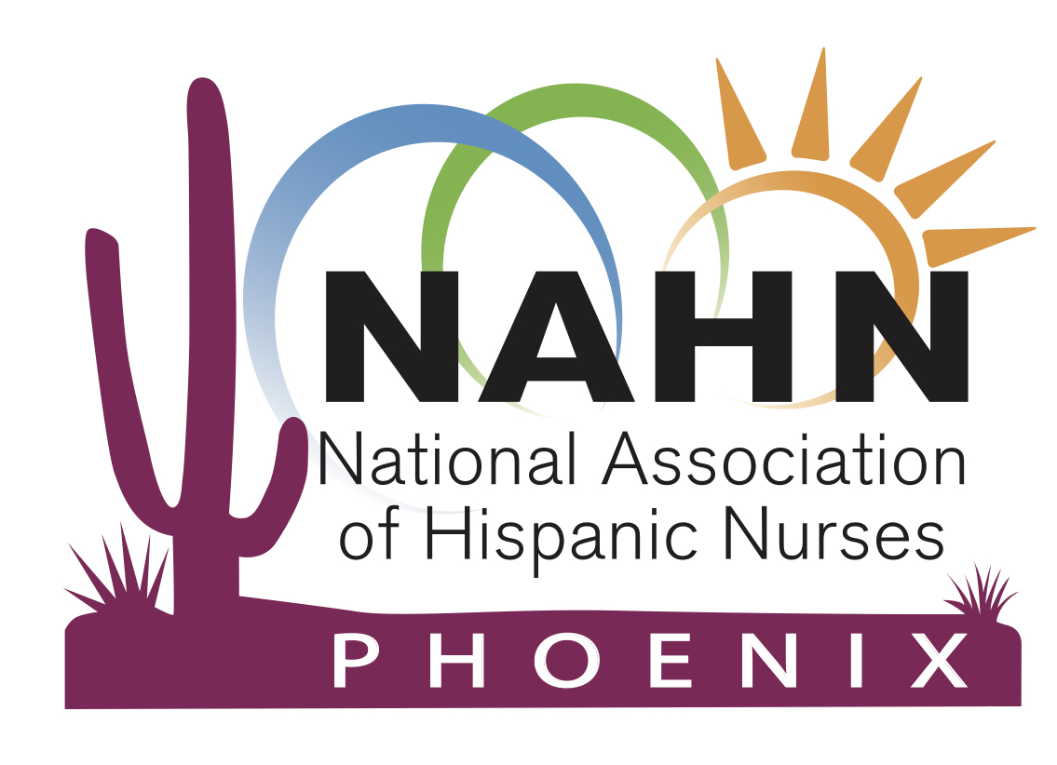

*NAHN Phoenix Position Statement and Bio due September 20, 2020 Checklist:*

The following will need to be included:

* Full name with credentials
* Contact information; email address, phone number
* Position statement: A **200-word count or less** position statement which should include stated position running for, your goal and qualifications and how you will make an impact in the Hispanic population for intended position
* Biography: A **200-word count bio or less** with attached headshot in a jpg format
  + Bio will be used for website, facebook, and newsletter
  + Please see below for example
* Submit to [nahnnominationsphx@gmail.com](mailto:nahnnominationsphx@gmail.com) by deadline ***Sunday, September 20, 2020***

*NAHN Phoenix Nominations Chair Checklist:*

Upon receipt and approval of nominee paperwork, the following tasks will be performed by the NAHN Phoenix Nominations chair:

* Electronic version of Roles & Responsibilities resent to nominee
* Website will be updated to reflect running candidates
* Candidates will have the opportunity to campaign during the October Member meeting with the assistance and guidance of the Nomination committee
* Survey Monkey ballot opens October 15 – October 29
* Candidates will be notified of results on November 1st
* Thursday, November 19 newly elected board members will be announced during NAHN Phoenix chapter meeting and formally inducted
* January 2021 – board member term will begin

*NAHN Nominations Chair Contact:*

Nominations Chairperson

Caesar Rangel, BSN, RN

nahnnominationsphx@gmail.com

*Sample Bio & Position Statement*:*

**Candidate for 2018-2020 President-elect: Norma Cuellar, PhD, RN, FAAN**

|  |  |
| --- | --- |
| https://www.nahnnet.org/images/2016_election_Norma-2014.gif | **Relevant NAHN Experience (Biography):**  My leadership contributions include active national participation within several critical areas for NAHN's transformation journey. From 2012-2014, I served as Nominations Chair on the Board of Directors. Previously to this, I served as the National Nominations Committee member (2012-2014). In this biennium (2014-2016), I am continuing my service in the national Awards Committee.  My community service involvement was recognized with the Henrietta Villaescusa Community Service Award and in academia with the Ildaura Murillo-Rohde Award for Education Excellence Award (2007). I also represented NAHN in the National Coalition of the Ethnic Minority Nurses Association Board of Directors and Mentorship Program. |
| **Platform Statement**  My passion for improving Hispanic healthcare and opportunities for Hispanic nurses has led to my decision to seek YOUR support for my NAHN President candidacy. My goals include a focus on membership recruitment and retention, professional development of members, and commitment to work on the strategic plan of NAHN. I believe every individual in NAHN has a purpose and can contribute their own unique experiences to make this an exemplar organization and known worldwide as Hispanic leaders "to go to." My experience as a clinician, educator, and leader will be a tremendous asset for NAHN and will provide a wide range of perspectives to continue the growth and development of NAHN. I am faithful and loyal to NAHN's mission, vision and value statement and dedicated to the empowerment of our members to improve the quality of health and nursing care outcomes for not only Hispanics but all other at-risk populations.  ***\*Permission has been granted from Norma Cuellar to use bio, platform statement for the purpose of an example only.*** | |