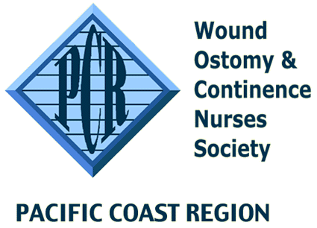
PCR Advance Practice Scholarship Application
Attachment A

Fund Application
All information will be kept confidential, LEAVE NO BLANKS and do not abbreviate terms or names. Incomplete applications will not be reviewed. Applications must be received by March 31st, 2022
Return the completed application, attachments and letters of recommendation to:

Carey Webster, Scholarship Chairperson
careycwebster@gmail.com
(530) 277-0535

Eligibility Criteria

- Applicant must be certified in wound, ostomy or continence nursing.
- Proof of one of the following:
  - Acceptance to an accredited Nurse Practitioner program.
  - Current enrollment in an accredited Nurse Practitioner program.
  - Completion/graduation from an accredited Nurse Practitioner program within the past year.
- Reside in the Pacific Coast Region.
- Proof of a current, unrestricted RN license.
- Proof of current or previous employment as a wound, ostomy and/or continence nurse for three years during the last five years.

NOTE: It is advisable that you keep a copy of your completed application packet. Email submission is required. The application should be emailed no later than midnight March 31st, 2022.

Applicant Information

- Name: _________________________________________________________________________
- Mailing Address: _________________________________________________________________
- City/State/Zip code: ______________________________________________________________
- Phone: Home ( )_________________ Cell ( ) __________________________
- Email: ______________________________________________
- WOCN Member # if applicable:
- Attach a copy of applicant’s resume.
- Attach proof of acceptance, enrollment, or completion/graduation (within previous year) from an NLN accredited advance practice nursing program.
- Attach three satisfactory letters of recommendation from professional associates who have known the applicant for at least one year (one from current employer is preferred).
- Letter from applicant of 500 words or less discussing reasons for pursuing an advance practice degree. Weight in scoring will be given to applicants who communicate a plan to maintain WOC certification and incorporate the advance practice degree into the WOC role. Include your work experience over the past 5 years.
- Attach signed Attachment B (Release & Agreement).
- Attach a copy of your current nursing license.
- Please make sure your name is on every document.

