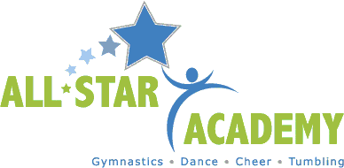

PHYSICAL ASSISTANCE AWARENESS AGREEMENT

I,___________________________________________ am aware that while gymnastics, trampoline, tumbling, cheer and ninja activities are individual sports, there will be times when incidental contact will occur. All-Star Academy programs are operating in a social and physical distancing environment but even with the best efforts and intentions there will be times when the children and/or instructor/coach will breach the prescribed (currently 6 feet) distancing recommendation.
In addition, our instructing and coaching staff will spot (physical assistance) when the circumstances require it. Spotting our students and athletes is often necessary in order to teach skills safely, to help athletes perform skills correctly and to prevent injury. I understand and agree that spotting will be part of the learning process at All-Star Academy and I agree to permit my child’s instructor and/or coach to physically assist my child when needed.
Direct assistance will also be provided in the event of an incident that requires medical attention or even just a little TLC (tender loving care) by instructors, Coaches or office staff.

______________________________ ____________
Signature of Parent Date

