**Metro B Water District (4220003) June, 2024 7520 Jennings St., Spartanburg, S.C. 29303**

Este informe contiene informacion muy importante. Traduscalo o hable con alguien que lo entienda bien.

This report is intended to provide you with important information about your drinking water and the efforts made by the water system to provide safe drinking water.

**The source of drinking water used by the Metro B Water District is surface water.**

**ANNUAL DRINKING WATER**

**QUALITY REPORT**

**CONSUMER CONFIDENCE REPORT**

On August 6, 1998, the Environmental Protection Agency promulgated the Consumer Confidence Report Regulation. This Rule requires public water systems to publish an annual report for distribution to their customers and other water consumers which gives detailed information about water sources, water treatment, water quality and regulatory compliance. The annual reports covering the calendar year 2023, must be prepared and distributed by July 1, 2024.

**SOURCE WATER INFORMATION**

Metro B Water District purchases water from the Spartanburg Water System (SWS) for distribution to residential, commercial and industrial customers. Spartanburg Water System uses surface water from three lakes within Spartanburg County: Lake William C. Bowen, Municipal Reservoir #1, and Lake Taylor H. Blalock (Figure 1)

Lake Bowen is a man-made lake formed by the water of the South Pacolet River and its tributaries. Water flows from Lake Bowen into Municipal Reservoir #1, another man-made lake. The entire water shed for these lakes lies within the state of South Carolina, in Spartanburg and eastern Greenville Counties. Water from these lakes is treated at the R. B. Simms Water Treatment Plant. Lake Blalock is also a man-made lake formed by the combining of surplus water from the Bowen/Reservoir #1 system with the North Pacolet River and its tributaries. Part of the Blalock watershed is in South Carolina and part is in North Carolina. Water from Lake Blalock is treated at the Miles W. Whitlock Water Treatment Facility.

The South Carolina Department of Health and Environmental Control (SCDHEC) is required by the Safe Drinking Water Act Amendments of 1996 to perform a delineation and assessment of watershed in South Carolina which is used as a drinking water source. Additional information about SCDHEC’s Source Water Assessment Program and the specific Assessments are no longer on the SCDHEC website but may be found though the following website. www.scdhec.gov/homeandenvironment/water/sourcewaterprotection/



**TREATMENT PROCESS**

Conventional water treatment is used at both the R.B. Simms and Whitlock treatment plants. “Raw” water from the reservoir is first passed through a screen to remove large objects, and then treated with chlorine and chlorine dioxide. These treatment chemicals aid in the removal of iron and manganese, two natural substances in the water which would stain clothing and plumbing fixtures if not removed. They also act as a disinfectant, destroying bacteria, viruses, algae , and other organisms, some of which could cause illness. Alum, poly-aluminum chloride, lime, and polymer are then added. In a process call coagulation, these substances combine with each other and with fine particles in the water to form a substance called “floc” which is heavier than water. Powdered activated carbon is added at this stage as needed to help remove unpleasant taste or odors. The water then passes through large basins where the floc settles to the bottom and is removed, taking unwanted substances with it. Clear “settled” water is skimmed from the top of the basins and filtered to remove still more unwanted material. Additional chlorine disinfectant and lime are added as needed to meet state requirements. A corrosion inhibitor containing zinc and phosphate is added to preserve distribution piping and prevent lead and copper contamination. Finally, fluoride is added to prevent tooth decay.

Each step of the treatment process represents a barrier which prevents chemical contaminants and disease organisms from passing through the treatment plant into the drinking water. EPA has established standards for the performance of each of these barriers. The effectiveness of coagulation, sedimentation and filtration in removing particles from the water is determined by measuring the turbidity of the water as it leaves the filters. Turbidity is a measure of the quantity of finely divided particles suspended in the water, and is reported in units called NTU. The EPA standard for the turbidity of filtered water states that turbidity may not exceed 0.3 NTU in more than 5% of all the measurements taken, and must never exceed 1 NTU. 1 NTU turbidity cannot be seen by the human eye. Turbidity measurement is required every 4 hours. SWS was in full compliance with this requirement in 2023.

**SOURCE OF DRINKING WATER**

The sources of drinking water (both tap water and bottled water) include rivers, lakes, streams, ponds, reservoirs, springs, and wells. As water travels over the surface of the land or through the ground, it dissolves naturally-occurring minerals and, in some cases, radioactive material, and can pick up substances resulting from the presence of animals or from human activity.

Contaminants that may be present in source water include”

-Microbial contaminants, such as viruses and bacteria, which may come from sewage treatment plants, septic systems, agricultural livestock operations, and wildlife.

-Inorganic contaminants, such as salts and metals, which can be naturally-occurring or result from urban storm water runoff, industrial or domestic wastewater discharges, oil and gas production, mining, or farming.

-Pesticides and herbicides, which may come from a variety of sources such as agriculture, urban storm water runoff, and residential uses.

-Organic chemical contaminants, including synthetic and volatile organic chemicals, which are by-products of industrial processes and petroleum production, and can also come from gas stations, urban storm water runoff, and septic systems.

-Radioactive contaminants, which can be naturally-occurring or be the result of oil and gas production and mining activities.

**CHEMICAL MONITORING**

Public water systems are required to monitor their drinking water for a large number of chemical contaminants. These include inorganic chemicals, synthetic organic chemicals, volatile organic chemicals, disinfection byproducts, and radioactive contaminants. For some of these contaminants, EPA has established and SCDHEC has adopted maximum contaminant levels and maximum contaminant level goals. These contaminants are referred to as regulated contaminants. Unregulated contaminants are those that do not have a drinking water standard set by EPA. EPA is required by the Safe Drinking Water Act to identify every five years a list of potential contaminants, make a rule for water systems to test for them , and then make a decision whether regulation is necessary. As part of the Unregulated Contaminant Monitoring Rule 3 (UCMR#), DHEC recently tested Spartanburg Water’s water for 28 unregulated contaminants. Twenty-three of the contaminants under review were not detected, but five were detected. The levels measured are included in this report. If you have any questions about these results or are interested in the full list of contaminants that were monitored, please contact Chad Lawson at 864-580-5693. For other contaminants, EPA and SCDHEC require monitoring as a means of building a base of occurrence data, but there are not at this time any enforceable limits on the concentration of these contaminants. These are referred to as unregulated contaminants. FDA regulations establish limits for contaminants in bottled water which must provide the same protection for public health.

Some people may be more vulnerable to contaminants in drinking water than the general population. Immuno-compromised persons such as persons with cancer undergoing chemotherapy, persons who have undergone organ transplants, people with HIV/Aids or other immune system disorders, some elderly, and infants can be particularly at risk from infections. These people should seek advice about drinking water from their health care providers. EPA/CDC guidelines on appropriate means to lessen the risk of infection by cryptosporidium and other microbiological contaminants are available from the **Safe Drinking Water Hotline 1-800-426-4791**.

We are required to report only those contaminants which have been detected during the calendar year 2023, or in the most recent sample taken for parameters measured less frequently than once per year. The information must include the contaminant name, the MCLG and MCL, the highest level found (or the average for substances subject to secondary MCL’s) and the range of measurements if multiple samples were taken, the date samples were taken, and the typical source or sources of the contaminants detected. Since no MCL/s were exceeded, no health effects language is required.

All sources of drinking water are subject to potential contamination by substances that are naturally occurring or man-made. These substances can be microbes, inorganic or organic chemicals and radioactive substances. All drinking water, including bottled water, may reasonably be expected to contain at least small amounts of some contaminants. The presence of contaminants does not necessarily indicate that the water poses a health risk. More information about contaminants and potential health effects can be obtained by calling the **Environmental Protection Agency’s Safe Drinking Water Hotline at 1-800-426-4791**.

If present, elevated levels of lead can cause serious health problems, especially for pregnant women and young children. Lead in drinking water is primarily from materials and components associated with service lines and home plumbing. Metro B Water Works is responsible for providing high quality drinking water, but cannot control the variety of material used in plumbing components. When your water has been sitting for several hours, you can minimize the potential for lead exposure by flushing your tap for 30 seconds to 2 minutes before using water for drinking or cooking. If you are concerned about lead in your water, you may wish to have your water tested. Information on lead in drinking water, testing methods, and steps you can take to minimize exposure is available from the Safe Drinking Water Hotline or at <http://www.epa.gov/safewater/lead>.

The US Environmental Protection Agency has mandated that all public water systems survey their system for lead service lines by October, 2024. Metro Water Works has completed this survey and it can be viewed at our office at 7520 Jennings Street, Spartanburg, SC.

MCL’s are set at very stringent levels. To understand the possible health effects described for many regulated constituents, a person would have to drink 2 liters of water every day for a lifetime at the MCL level to have a one-in-a-million chance of having the described health effect.

This year you may have noticed that no Unregulated Contaminants are included in a table. Unregulated Contaminants are those that do not have a drinking water standard set by EPA. EPA is required by the Safe Deinking Water Act to identify a list of potential contaminants every five years, make a rule for water systems to test for them, and then make a decision whether regulations are necessary. Under the Unregulated Contaminant Monitoring Rule 5(UCMR5), which is the latest mandated testing rule for selected contaminants, SCDHEC began Spartanburg Water’s testing in 2023. While 29 different samples types of per- and polyfluoroalkyl substances (PFAS) and lithium were collected to be analyzed, all 30 samples came in below the minimum report limit. For this reason, there is nothing to report at this time.

Metro B Water District and the South Carolina Department of Health & Environmental Control routinely monitor for 81 contaminants in your drinking water according to federal and state laws.

The tables below show the results of monitoring for contaminants which have been detected during the period of January 1st to December 31st, 2023

**No MCL’s were exceeded!**

|  |  |  |  |  |  |  |
| --- | --- | --- | --- | --- | --- | --- |
| **Substance** | **MCLG** | **MCL** | **Highest Level** | **Year**  **Sampled** | **MCL**  **Exceeded ?** | **Typical Source** |
| Fluoride  R.B. Simms | 4.0 ppm | 4.0 ppm | 0.67 ppm | 2023 | NO | Erosion of natural deposits.  Water Additive which promotes strong teeth |
| Nitrate  R.B. Simms | 10 ppm | 10 ppm | 0.04 | 2023 | NO | Naturally occurring and  Fertilizer runoff |
| Sodium  R.B. Simms | NA | NA | 7.7 ppm | 2023 | NO | Naturally occuring |

|  |  |  |  |  |  |  |
| --- | --- | --- | --- | --- | --- | --- |
| **Contaminant**  **Unit** | **Action**  **Level (AL)** | **90th**  **Percentile** | **# of Sites Over**  **Action Level** | **Year**  **Sampled** | **Violation** | **Typical Source of Contamination** |
| Copper (ppm) | 1.3 | 0.049 | 0 | 2023 | NO | Erosion of natural deposits;  Leaching from wood preservatives;  Corrosion of household |
| Lead (ppb) | 15 | 0 | 0 | 2023 | NO | Corrosion of Household plumbing system;  Erosion of natural deposits |

|  |  |  |  |  |  |  |  |
| --- | --- | --- | --- | --- | --- | --- | --- |
| **Contaminant** | **Running**  **Annual**  **Average** | **Range**  **of Levels** | **Units of**  **Measure** | **MCLG** | **MCL** | **Violation** | **Year**  **Complete** |
| Trihalomethanes | 40.5 | 34-47 | ppb | NO MCLG | 80 | NO | 2023 |
| Haleoacetic Acids | 40 | 36-44 | ppb | NO MCLG | 60 | NO | 2023 |
| Chlorine | 0.96 | 0.31-1.43 | ppm | MRDLG=4 | MRDL-4 | NO | 2023 |

Metro Sub District B Water & Sewer

**METRO B WATER DISTRICT MONITORING OF THE LEAD & COPPER RULE**

**METRO B WATER DISTRICT MONITORING DISINFECTION AND DISINFECTION BY-PRODUCTS**

Non-Detects (ND) – Laboratory analysis indicates that the constituent is not present.

Parts per million (ppm) or Milligrams per liter (mg/l)-one part per million corresponds to one minute in two years or a single penny in $10,000.

Part per billion (ppb) or Micrograms per liter-one part per billion corresponds to one minute in 2,000 years, or a single penny in $10,000,000.

Action Level-the concentration of a contaminant which, if exceeded, triggers treatment or other requirements which a water system must follow.

Maximum Contaminant Level Goal (MCLG) – The “Goal” is the level of a contaminant in drinking water below which there is no known or expected risk to health. MCLGs allow for a margin of safety.

**SPARTANBURG WATER SYSTEM MONITORING**

7520 Jennings Street

Spartanburg, South Carolina 29303

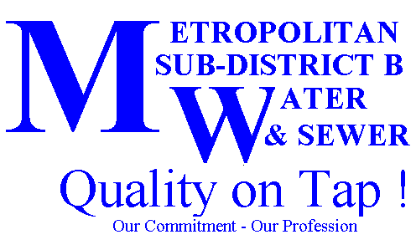

[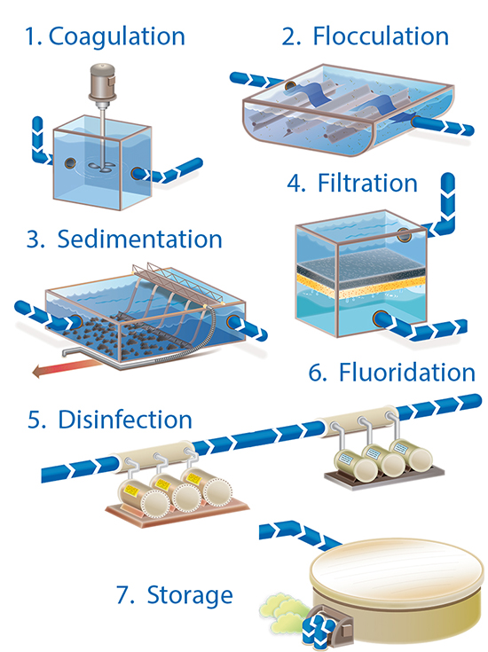](https://www.google.com/url?sa=i&rct=j&q=&esrc=s&source=images&cd=&cad=rja&uact=8&ved=0ahUKEwjK877y7ojUAhUR9mMKHYIKDsUQjRwIBw&url=https://www.sawater.com.au/community-and-environment/our-water-and-sewerage-systems/water-treatment&psig=AFQjCNGjNabkKBlMjE50N0t0yeUZDfQrZw&ust=1495726811488744)

If you have questions about this report, please call our office at 864-503-0822. Our District is governed by a Board of Commissioners who meet at the District Office on the third Thursday of each month at 4:30 PM.