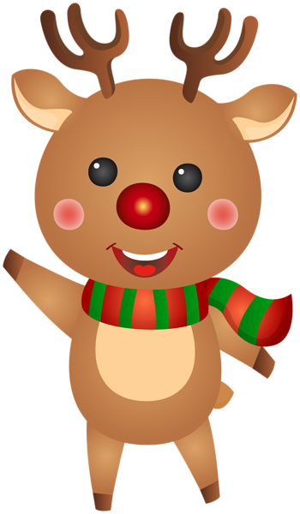

**Finger Plays & Songs!**

Five Little Bells

S-A-N-T-A

Peppermint Stick

Reindeer Pokey

We Wish You a Merry Christmas



**What's Happening**

* We are having a puzzle gift exchange during our Christmas Party! If you would like your child to participate, please send a new, wrapped puzzle with your child's name on the gift before **Friday, December 16th.** Please choose a puzzle that is age appropriate and cost no more than $5.
* Our Christmas Party is **Tuesday, December 20th from 10:00 to 11:00** **for AM and 12:30 to 1:30 for PM.**
* Scholastic Book orders are due by **Wednesday, December 7th**. Orders will be in just in time for Christmas!
* Let's Be Friends is helping our community by creating a Mitten Tree! We are collecting new mittens, gloves or hats to donate to our community. Items collected will be donated to Maumee Schools.
* We are working on Beginning Letter Sounds! Please have your child bring in a picture of something that starts with the letter sound of their first name!

We love the month of December at Let’s Be Friends! We are excited for the Christmas season to start and we have some fun activities planned. With 2022 coming to an end, we look back at how much our little school has grown. We are blessed to have each family with us. We’ve seen growth with each friend in just a few months and we are so proud of them! We wish each of you a Merry Christmas & Happy New Year!



**December Newsletter 2022**

Writers Date

**December Concepts**

**Letters:** Ii, Jj, Kk

**Shape:** Rectangle

**Number:** 4

**Color:** Red

**Club:** I Clean Up!

**Yoga:** Reindeer (Warrior)

**Themes:** Helping Others, Christmas Cheer



**A Few Notes**

* Please call or message if your child will miss school.
* All weather closings will be posted on Facebook, Channel 11, Channel 13 and on the Class Dojo App.
* Please label all coats, hats, etc. with your child's name.
* Christmas Break begins on **Wednesday, December 21st**. We return on **Wednesday, January 4th**.

.

* You can reach the school at 419-893-3476, letsbefriendspreschool18@gmail.com, Class Dojo or Facebook.
* Don’t forget to join our Club each month!