***A Few Notes***

* Thanksgiving Break is **Wednesday, November 23rd to Sunday, November 27th**. We return **Monday, November 28th.**
* Please label all coats, hats, gloves with your child's name.
* Scholastic Book orders are due **November 18th**.

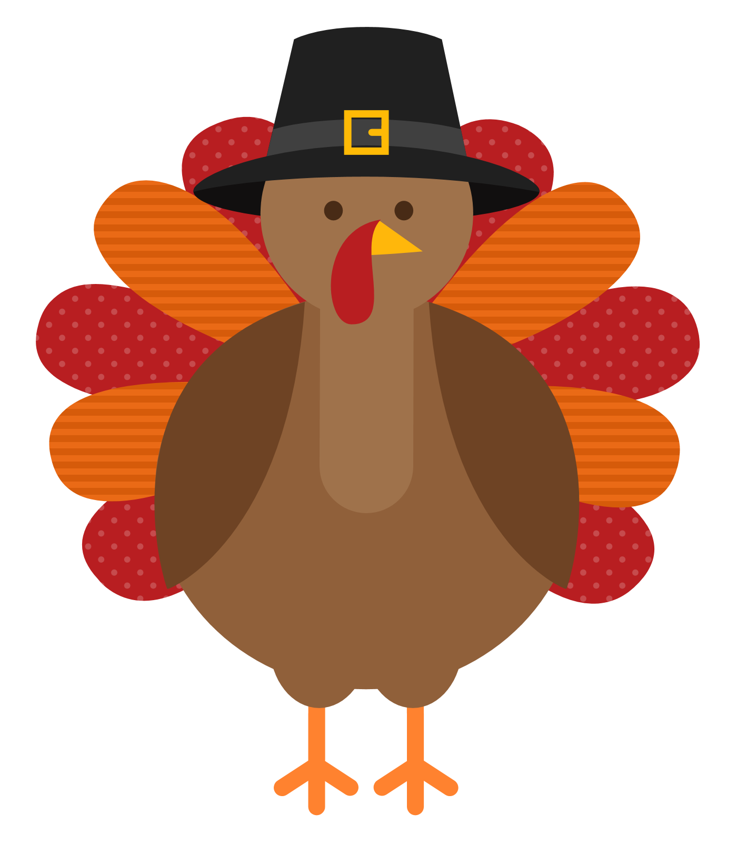 

**What's Happening**

* **No school Tuesday, November 8th** for Teacher Inservice.
* Our Thanksgiving Feast will be on **Tuesday, November 22nd from 10:00 to 11:00 for morning session and 12:30 to 1:30 for afternoon**. Parent volunteers who receive a slip home may attend. Look for those next week!
* Our Share Bag has started to make its way out! There will be plenty of opportunities for friends to bring in a special show ‘n tell this year!
* The Metroparks will be in **November 9th** for a program on Ohio Animals.
* Please let us know if a family member or friend would like to be a Mystery Reader!

A huge thank you to everyone who attended our Halloween Parade! We were so happy to see so many smiling faces of parents, siblings and grandparents. We saw so many LBF alumni, too! Our Wellness Wednesdays with Miss Sheila have been so much fun. The kiddos are so attentive and love participating. This month, we will focus on being mindful. Miss Sheila has some great activities planned. We wish everyone a Happy Thanksgiving!

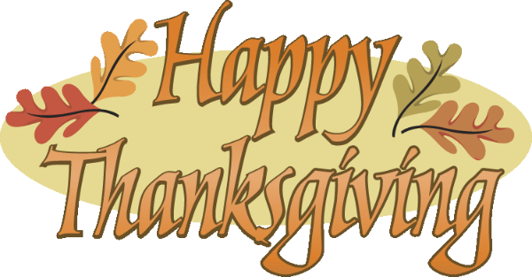

**November Newsletter 2022**

Writers Date

**Finger Plays & Songs!**

Turkey Dinner

Funny Turkey

If You're Thankful and You Know It

5 Little Turkeys

Zip Up Your Jacket

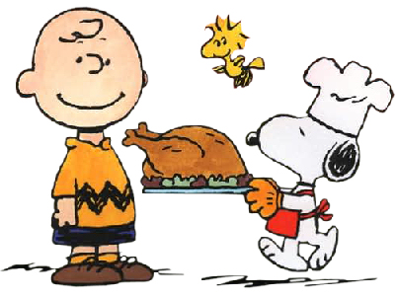

**November Concepts**

**Letters:**  Ff, Gg, Hh

**Shape:** Triangle

**Number:**  3

**Color:** Brown

**Club:** Try five new foods!

**Themes:** Thankful, Five Senses

**Yoga**: Turkey Twist

* Don't forget to have your child join our Club each month!
* You can reach the school at or 419-893-3476, letsbefriendspreschool18@gmail.com, Facebook or Dojo.