**A Few Notes**

* We are starting our Mystery Reader this month! Any parent, friend, family member may come in to read to our class. Please let us know if you’d like to participate!
* Please pack a napkin with your child’s snack.
* Scholastic book orders are due Friday, October 21st.
* Be sure to sign up for the Class Dojo App.

**What's Happening**

* We will be welcoming the Maumee Fire Department in for Fire Safety Month!
* **Thursday, October 27th** is our Halloween Party! School will be from **10:00 to 11:00 for Morning only and 12:30 to 1:30 for Afternoon** **only,** so we may enjoy our time. Friends are encouraged to dress in their costumes. Our Halloween parade will start at **10:45 for Morning and 1:15 for Afternoon**. Friends and family may enjoy the parade on our front lawn. We will ask for party donations and parent volunteers soon!
* We will continue to work on our scissor skills. A good way to practice is to have your child rip small pieces of paper, cut small snips or cut out coupons. If you would like us to send home a pair of safety scissors, please let us know!

Happy Fall everyone! Thank you for everyone who donated supplies to the school. We will definitely put everything to good use. The kiddos are getting in the routine of school and following rules. This month we will focus on the gorgeous colors of Fall, fire safety and pumpkins. Finally, LBF received a grant to bring health and wellness in the school. Miss Sheila will be in for Wellness Wednesdays! She will be teaching our friends yoga, balance and mindfulness. We are excited to welcome her!

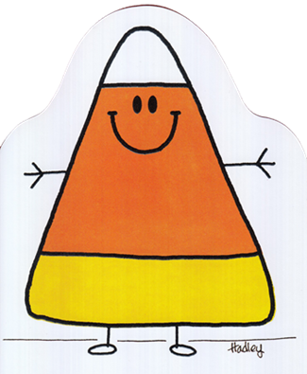

**October Concepts**

**Letters:** Cc, Dd, Ee

**Shape:** Square

**Number:** 2

**Color:** Orange

**Club:** I know my last name!

**Yoga:** Triangle

**Themes:** Fire Safety, Autumn, Pumpkins

**October Newsletter 2022**

Writers Date

* Don't forget to have your child join our Club each month!
* You can reach the school at or 419-893-3476, Dojo, letsbefriendspreschool18@gmail.com, or on Facebook.

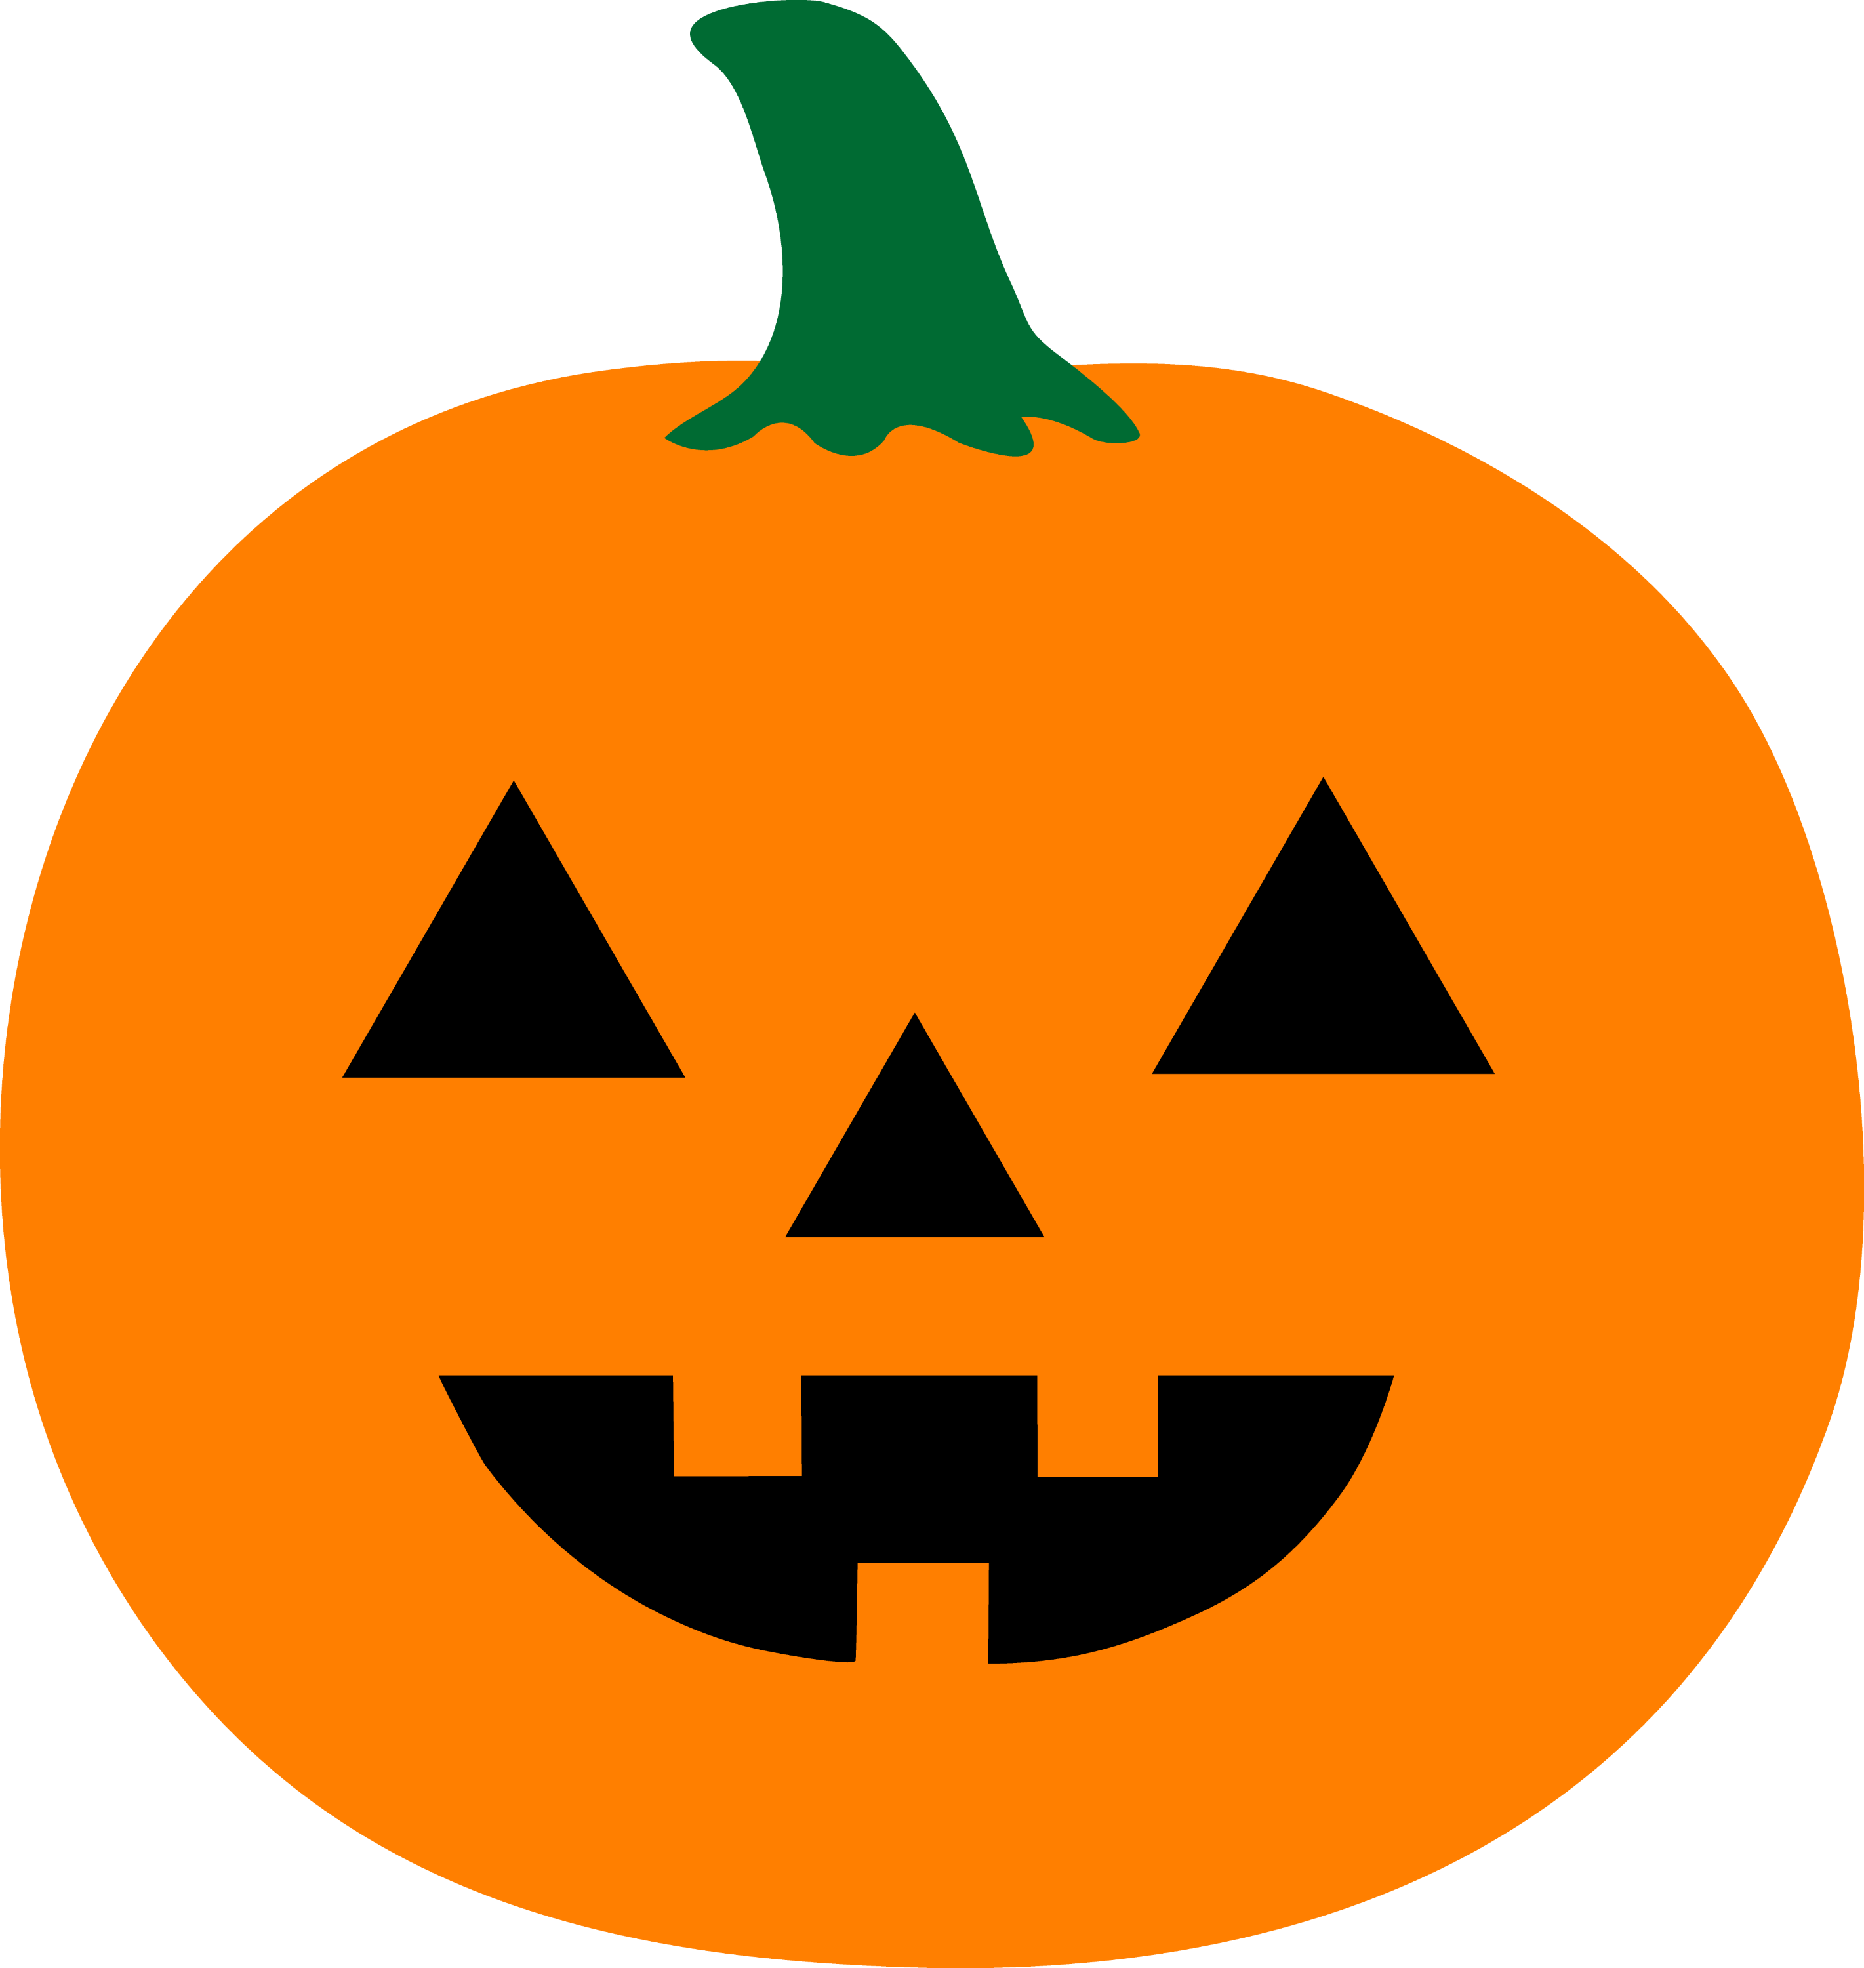

**Finger Plays & Songs!**

The Leaves on the Trees

Five Little Pumpkins

Scarecrow, Scarecrow

Autumn Time is Coming

Spooky Walk

