September Concepts

**Letters:** Aa, Bb

**Shape:** Circle

**Number:** 1

**Color:** Yellow

**Club:** I help clean up!

**Yoga:** Starfish

**Themes:** Safe Choices, School Routine, Apples

What's Happening

* LBF is excited to welcome Officer Jillian Elliott from the Maumee Police Department this month. Officer Elliott will talk about safe choices.
* Scholastic Book Orders will be due by Friday, September 24th.
* Please welcome Miss Jessica to her new role as Lead Teacher! Miss Jessica has been with Let’s Be Friends since 2018. She is the perfect fit!
* LBF will be holding a fundraiser in October. We will be offering products from Buff City Soap. All earnings will go to upgrade out library will cozy pillows and relaxing mats to sit on for library time!

Welcome to another fantastic year at Let’s Be Friends! We are eager to get back in the school with our friends and families. Our programs during the school year will return with visits from the Maumee Police and Fire Department, Nature’s Nursery and Toledo Metroparks. We will head outside plenty this year so please have the kiddos dress appropriately. A reminder, we are on shorter hours for the first two weeks of September. The first week our hours are 12:30 to 2:00. The second week our hours are 12:30 to 2:30. This will help each child adjust to a new and exciting routine. Let’s make this a wonderful year!



Just a Few Notes

* Please be sure to check your child's folder each day. Important information will be sent home weekly!
* Parents have asked what supplies can they donate. We would love to add to our craft area. Beads, buttons, coloful paper or feathers are always fun!

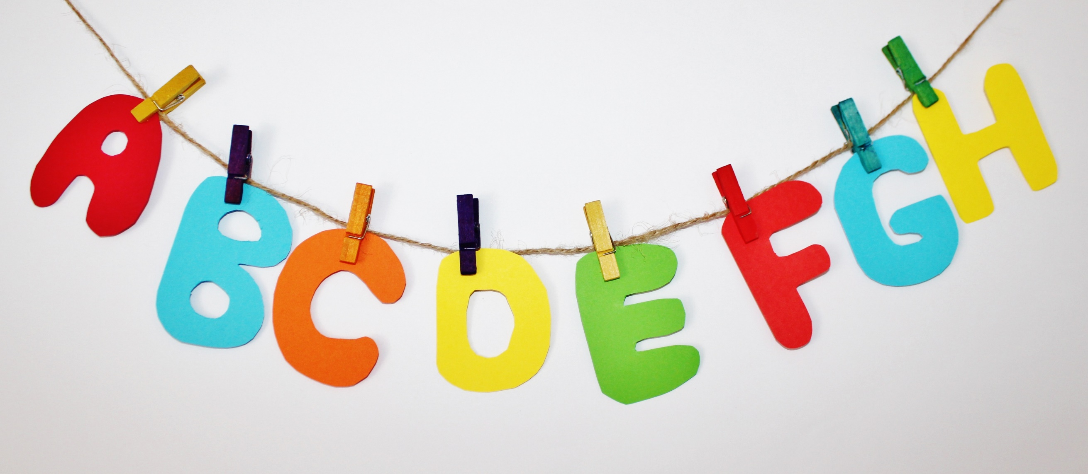

Finger Plays & Songs!

Way Up in the Apple Tree

I’m a Police Officer

5 Little Apples

My Friends Go Marching

Put Your Apple In The Air

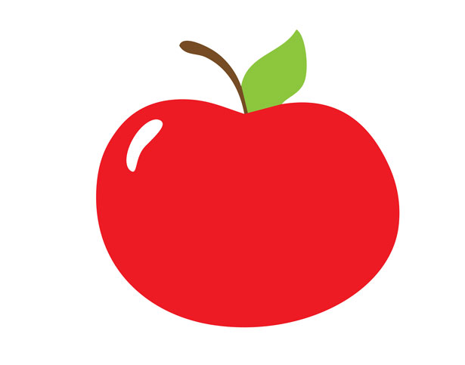

September Newsletter 2021

2019

Writers Date