Welcome to another wonderful year at Let’s Be Friends! We are excited to get back in the school with our friends and families. Our programs during the school year will return with visits from the Maumee Police and Fire Department, Nature’s Nursery and Toledo Metroparks. We will head outside plenty this year so please have the kiddos dress appropriately. We are also bringing a little health and wellness in this year. Miss Sheila will be leading us in yoga and exercise. Let’s make this a happy and safe year!

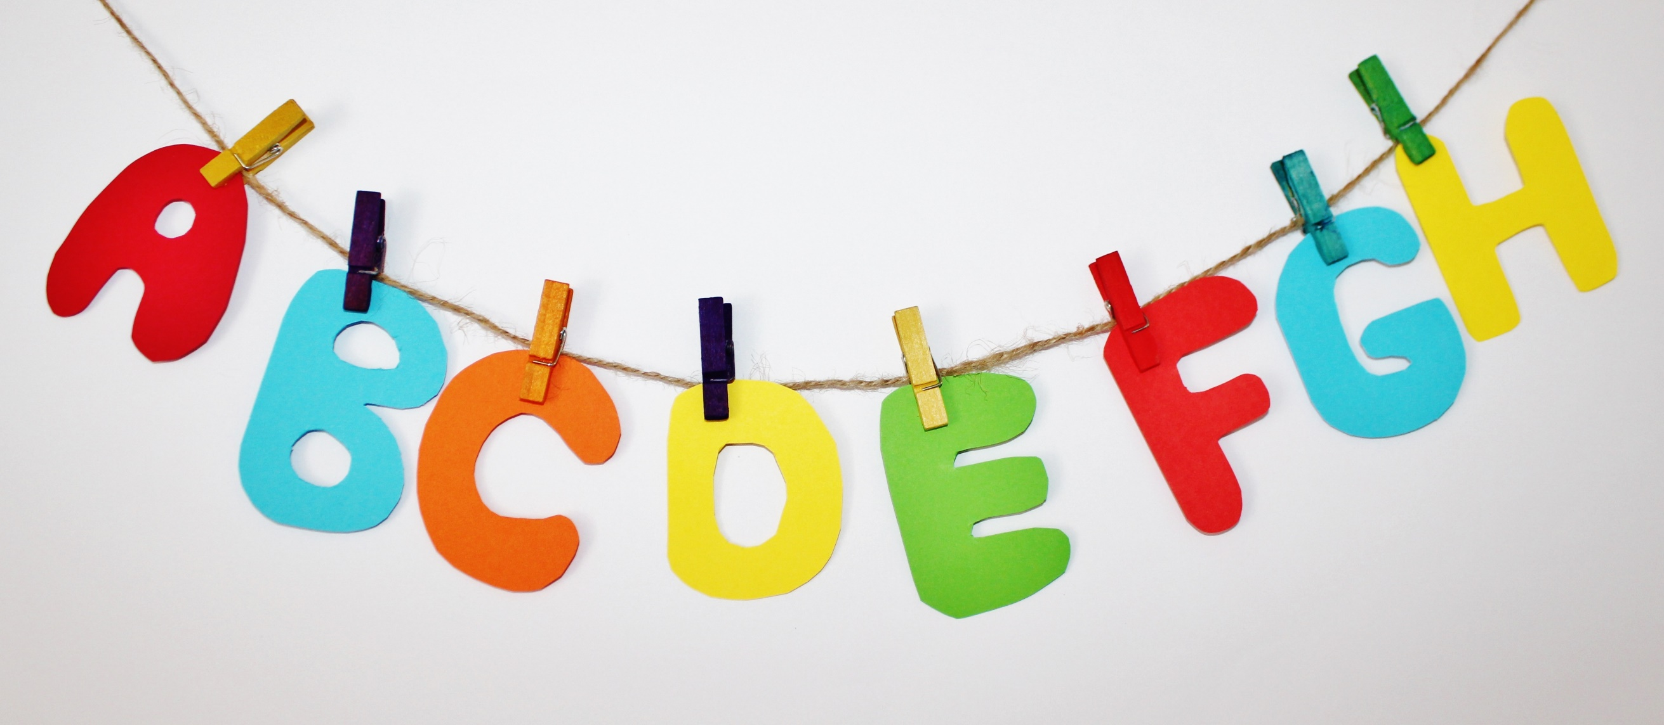

What's Happening

* LBF is excited to welcome in the Maumee Police Department this month for a program about safety.
* Scholastic Book Orders will be due by Friday, September 23th.
* Our Share Bag will start to go home the week of September 19th. This is a fun way for friends to Show and Tell. There will be plenty of times for each friend to bring the Share Bag in!
* Consent forms for Social Media and Parent Roster are due Friday, September 16th.



September Concepts

**Letters:** Aa, Bb

**Shape:** Circle

**Number:** 1

**Color:** Red

**Club:** I help at home!

**Yoga:** Starfish

**Themes:** Apples, Back to School

Finger Plays & Songs!

Way Up in the Apple Tree

I’m a Police Officer

5 Little Apples

This Little Light of Mine

Popcorn Kernels

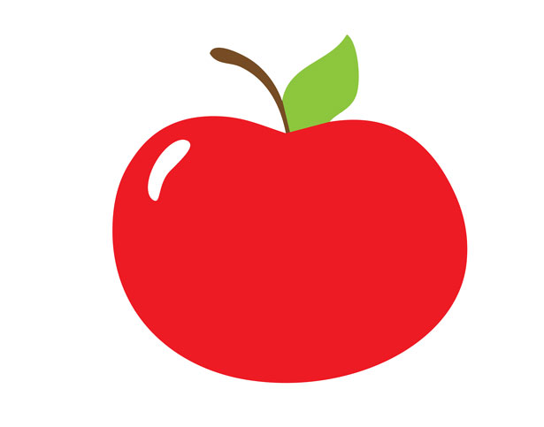

Just a Few Notes

* Please be sure to check your child's folder each day. Important information will be sent home weekly!
* Parents have asked what supplies can they donate. Jumbo sized Crayons and Paper Towels are always helpful!
* We will be on shorter hours the first two week of school. Week 1 our hours are 12:30 to 2:00. Week 2 our hours are 12:30 to 2:30. Week 3 will begin our normal school hours.

September Newsletter 2022

2019

Writers Date