Dr. Joe Olivacz: Sports Chiropractor and Pitching Doctor
Private Lessons & Pitching 101 for Coaches/Parents
Dr. Joe Olivacz offers several services: Private pitching lessons for kids between the ages of 7-14; Prevention/Treatment of Sports Injuries; as well as the Rec/Travel League presentation:
Pitching 101: What Every Coach/Parent of a Youth Pitcher Should Know
• 4-Year College Pitcher & Still Pitching Competitively For Over 34 Seasons
• Head Coach/Pitching Coach for Churchville Baseball
• Current Pitcher in the Harford County Over-30 League
• Certified Chiropractic Sports Practitioner (C.C.S.P.)
• Certified Strength and Conditioning Specialist (C.S.C.S.)
• Certified Graston Practitioner (Soft Tissue Treatment)
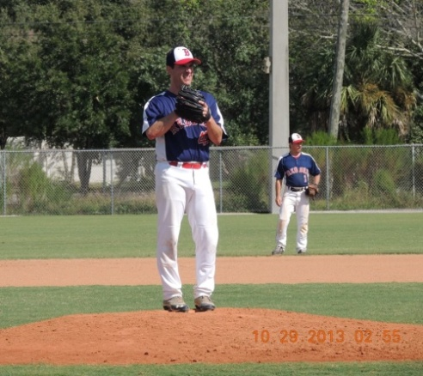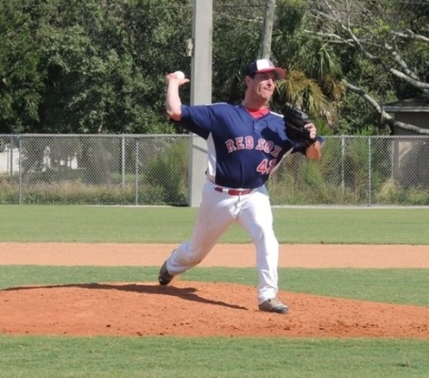
The best way to treat an injury is to prevent an injury. My lessons focus on proper mechanics, drills, conditioning and arm-care with emphasis on how to greatly reduce the risk of injury.
Facebook Page: Dr. Joe Olivacz : The Pitching Doctor
Contact: jolivacz@yahoo.com or 410-925-0055

