

Opening Day 2023

April 15, 2023

**Opening Day Timeline**

9:00 - 4:00 - **Snack Shack - Open all day**

Snacks, drinks, hamburgers, hot dogs, candy, Churchville merch and more!

Raffle Tickets - Grand Prize $2,500 toward Disney Vacation!

9:00 - 11:00 - Pictures, all teams (team schedule below)

9:00 - 10:45 - Activities: bounce houses, carnival games, snack shack, vendors

10:45 - Parade lineup - All teams

11:30 - Parade start - All teams

11:45 - Opening Ceremonies - Field 2

12:15 - 2pm “Over the Hill” home run contest

12:00 - 2pm Activities: bounce houses, carnival games, snack shack, vendors

1:00 - First Games - FIelds 1,3,4,5,6,7 (team schedule below)

2:30 pm - Second round of games (team schedule below)

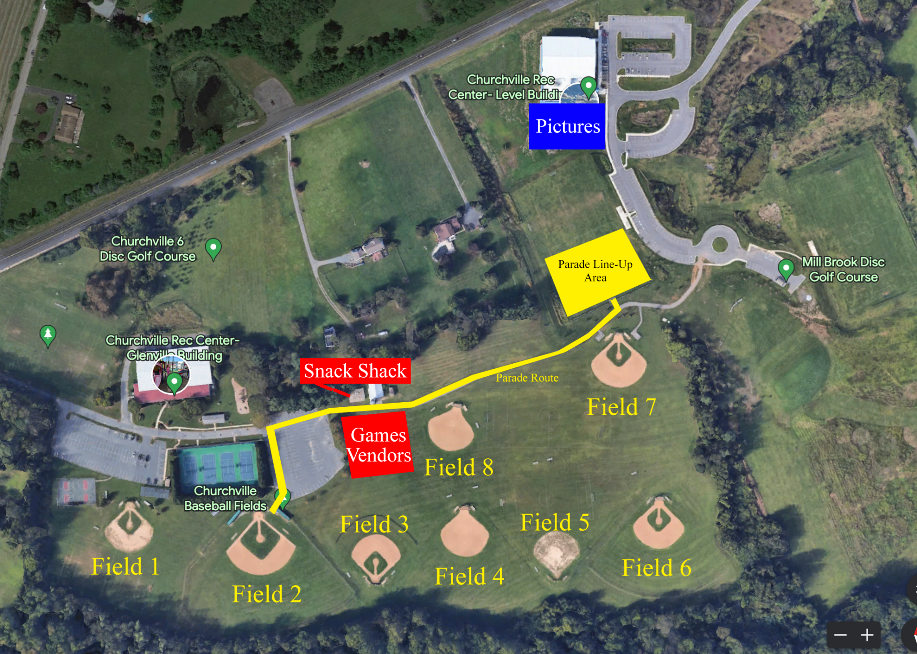

**Individual and Team Photos 9:00am - 11:00am**

Location: NEW Churchville Rec Center Level Building

Instructions:

* Each team to arrive by their posted picture time
* Team photos will be a composite (each individual player photoshopped into a background)
* After photos, proceed to other activities

**Parade Lineup - All Teams 11:00am (11:15 Start)**

Location: Soccer field 6 next to Churchville Rec Center Level Road Building

Instructions:

* Each team must be in place by 11:00am.
* Team names will be labeled on the ground with paint
* First is t-ball teams, last is 16+ teams
* Teams will march along parade route, waving to onlooking families.
* Parade ends on Field 2
* After parade passes, parents follow players to field 2 for opening ceremonies

**Opening Ceremonies - All Teams 11:30am - 12:00pm**

Location: Field 2 by tennis courts

Instructions:

* Players and coaches will stay together and will sit in the infield grass of Field 2
* Parents will stand in foul territory around the the Field 2 infield.

Order of Ceremonies:

* Presentation of flags
* National Anthem
* Speeches & announcements
* First pitch
* Play ball!

**Over the Hill Home Run Contest 12:00 - 2:00pm**

Location: Field 2 by tennis courts

Instructions:

* Parents may enter the competition for a $20 entry fee.
* Each contestant will receive 10 hittable pitches
* Each batted ball that goes beyond the marked line (approx 250’ from home plate) equals 1 point
* Each batted ball that goes over the outfield fence equals 2 points
* The contestant with the most points at the end of the day wins a prize!

**Snack Shack - Open all day 9:00am - 4:00pm**

* Snacks, drinks, hamburgers, hot dogs, candy
* Churchville Baseball merch
* 50/50 raffle
* Grand prize raffle drawing

**Midway Games, Activities, and Vendors**

Before opening ceremonies **10:00am - 11:00am**

After opening ceremonies **12:00pm - 2:00pm**

* 2 Bounce Houses (free of charge)
  + Parent supervision required - See bounce house attendant for details
* Dunk Booth (1 throw for $3, 2 throws for $5)
  + Dunk your coaches!!! Throw a bullseye and dunk a coach in the tank!

**Vendors 10:00am - 2:00pm**

Kona Ice - Snowball Truck

Level Fire Department - Firefighters and life saving equipment

Legends of the Fog - Haunted Attraction - Churchville / Aberdeen MD

Churchville Lions Club

Churchville Ruritan Club

Churchville Disc Golf

Jarrettsville Young Marines

Creations by Raquel

Churchville Rec Center

Noorani Orthodontics

Mission Pet Supplies

Bella Boutique and Crafts

Castle Explorers Travel

Play it Again Sports

Creations 123

Amy’s Rad Crafts

**Games 1:00pm & 2:30pm**

All Churchville Rec Teams will have games on opening day

See schedule below for other games

**Churchville Baseball - Opening Day 2023 Schedule**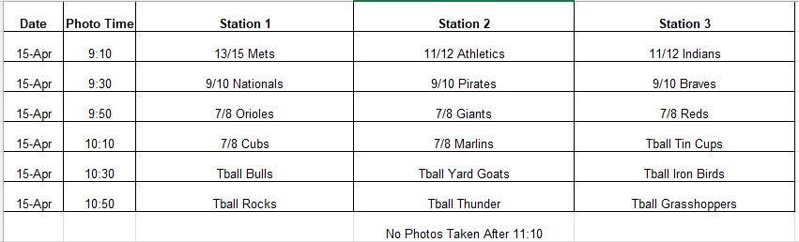

|  |  |  |  |  |  |  |  |  |  |  |
| --- | --- | --- | --- | --- | --- | --- | --- | --- | --- | --- |
| Opening Ceremonies | 11:00 Parade Lineup | **All Teams - Meet on Soccer Field 6 (near Level Road Building)** | | | | | | | | |
| 11:15 - 11:30 Parade | **All Teams - Leaves Soccer FIeld 6 - Proceeds on paved path - Ends of Baseball Field 2** | | | | | | | | |
| 11:15 - 12:00 - Opening Ceremonies | **All Teams - Baseball Field 2** | | | | | | | | |
| 12:00 - 1:00 - Lunch | **Lunch, Activities, Bounce Houses, "Over the Hill Home Run Competition"** | | | | | | | | |
|  |  |  |  |  |  |  |  |  |  |  |
| Games | **Field** | **1** | **2** | **3** | **4** | **5** | **6** | **7** | **8** | **CVES** |
| **1PM Timeslot** | 7/8 - Orioles VS. Giants | HOME RUN DERBY  12 - 2pm | 9/10 - Nationals VS Pirates | Tball - Thunder & Tincaps | Tball - Bulls & Yard Goats | 11/12 - Athletics VS Indians | 7/8 Reds VS Marlins  (2 innings) | Tball - **(12:30 Start)**  Grass-  hoppers vs Ironbirds | Tball - APG Bats vs. Blue Rocks |
| **2:30 Timeslot** | Ctd | 13-15 Mets VS 16-20 Orioles | 9/10 - Nationals VS Braves |  |  |  | 7/8 Reds VS Cubs  (2 innings) |  |  |

Tball Games - Max 2 innings - 60 minutes or less

7-8 Games - Max 3 innings - 90 minutes or less

9-10 Games - Max 3 Innings - 90 minutes or less