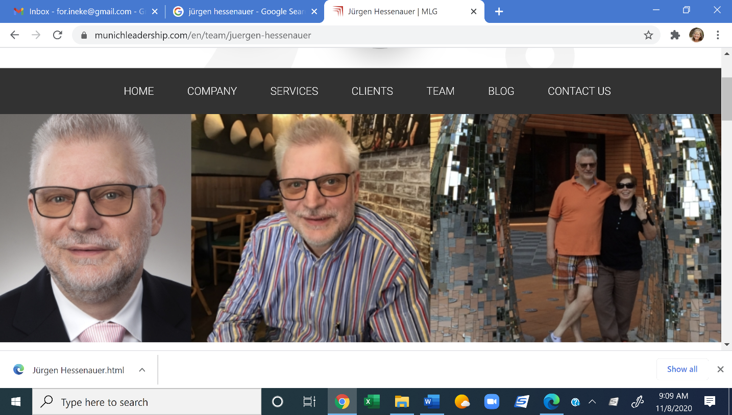 [](https://www.google.com/url?sa=i&url=https%3A%2F%2Fwww.conferenceroomsystems.com%2FZoom-Pro-Annually-p%2Fzoom-pro-annually.htm&psig=AOvVaw01PYb_4PqAmjZ9E2AW_XrK&ust=1585535762928000&source=images&cd=vfe&ved=0CAIQjRxqFwoTCNCltpbTvugCFQAAAAAdAAAAABAD)

**Monday December 7 - Shayna Inman**

**Guatemala Challenge**

**Monday November 30 - Juergen Hessenauer**

**Effective Leadership Communication. Practical insights from Neuroscience.**

## **President’s Message**

## **By Kent Pike**

Greetings fellow Rotarians,

I hope your bellies are full from Thanksgiving and that you have all remained healthy. We will continue to follow the Governor's Orders for the Month of  December with all virtual meetings.

Fantastic job to Mark on delivery of the wreaths as Santa's Helper, and to Walter and Eric for helping pass them out.

This week our own Juergen has the podium, so don't miss it.  See you on Zoom at 5:30!



**We meet at:**

**Spare Time Bowling Alley**   
[**16317 Statesville Rd**](https://maps.google.com/?q=16317+Statesville+Rd+%0D+*Huntersville,+NC+28078*&entry=gmail&source=g)   
[**Huntersville, NC 28078**](https://maps.google.com/?q=16317+Statesville+Rd+%0D+*Huntersville,+NC+28078*&entry=gmail&source=g) **Every Monday**

**from 5:30 till 6:30 PM  
  
For info contact:  
Ineke Wilson – 704-905-5002**

**Website: https://huntersville-happy-hour-rotary.org/**

**Upcoming programs,**

**speakers and events:**

**November 9 – Ashley Cannon**

**Climbing Kilimanjaro**

**November 16 – Dana Hicks**

**Climate Change**

**November 23 – Wreath Pick Up**

**Parkinglot Spare Time**

**November 30 - Juergen Hessenauer**

**Neuroscience**

**December 7 – Shayna Inman**

**Guatamala Challenge**

**December 14 – Ryan McDaniels**

**LKN Economic**

**Development**

**December 21 – No Meeting**

**Christmas**

**December 28 – No Meeting**

**New Years Eve**

**January 4 –**

**January 11 –**

[](https://www.google.com/url?sa=i&url=https%3A%2F%2Frotaryclubofboise.org%2Fbulletin%2FView%2Ff7c30e78-aec1-45ca-b649-6fd5fc8a2cfb&psig=AOvVaw3A6pYXmp0MVGivcYMNxbss&ust=1586190540675000&source=images&cd=vfe&ved=0CAIQjRxqFwoTCKDZ-7Xa0egCFQAAAAAdAAAAABAD)A person wearing a blue shirt
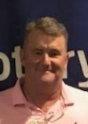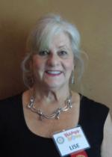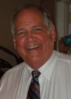9A person wearing a suit and tie smiling at the camera

Description generated with very high confidenceA person wearing a suit and tie smiling at the camera

Description generated with very high confidence

**Club Fundraiser**

**Fresh Fir Wreaths**

Proceeds go to community projects like Hinds Feet Farm, Caterpillar Ministries and other projects.

**Club Fundraiser**

Thank you to the following Rotarians that have ordered wreaths!

|  |  |  |  |  |  |  |  |  |  |  |  |  |  |  |  |  |  |  |  |  |  |  |  |  |  |  |  |  |  |  |  |  |  |  |  |  |  |  |  |
| --- | --- | --- | --- | --- | --- | --- | --- | --- | --- | --- | --- | --- | --- | --- | --- | --- | --- | --- | --- | --- | --- | --- | --- | --- | --- | --- | --- | --- | --- | --- | --- | --- | --- | --- | --- | --- | --- | --- | --- |
| |  |  | | --- | --- | | **Ashley** | **4** | | **Bob & Ineke** | **20** | | **Cori** | **4** | | **Dana** | **1** | | **Eileen** | **4** | | **Eric** | **2** | | **Gay** | **4** | | **Juergen** | **4** | | **Kandi** | **6** | | **Kent** | **5** | | **Kim** | **6** | | **Lise** | **3** | | **Mark** | **10** | | **Peter** | **3** | | **Shayna** | **3** | | **Tom & Joyce** | **6** | | **Walter** | **3** | | **Caterpillar** | **28** | |  | **116** | |  |
|  |  |
|  |  |
|  |  |
|  |  |
|  |  |
|  |  |
|  |  |
|  |  |
|  |  |
|  |  |
|  |  |
|  |  |
|  |  |
|  |  |
|  |  |
|  |  |

**Previous program - Dana Hicks**

**Climate Change**

Dana gave a presentation on "**The Climate Crisis in 2020 and Potential Solutions**".

**Club Service**

**Happy Birthday**

November 8 – Eileen Solomon

November 19 – Erin Lyons

November 29 – Kent Pike

**Happy Anniversary**

November 27 – John & Cynthia Beiler

**Happy Club Member Anniversary**

November 10 – John Beiler – 6 years member

November 10 – Tom Ford – 6 years member

November 13 – Eileen Solomon – 2 years member

**Club Service – New Shirts $20**   
Eric will be ordering new shirts. Very timely, since we are doing so many community service projects. Let Eric know your size! To pay:

**https://huntersville-happy-hour-rotary.org/tshirts**

**Club Officers**

**Kent Pike**

**President**

**Eileen Solomon**

**President-Elect**

**Ineke Wilson**

**Secretary, Historian,**

**Club Bulletin**

**Kim Van Sickler**

**Club Treasurer**

**Club Service**

**Tom Ford**

|  |
| --- |
|  |

**Sergeant-at-Arms**

**Ed Lowry**

**Sergeant Assistant**

**Lise Squillace**

**Club Greeter**

**Gay Rudisill**

**Club Happy Dollars**

**Bob Wilson**

**Club Fundraising**

**Bob Gors**

**Club Membership**

**Peter Capponi**

**Club Socials**

**Joyce Schiaffo**

**Club Socials**

**Walter Siegenthaler**

**Club Programs / Speakers**

A person smiling for the camera

Description generated with very high confidence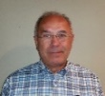A person wearing a suit and tie smiling at the camera

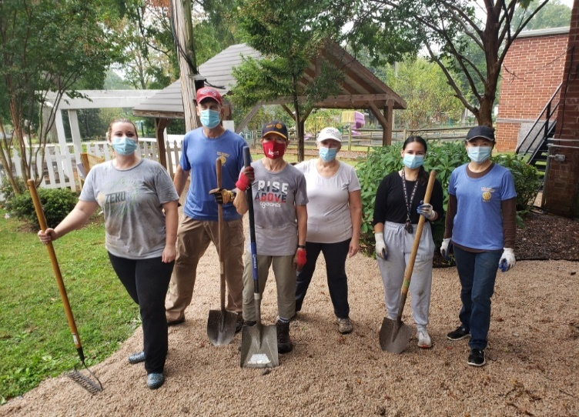A person wearing a suit and tie smiling at the camera

Description generated with very high confidence  mail

**Community Service - Hinds Feet Farm Update**

Our club installed pavers and provided an even walking surface for the patients as they are having therapy-based walks and outside time. We installed the garden boxes and we even have our own sign on the planters. Thanks to all Rotarians that helped, but especially our fearless leaders Mark, Kent, Eric and Tom for taking this project on.

**Community Service – Caterpillar ministries**  
**Saturday October 17** members Kim, Steve, Eric and Sharipainted the ceilings and walls of the new headquarters at Caterpillar Ministries at 12001 Cimmaron Road. Caterpillar Ministries serves the Huntington Green community of Huntersville, an impoverished and largely Hispanic area. The lease on their current headquarters has not been renewed, forcing them to move. This is another project we are doing with the Lake-Norman Huntersville Rotary Club.

**Community Service – Ada Jenkins Community Center**

**Saturday, October 10** members Kim, Shari and Shayna helped at Ada Jenkins, a community center assisting economically disadvantaged families in Davidson, Cornelius and Huntersville. They are located at 212 Gamble Street in Davidson. The Lake Norman-Huntersville Rotary Club needed additional help with a headquarters beautification project from 9am-noon. We mulched flower beds, lay stone, spray paint chairs, sand/paint picnic tables, weed and place edging and landscape fabric.

**Club Service contined**

**Eric Franzen**

**Club Website**

**Kent Pike**

**Club Entertainment**

**Cheryl Holt**

**Club Raffle**

**Eileen Solomon**

**Public Relations**

**Community Service**

**Eric Franzen**

**Community - Hinds Feet Farm**

**Tom Schiaffo**

**Community Service**

**Joyce Schiaffo**

**Community Service**

**Kim Van Sickler**

**Community Service**

**Dana Hicks**

**Community – Riversweep**

**Kitty Long**

**Community - Lydia’s Loft**

**Rick Zoerb**

**Community – Police**

**Foundation Chair**

**Mark Kincer**

**Foundation Chair**

A person in a red shirt

[](https://www.google.com/url?sa=i&url=https%3A%2F%2Fwww.smartblonde.net%2Fusa-mexico-crossed-flags-wholesale-novelty-metal-magnet-m-532%2F&psig=AOvVaw3BldrQguR3WSXRn2f5Hv7Y&ust=1589839400073000&source=images&cd=vfe&ved=0CAIQjRxqFwoTCOiw67vzu-kCFQAAAAAdAAAAABAD)[](https://www.google.com/url?sa=i&url=https%3A%2F%2Funcw.edu%2Fint%2F&psig=AOvVaw0aaoAD3Nc79yM101gdufdI&ust=1589839228659000&source=images&cd=vfe&ved=0CAIQjRxqFwoTCJja3ebyu-kCFQAAAAAdAAAAABAd)A person standing in front of a group of people posing for the camera

**Community Service - Catawba Riversweep**

**Saturday October 3**, 8 members of our club participated in a one day clean up event. They joined more than a thousand volunteers spread out over the entire Catawba River. Tailrace Marina supplied the kayaks, the bags and the dumpster. Afterwards a cookout was enjoyed by many. Thanks to Dana Hicks, Shari, John Beiler, Eric Franzen & family, Eileen & George, Kim & Steve and Bob & Ineke for coming out and cleaning the river!

**Community Service - Hinds Feet Farm**

Hinds Feet Farm is a resident (and day patient) facility that treats

patients with traumatic brain injuries.

Our club installed pavers around the gardens and provided an

even walking surface for the patients as they are having

therapy-based walks and outside time. Rotary themed benches will

also be installed to allow for rest areas and areas of repose for the patients, staff, and volunteers. Huntersville Happy Hour Rotary club will raise $4,000 of the approximately $8,000 in total cost. The other $4,000 comes from a matching district grant.

**International Service – Sponsorship**

**Shari Garcia from Mexico**

Visiting from Mexico and our club sponsored Shari to be a student at CPCC studying International Business.

**International Service**

**Cori Stuart**

**International Service Chair**

**Ashley Cannon**

**International Service**

**Shayna Inman**

**Public Relations**

**Vocational Service**

**Shari Garcia**

**Vocational Service Chair**

**Youth Service**

**Erin Lyons**

**Huntersville Elementary**

**John Beiler**

**High Schools – Interact**

**Kevin Boyle**

**High Schools - Interact**

**Lew Davis Mallard Creek High School**

**Past Presidents**

**Mark Kincer**

**2019-2020**

**Mike Fitzgerald**

**2018-2019**

**Walter Siegenthaler**

**2017-2018**

**Debbie Jackson**

**2016-2017**

**Michael Dane**

**2015-2016**

**Ineke Wilson**

**2014-2015**

**Huntersville Happy Hour Chartered June 16, 2014**