EARTH’s TECTONIC PLATES
Use with Chapter 17
Section 17.3
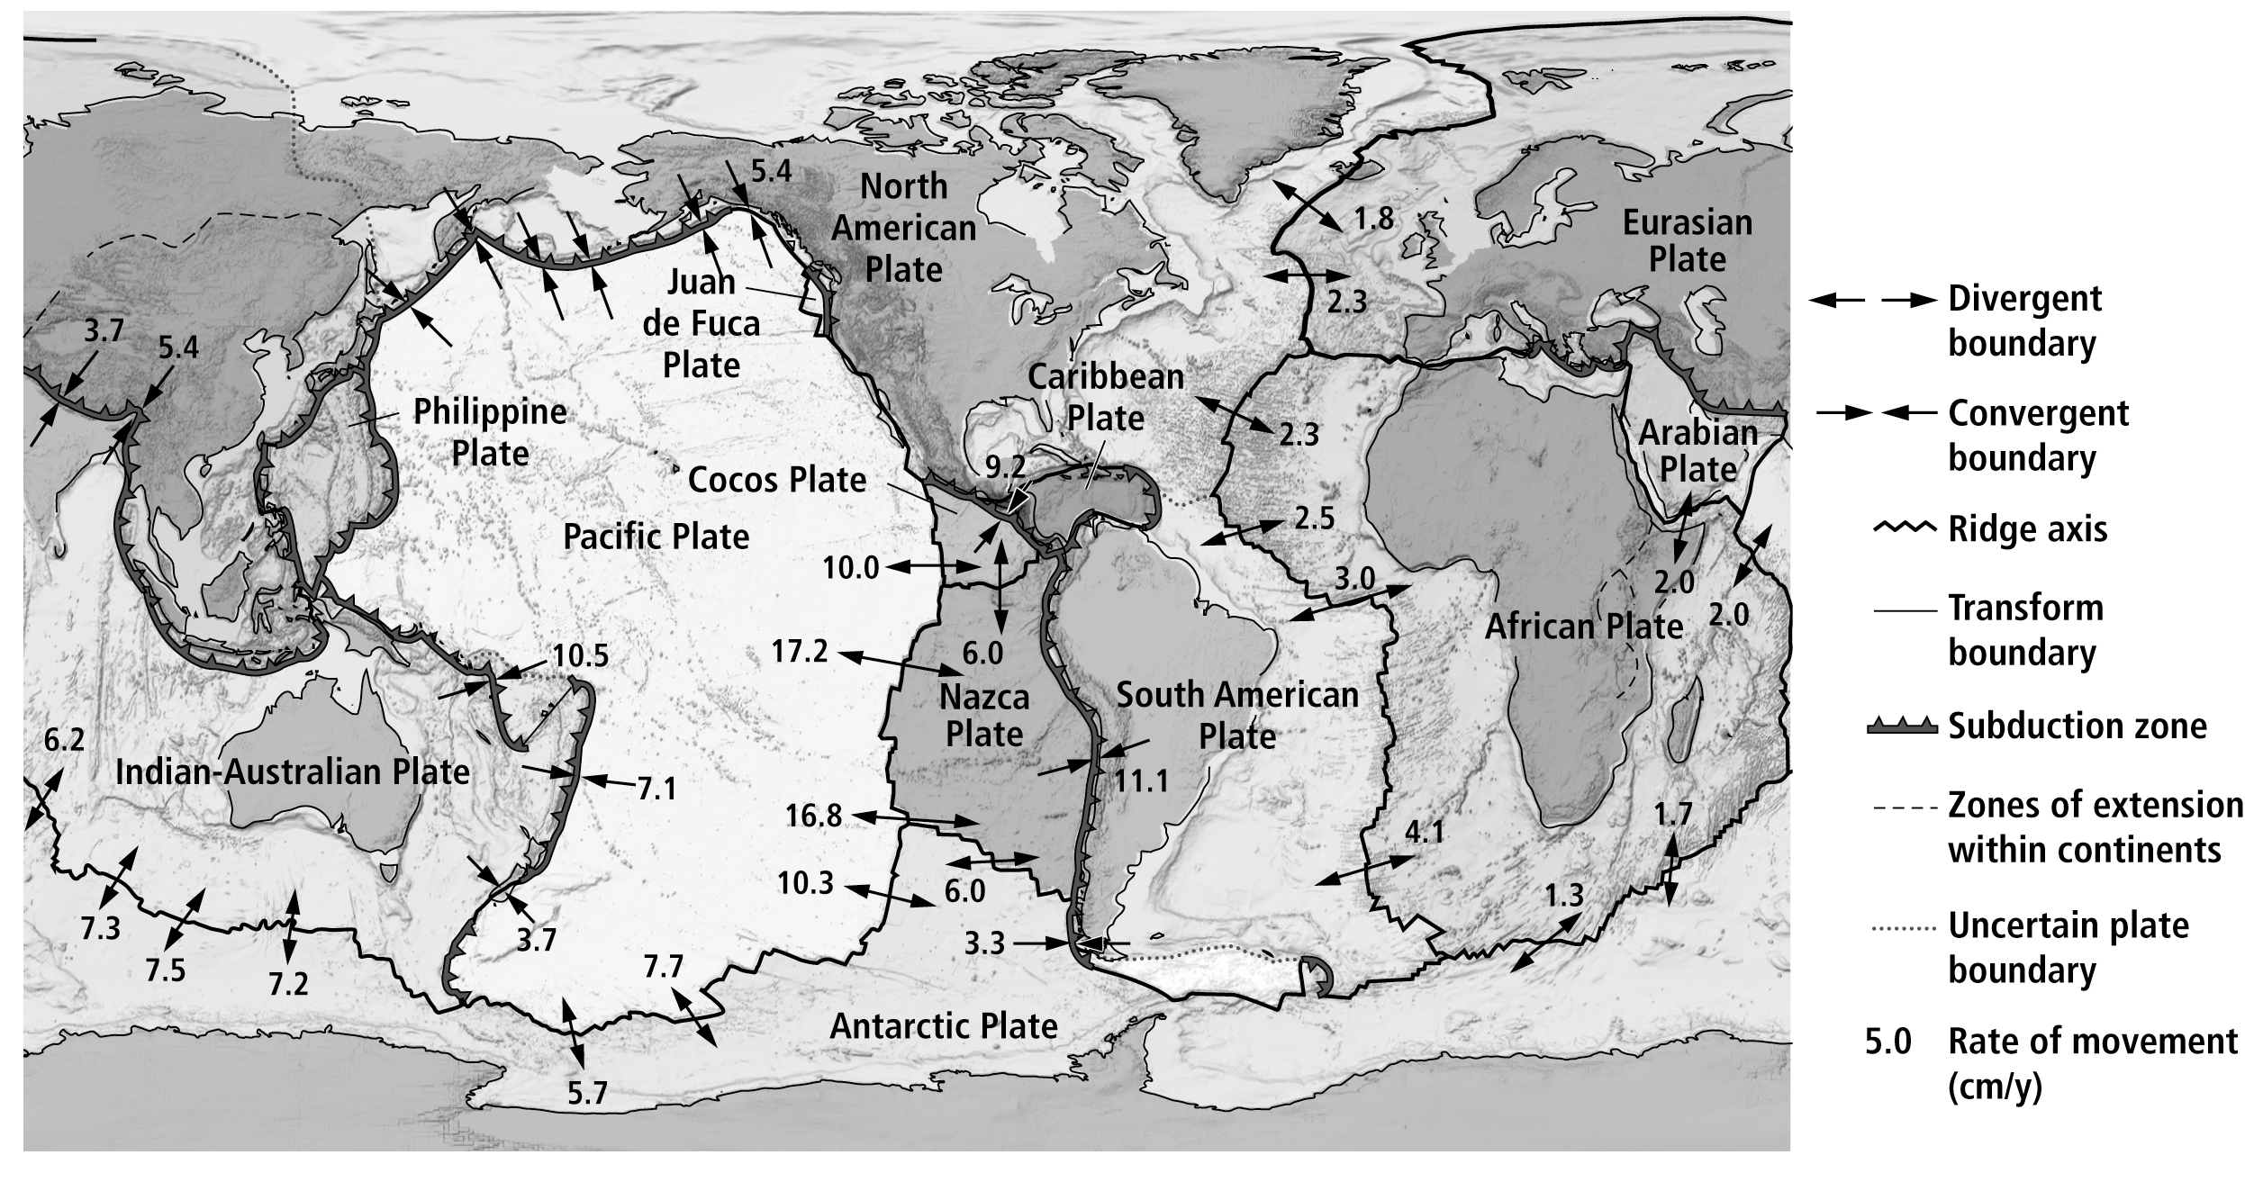

EARTH’S TECTONIC PLATES
Use with Chapter 17
Section 17.3
- In what direction is the Pacific Plate moving?
____________________________________________________________________________________
- Are the Pacific Plate and the Antarctic Plate moving toward each other, away from each other, or past each other? Explain your answer.
____________________________________________________________________________________
____________________________________________________________________________________
- What type of boundary separates the South American Plate from the Nazca Plate?
Explain your answer.
____________________________________________________________________________________
____________________________________________________________________________________
____________________________________________________________________________________
- Describe the relative motion between the North American Plate and the Pacific Plate.
____________________________________________________________________________________
____________________________________________________________________________________
- Between which plates is the relative motion the fastest?
____________________________________________________________________________________
- Would you predict that, over time, the distance between New York and Miami will increase, decrease, or stay the same? Explain your answer.
____________________________________________________________________________________
____________________________________________________________________________________
- Would you predict that, over time, the distance between New York and Lisbon, a city in southern Europe, will increase, decrease, or stay the same? Explain your answer.
____________________________________________________________________________________
____________________________________________________________________________________
____________________________________________________________________________________
____________________________________________________________________________________

