Use with Chapter 21
Section 21.2
Determining Relative Age

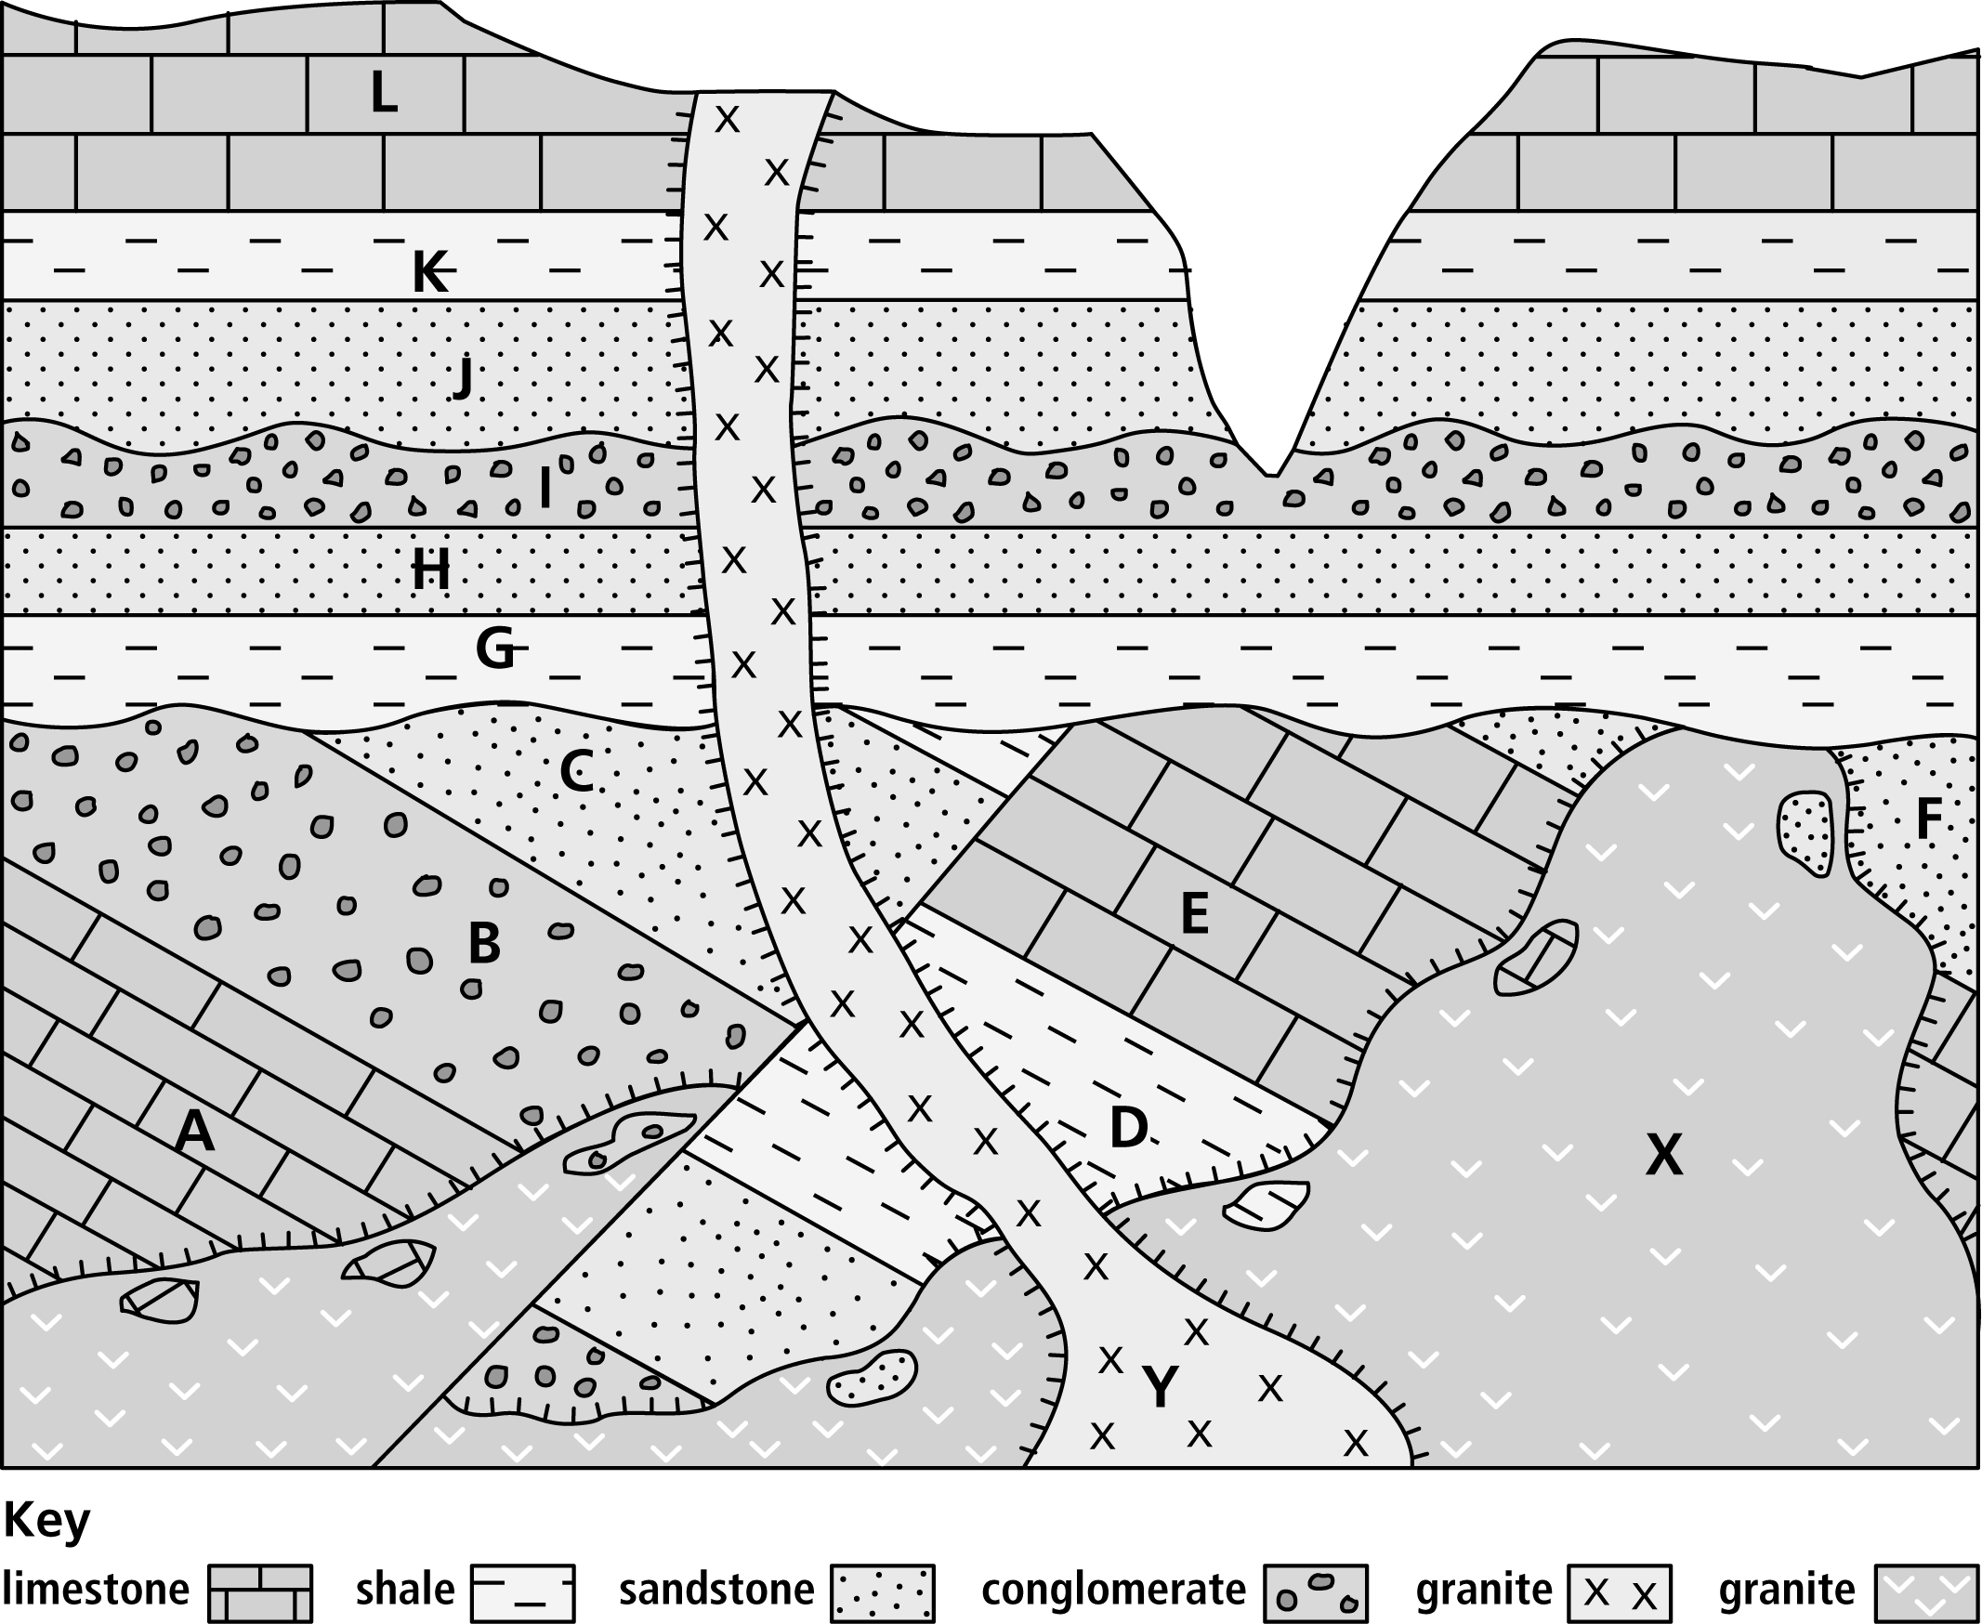

Determining Relative Age
Use with Chapter 21
Section 21.2
- Which rock is the youngest?
____________________________________________________________________________________
- Which rock is the oldest?
____________________________________________________________________________________
- Where in the rock sequence does a disconformity occur?
____________________________________________________________________________________
- Where in the rock sequence does an angular unconformity occur?
____________________________________________________________________________________
- What is the relative age of the fault? Explain your answer, naming any principle you applied.
____________________________________________________________________________________
____________________________________________________________________________________
____________________________________________________________________________________
____________________________________________________________________________________
____________________________________________________________________________________
- What is the relative age of X? Explain your answer, naming any principle you applied.
____________________________________________________________________________________
____________________________________________________________________________________
____________________________________________________________________________________
____________________________________________________________________________________
____________________________________________________________________________________
____________________________________________________________________________________
- List the rock layers in order from oldest to youngest.
____________________________________________________________________________________

