Seismic Waves
Use with Chapter 19
Section 19.2

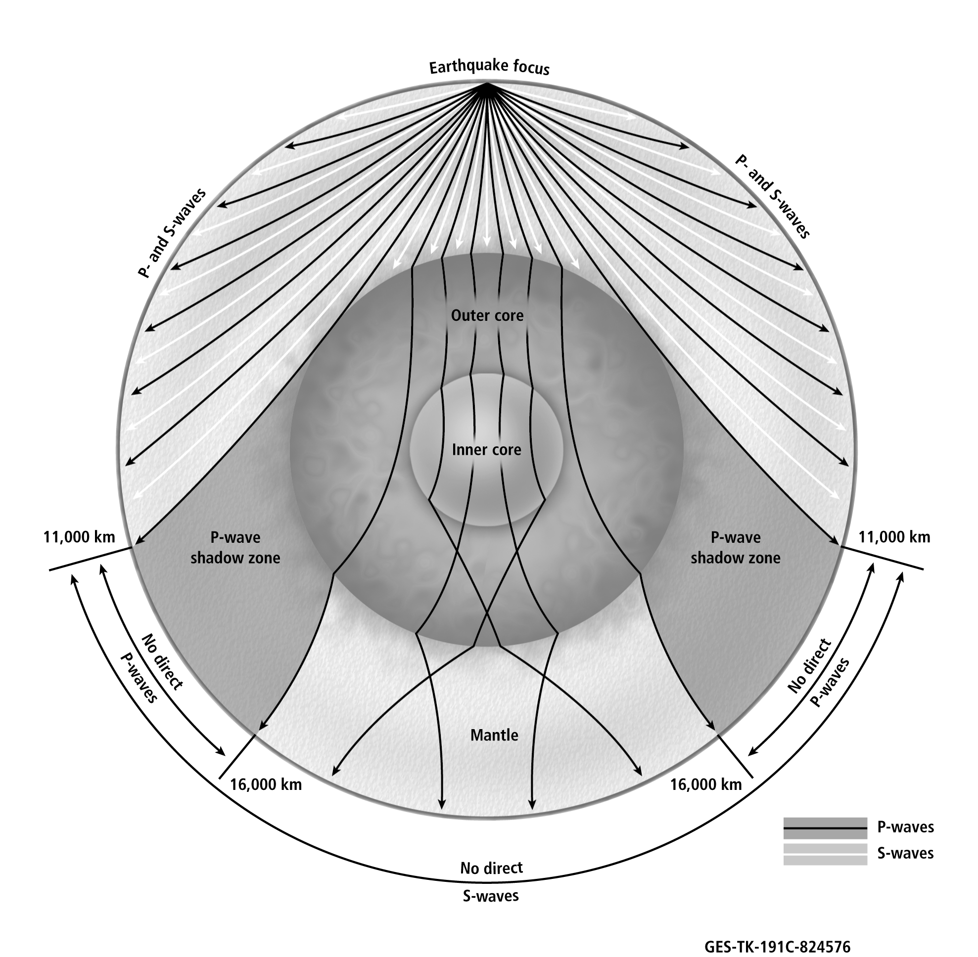
Seismic Waves
Use with Chapter 19
Section 19.2
- What are the three types of seismic waves produced during an earthquake?
____________________________________________________________________________________
- Describe how the different types of seismic waves affect the rocks through which they travel.
____________________________________________________________________________________
____________________________________________________________________________________
____________________________________________________________________________________
____________________________________________________________________________________
- What type of wave is shown traveling through the core? Explain why this is the only wave type shown in the core.
____________________________________________________________________________________
____________________________________________________________________________________
- What happens to P-waves when they strike the inner core?
____________________________________________________________________________________
- What is the P-wave shadow zone?
____________________________________________________________________________________
____________________________________________________________________________________
- Why have scientists reasoned that Earth’s outer core is liquid?
____________________________________________________________________________________
____________________________________________________________________________________
- How have scientists inferred the composition of Earth’s interior?
____________________________________________________________________________________
____________________________________________________________________________________

