Population Growth
Use with Chapter 26
Section 26.1
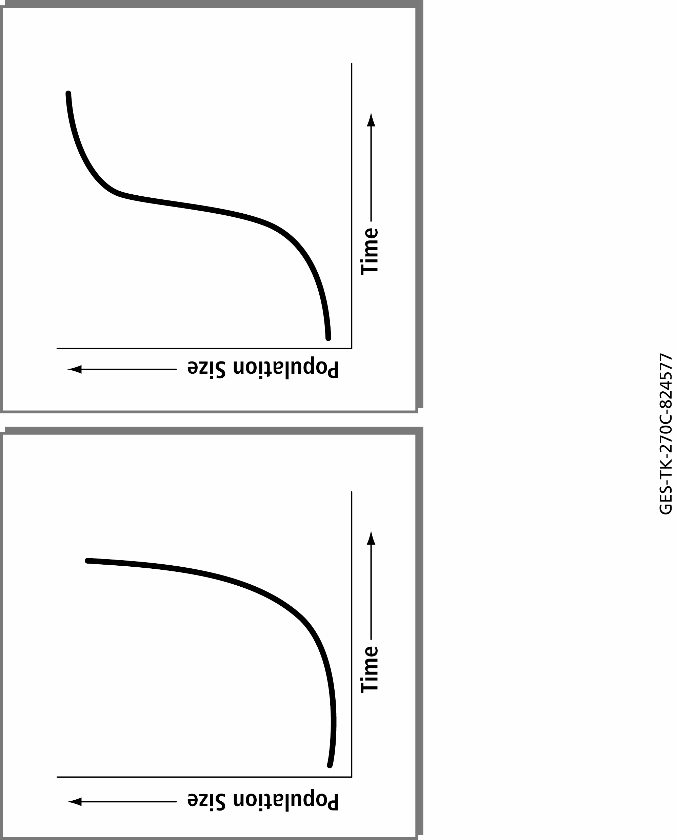

Population Growth
Use with Chapter 26
Section 26.1
- What is population growth?
____________________________________________________________________________________
- In the first graph, how does the rate of population growth compare for the first half and the second half of the time shown on the graph? Explain any difference.
____________________________________________________________________________________
____________________________________________________________________________________
____________________________________________________________________________________
- What is the pattern of growth shown in the first graph called?
____________________________________________________________________________________
- How does the second graph compare to the first? Explain any differences in terms of rate of population growth.
____________________________________________________________________________________
____________________________________________________________________________________
____________________________________________________________________________________
____________________________________________________________________________________
____________________________________________________________________________________
- Which graph shows a population that has not reached the carrying capacity for the environment in which it lives? Explain your answer.
____________________________________________________________________________________
____________________________________________________________________________________
____________________________________________________________________________________
____________________________________________________________________________________
- Which graph do you think most closely resembles the population growth of Earth’s humans? Explain your answer.
____________________________________________________________________________________
____________________________________________________________________________________

